Pictures in August

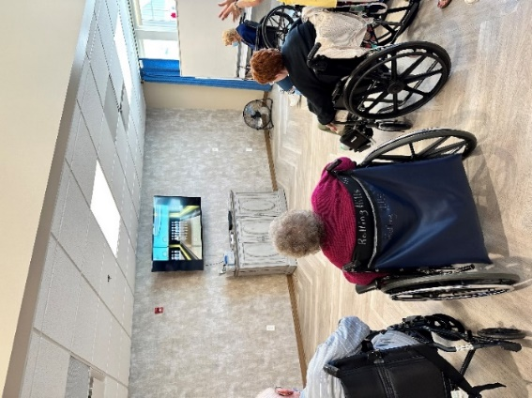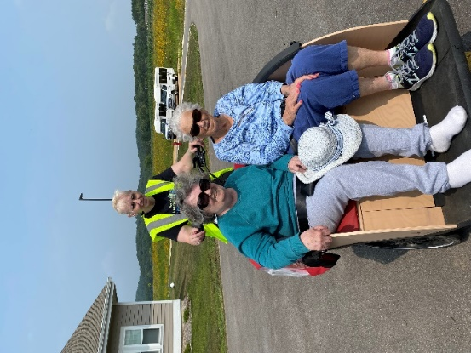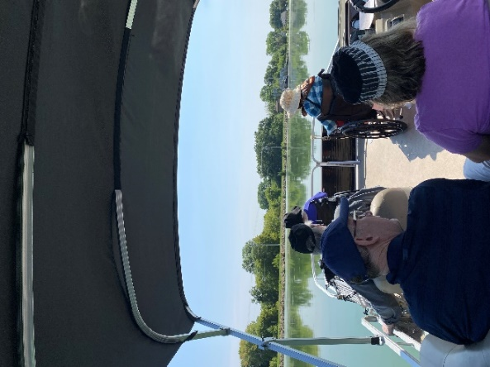

Playing Wii Bowling-Bike & Pontoon Rides

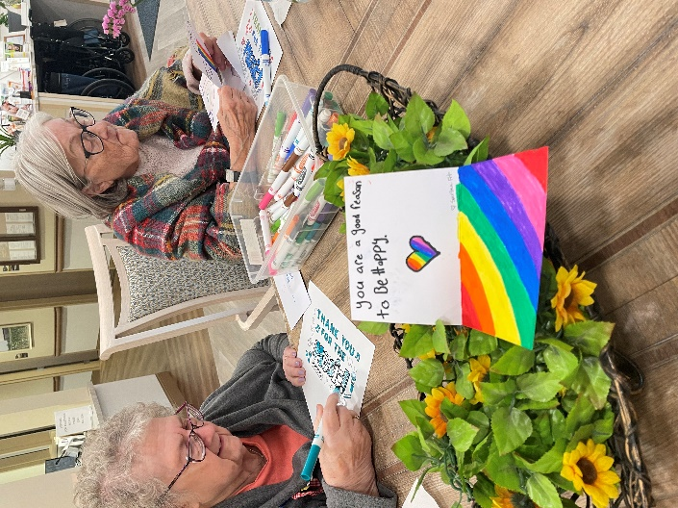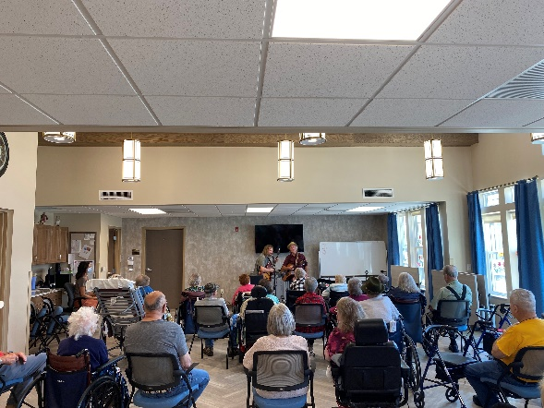

Sparta Fit students gave the residents encouraging cards and Faith Evangelical Free Vacation Bible school donated money to help fund all of our entertainment

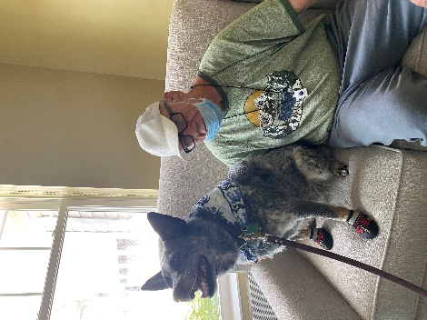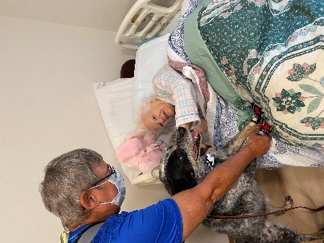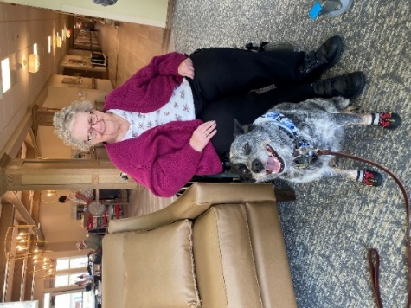

Keota always brings smiles

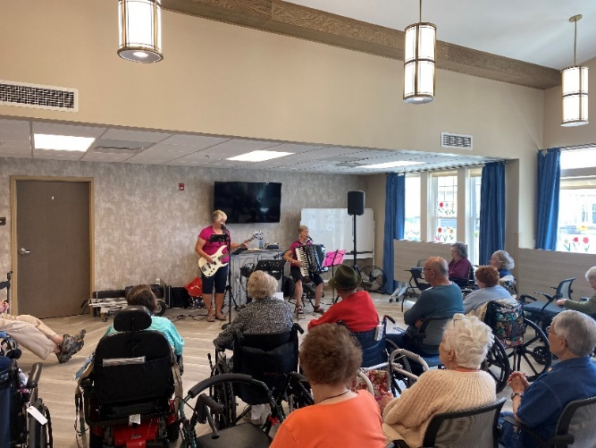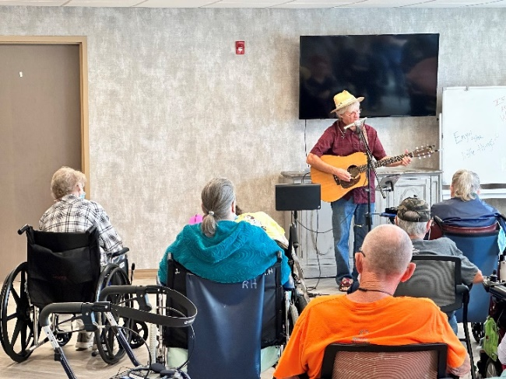

Music to our ears!

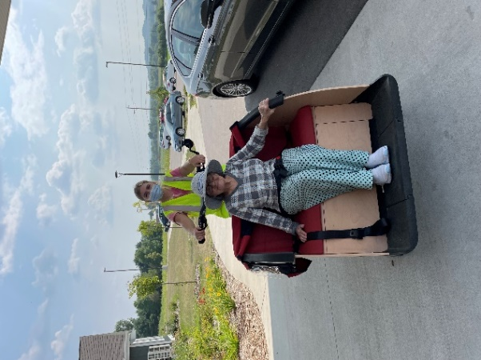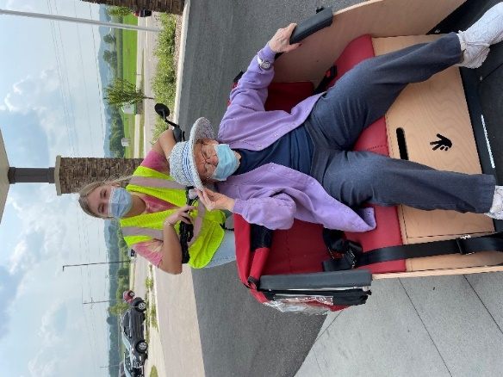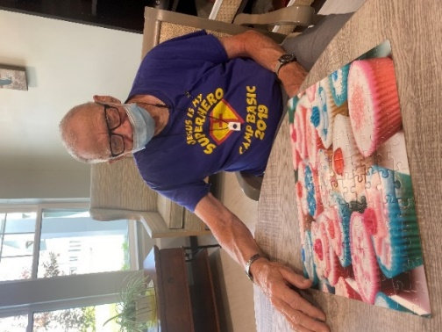

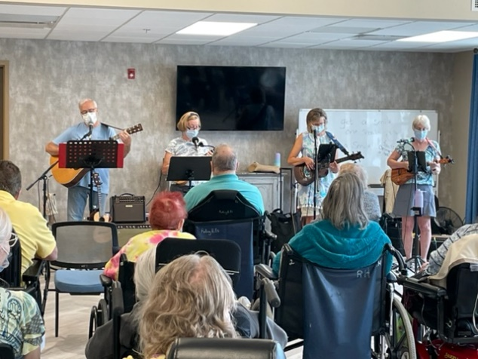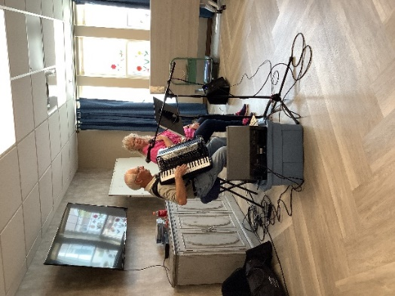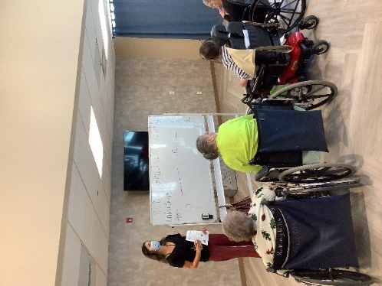

More music and playing Hangman

August kept us all busy. We played a variety of games including hangman and wii bowling which are 2 of our favorites. We raced Dogs for the Dog Days of Summer, enjoyed tasting and learning about watermelon, s’mores and lemonade and sang along to all of our music. When it wasn’t too hot we got out on the last pontoon rides of the summer, went for bike rides and just enjoyed time on our patio. We are looking forward to more adventures in September.

-Linda