April in Pictures

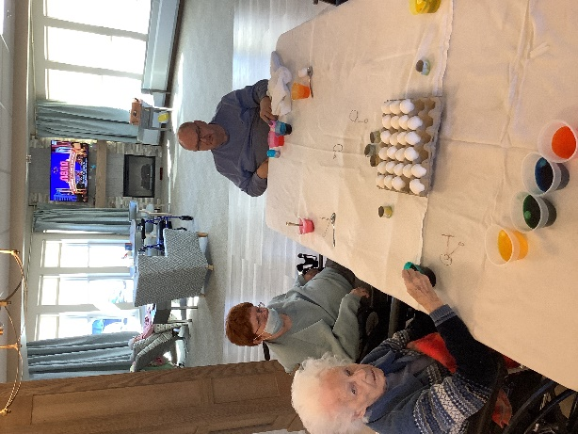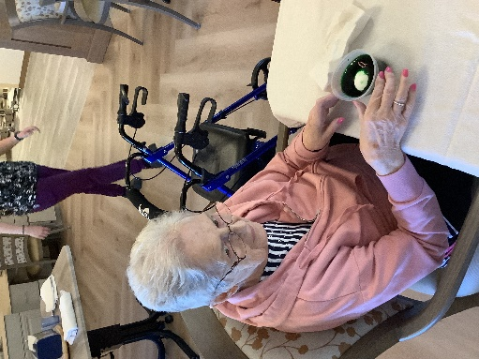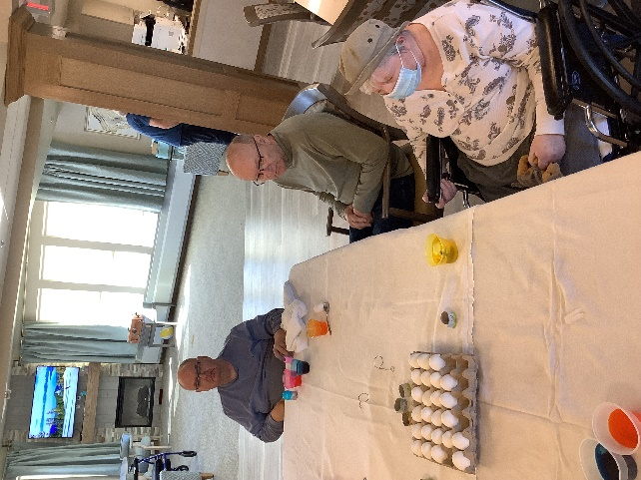

Those of us that could made sure everyone would get a colorful Easter Egg!

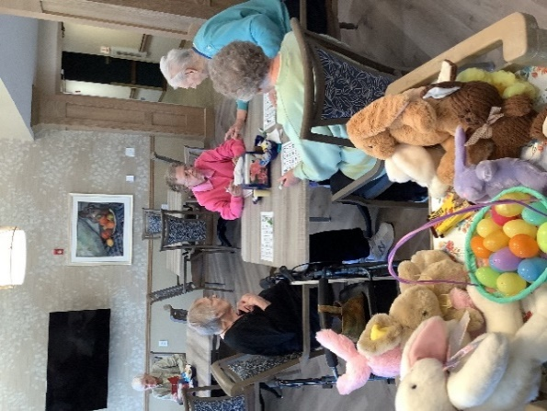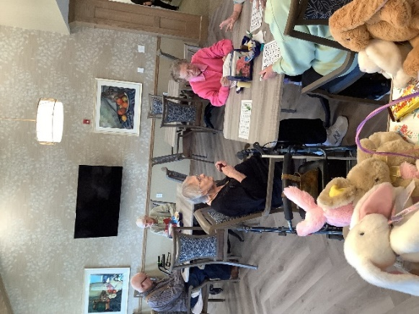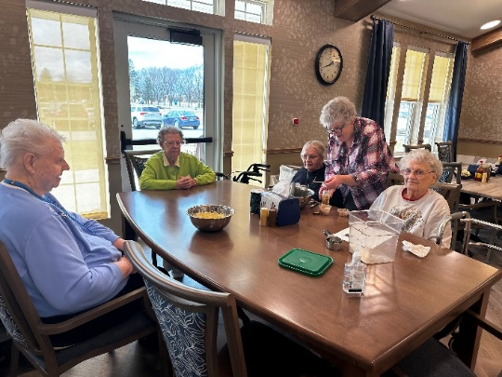

Some Easter Bingo at the apartments

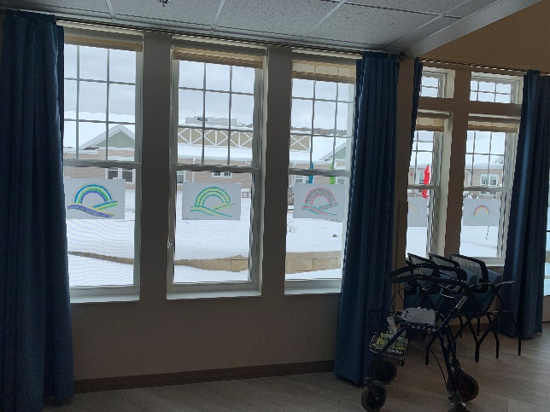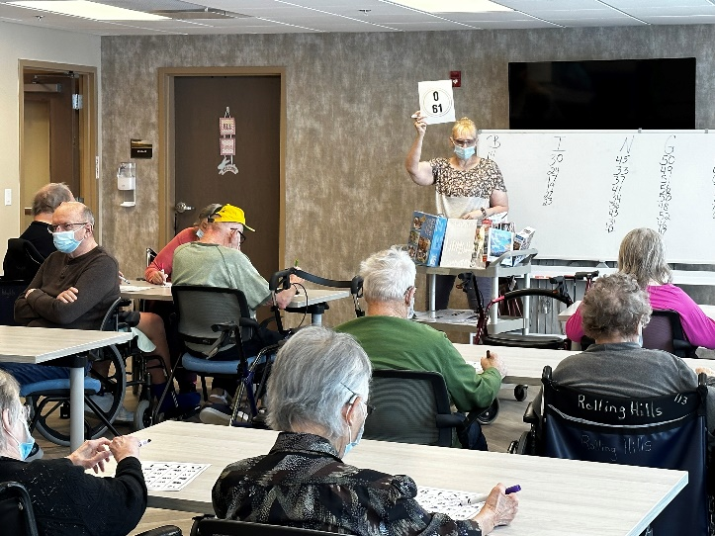

Music & Art making rainbows in the snow

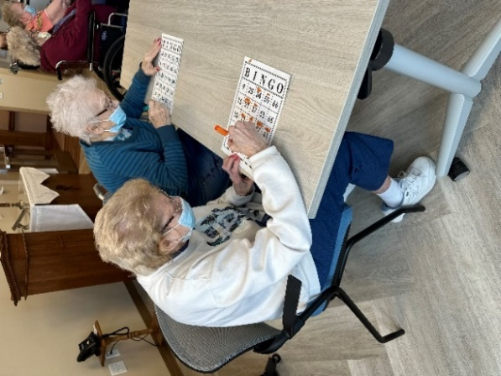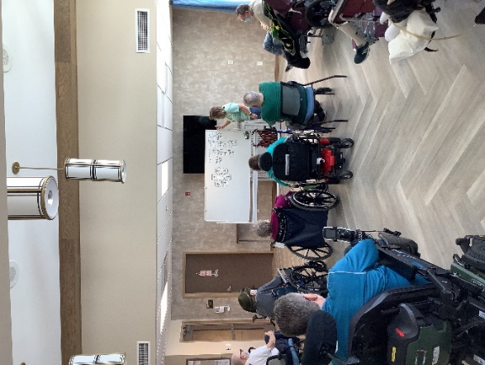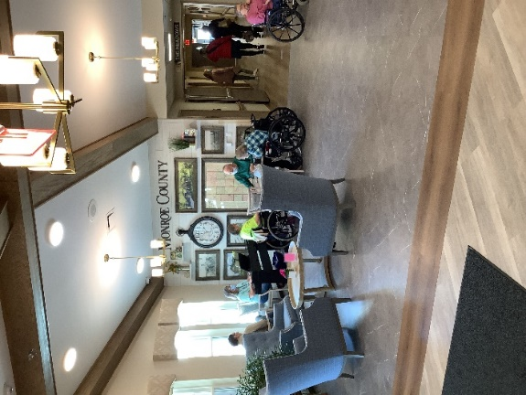

We do love playing a variety of games here!

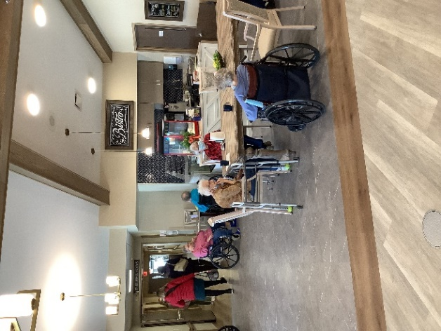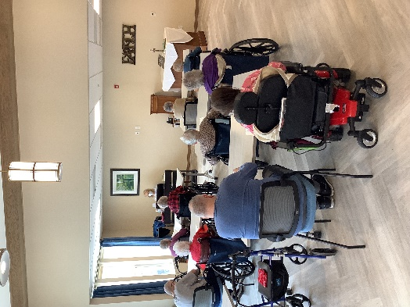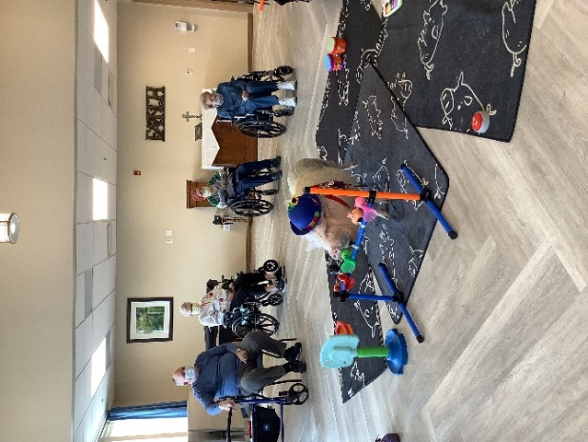

Brutus the pig, music, church services and time at the bistro filling our days.

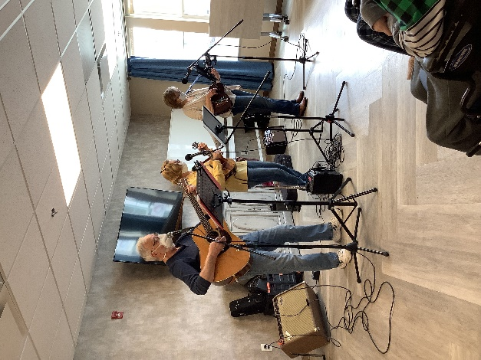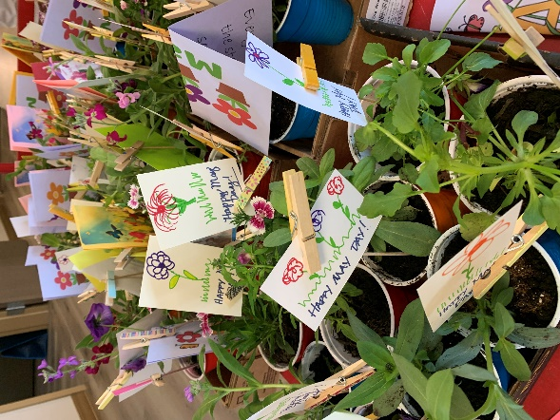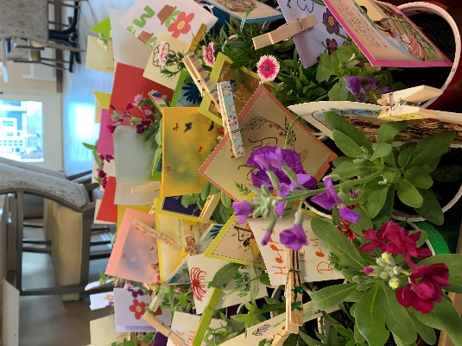

Thanks to the Monroe County Community for the May Day Flowers

Happy May Day!

In April we had a slow start to the month with limited activities, but we got right back into them as soon as we had the go ahead! Bingo, Hangman, Music, Pets, Shopping, Bike rides, art and socializing kept us all busy.

Help support future activity supplies and entertainers by coming to our Flower sale.



It’s Back!

2023 Rolling Hills Annual Flower Fundraiser Sale

Come Shop 2 sizes of Flower Baskets from Sparta Floral

Thursday, May 11th from 9-6

Friday, May 12th from 9-6

Saturday, May 13th from 9-1

In the Rolling Hills Multipurpose Room

(Enter the main door and walk straight ahead

until you see the sign)