October at Rolling Hills in Pictures

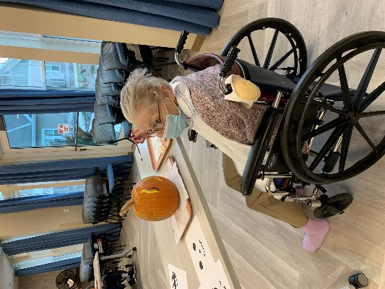 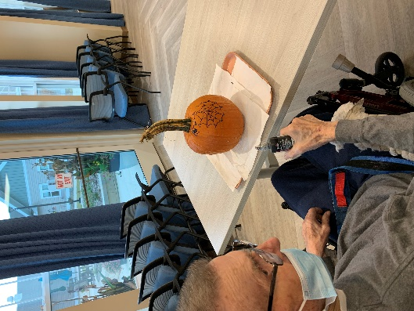 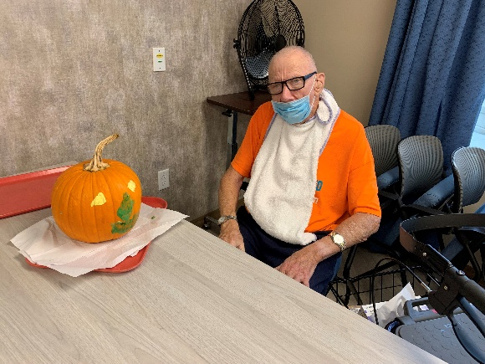

Painting pumpkins

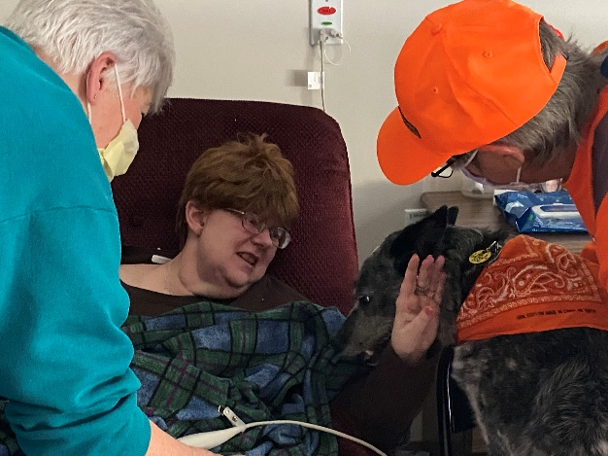 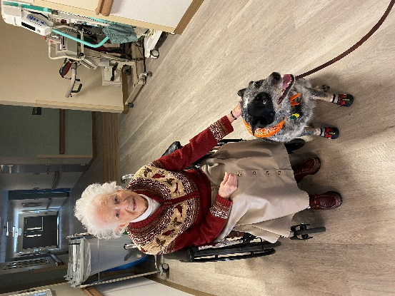

Keota visits

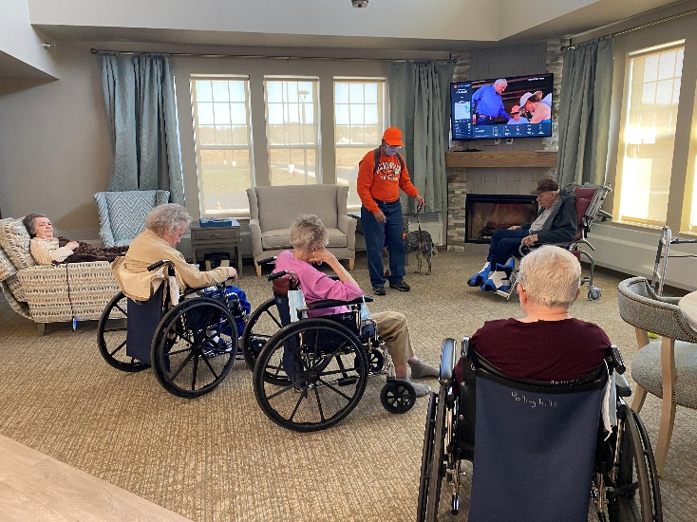 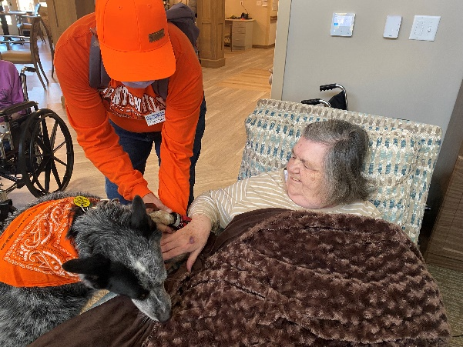

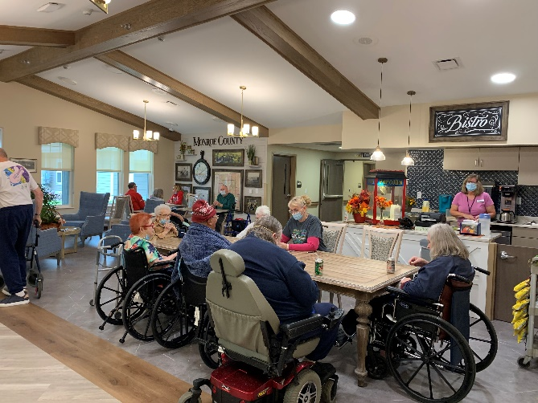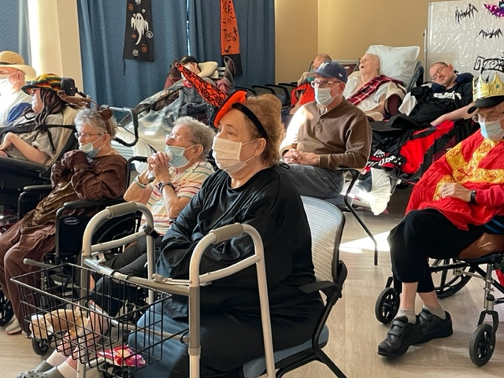

Halloween Party

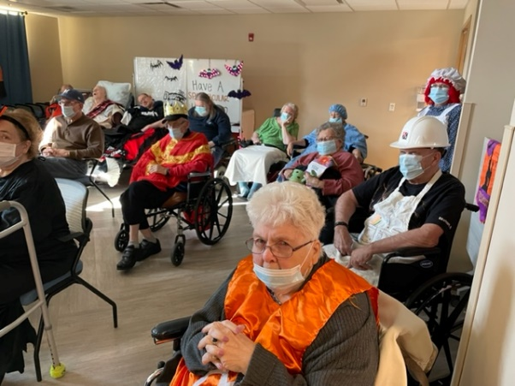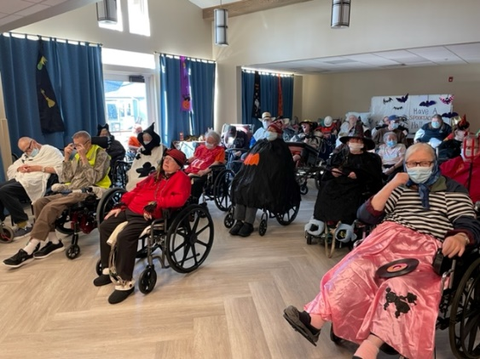

Loving the costumes and fun facts, jokes and finish the phrases

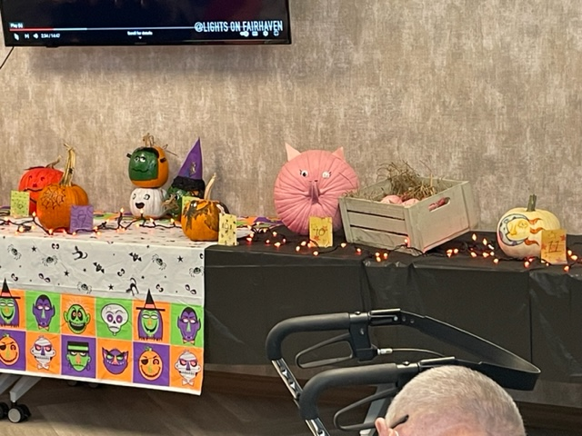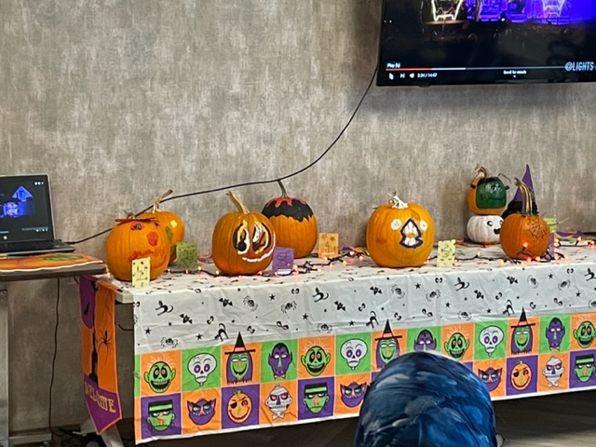

Pumpkin decorating contest

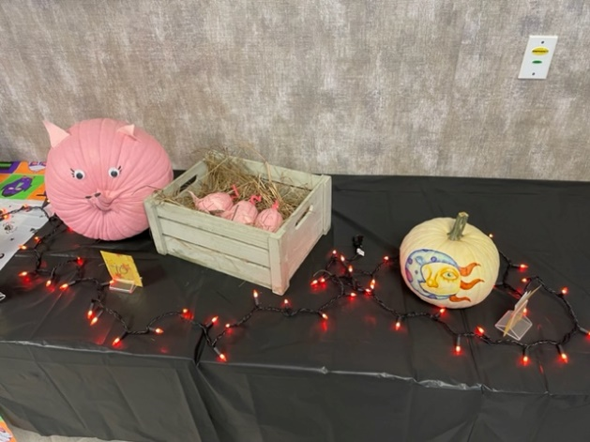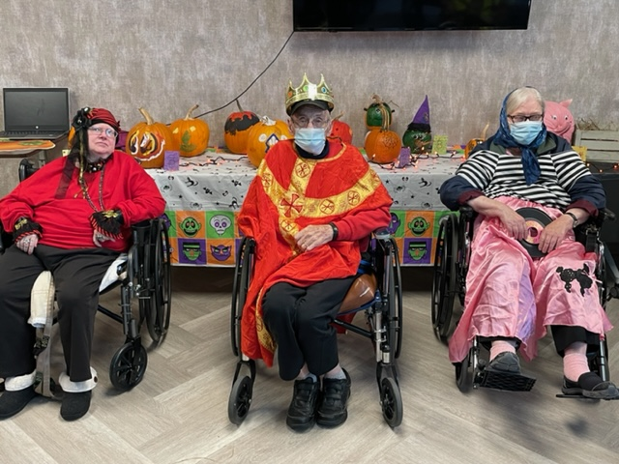

Pumpkin and costume contest winners!

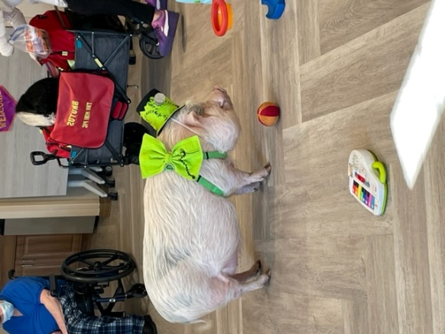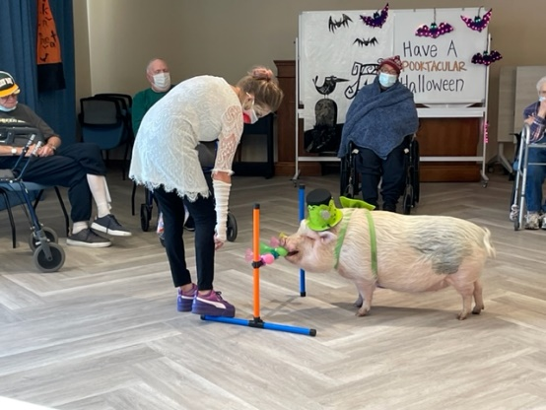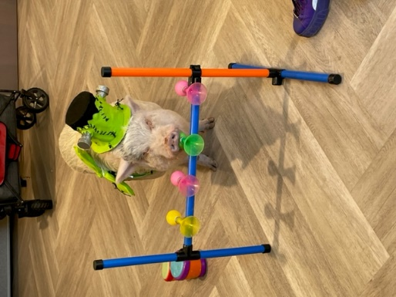

Brutus, AKA, FrankenPIg came with his bride on Halloween too!

This month we have kept busy and enjoyed all that nice days we could outside. We were able to go shopping at Walmart, enjoy some scenic drives, play bingo, have a movie matinee with Hocus Pocus, sing along with all our entertainers, interact with our pet therapy animals and took part in Halloween activities such as baking pumpkin bars, decorating pumpkins and having a party. Check out the pictures of Brutus all dressed up for Halloween as well as the residents.

-Linda