The end of August and a start in the new home

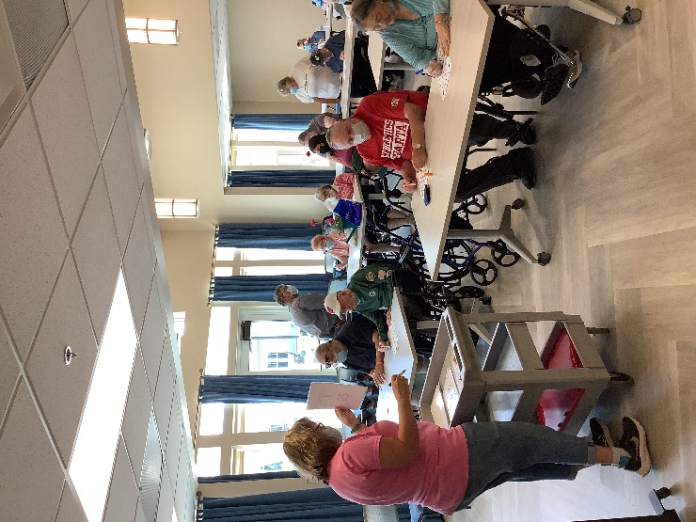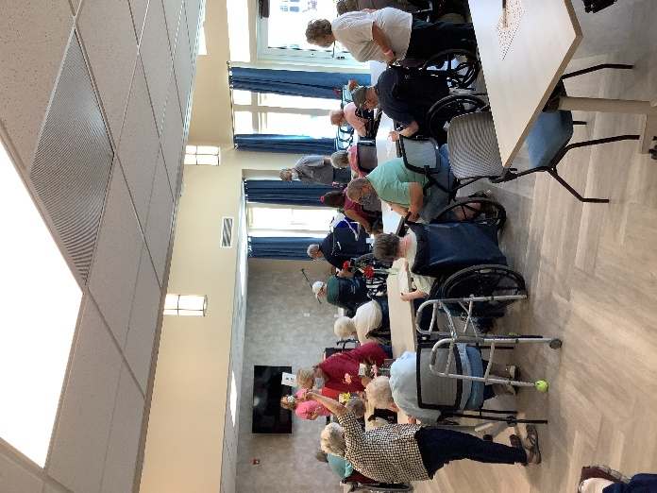

Bingo and sitting outside while the movers got our stuff to our room

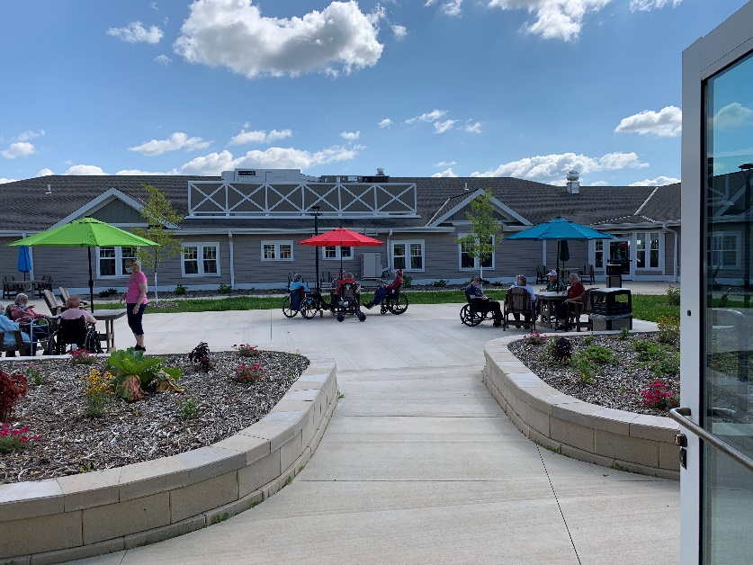

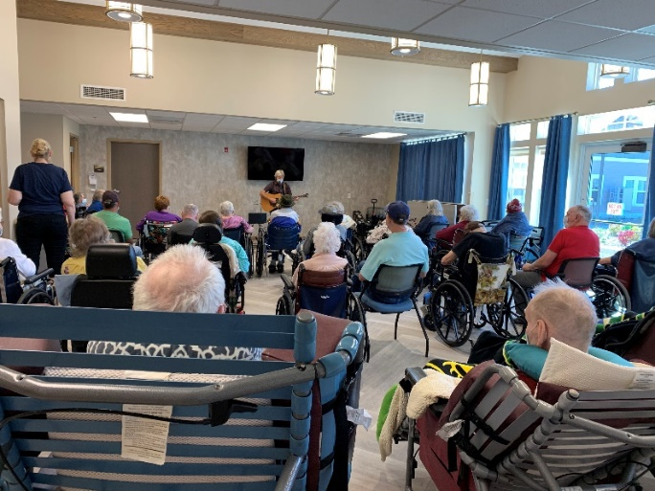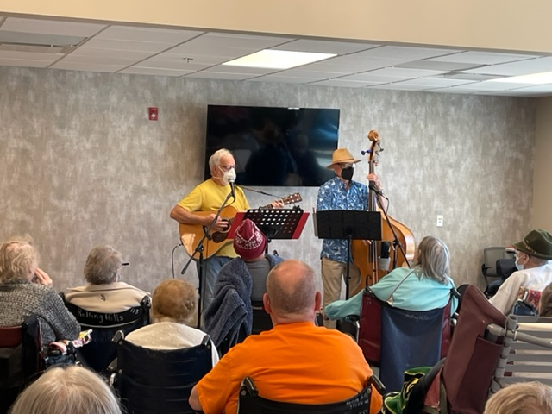

Music with Jay and Old Moldy Hay

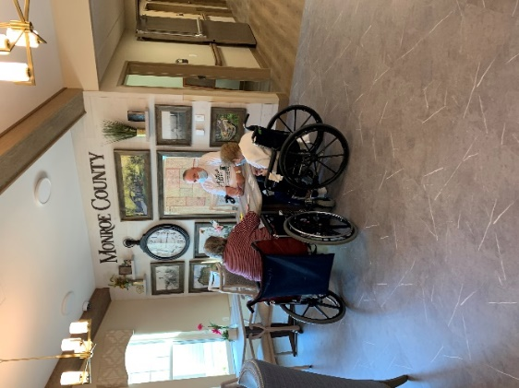 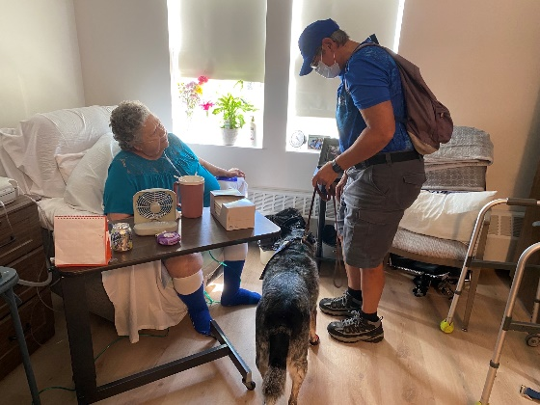

This group took advantage of the lobby for a card game

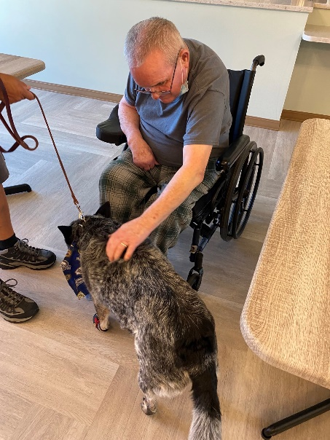 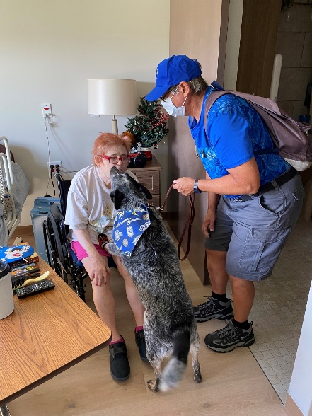 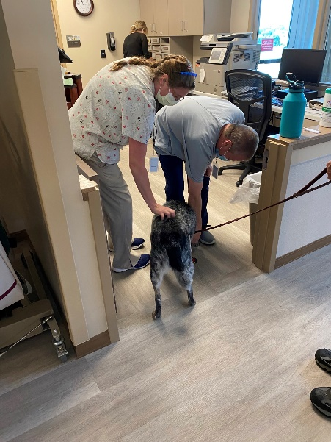

Keota came to bring some smiles

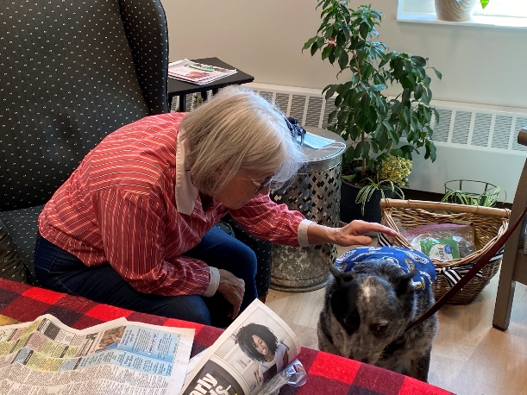 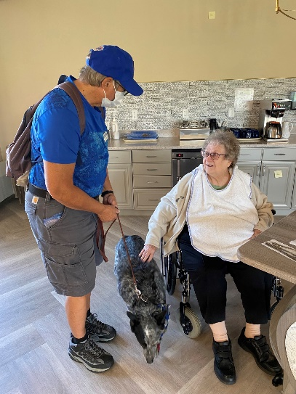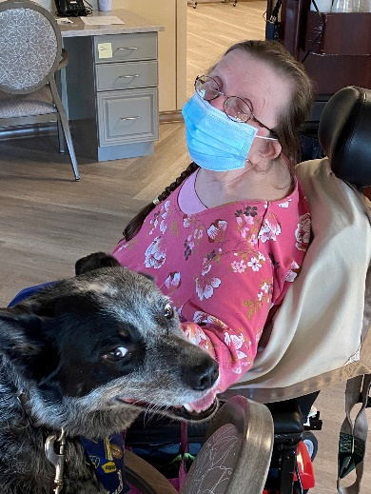

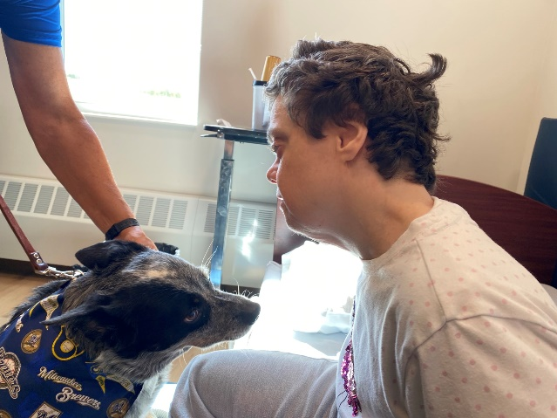 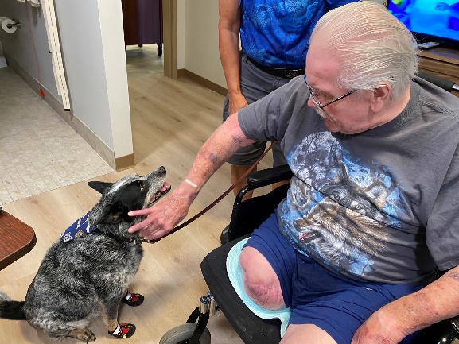

I know it has been a couple of weeks and I do apologize, but the move was a very exciting time for us that kept us very busy.

Here is a link of the local news that came on moving day: [A new home down the road: Sparta's new Rolling Hill nursing home opens (news8000.com)](https://www.news8000.com/a-new-home-down-the-road-spartas-new-rolling-hill-nursing-home-opens/)

We also managed to keep the residents entertained amongst our assistance with packing and unpacking. We had music with Lisa the morning of our move and bingo with our Hands & Feet volunteers. Then we had Jay come and play in the new home too last week. This week Brutus the pig got to check out his new area to show off his tricks. Old Moldy Hay got to perform in our new home, Keota came back to bring smiles, some played hangman and we all enjoyed some fresh air too. Have a great Labor Day Weekend.

-Linda