2nd week of August in pictures
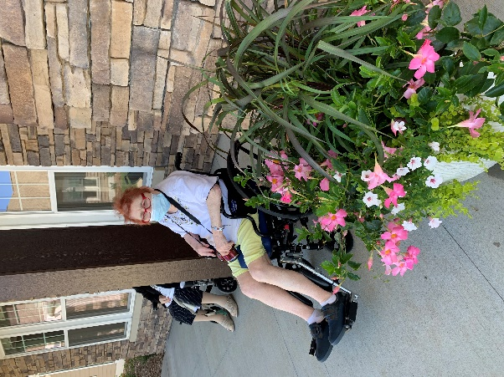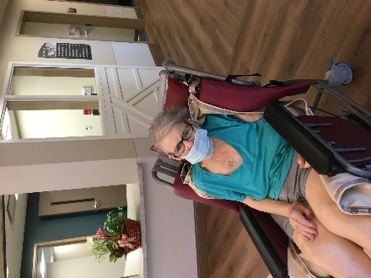
Enjoying the weather outside the new home
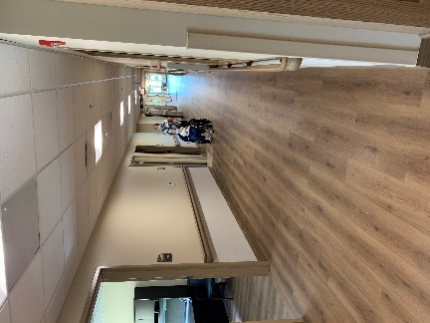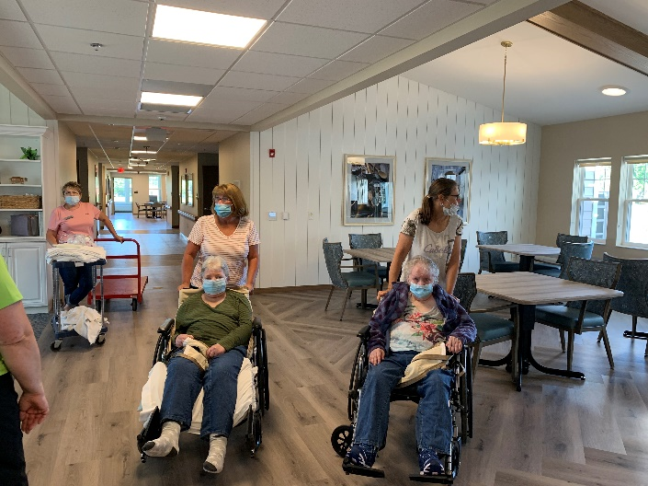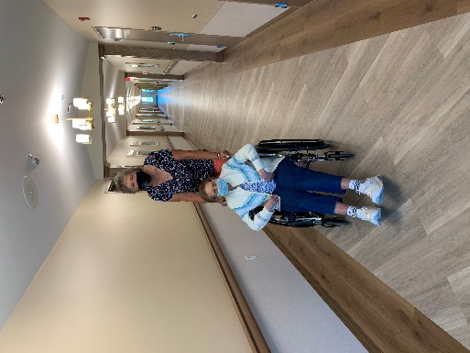
Checking out their new home and rooms!
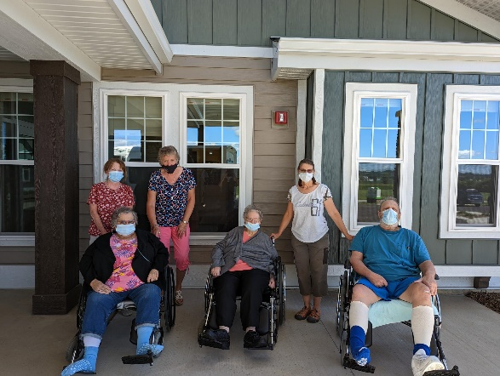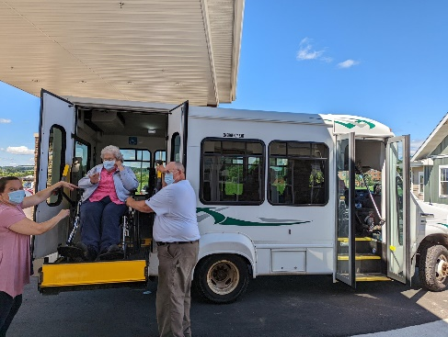
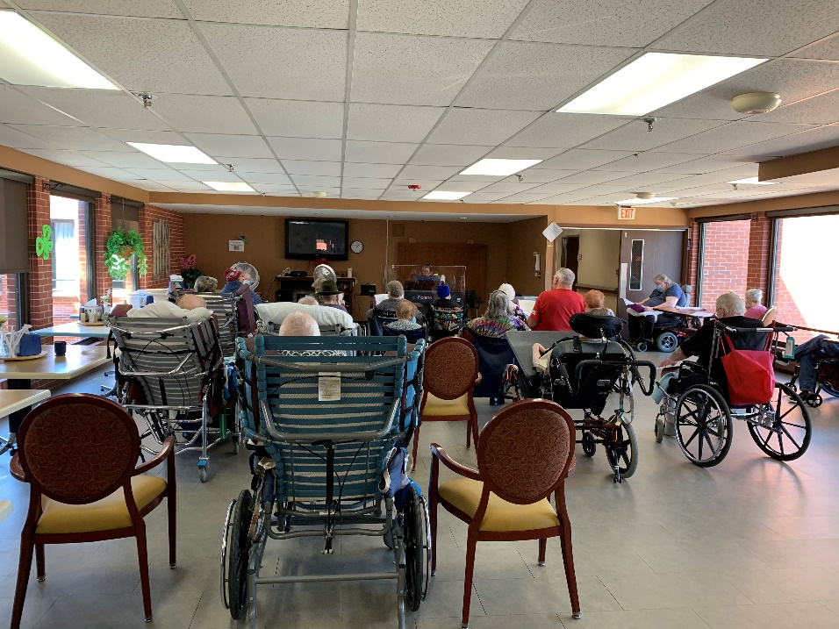
Sing a long with Lisa
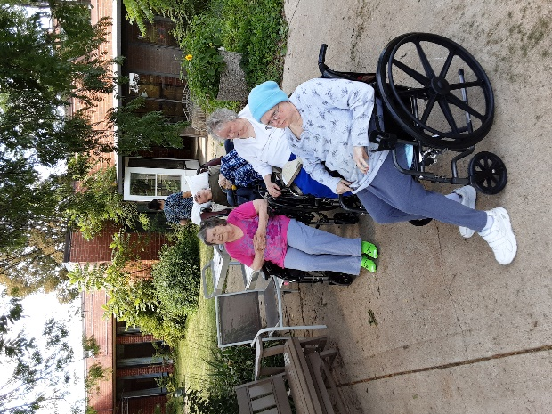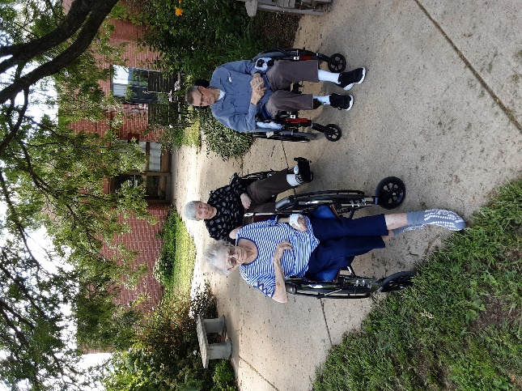
Time outdoors with Watermelon and facts
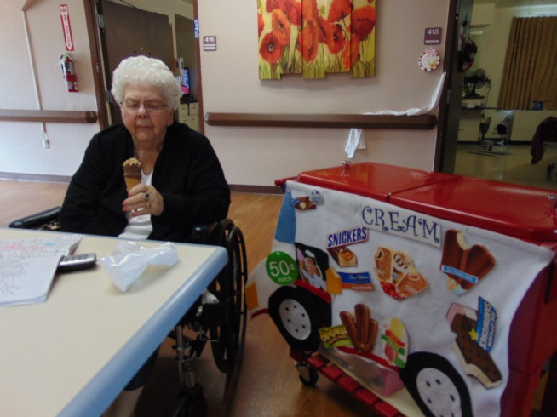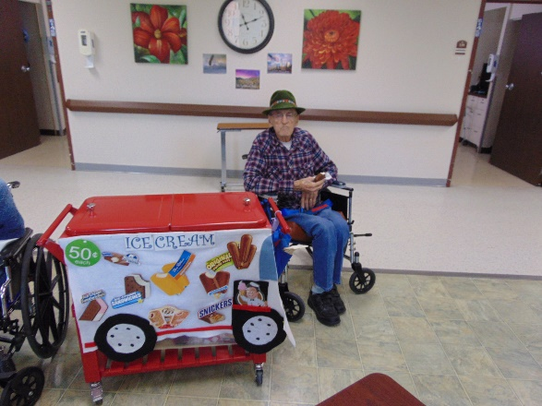

This week was so much fun as everyone finally was able to see the new home and progress being made. If you had the chance to tour, you know we still have some things to finish, but the end is in sight!
So many positive comments were made and we are proud to be part of this amazing home.
-Linda
This week we also enjoyed ice cream treats from the Ice Cream Truck, singing summer songs with Lisa, spending time outside eating watermelon and learning some fun facts too.

