Last week of June in pictures

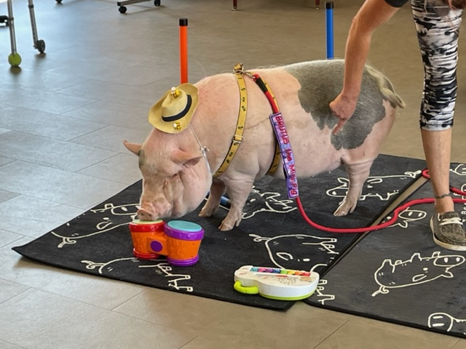

Brutus looking good with his hair cut!

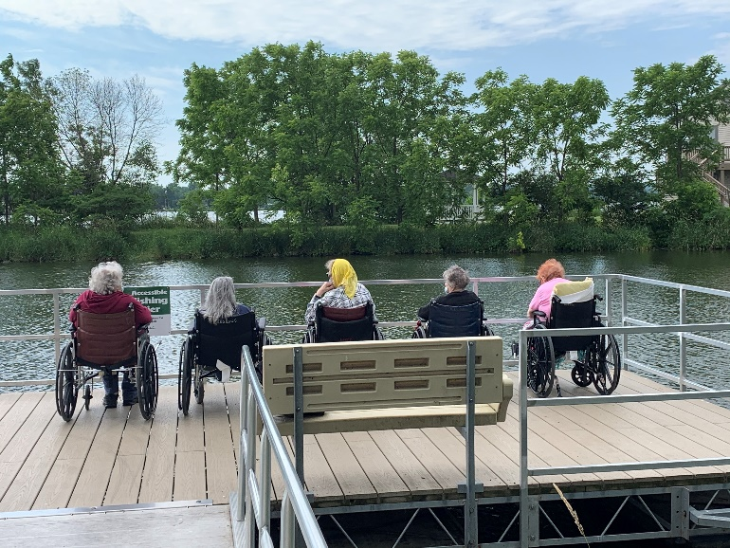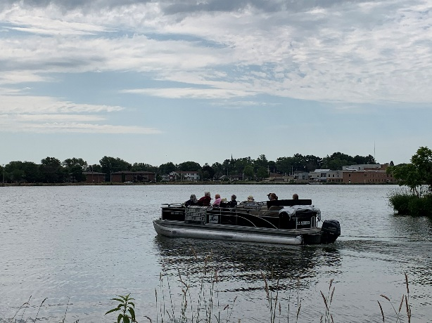

Pontoon rides

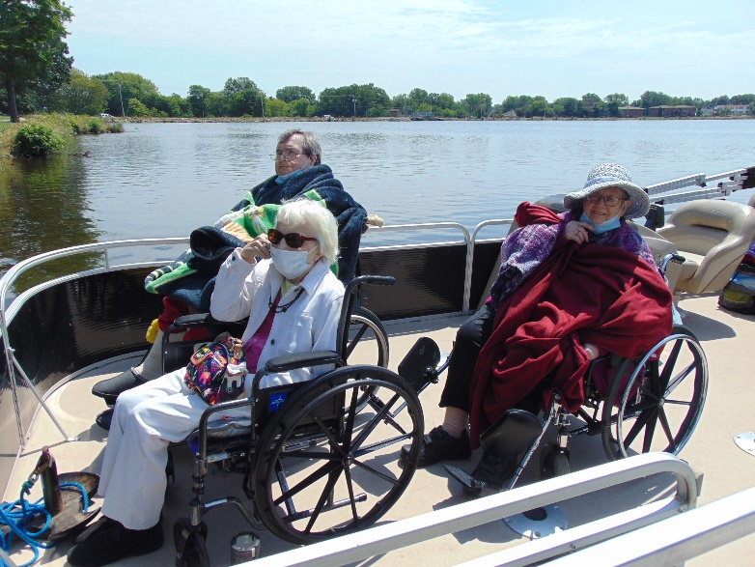

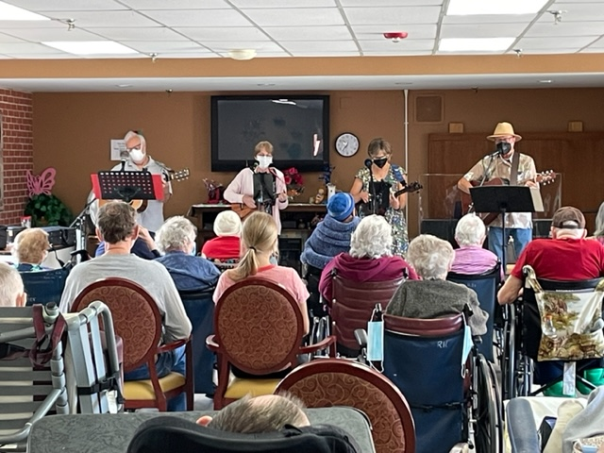 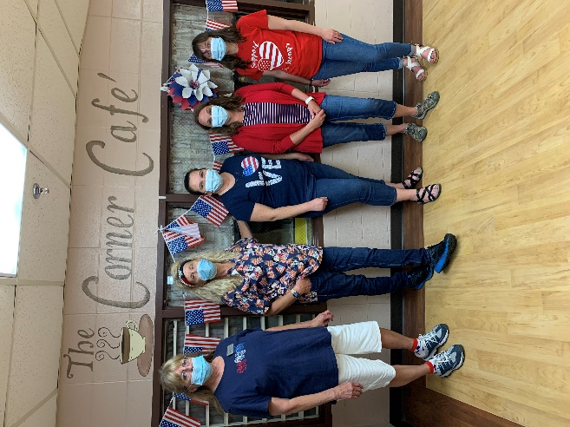

Music Time; Red, White & Blue Day

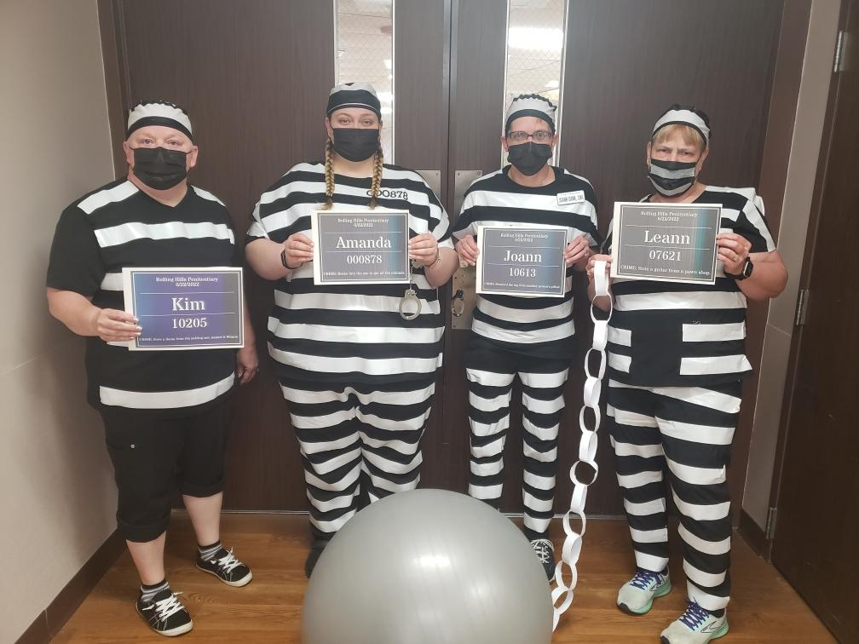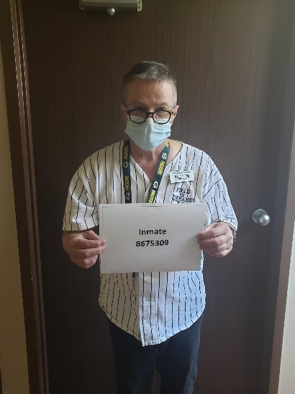

Jail Break theme

 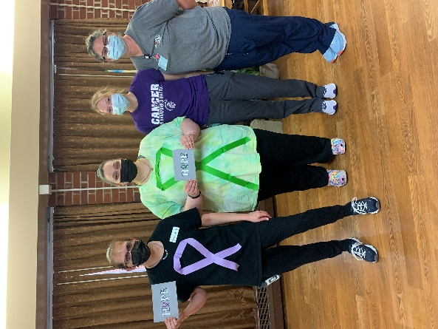

Support your cause day

This week we began by watching Brutus the mini pig and all his tricks, including dunking a basketball! Then we had great weather for our second round of pontoon boat rides in Tomah. Old Moldy Hay shared their musical talents for a large crowd on Wednesday morning and then Elaine took residents outside to make cheerio bird treats. Tim led us in exercise, Carys and Jessica got a bingo game going and today we finish with playing a dice baseball game. We hope everyone had a great 4th of July!

-Linda