Last week of July in pictures

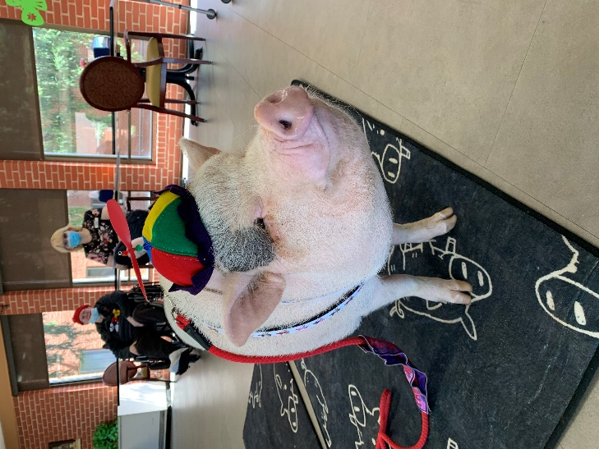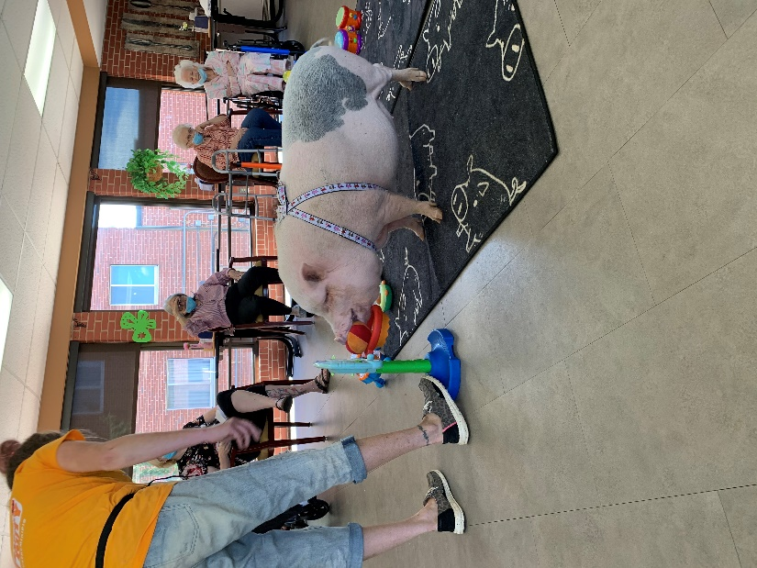
Brutus came to show off his talents again
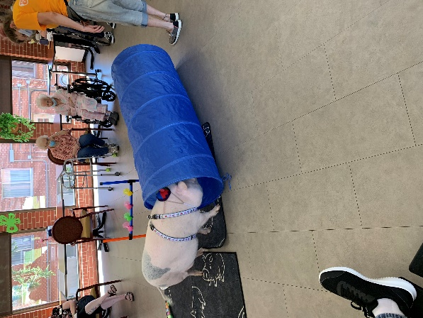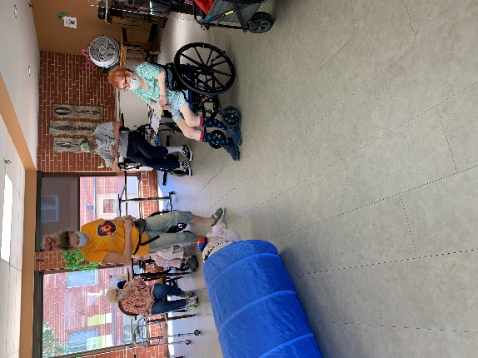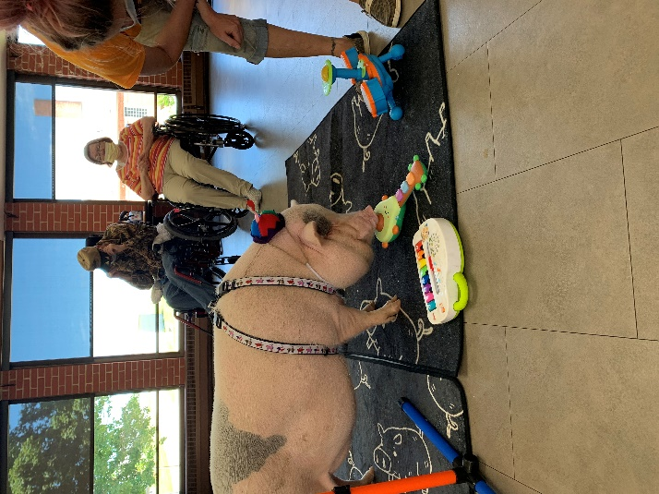
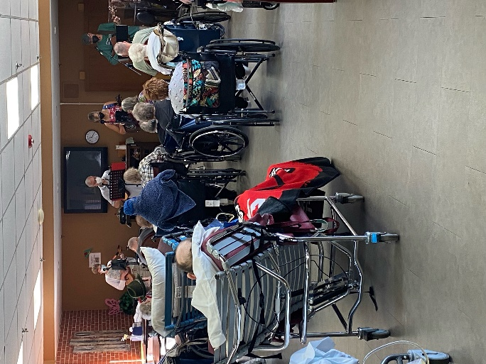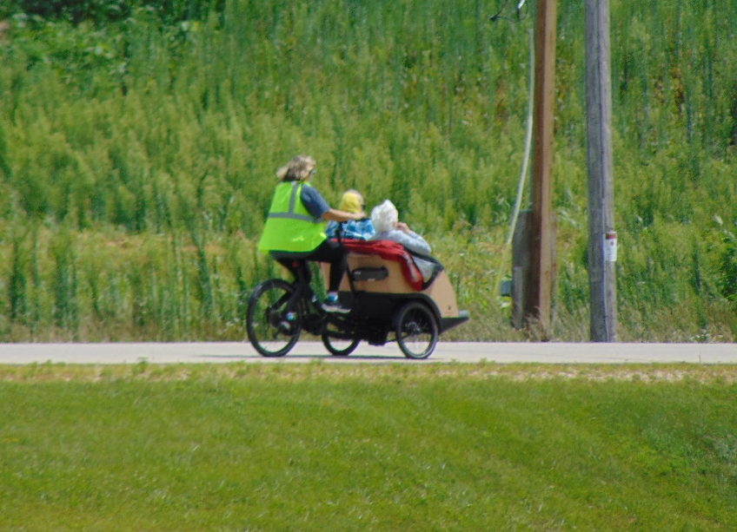
Some good Blue Grass Music Trishaw bike rides

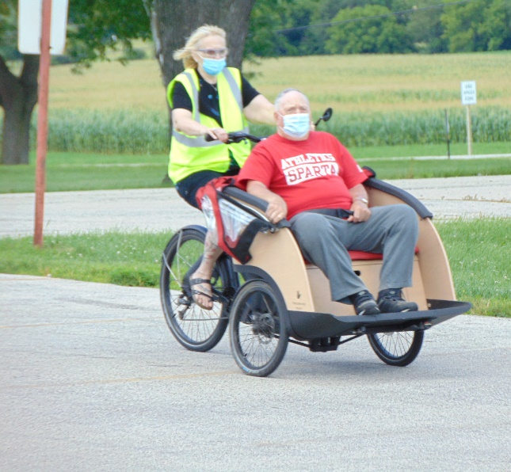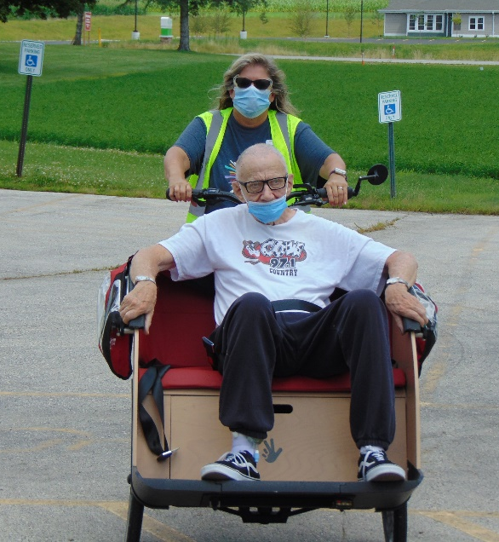

Park Outing
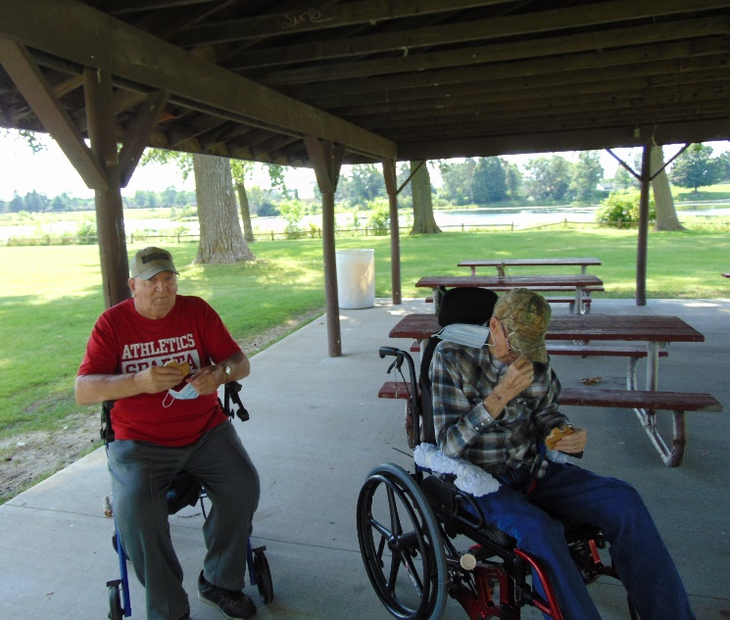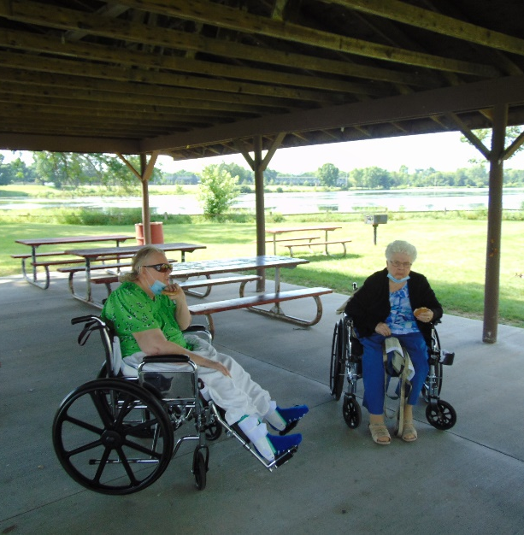

This week we had fun playing hangman and being entertained by Brutus the mini pig. A group of us took advantage of the nice weather and went for a drive with a stop at the park. Then Elaine tempted all of us with the ice cream truck to cool off when it was hotter. We were able to enjoy some great blue grass music and play bingo with the Lion’s club. A few of us also were able to go for a ride on the trishaw bike. We finished the week with a sing-a-long with Lisa. What a beautiful week to enjoy some great outdoor activities.
Have a nice weekend!

