First Week of July in Pictures

Dice Baseball Piano music with Lisa
Piano music with Lisa
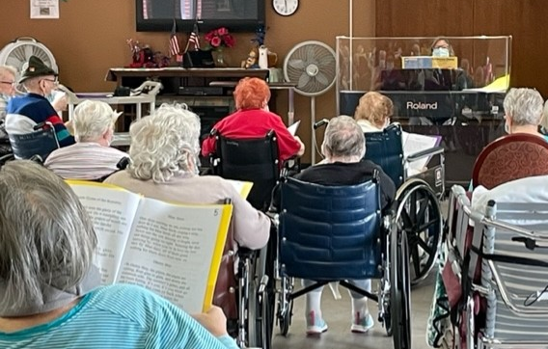

Happy Friday all!
With the short holiday week and some activity changes, we were not able to get many pictures this week. Some highlights from this week include listening to Lisa play the piano, sitting in on a church service, listening to some stories, and some of us were able to enjoy a shopping trip to WalMart.
We hope everyone has a great weekend!

