2nd week of July in pictures

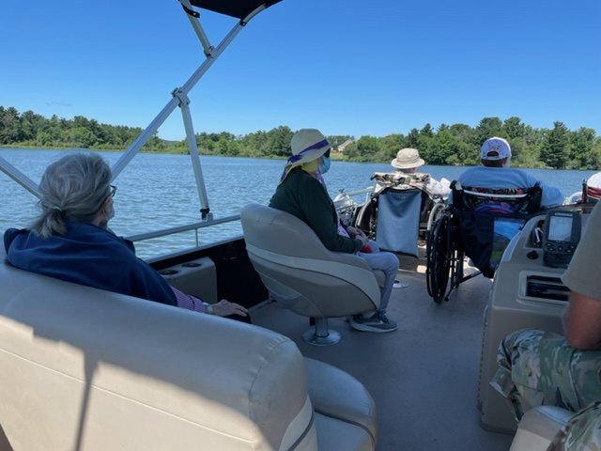

Last trip on the pontoon for the summer



Music /w Dylan

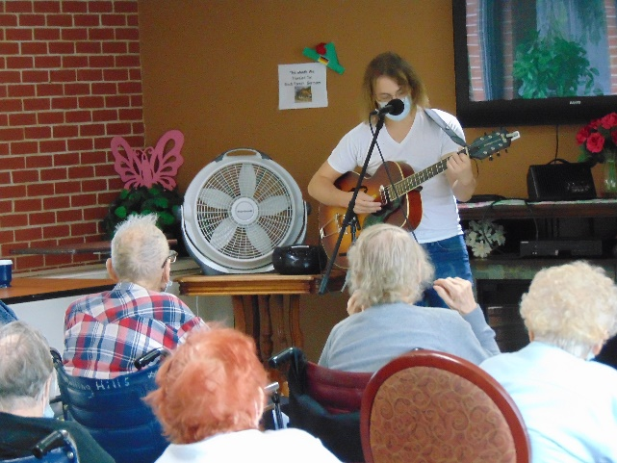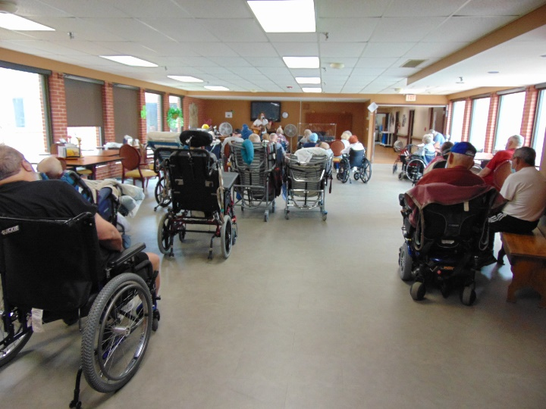

A nice afternoon at Ginny’s Cupboard downtown

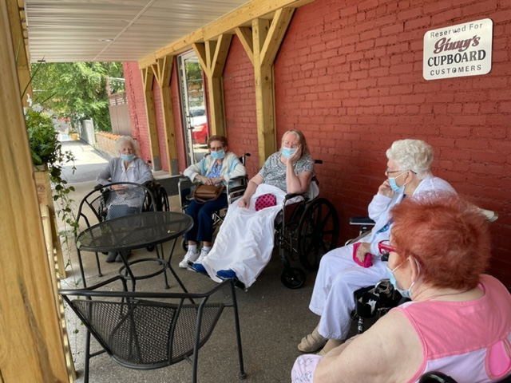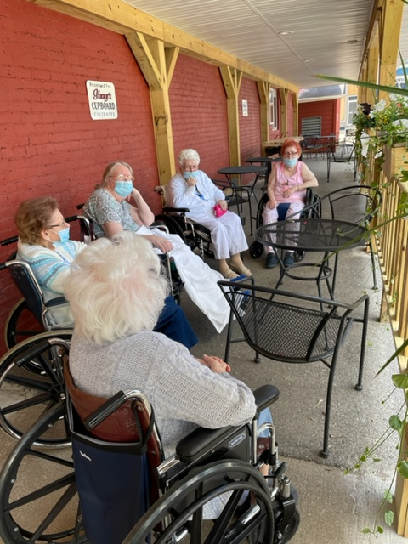

Park outing

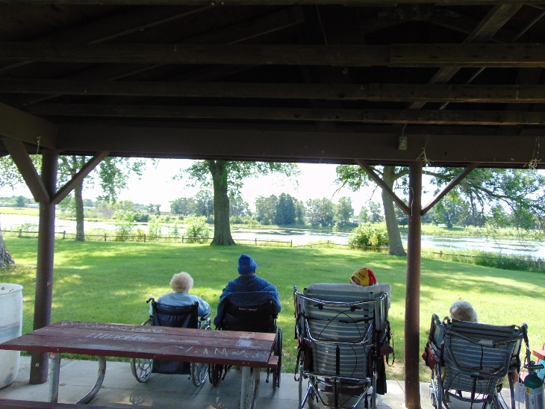

Moving and Open House:

We are set to have the Open House for the Public and invite you to join us on Tuesday, August 9th from 3:30-7.

Residents will be moving on Tuesday, August 23rd.

If you are wishing to help with the move, please contact your social worker so they are aware. We are only looking for 1 person per resident on the day of the move please.

This week we enjoyed the weather once again and even got to enjoy ice cream at Ginny’s Cupboard downtown. Dylan came and sang his tunes for us, we took our last pontoon boat ride of the summer and a few of us made it to the park to enjoy the day and paint rocks to hide. Hope you have a great weekend.

-Linda