4th Week of June in Pictures

Music with the Guthrie’s Bike rides!
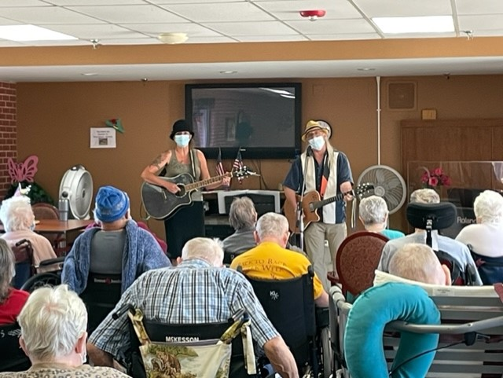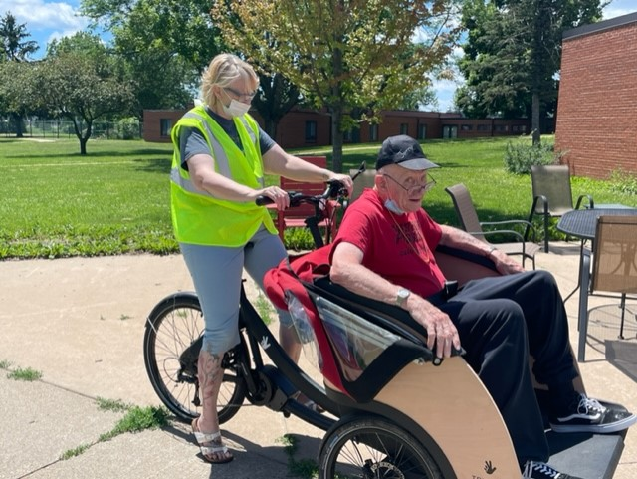

Fishing outing to VFW
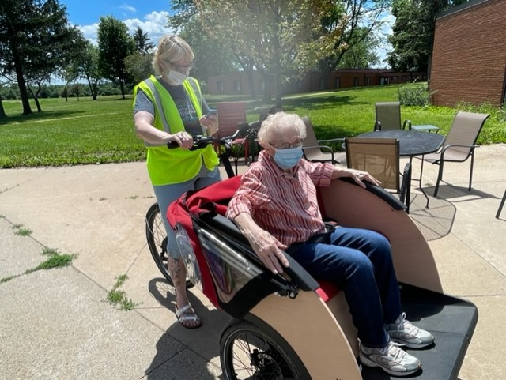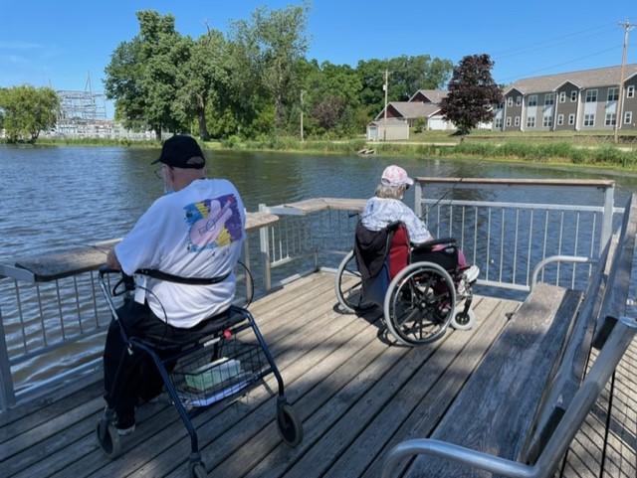

Happy Friday everyone!
Not many pictures this week but we were busy. We started out the week with lunch from Rudy’s, listened to music by a new entertainer, enjoyed some bike rides, won big at Lion’s Bingo, and finished off the week with a fishing trip.
It has also come to our attention that another option families can look into for phone service in the new building is Community Phone.
Have a great weekend!

