3rd week of June in pictures
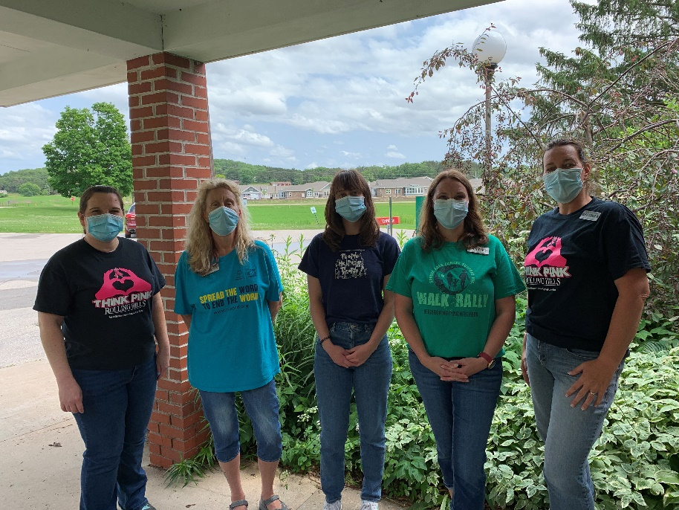
Support your cause shirt day and if you look close, you can see our new home!
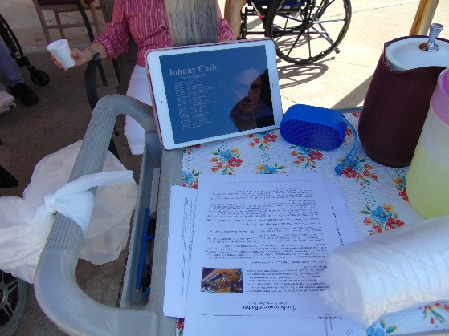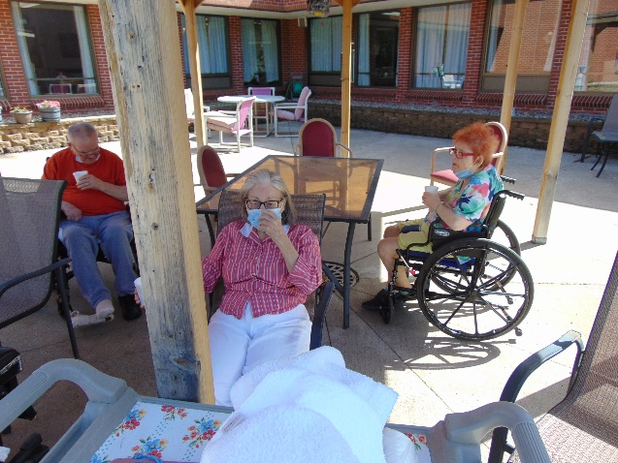
Lemonade, stories, Johnny Cash and news outside
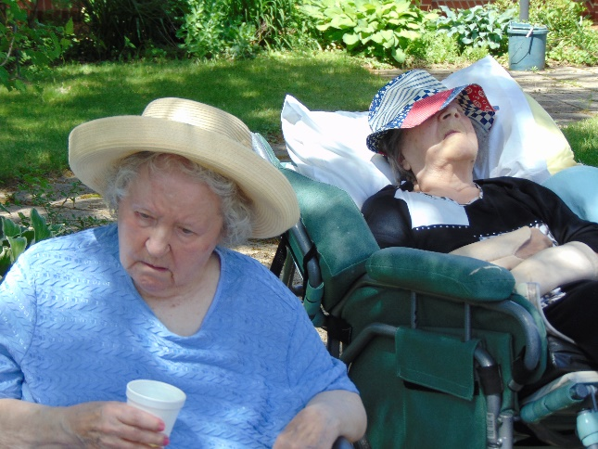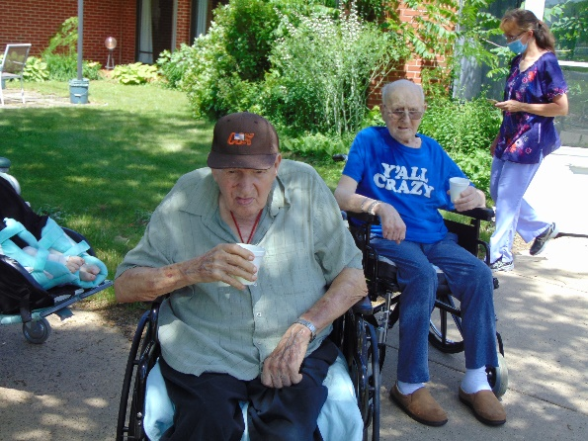
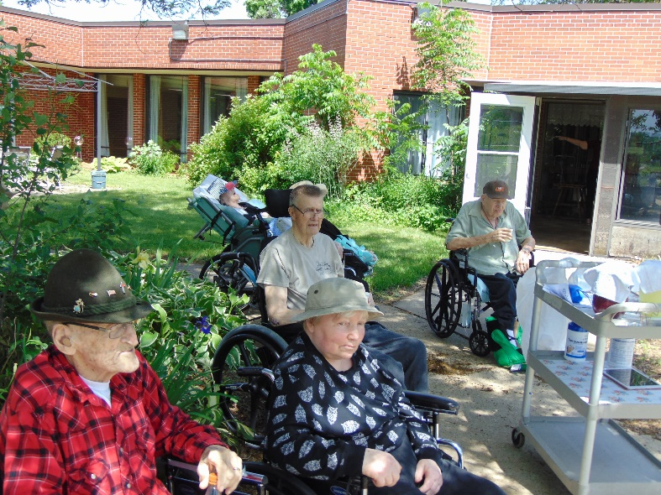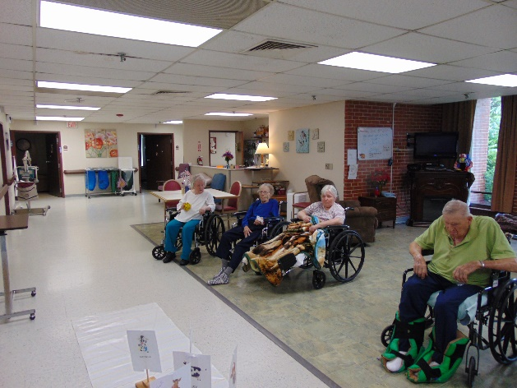
Cow Races for Dairy month

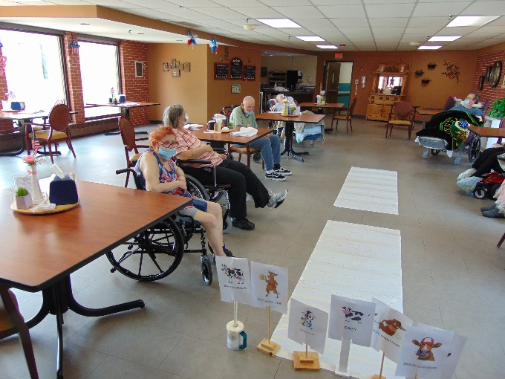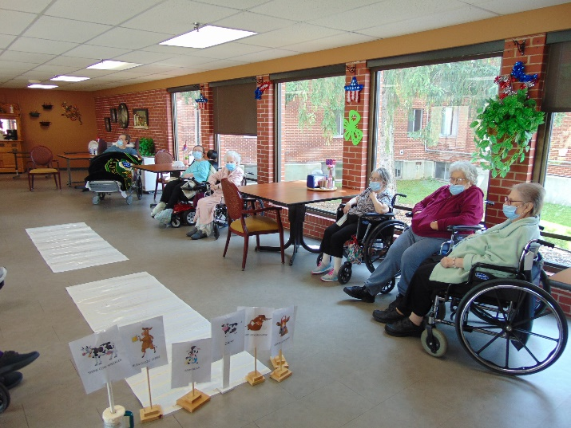
Cow Races for Dairy month
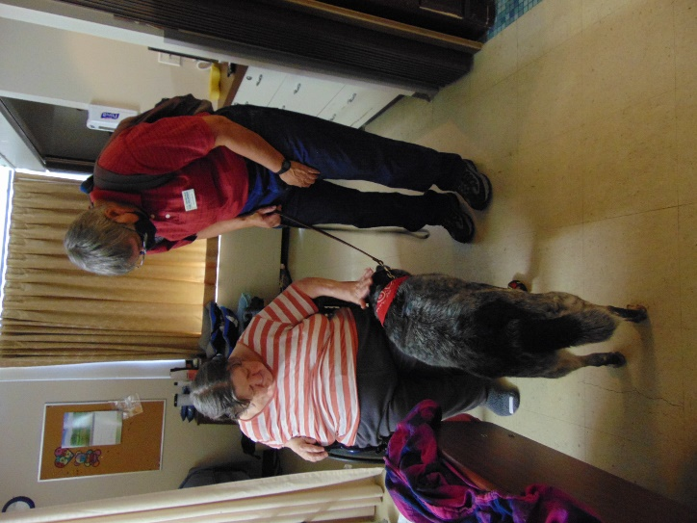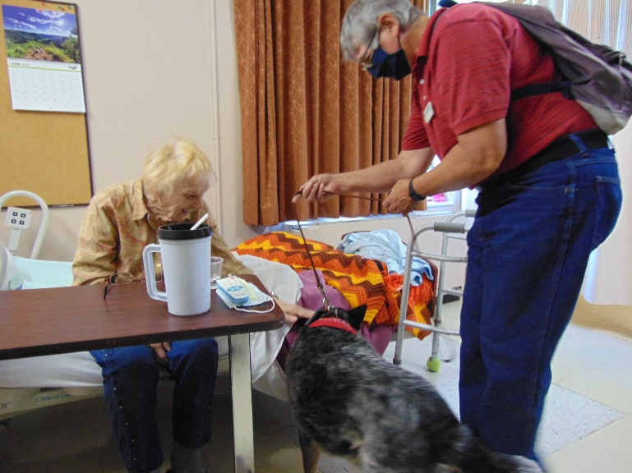
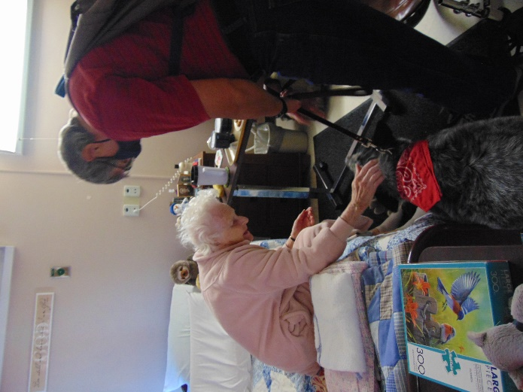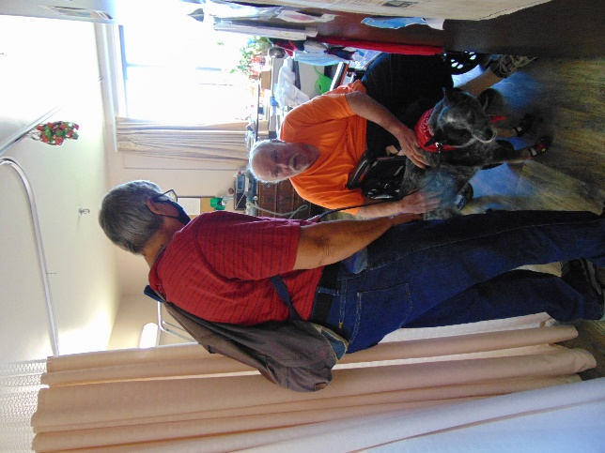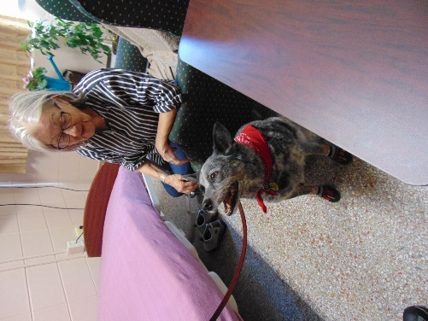
Keota Visits
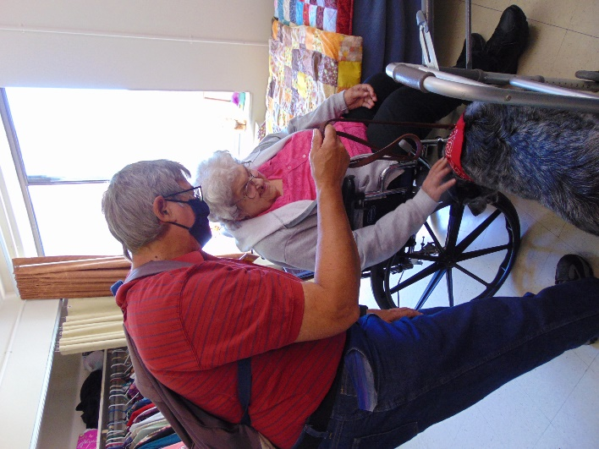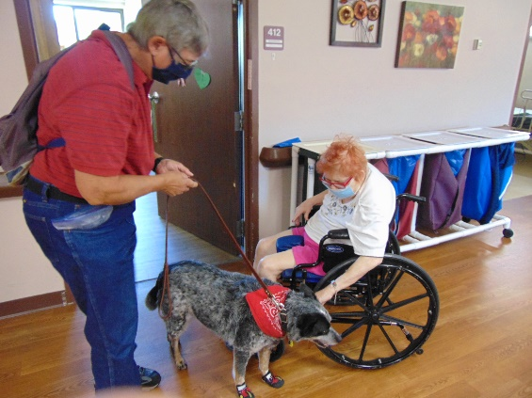

A few things of importance:
1- When we move to the new home, there are no phone jacks in the rooms, so it may be a good time to start looking into cell phone plans for your family members or contact US Cellular or Verizon as they do have devices to make personal phones cellular with equipment and a monthly fee.
2- No official move date has been selected yet, however it may be August 16/17 or 23/24 during the daytime hours. If someone from your family wishes to assist us move your loved one, please contact the social workers Sam or Christine for the nursing home and Linda for The Meadows. We are only looking for 1 person per resident unless one family member wishes to take their loved one for a ride while the other sets up their room. If you are unable to assist, we will have staff and volunteers available.
3-Thanks so much for those that have begun going through things and taking items home that may not fit or are no longer wanted. If you do this, please leave a list of items removed for the nurse so if your loved ones feels something is missing, we can look at the list to make sure we know its whereabouts. Also, it may be worth taking any valuables home prior to the move and bringing them back once we are settled

Sorry I have not been good at taking staff dress up day pictures. We recently had a dairy day dress up day and this week was wear your cause shirts. We began the week trying to avoid the rain and were successful with another scenic drive as well as a shopping trip and even some time outside for news group in the morning one day. Keota came to bring her tricks and Patti shared stories on their visit. Some tried to guess summer sounds and pictures and we are ending this week with music by Jay. Enjoy your weekend.
-Linda

