2nd week of June

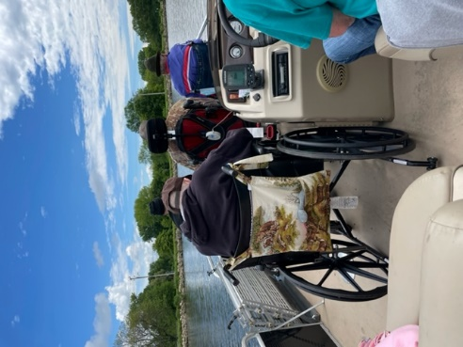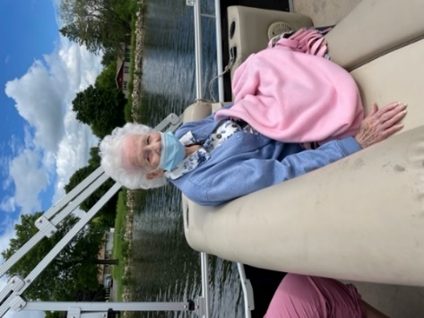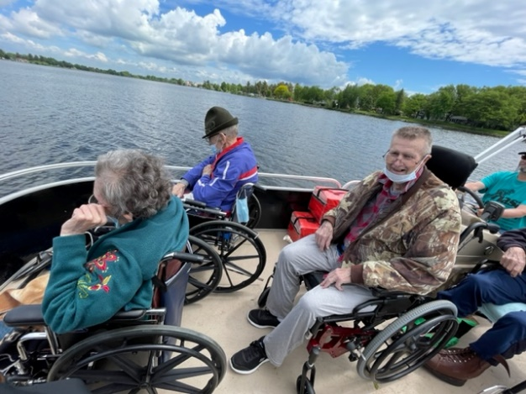

First couple of Pontoon Trips this summer with Tomah NASA

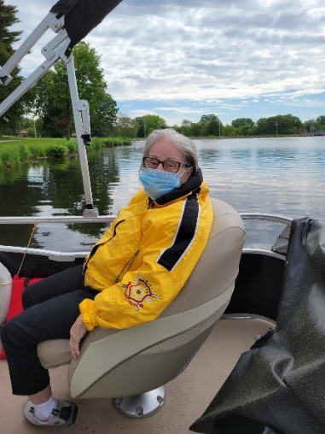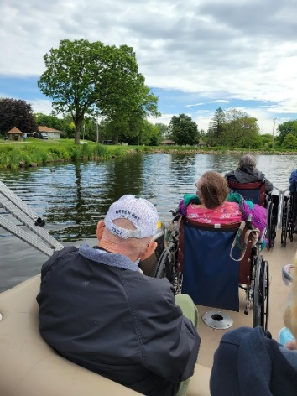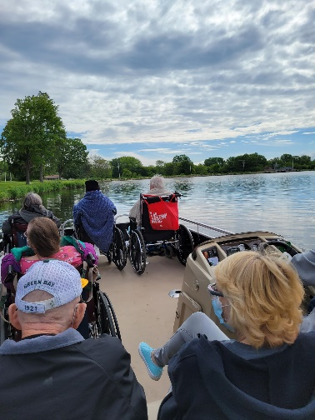

So much fun!

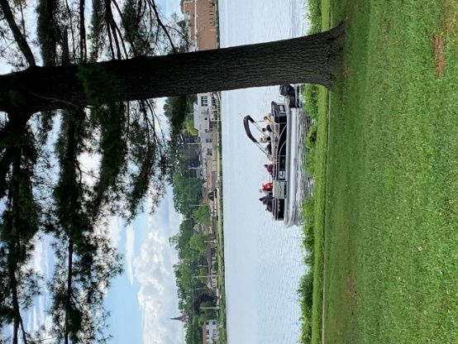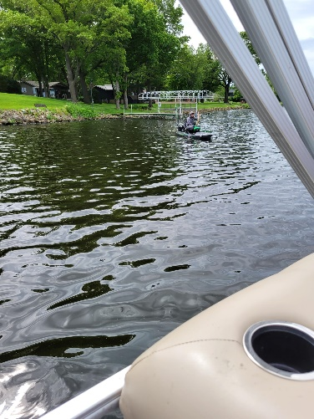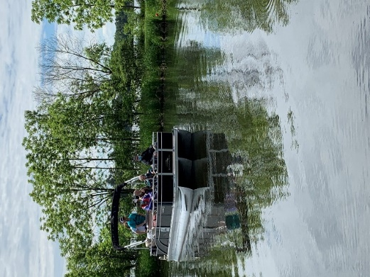

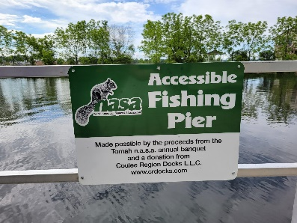

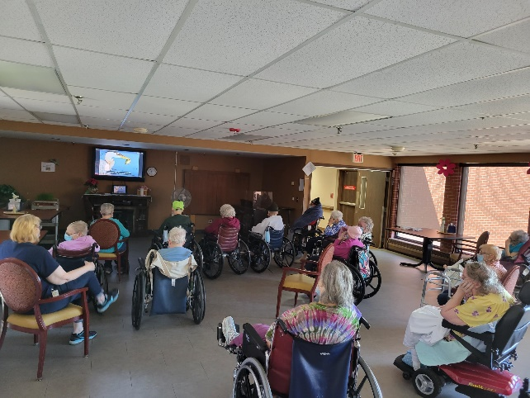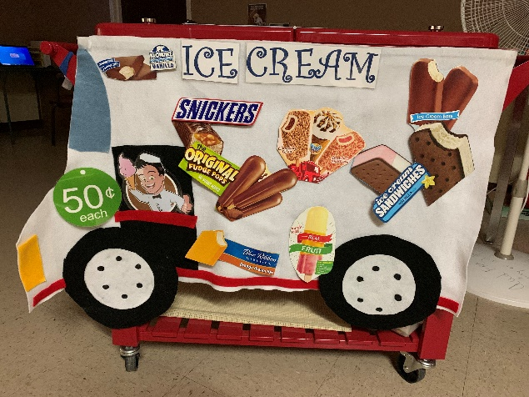

Sights & Sound of Tennessee video; The Ice Cream Truck has returned to the halls!

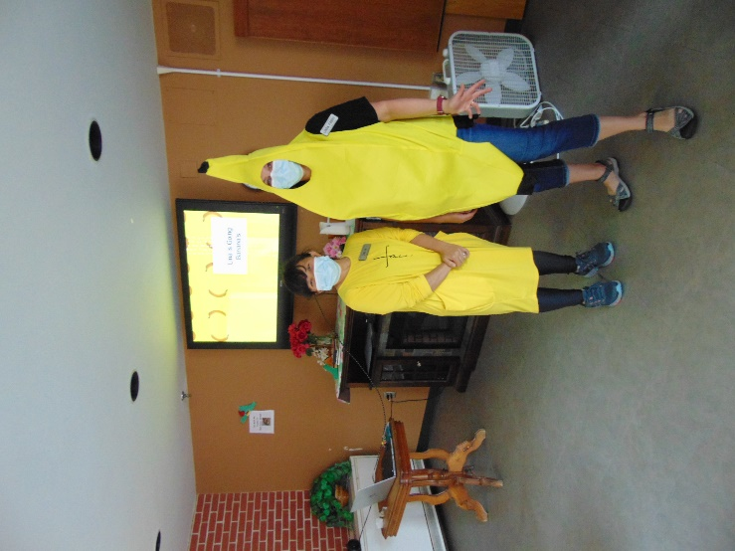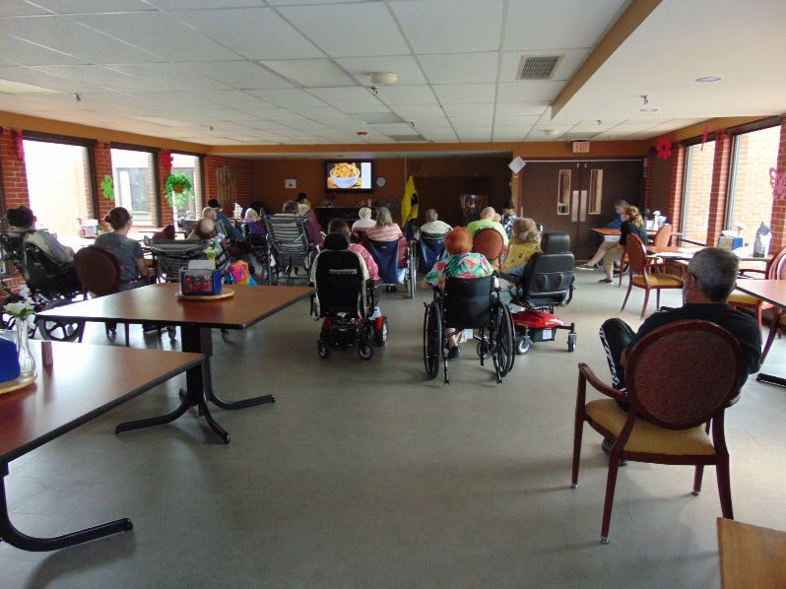

Going Banana’s with Lina, our housekeeper and Linda to learn about bananas in Indonesia

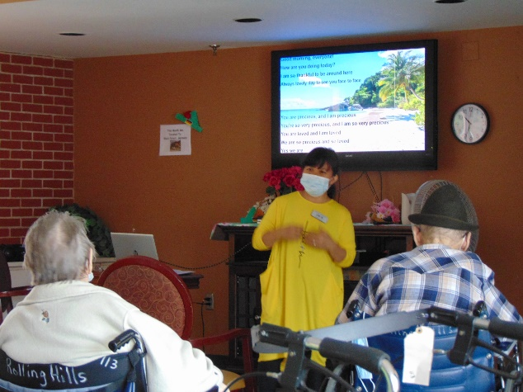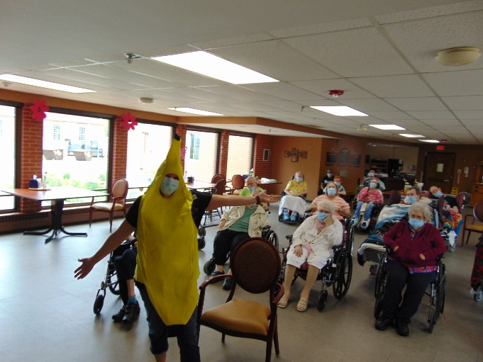

We all tried some banana chips too!

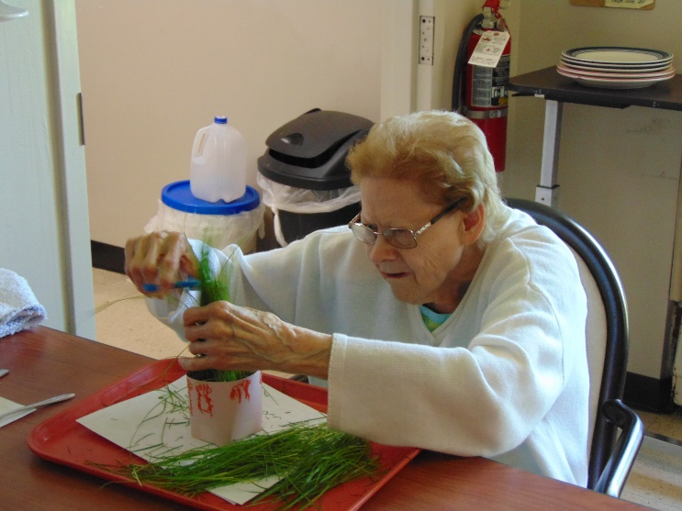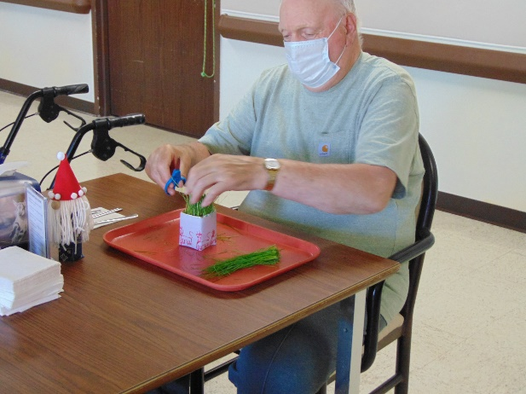

Nothing like fresh cut grass smell and turning that into a craft project!

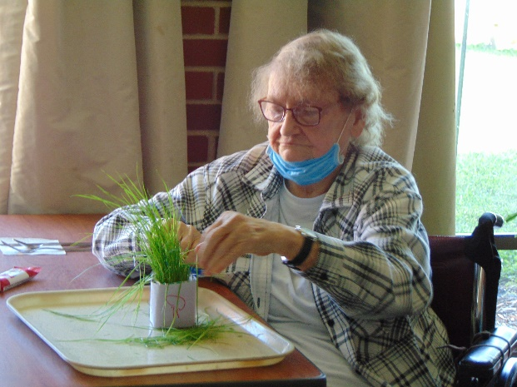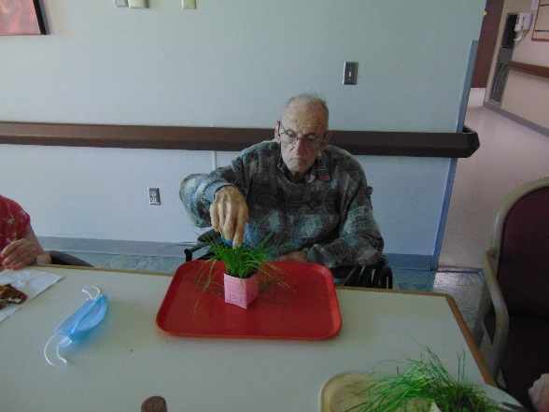

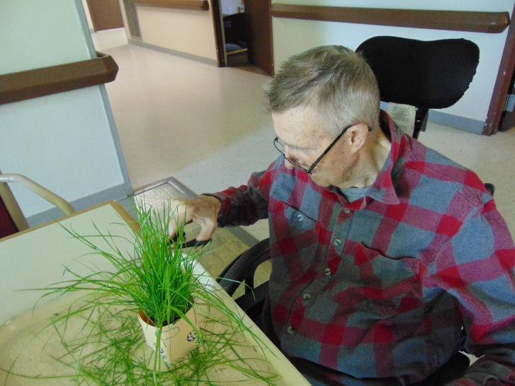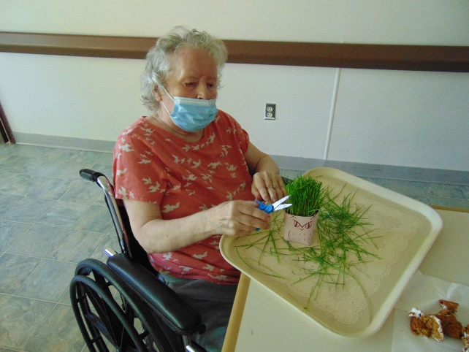

This week the warm weather had us out enjoying it. That ranged from going on the 1st pontoon boat rides of the summer, to sitting on the patio to cutting grass. Yup, we cut grass and crafted a container for the grass too. Our housekeeper Lina wanted to share some information on all the bananas from her home country and how she gets there too. Linda joined in on the fun and helped with her PowerPoint presentation. The ice cream truck is back too! Elaine went around the halls with her ice cream truck, music and yummy 50 cent treats! Have a great weekend!

-Linda