1st week of June in Pictures
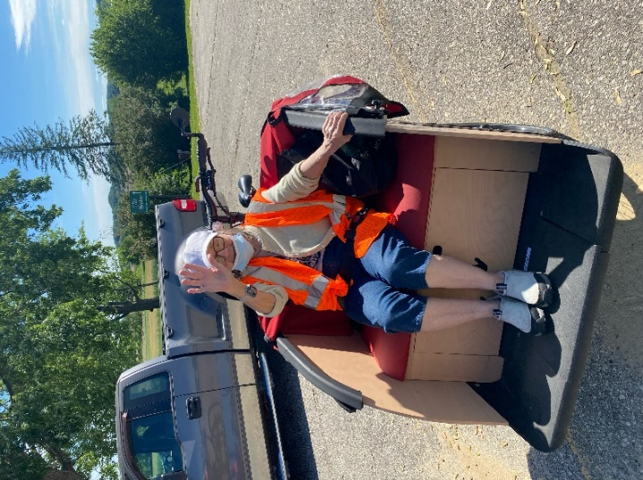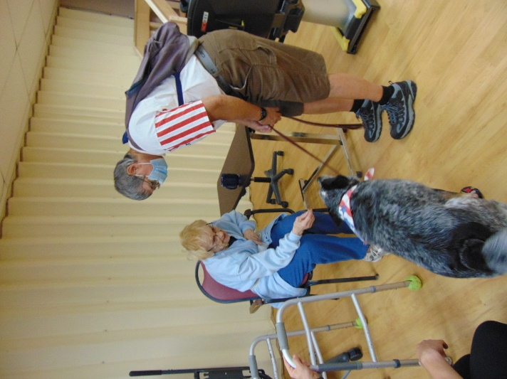
Bike rides on a nice day
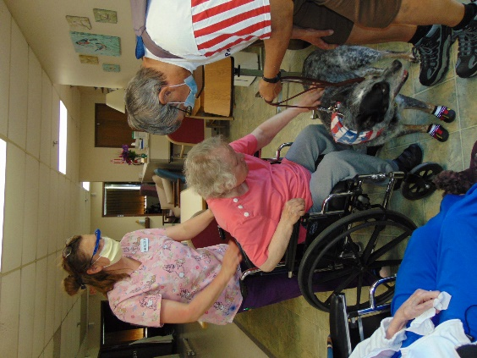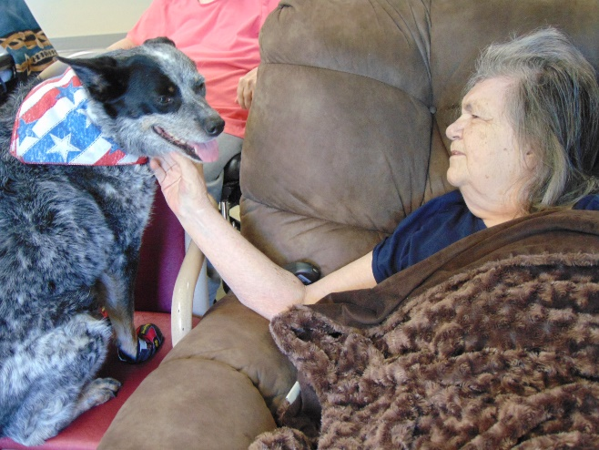
Visits with Keota
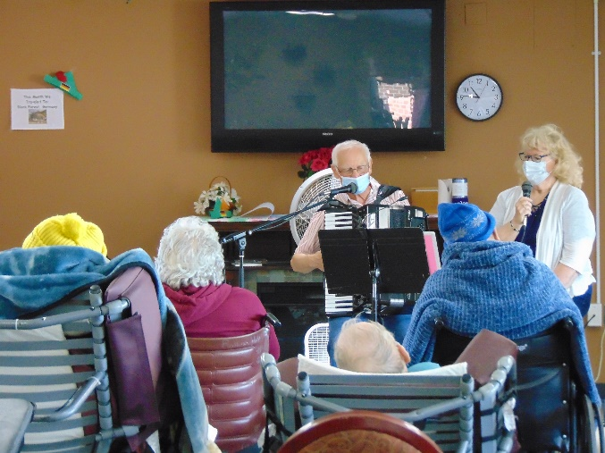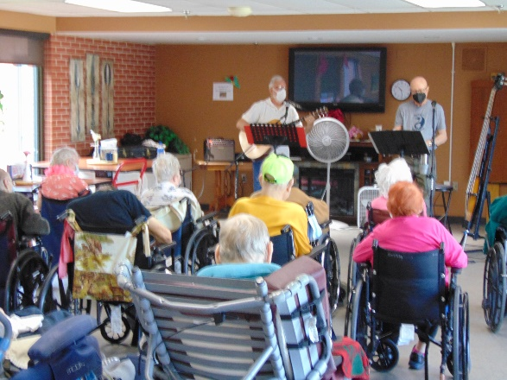
Music with Dianne and Laurel as well as Old Moldy Hay this week

Starting next week, please schedule all your visits through the social workers Sam (269-8824; samantha.colleran@co.monroe.wi.us) or Christine (269-8817; Christine.nelson@co.monroe.wi.us) or use the email RH_FamilyVisit@co.monroe.wi.us. Kristi is nearing retirement, so please use these 3 options for scheduling.
This shorter Holiday week had lots of music. First Old Moldy Hay came to play their tunes, then Dianne and Laurel entertained with songs & accordion and we finished the week out with Lisa leading us in songs and sharing accordion facts. Keota came to show us some tricks and bring some smiles. The weather was nice this week, so that meant it was great for a few bike rides and some scenic drives too. Narissa will be leading us in bingo and building updates will be shared at resident council today.
Have a great weekend.
-Linda

