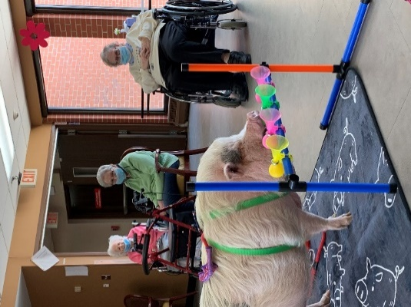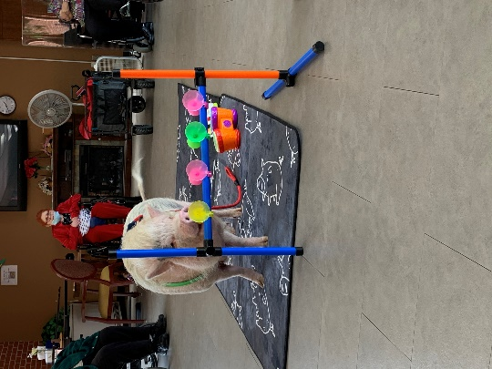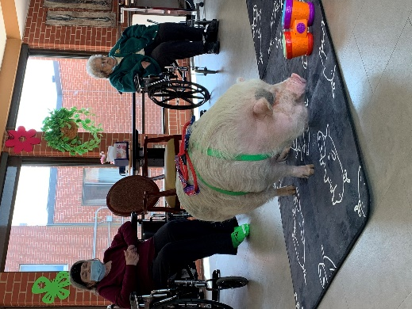

Brutus

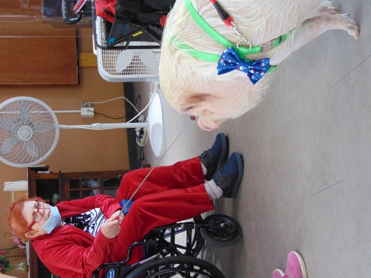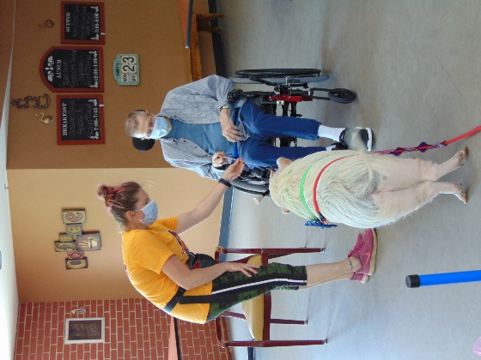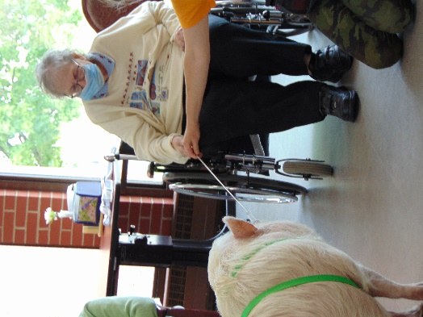

Feeding Brutus Carrots

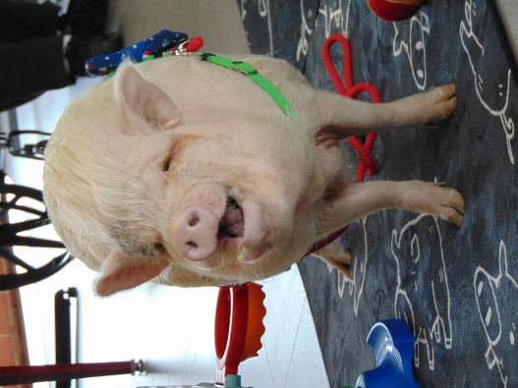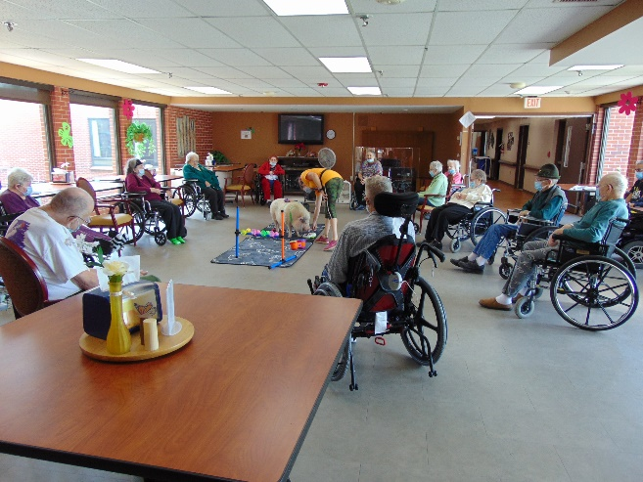

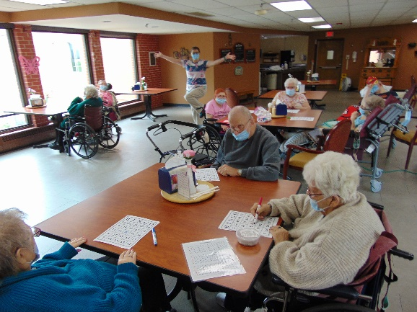

Dress up days continue

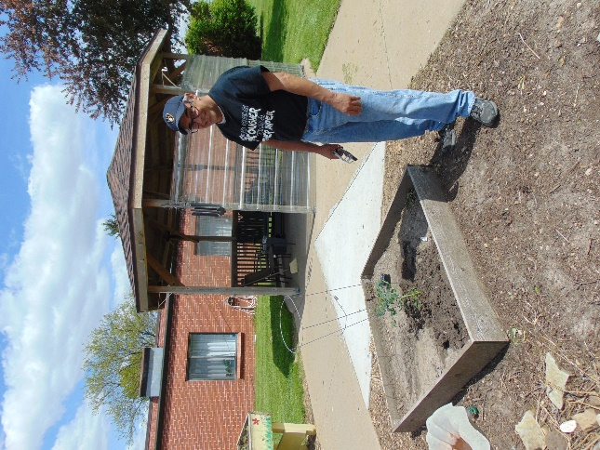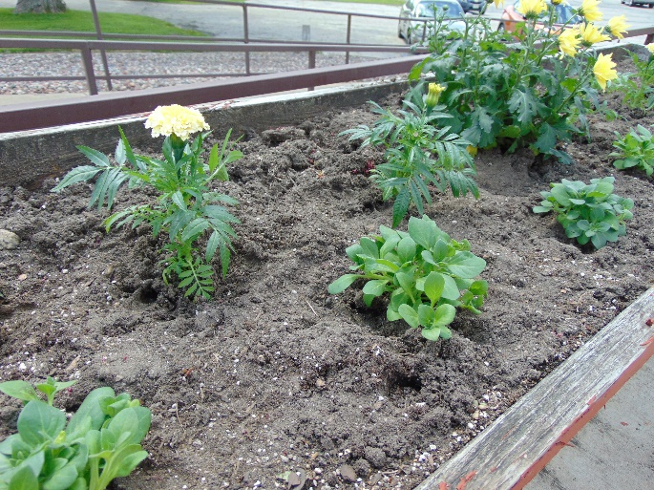

Karl has been busy cleaning out the garden beds and planting

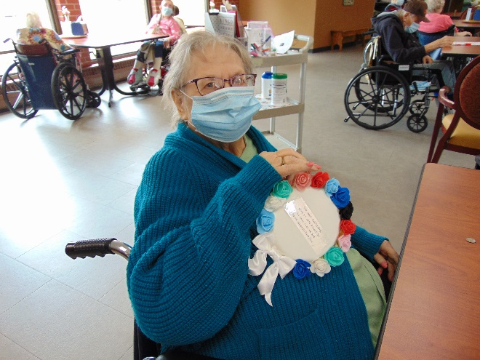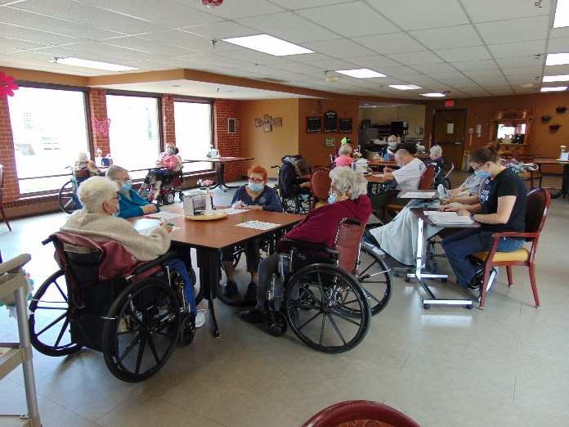

Bingo with prizes made by Ari

I have been asked by a few people but we are not quite ready for families to join us at activities with your loved ones. Currently our visitor policy says you can only visit the person you are here to see, but we can’t wait until the day that changes and will let you know.

This week we welcomed back Brutus the Mini Pig for tricks and information. Then we enjoyed playing bingo and hangman. Karl has been busy cleaning up the flower beds and planting so as they grow it will look great around the home. Some ordered in taco bell, a change up from Culvers. We also continue to take advantage of any nice weather to get outside and enjoy the sunshine. Have a great weekend!

-Linda