3rd week in May

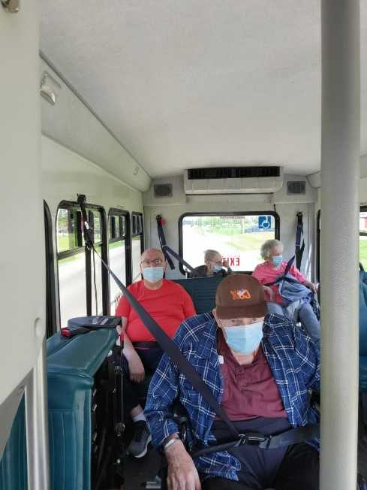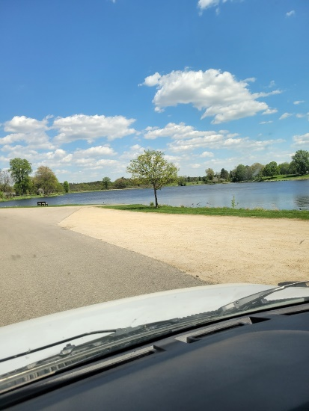

Making German hats; going for scenic drives and singing along with Jay

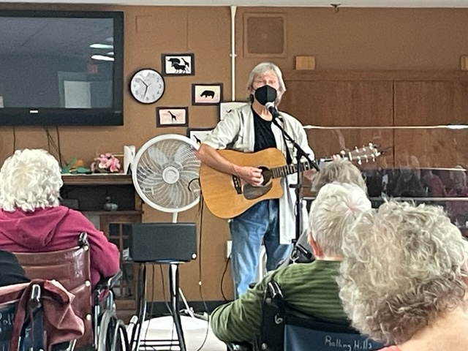

This week we had fun making a German hat to decorate our doors and dining room while we heard some interesting facts about Germany. Then Linda led a travel program to the Black Forest located in Germany later in the week. We all were hungry for some Black Forest Cake after! For those that like Perry Como’s songs, they came to listen and sing along while learning some interesting facts about him too. Our fishing trip was cancelled due to the uncooperative weather, so we played games and had some Culver’s custard instead. We are ending our week with music with Jay. Hope everyone has a great weekend.

-Linda