2nd week of May in Pictures; National Nursing Home Week

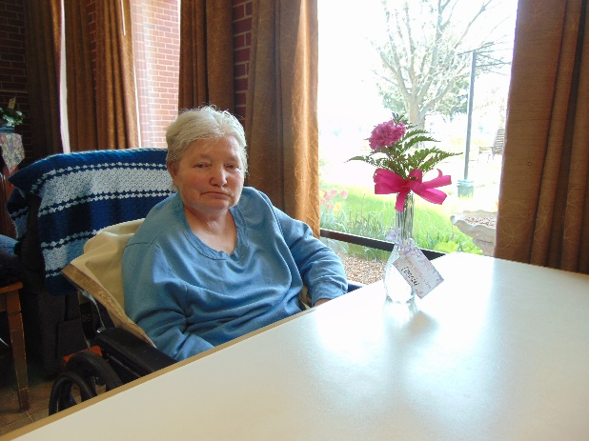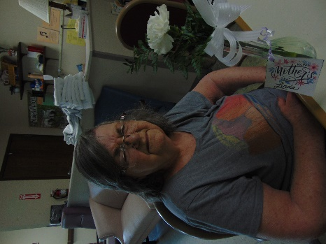

Thanks to a community member for providing all the Ladies with a flower for Mother’s day

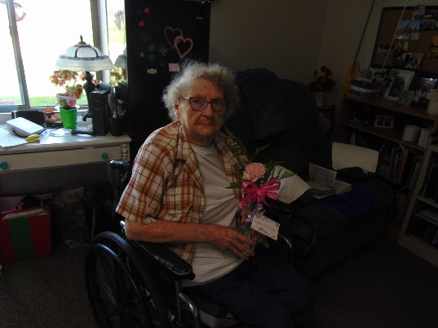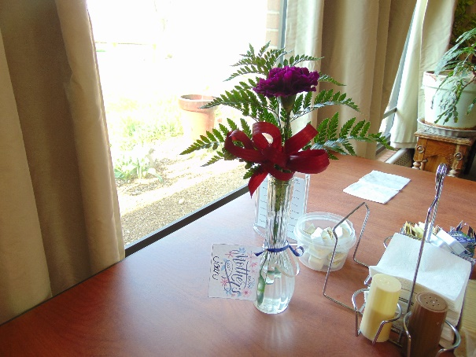

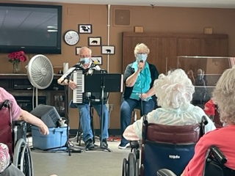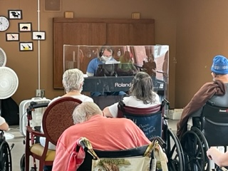

Laurel B and Dianne entertaining us and later on Dylan

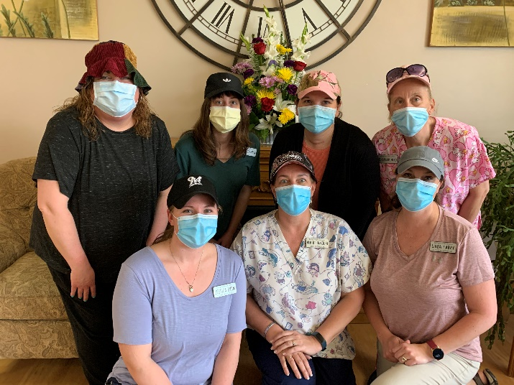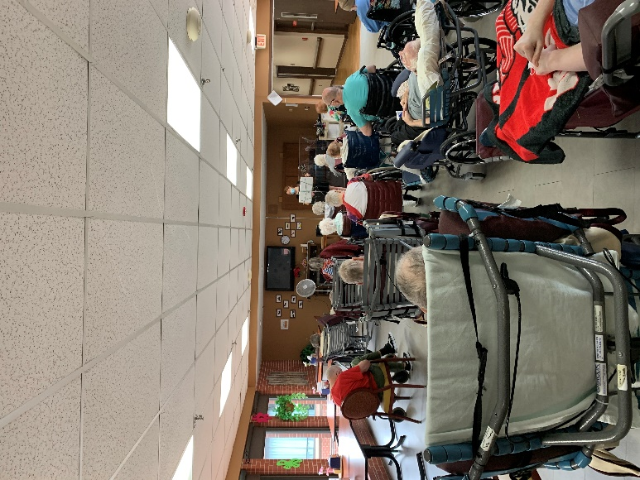

Hat Day Music /w Laurel A

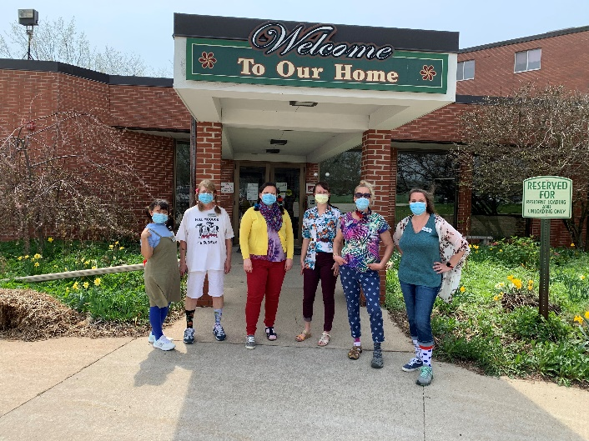 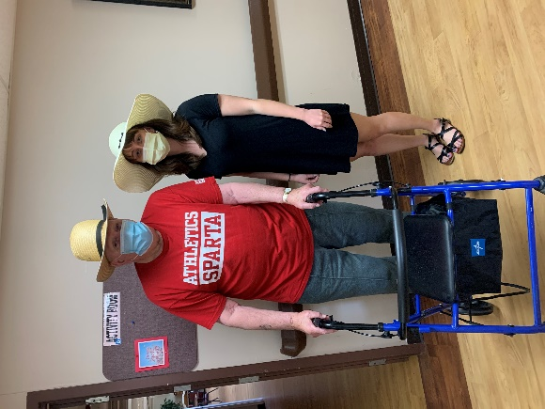

Wacky Wednesday; Beach Day

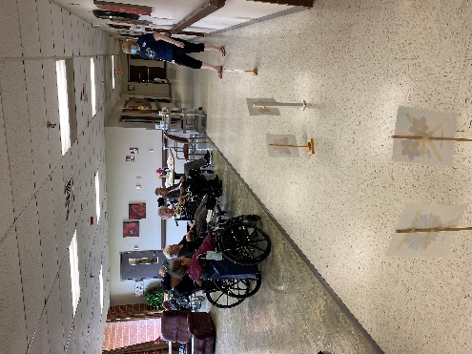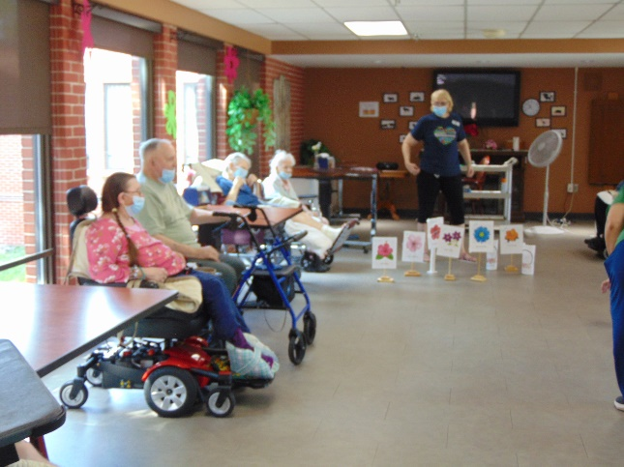

Flower Dice Races to celebrate May

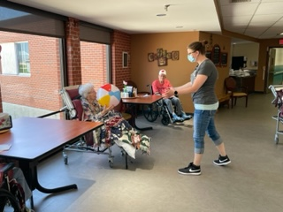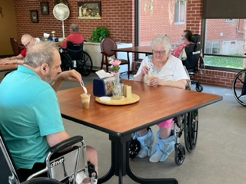

Beach Day Dress up and we had to celebrate with a beach ball and Root Beer Floats too!

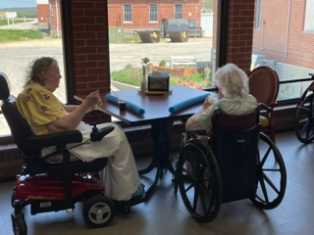 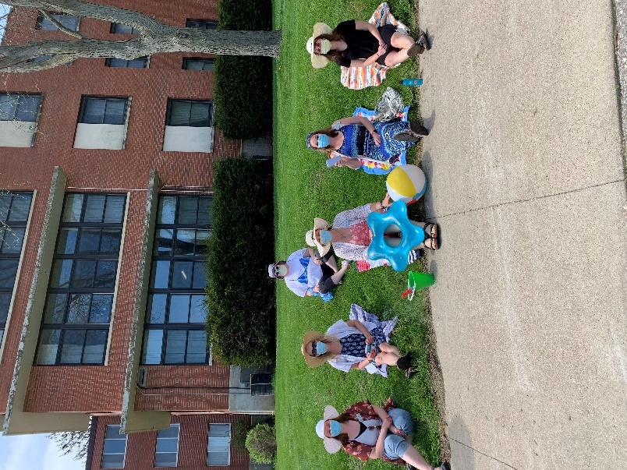

Leomonade on the patio

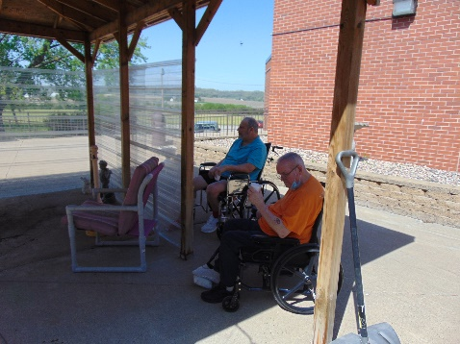 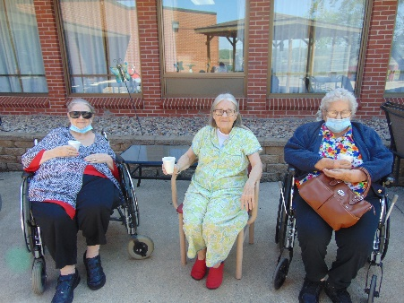 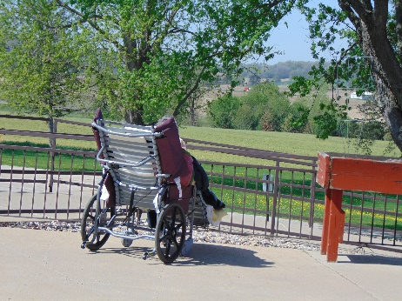

This week was National Nursing Home week and we celebrated with dress up days throughout the week. We enjoyed music with Dylan, did some Tai Chi with Lisa, sang along with Laurel A, shared stories over coffee, raced flowers, learned facts about and sang Patriotic songs and even had time to take in some fresh air. To end Nursing Home week we had a blast with the beach theme and had some root beer floats too! Enjoy your weekend

-Linda