1st week of May in pictures
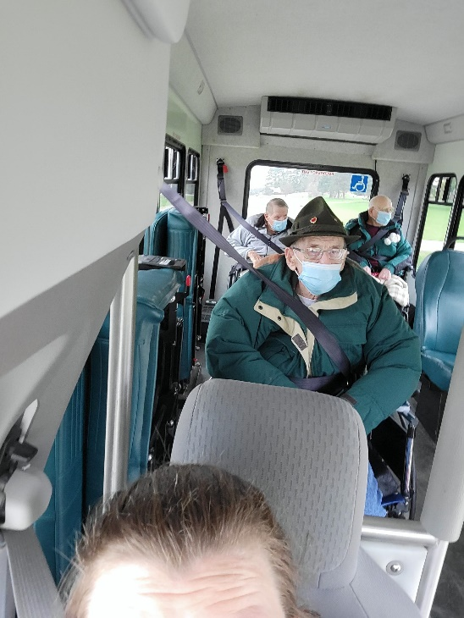
Scenic Drives to see how the colors are starting to appear
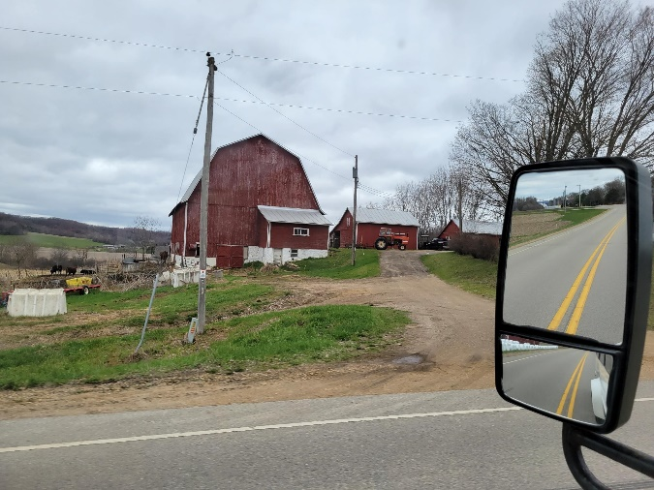
Residents received nice flowers from Monroe County Community members for May Day
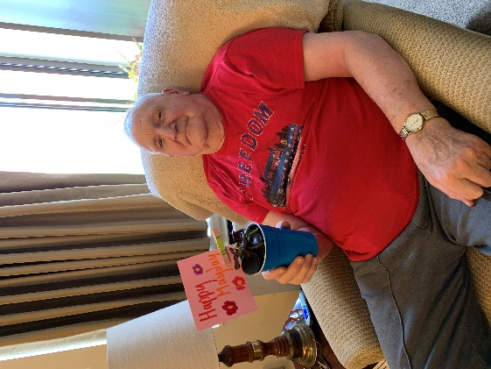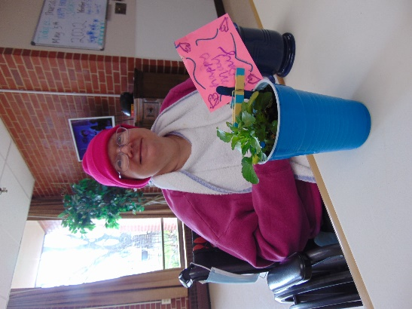
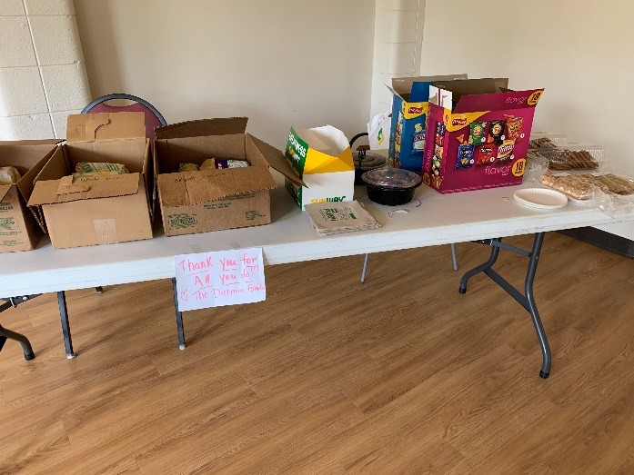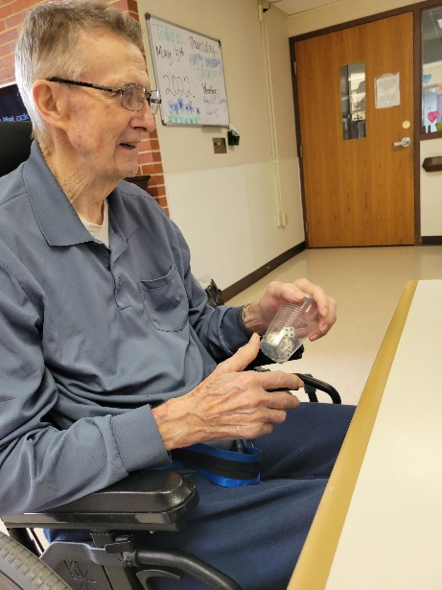
Staff enjoyed Subway from a family too; thanks so much!
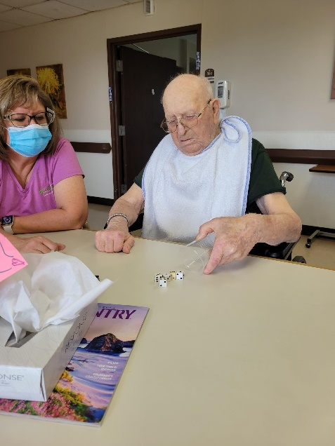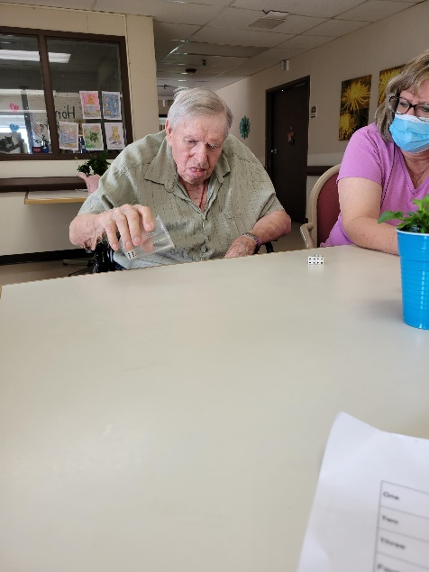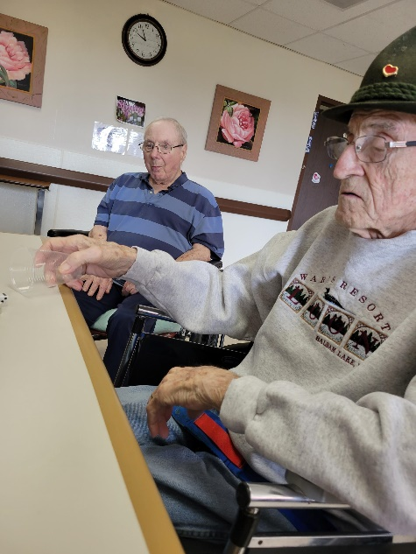
Yatzee Fun
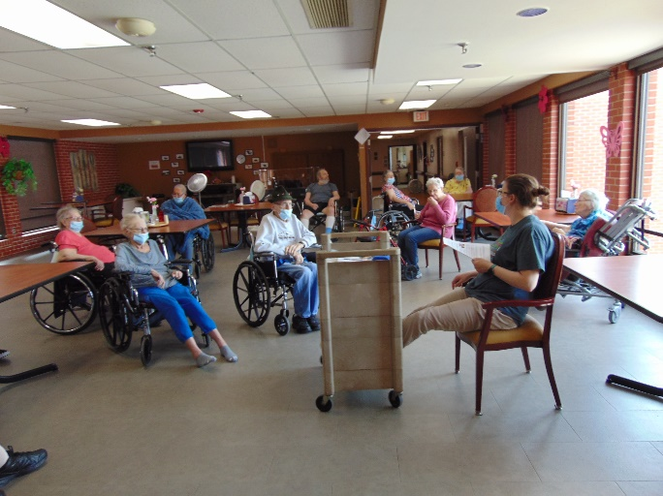
Cinco De Mayo consisted of facts, trivia, salsa and doing the Macarena!
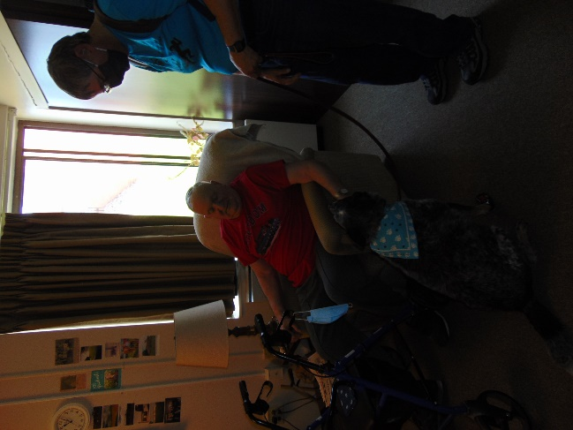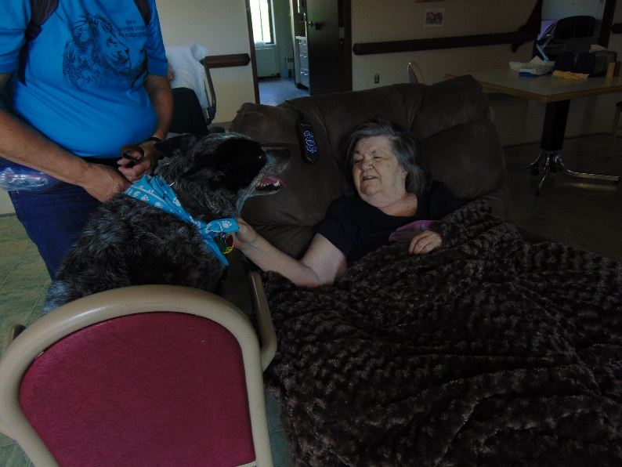
Keota visited Meadows and Haven House this week

This week we welcomed in May and were excited the weather got nice enough at the end of the week to get outside for some fresh air! When it wasn’t quite warm enough to go for a walk, we hopped in the vans and drove around the county. On May day we all received flowers from the Monroe County community members. We enjoyed our 1st visit from the new Trinity Lutheran interim Pastor, sang along to songs we know well with Lisa playing the piano and celebrated Cindo de Mayo with facts and some salsa. We end the week with bingo this weekend and celebrating our Mothers. Happy Mother’s day!
-Linda

Yat
Yatzee

