Last week of April in Pictures

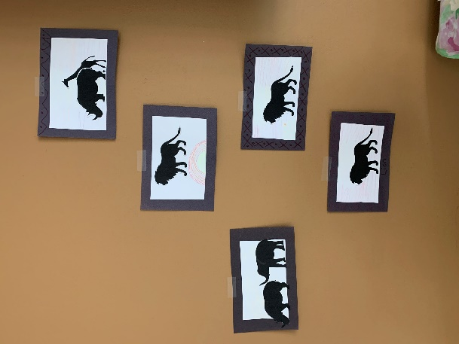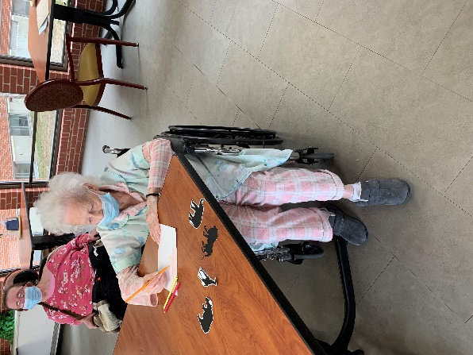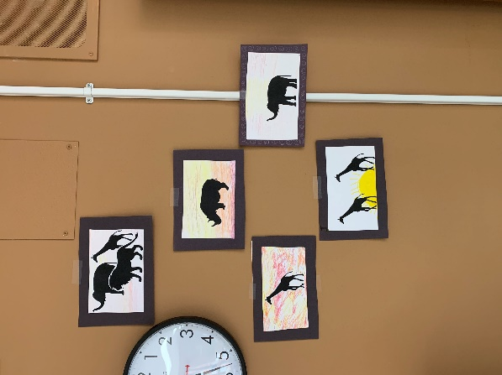

This month we traveled to Zambia, Africa

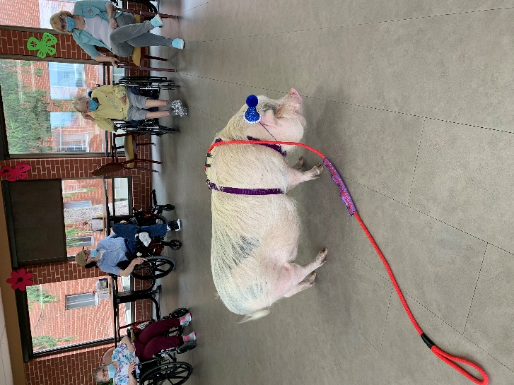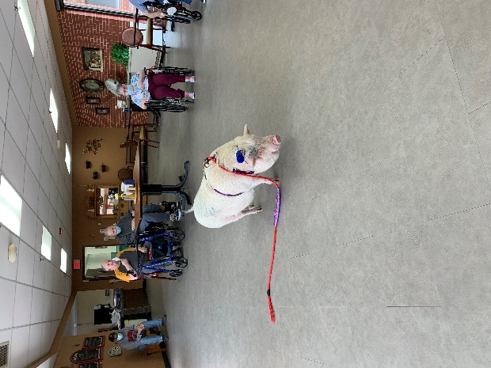

Jancee is a wealth of knowledge and we love having Brutus come and share his tricks with us

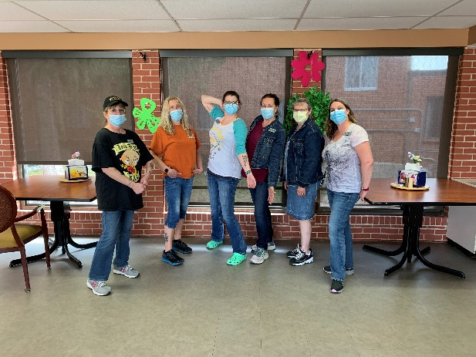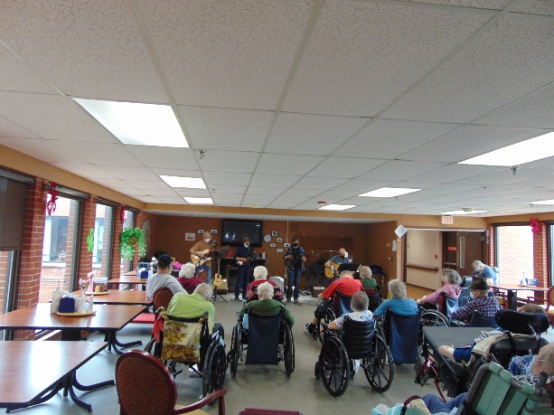

Denim and Tattoo day for the staff Music with Old Moldy Hay

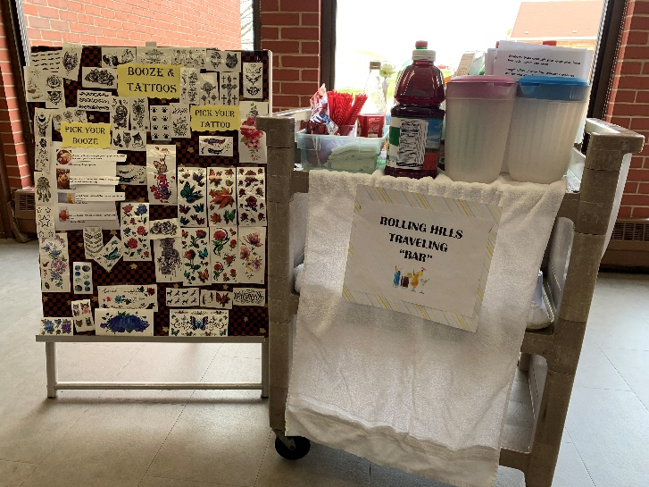 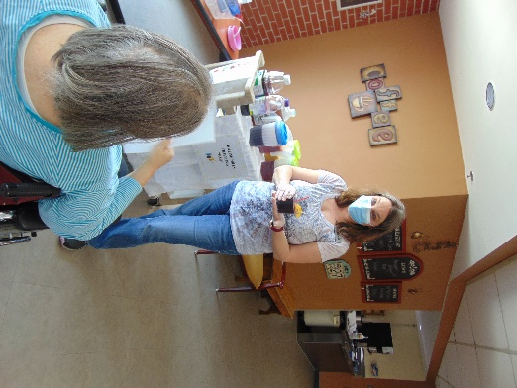 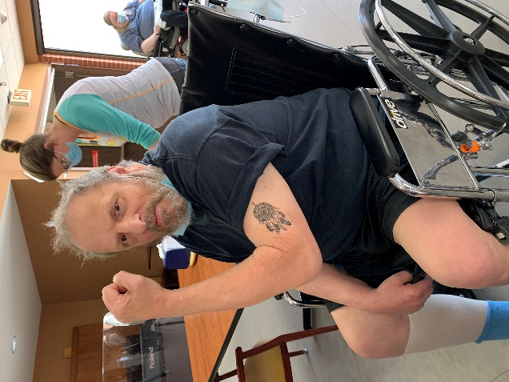 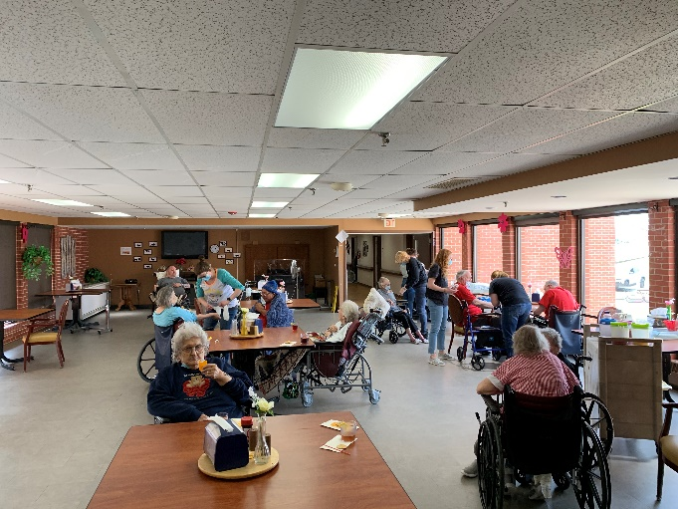

What a fun afternoon of drinks, tattoos, laughter, conversation and even cards!

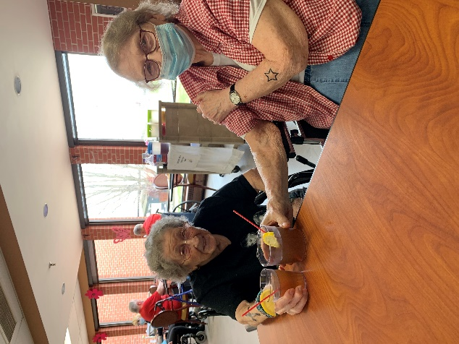 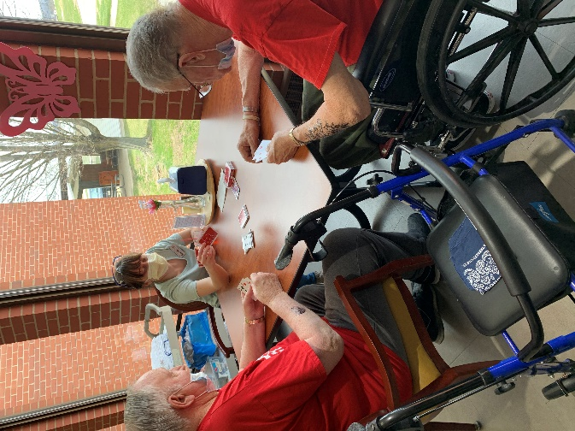

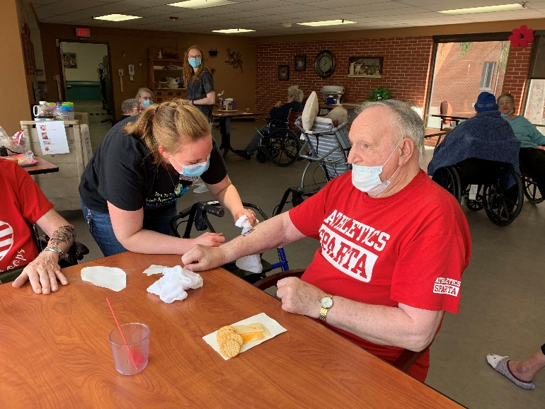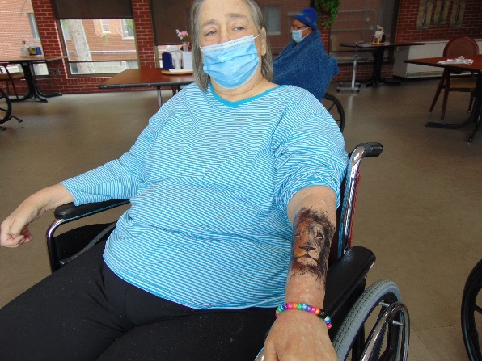

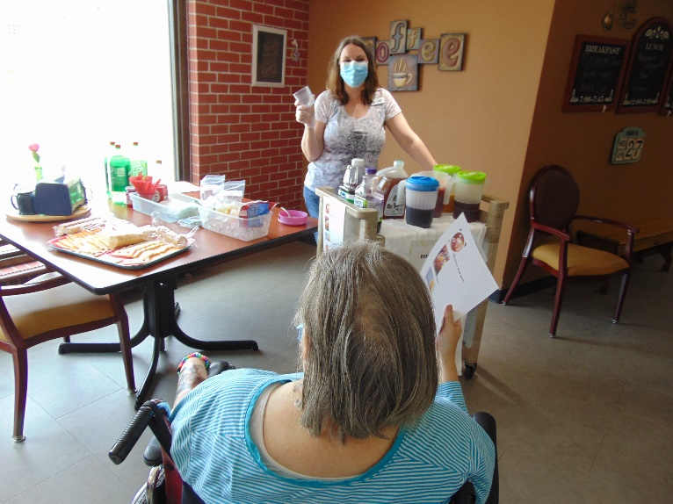

This week we began by traveling in our seats and learning about Zambia, Africa. We had fun creating a safari silhouette craft too. Brutus, the mini pig, also stopped by to do tricks for us, but we all know he doesn’t mind showing off for his treats! Old Moldy Hay came back to sing for us too this week with 2 new members. Our mocktails and tattoo afternoon went very well and lots of residents enjoyed this unique activity. Many like to come and challenge themselves at a game of hangman and win big at Lion’s bingo, so did they did that too. We hope you have a nice weekend!

-Linda