Last Week of March in Photos

Spring Craft from last week
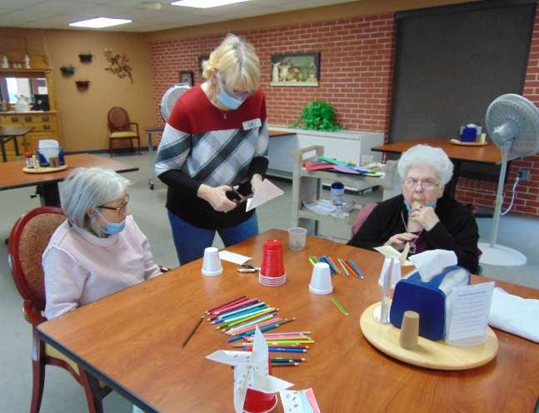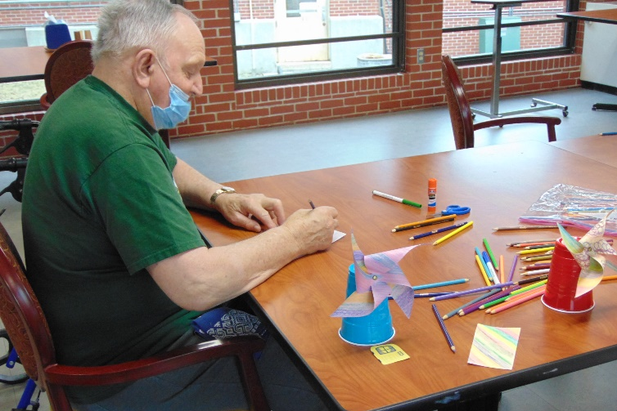
Culver’s order in from last week
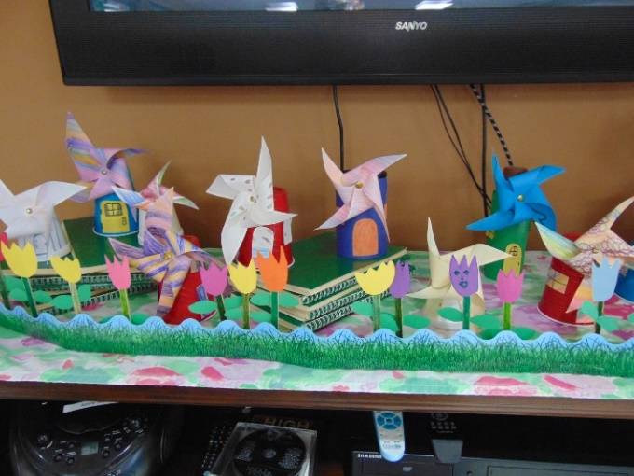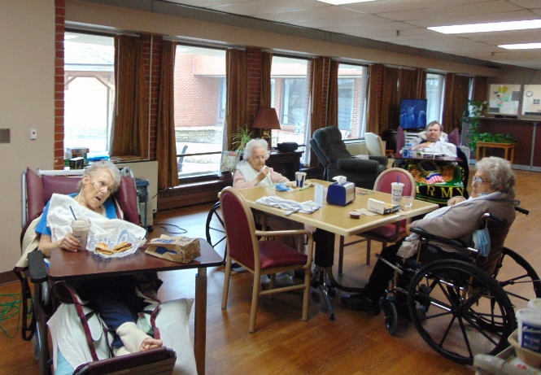

Brutus the pig visits!
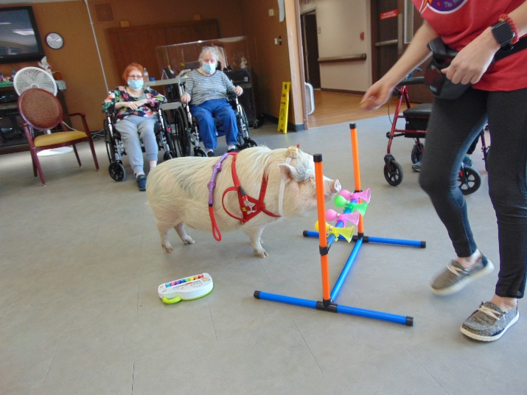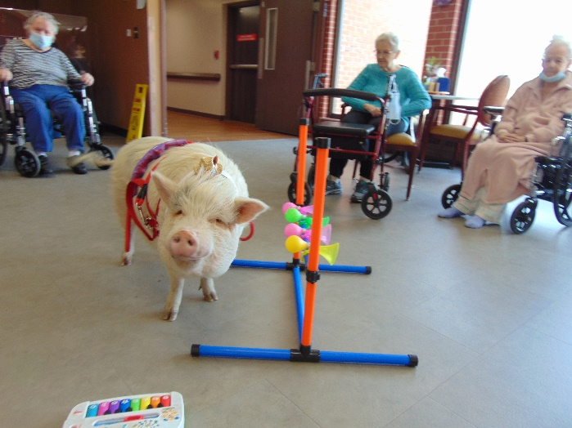

Music with Old Moldy Hay
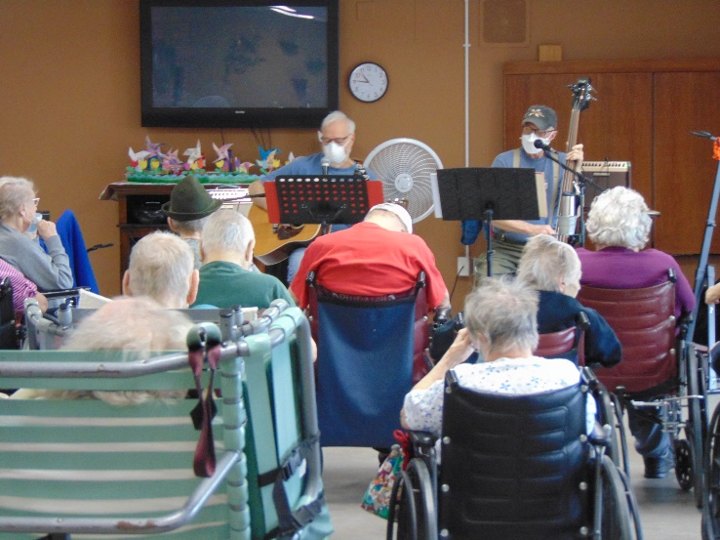

No Bake Cookie Bites
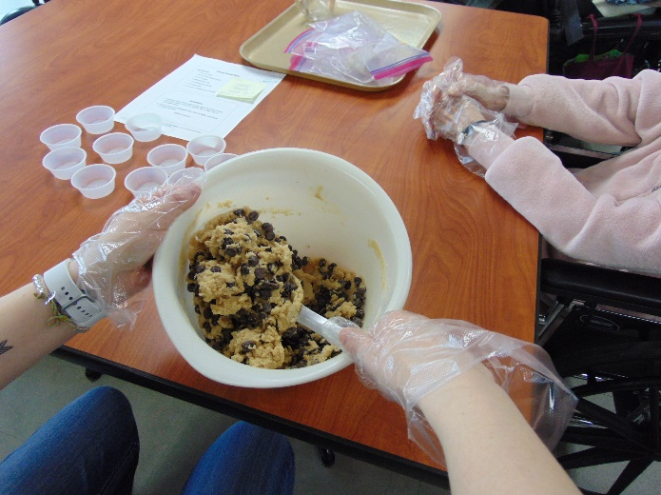

Word Games
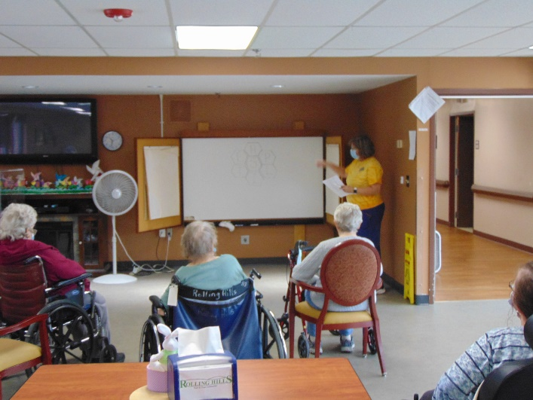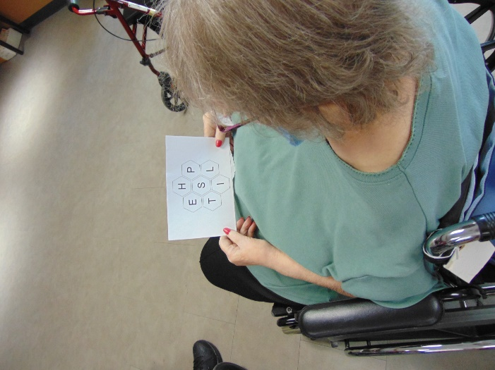

Dress up day: Crayons

Hello Everyone!
Happy April! Our dress up day this week was “Crayons”. We closed out the month of March with a variety of activities this week. We enjoyed another visit from Brutus the mini pig and music with Old Moldy Hay. We made a no bake treat – cookie bites – which we all enjoyed sampling. We took a “trip” to the Netherlands and enjoyed learning all about it. We played some word games and a few of us got to go out for a scenic drive. We hope the spring weather comes to stay soon.

