3rd week of April in Pictures

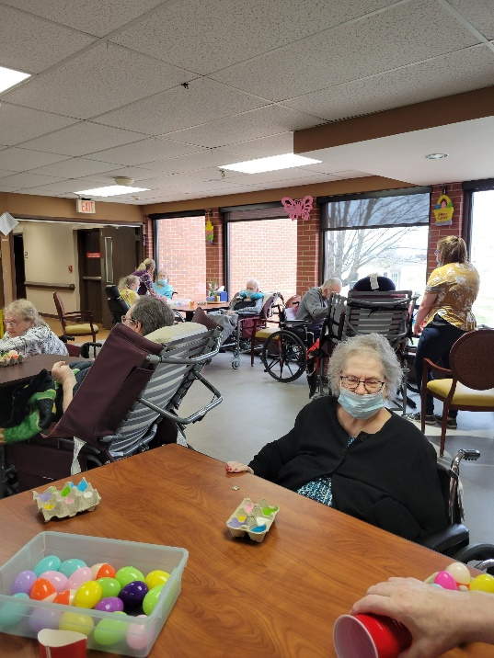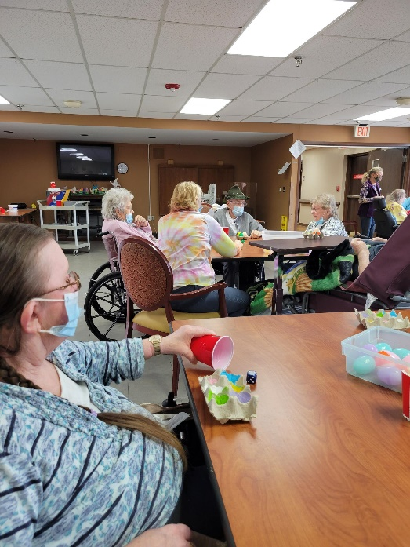

Playing an Easter Egg Dice game was fun

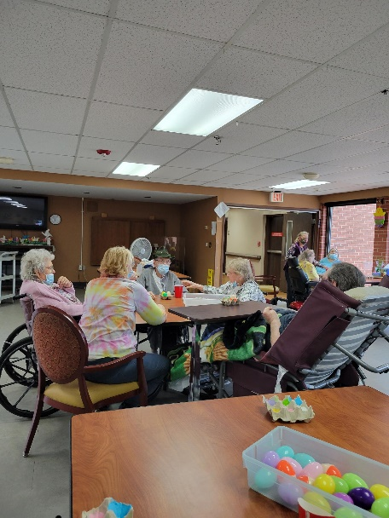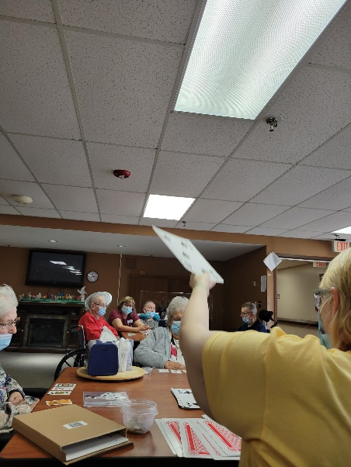

Mystery game is always fun as you never know how much you will win!

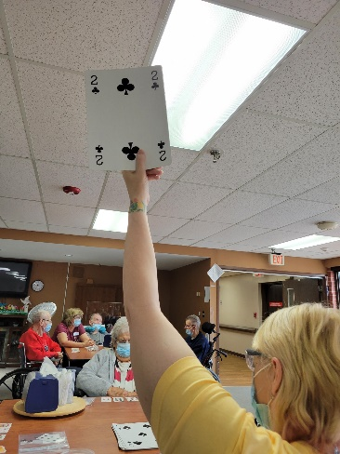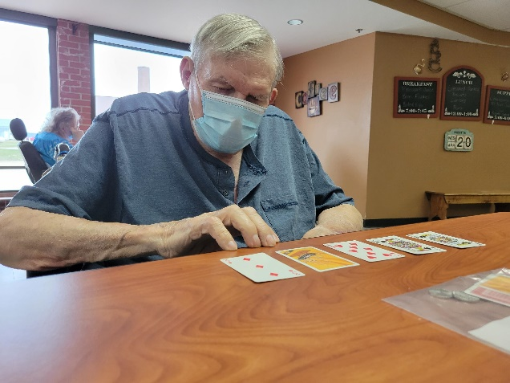

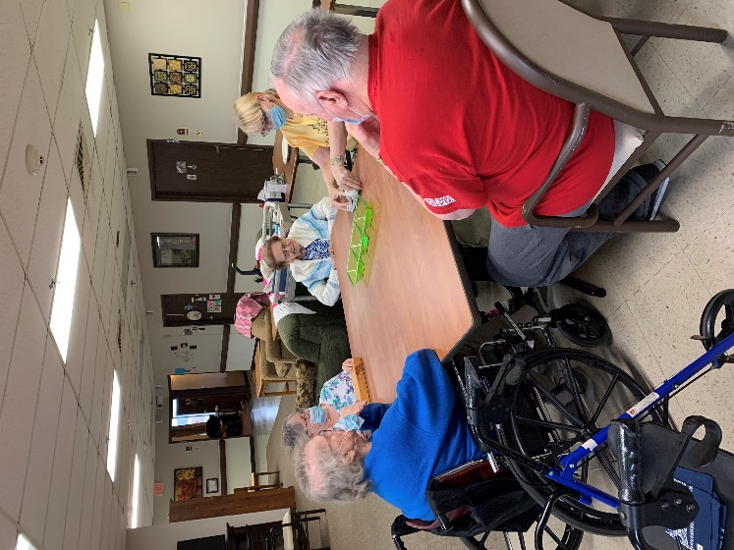

Pick up card games are always a good time! Pastel Color day

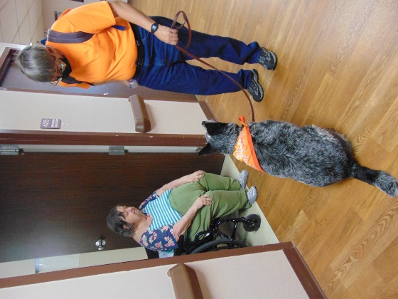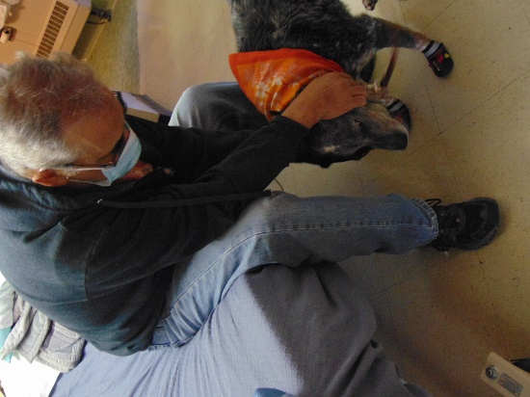

Keota visits are the best!

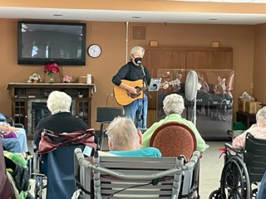

This week we began by still celebrating Easter and played a dice game with eggs that was fun. Dianne shared a nice Easter message at Bible study. Many liked winning an unknown amount during our mystery game day. Then Keota shared her licks and tricks for our 1st floor residents this week. We are ending with music by Jay today and then bingo with Tim on Saturday. Have a great and warmer weekend!

-Linda