2nd week of April 2022 in Pictures
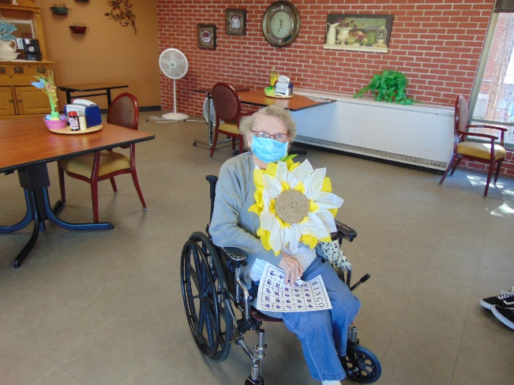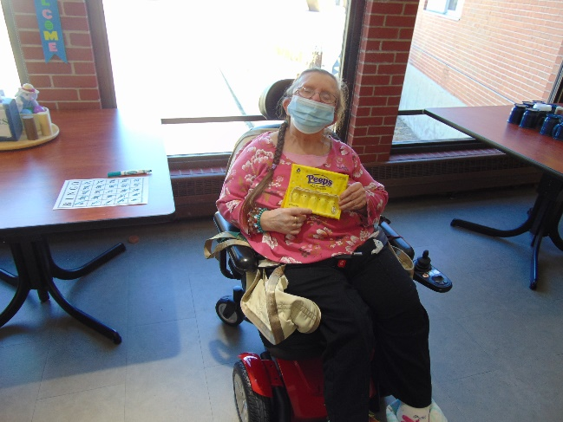
Spring Bingo Prizes were a welcomed treat this past Saturday
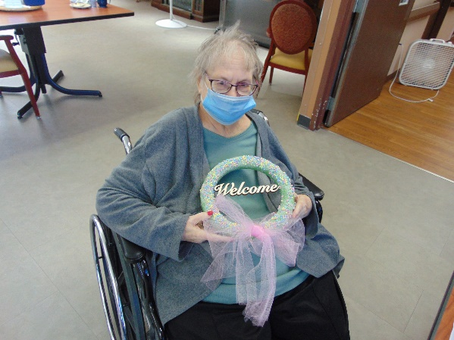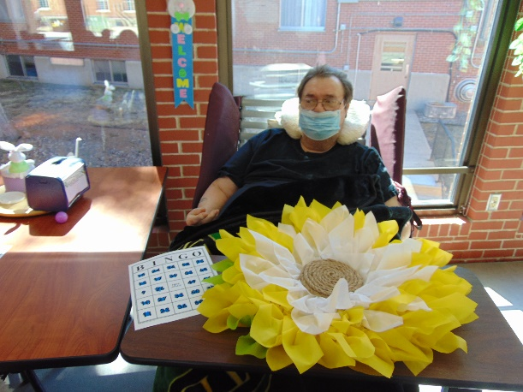
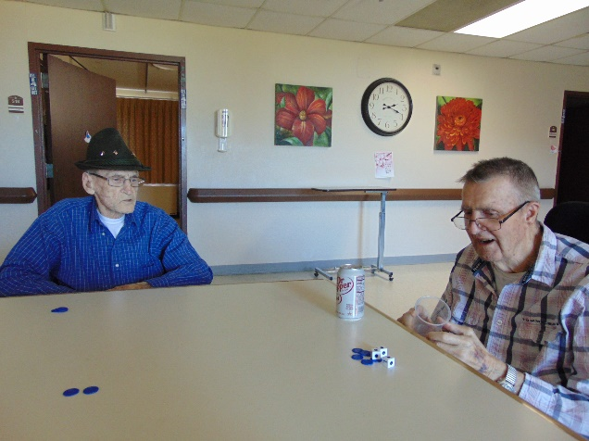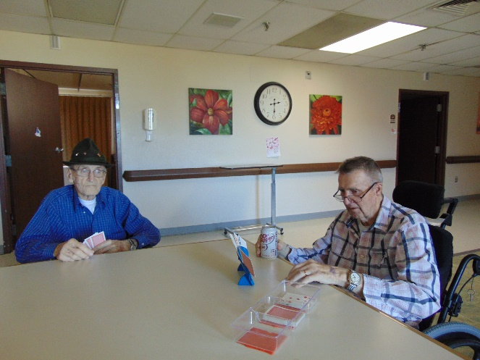
These gentleman have fun with Left/Right/Center and Crazy 8 card games
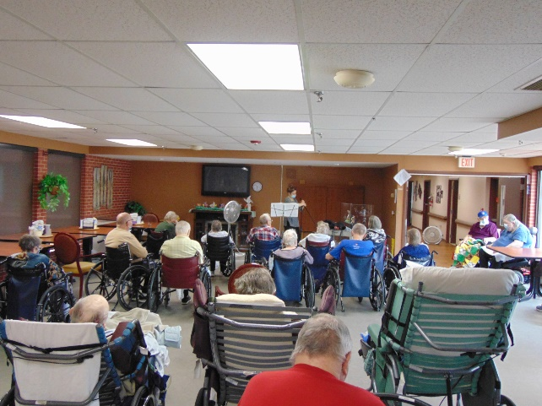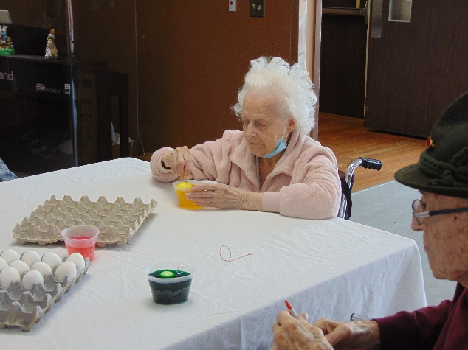
Large crowd for Laurel
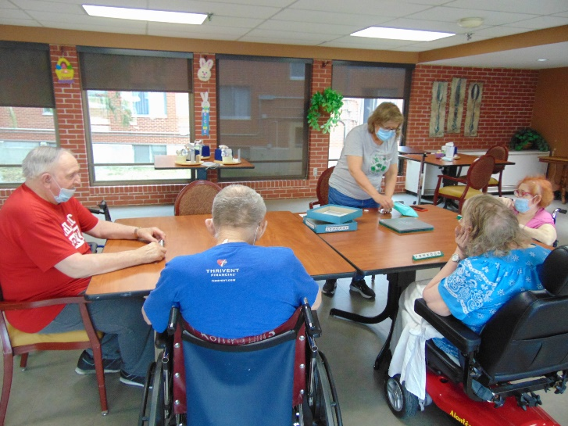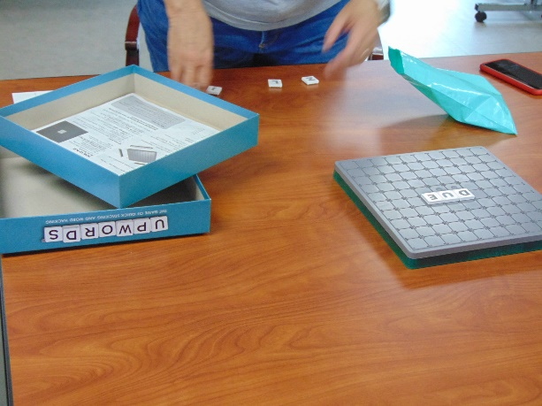
Fun game of Upwords to keep our minds active
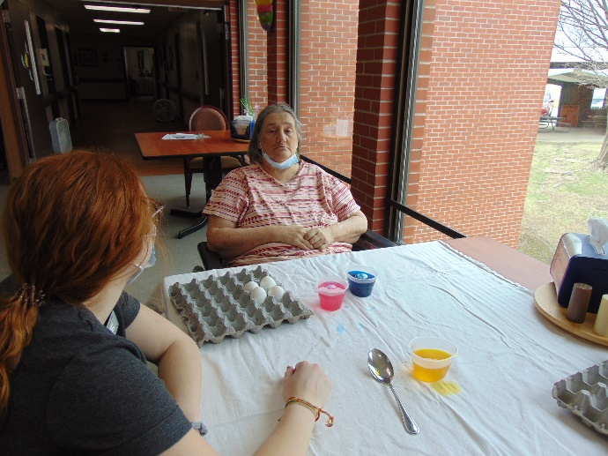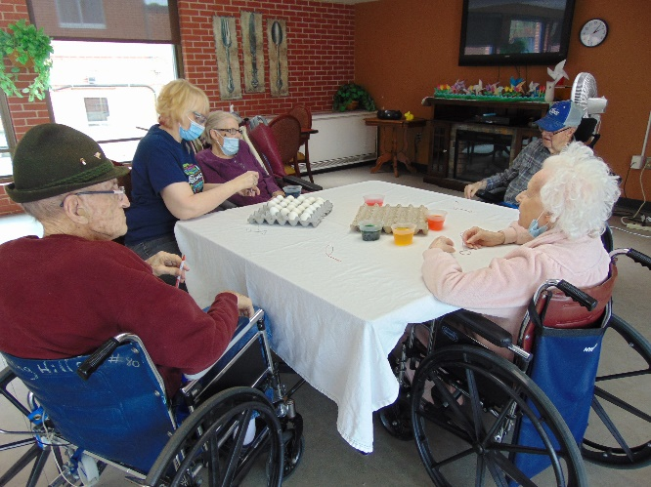
Getting Easter Eggs ready
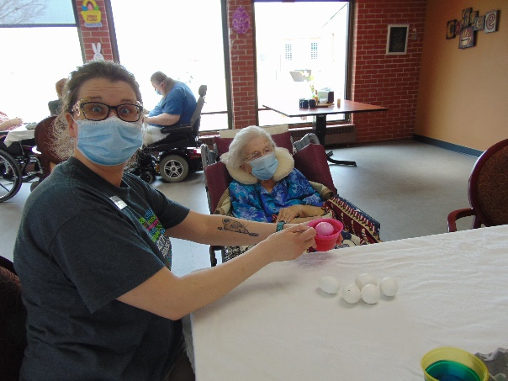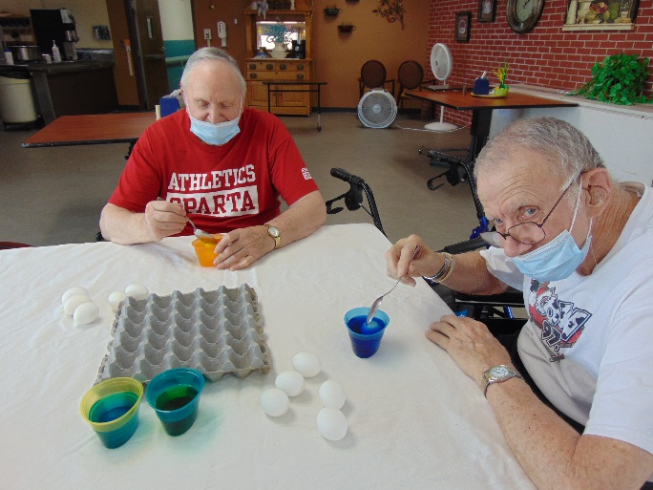
Racing our Bunnies
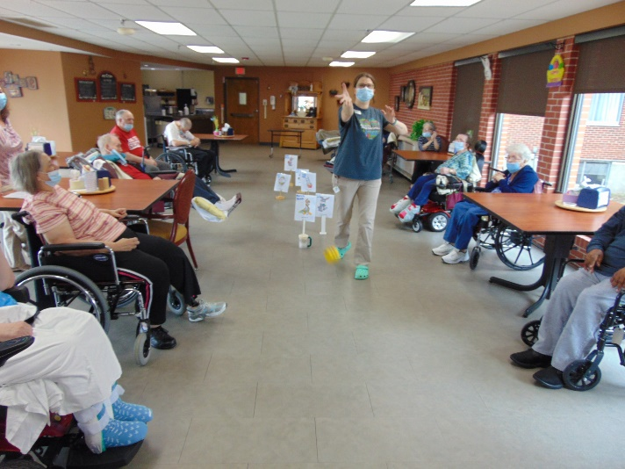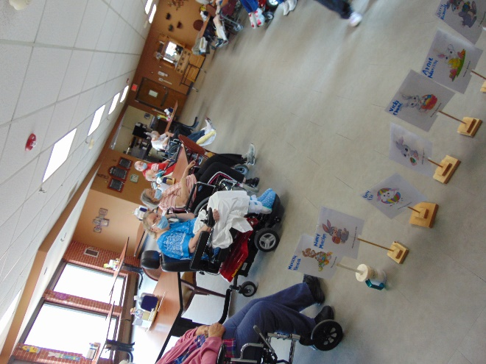

This week we got ready for Easter and you may need to wait until next week for more pictures too. We had fun playing Upwords for National Scrabble Day. Laurel Adams sang to us with her beautiful voice. Everyone got Easter cards from Monroe County Junior Miss United States Agriculture. We continue our monthly racing games with Bunny races this time. We even got our eggs decorated for Easter Sunday as well. Hands and Feet Church group will be leading us in a Good Friday worship and the week is not complete with exercise and news chat to burn off the treats bought from the café cart. We hope you all have a nice Easter weekend.
-Linda

