4th Week of March in Pictures

Last week Friday we enjoyed music with Jay Lion’s Bingo!
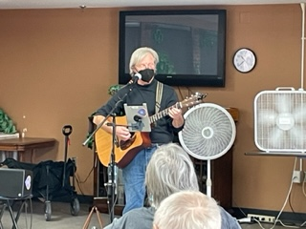

Games – Left, Right, Center Music with Laurel B
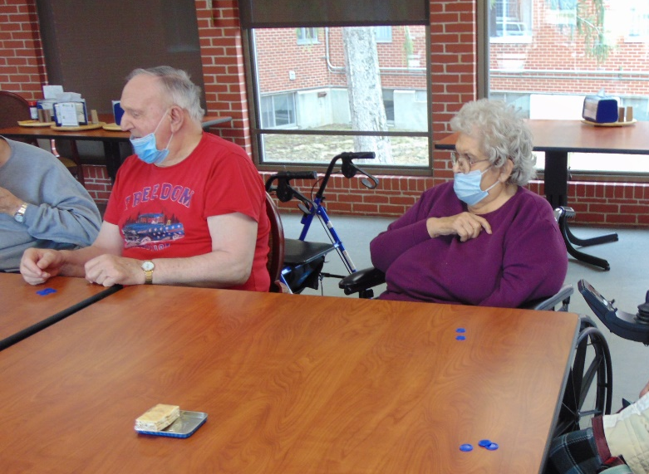

Weekend Bingo

This week we had fun playing hangman, as well as some other games. Laurel B was here to share his music with us, which we all enjoyed. The Sparta Lion’s Club was here for another round of Lion’s Bingo, and some of us were able to enjoy an order in from Culvers. We welcomed spring with a fun spring craft. The dress up day this week was March Madness, but we were not able to get any photos of that this week. We hope everyone has a great weekend!

