3rd week of March in Pictures
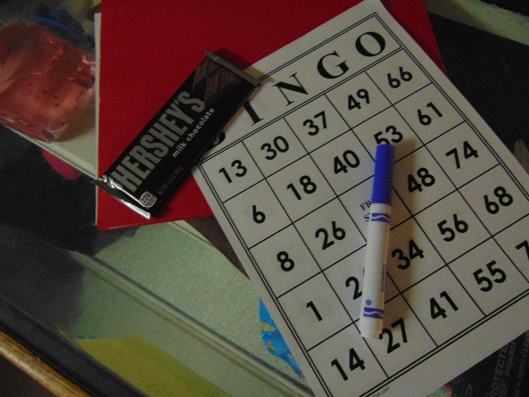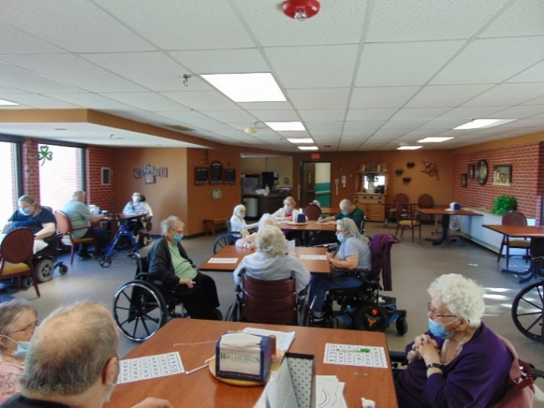
Hershey Bingo drew a large crowd on a Saturday morning
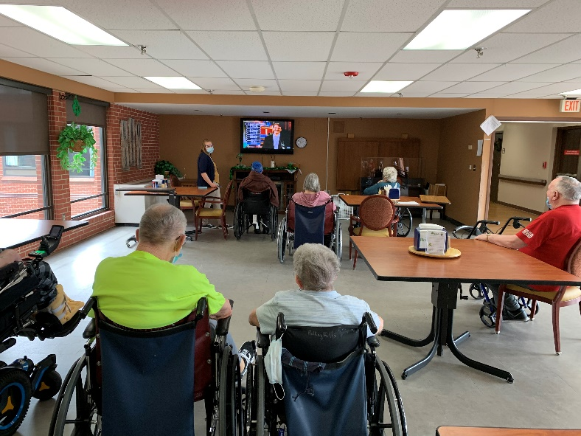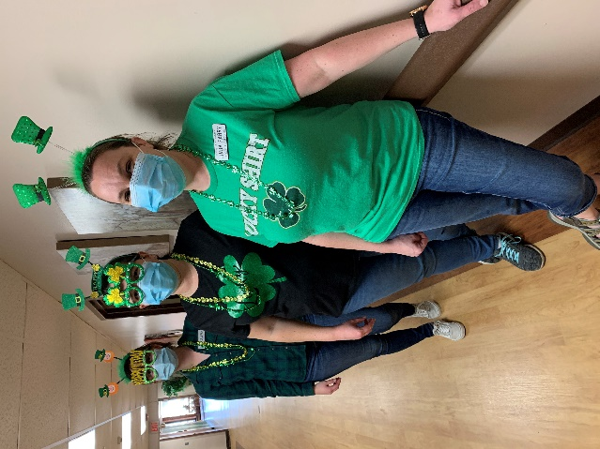
Are you smarter than a 5th grader fun
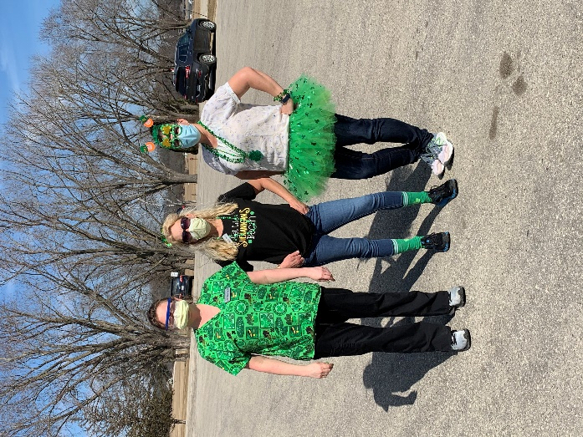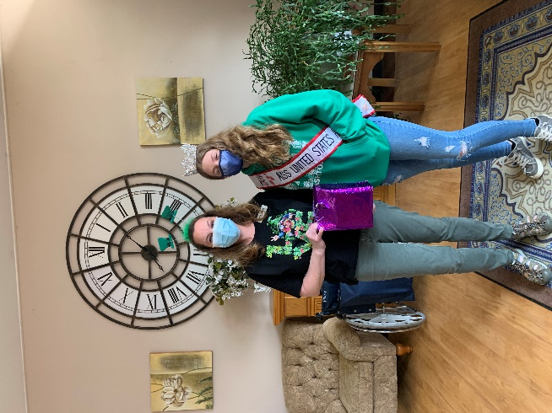
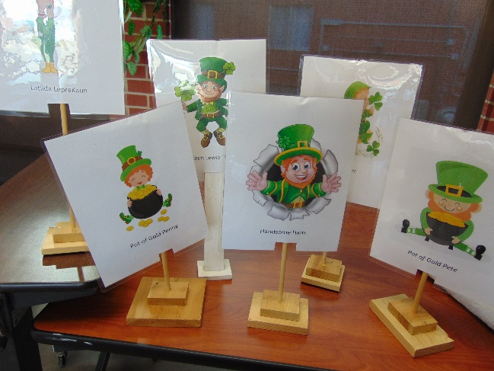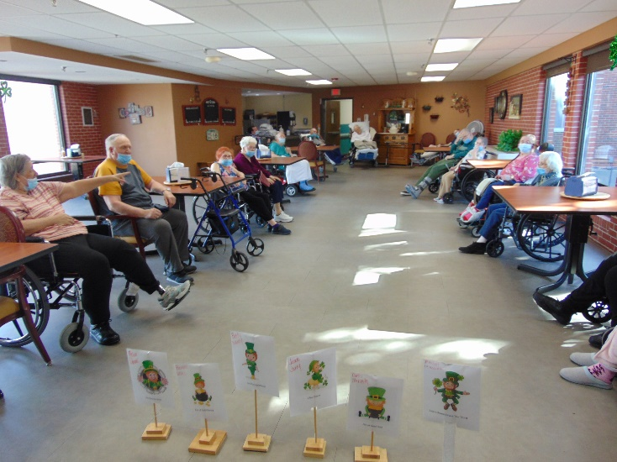
Leprechaun Races
Keota stopped on 1st floor
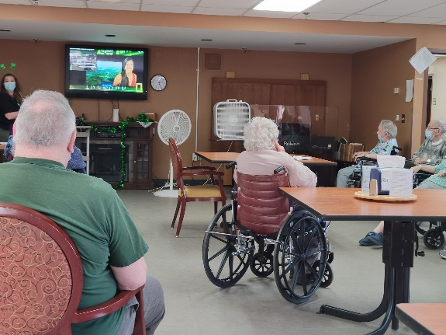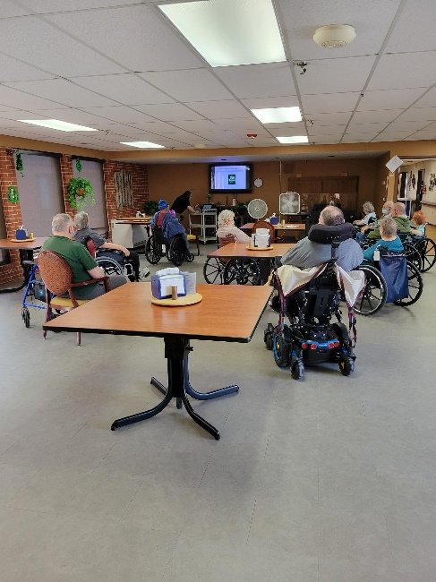
St Patrick’s day program complete with green trivia, Facts about Ireland and Irish songs

We were seeing Green a lot this week!
On Wednesday we celebrated on our usual day wearing green and then of course we had to wear it again on Thursday too. Jessica led Are you Smarter Than a 5th Grader. Even with Linda “cheating” a little, it is sad to say, but we were not for one game, but then pulled out all the stops and won the 2nd game!
Laughter and cheering was heard as our Leprechauns raced with the roll of the dice. Linda led a PowerPoint St Patrick’s Day program complete with green trivia, Ireland facts and some Irish songs. At the end of the week we enjoyed music with Jay too.
-Linda

