1st week of March in pictures

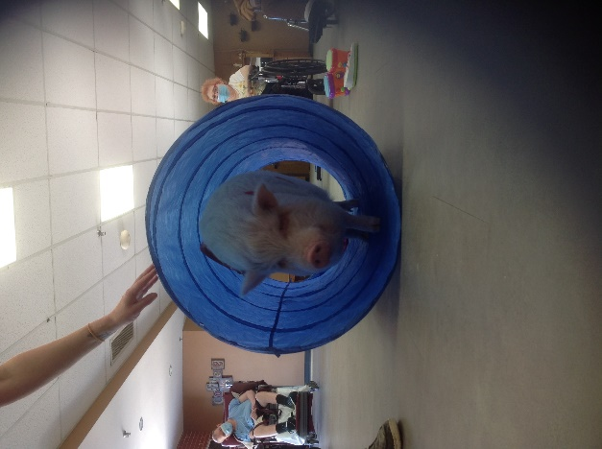 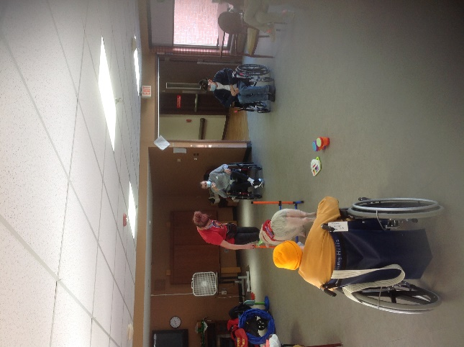

Brutus has some new toys to do tricks for us!

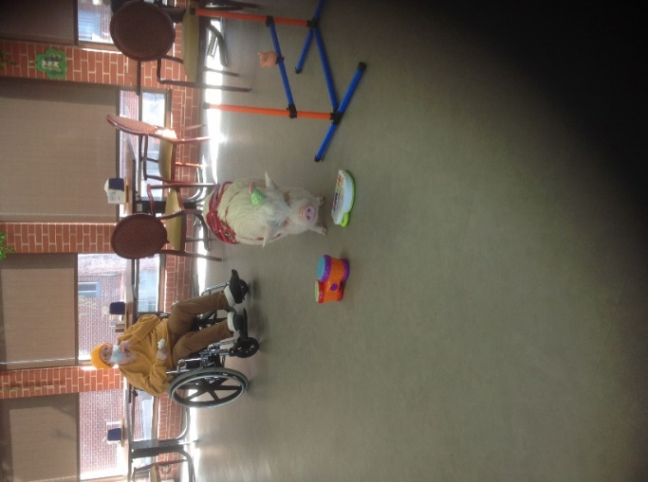 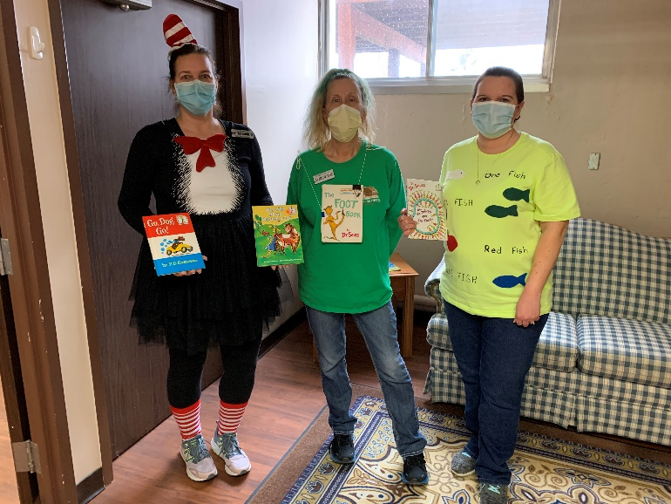

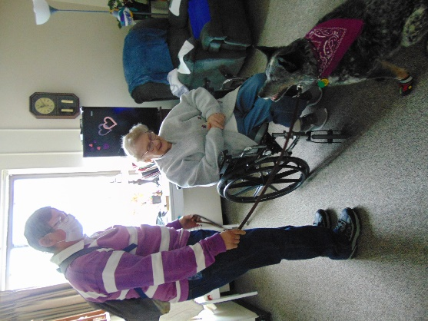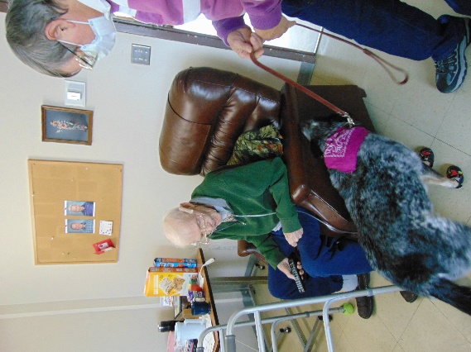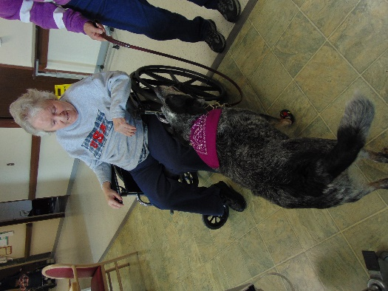

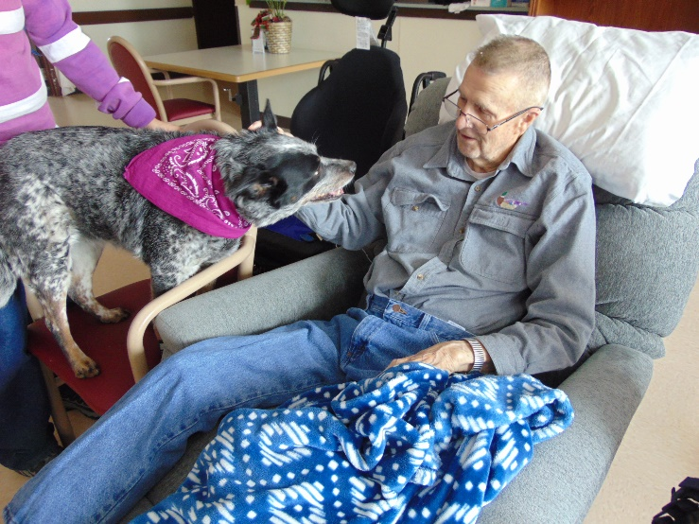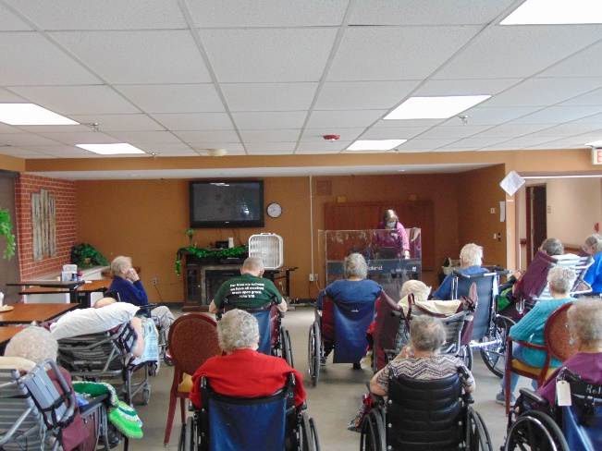

This week we began being entertained by Brutus, the pet therapy pig. He came with some new toys to show off some new tricks for us! Then we kept our weekly news and exercise routine so we have added range of motion with a fun twist into our weeks. Lisa led us in music and songs. Keota provided more smiles and tricks for us and the staff took a risk and put on a skit for everyone. This of course brought laughs and applause. Jessica was able to put together a video of the new building along with pictures that Linda shared on channel 25 too. This was also shown at resident council again and sure has everyone excited seeing the progress being made.

Have a great week

-Linda