Last week of February in pictures

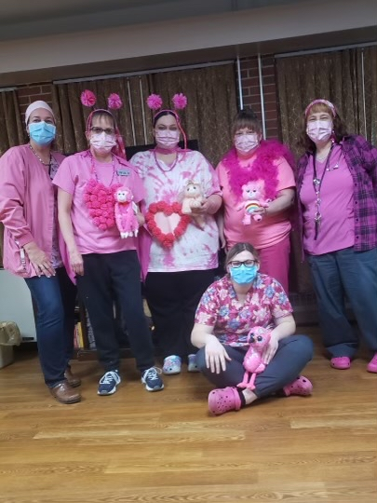 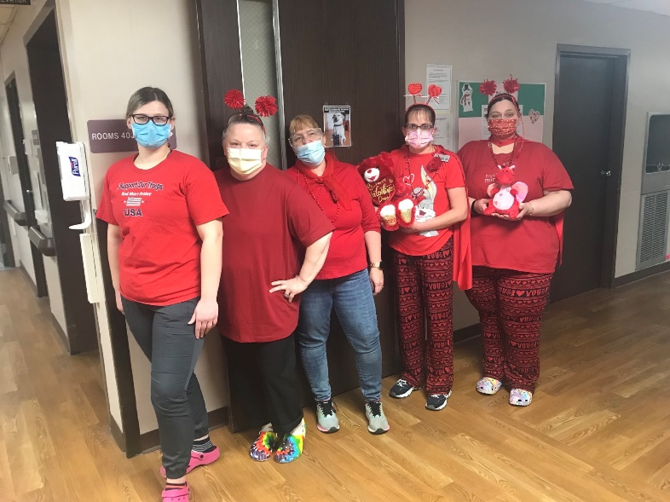

Staff Wednesday dress up days over the past month

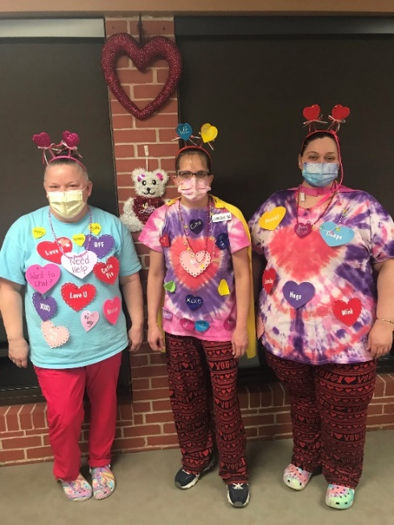 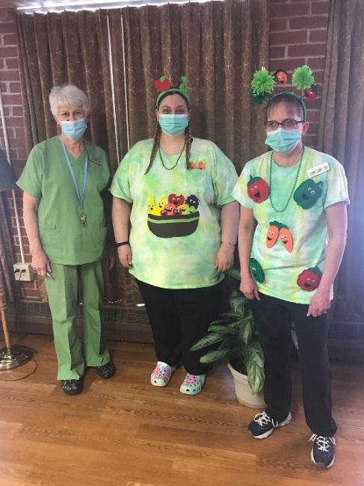

The Singing Birthday bear always brings smiles

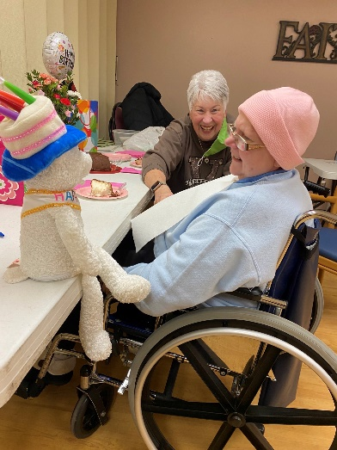 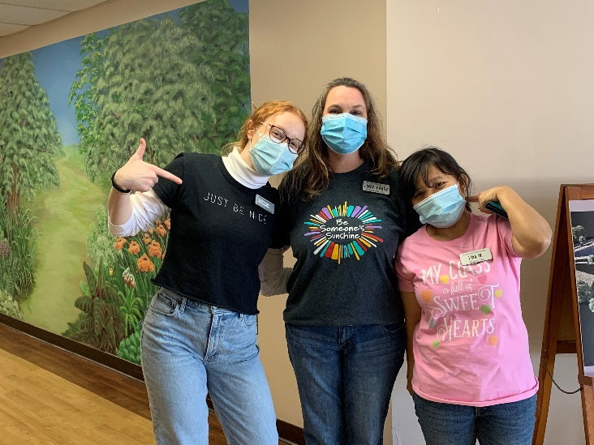

Movie matinee with snacks

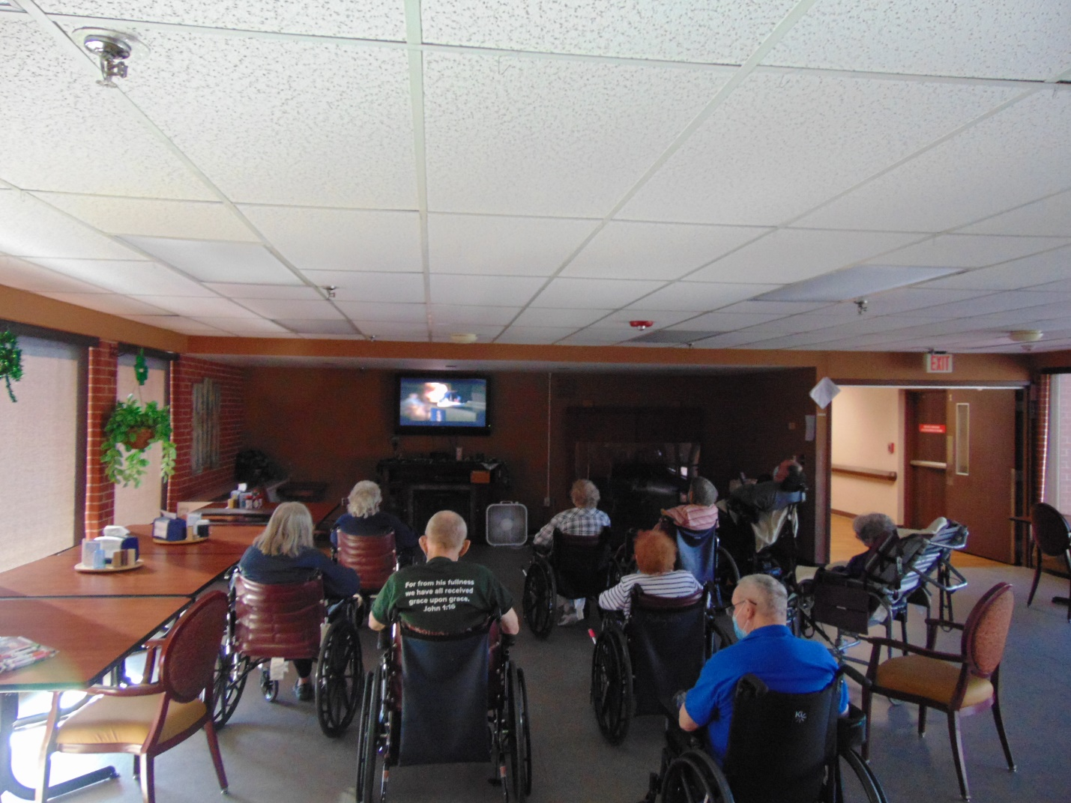 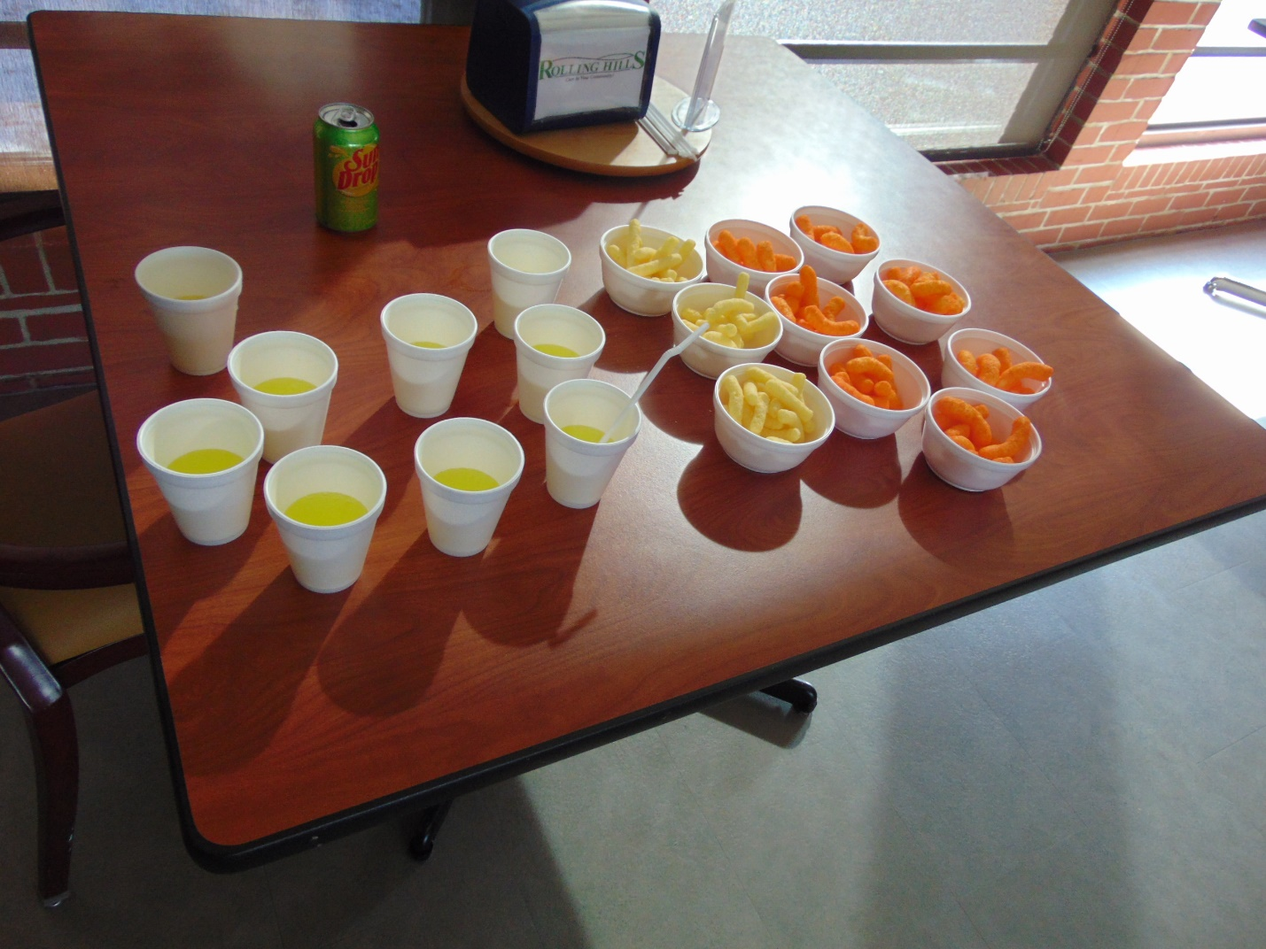

Lion’s Bingo

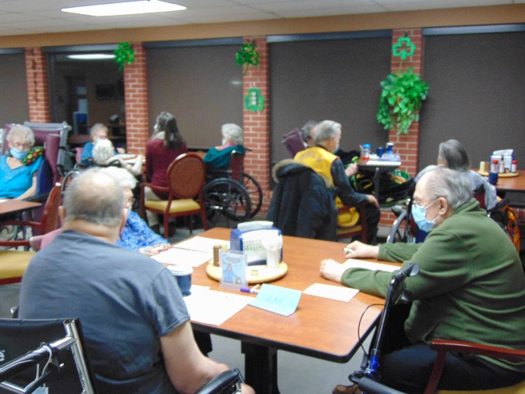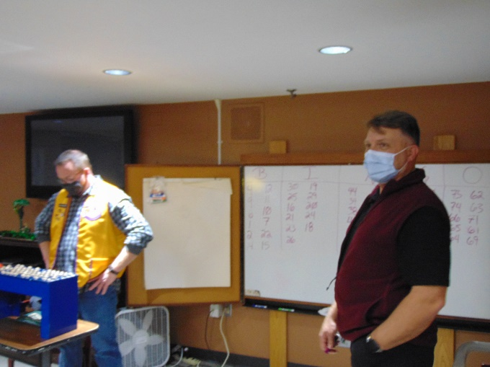

Music with Laurel B

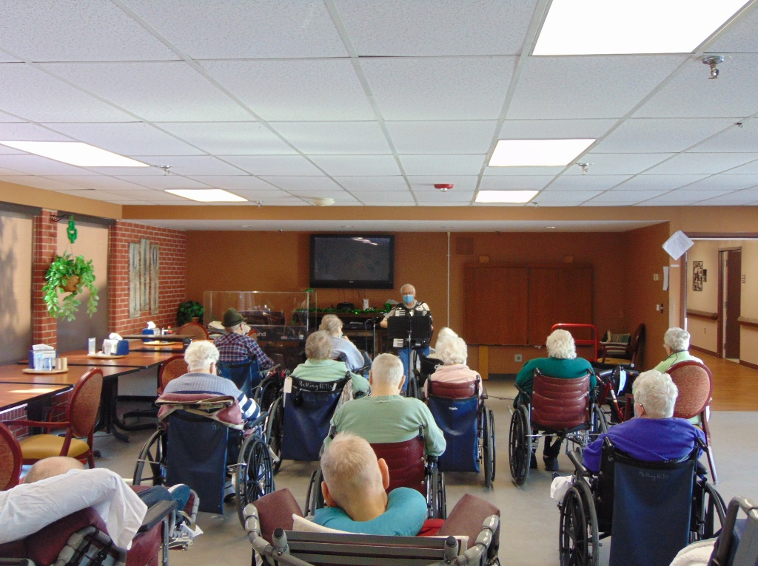

**This week we kept busy with playing bingo, celebrating Presidents Day, keeping our brains sharp with brain games, enjoyed a movie matinee with snacks and music with Laurel B. We also enjoyed a travel program to the Red Sea and “big buck bingo” with the Lions Club. Wishing everyone a great weekend!**