1st week of February in pictures

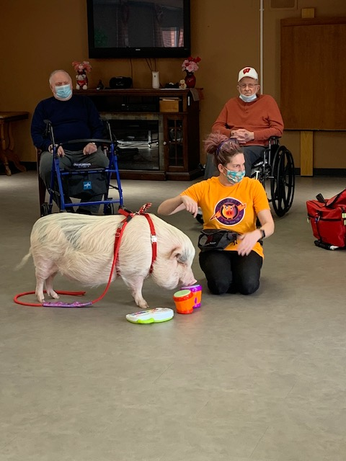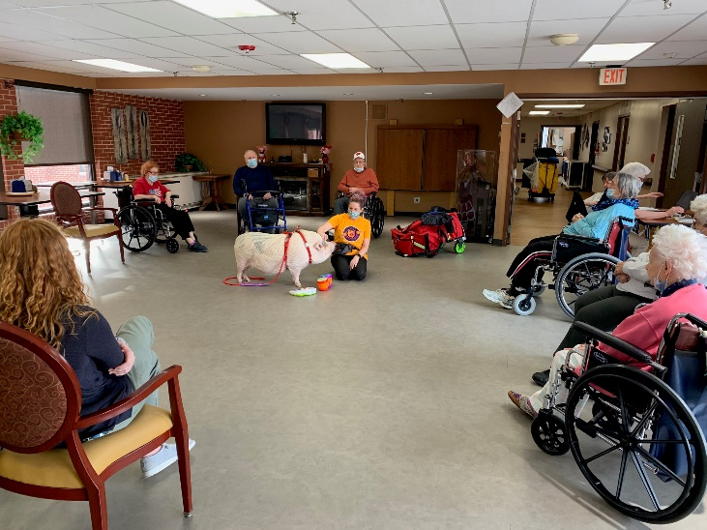

Always love having Brutus in our home!

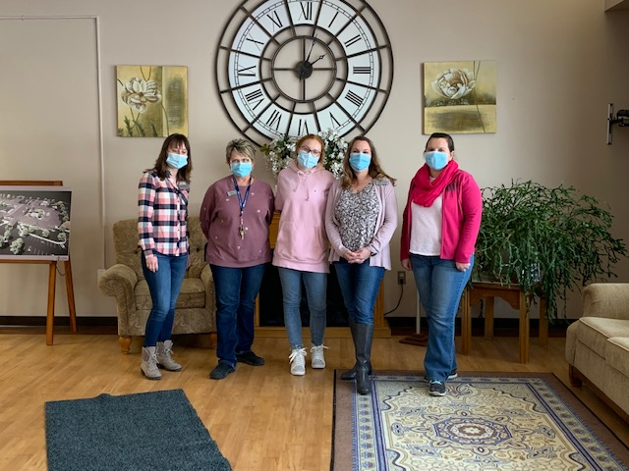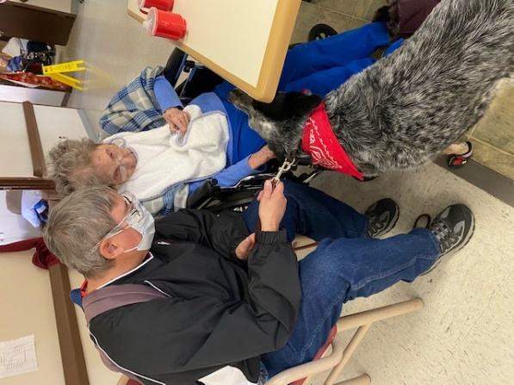

Pink Day! Keota came to visit!

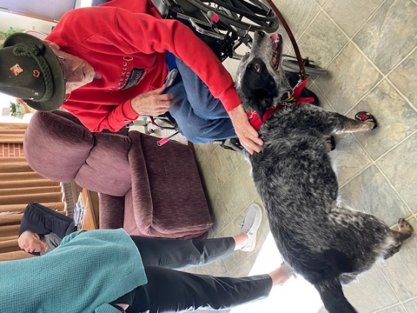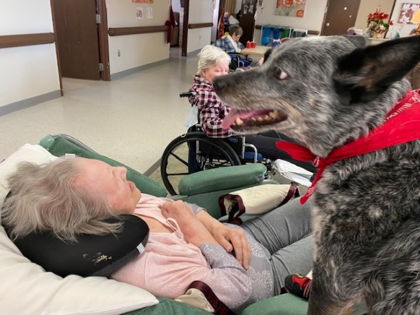

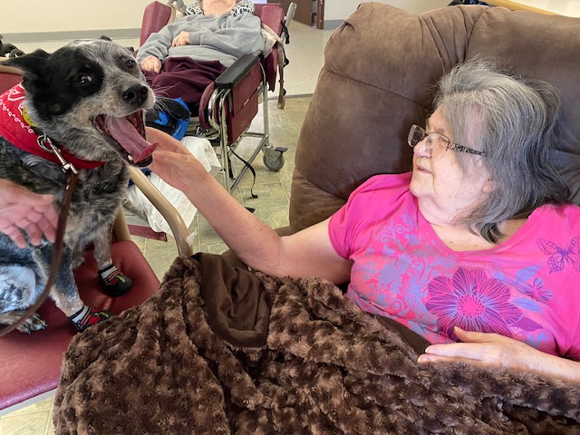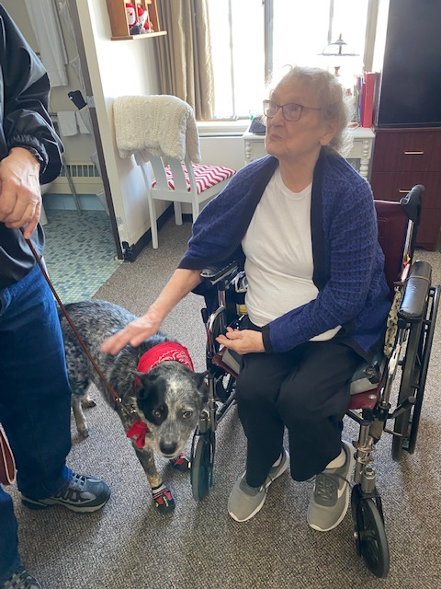

Keota brought lots of smiles this Thursday

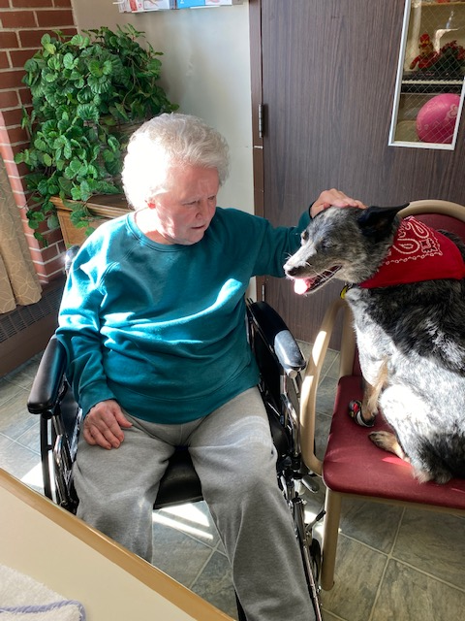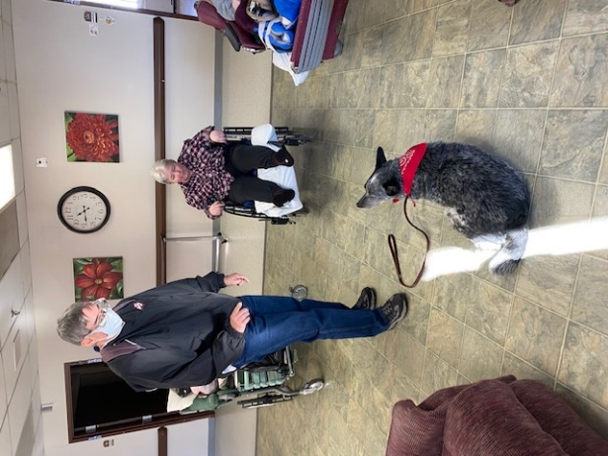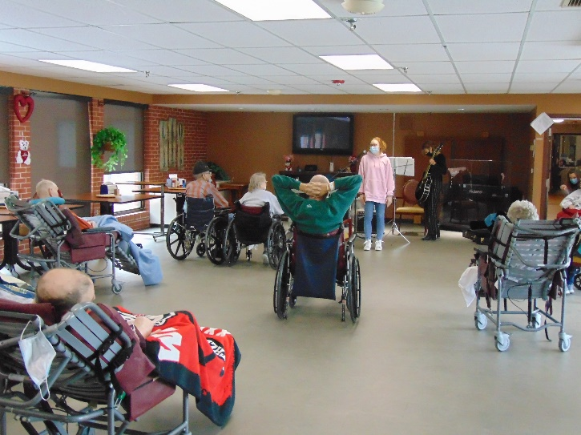

Meeting Olivia, the new social worker intern

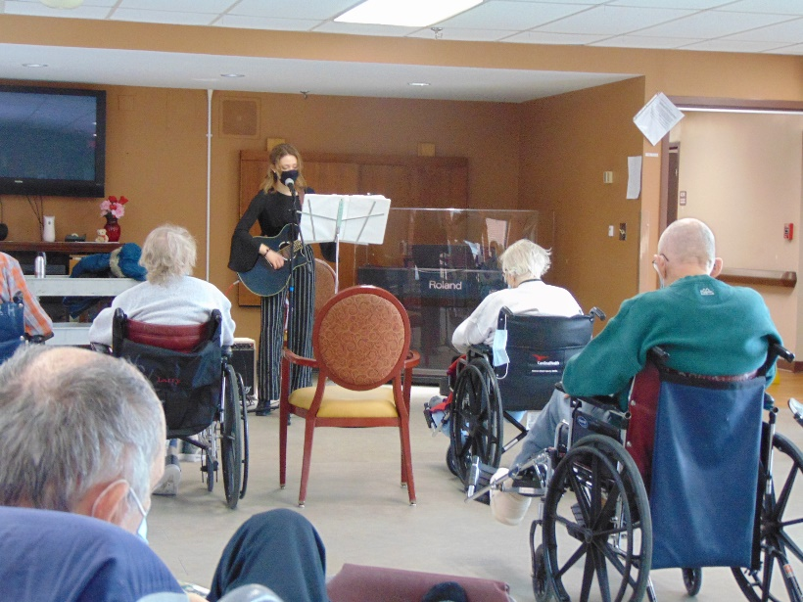 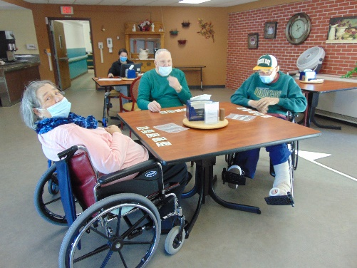

Music /w Laurel Adams

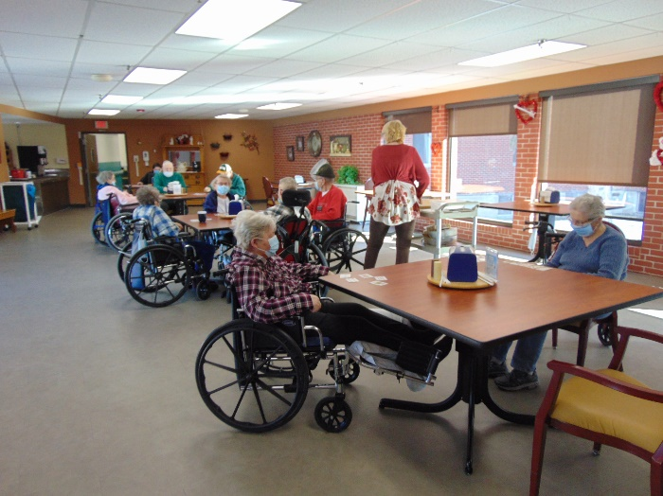 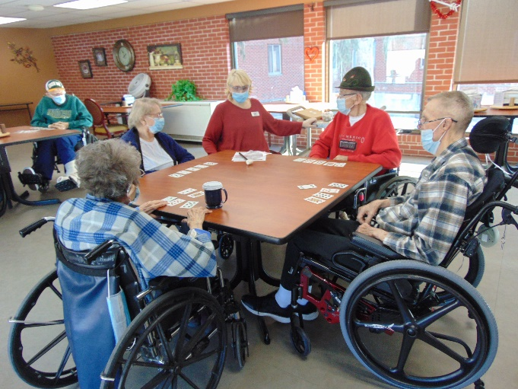

Mystery Game drew a nice crowd!

Happy February everyone!

This week we enjoyed all the pet therapy visits we had. It is fun to see and learn about pigs and watch Brutus play his instruments as well as pet and watch Keota do tricks! Narissa keeps everyone moving with exercise and news. Laurel Adams was able to join us and sing while playing her guitar. We are excited to have her back and love listening to her voice. Some of the residents had fun playing mystery game, which was card bingo! The weekend will bring church, bingo and more fun. Have a great weekend!

-Linda