Last full week of January 2022 in pictures

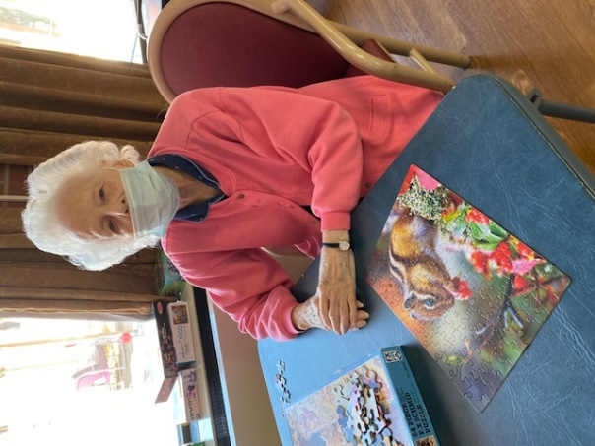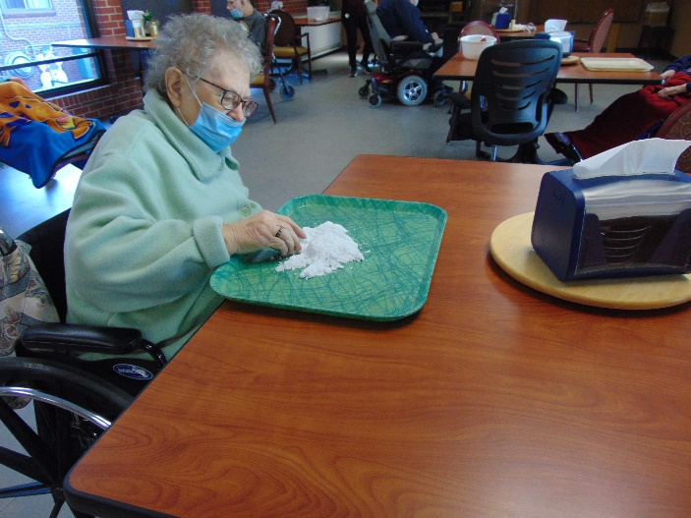

Keeping ourselves busy! Playing with “snow”

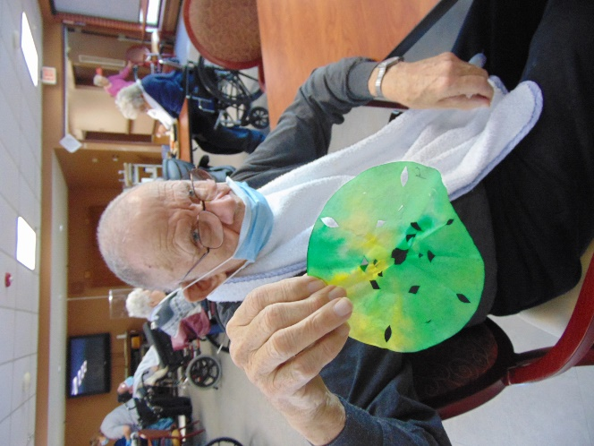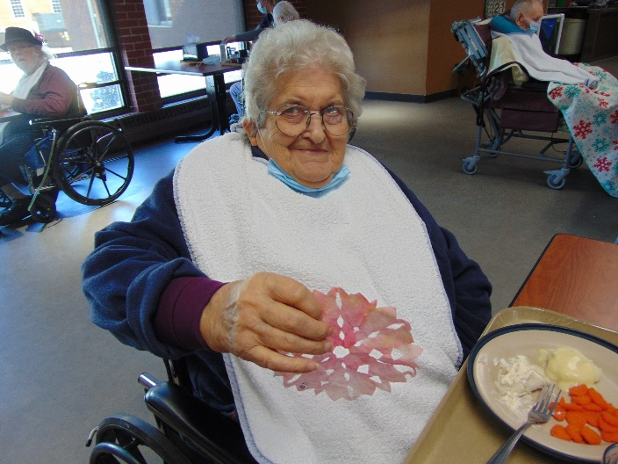

We took pictures once the snowflakes they made were dry

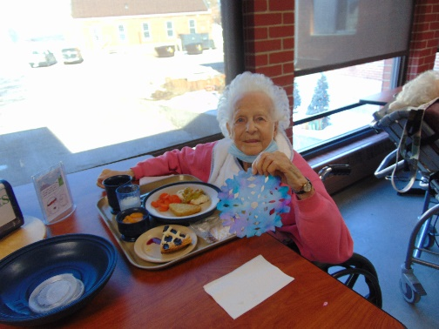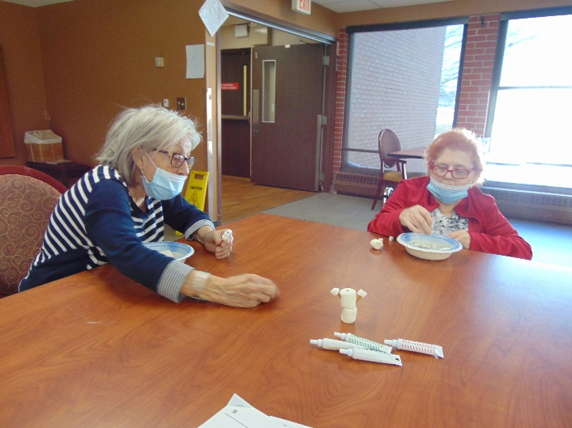

Building snowman with marshmallows

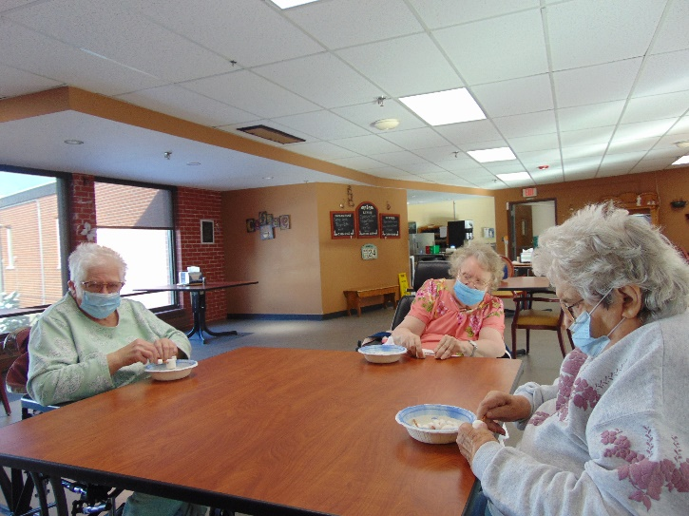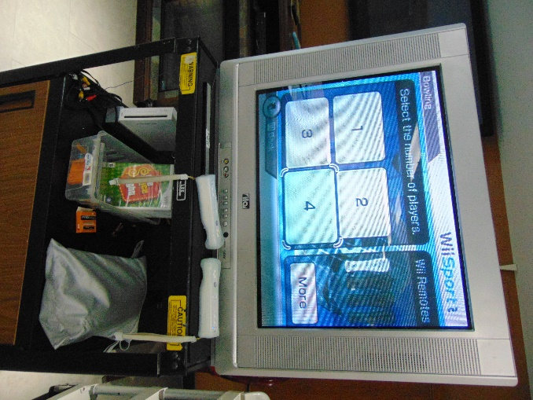

More Marshmallow fun

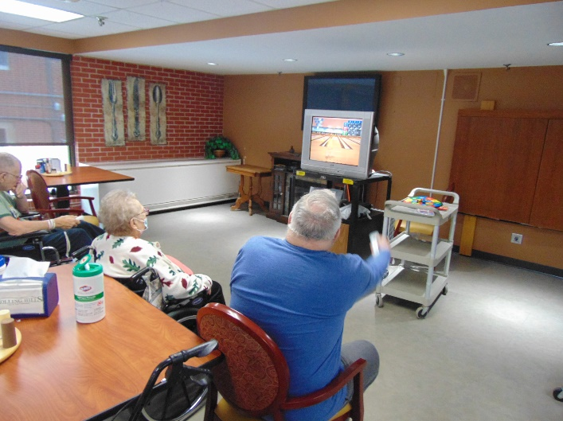

Had fun Wii Bowling

This week we had fun with Marshmallows and shared fun facts about them. We played with “snow” and made snowflakes too, but in the warmth of our home. Then we “traveled” to Costa Rica to stay warm on the day schools even closed! The residents had the chance to bowl using the Wii game. Lion’s Bingo is always a hit. We ended the week with Meadows ordering in Culvers. Continue to stay warm and have a great weekend!

-Linda