3rd week of January 2022 in Pictures
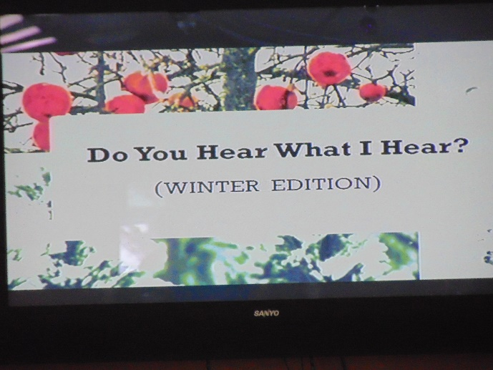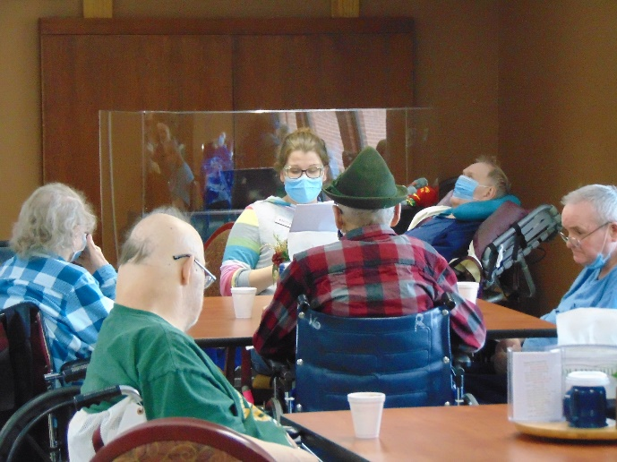
Fun Program with great pictures and sounds
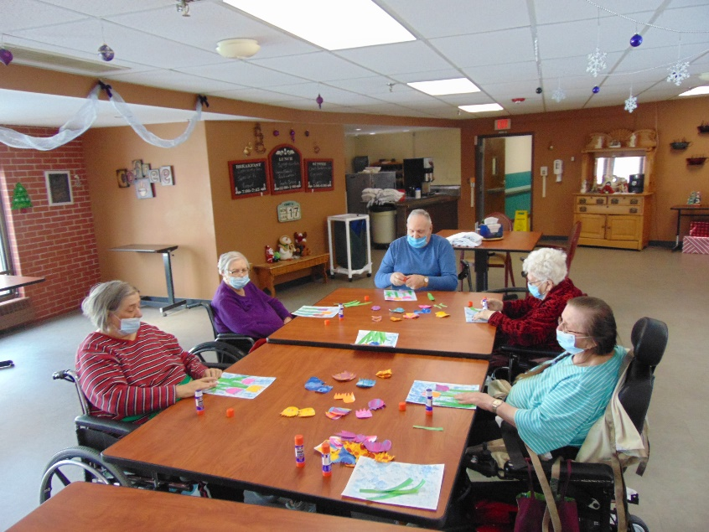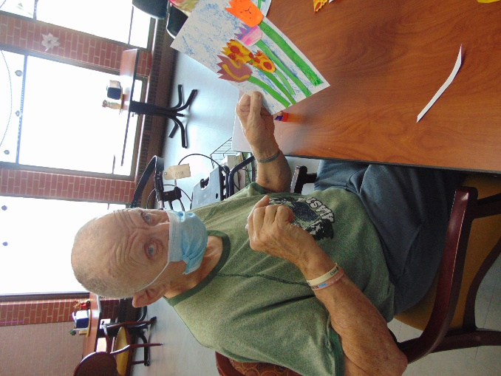
All About Tulips, Let’s forget how cold it is outside!
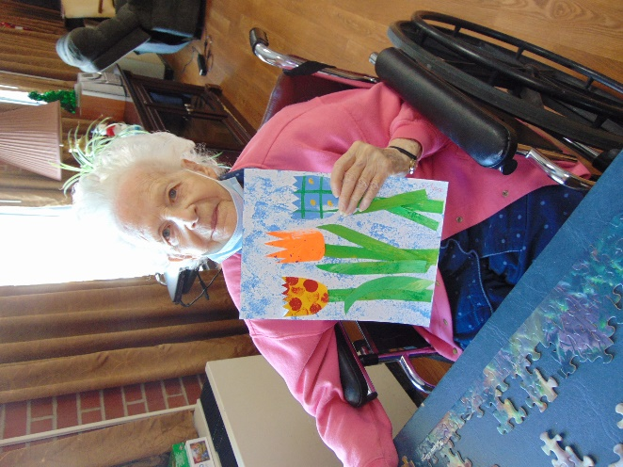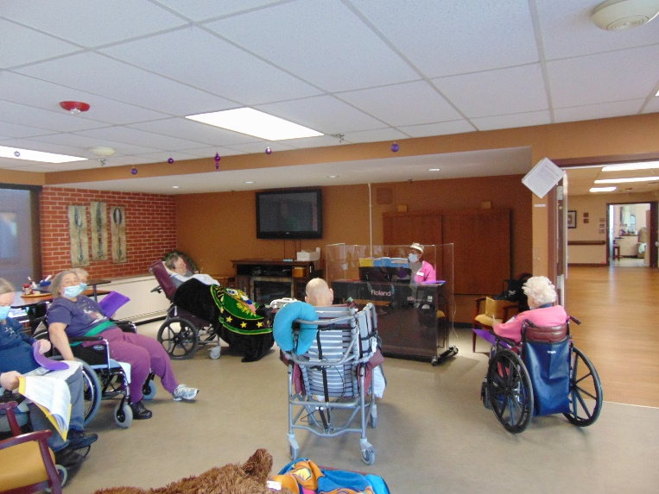
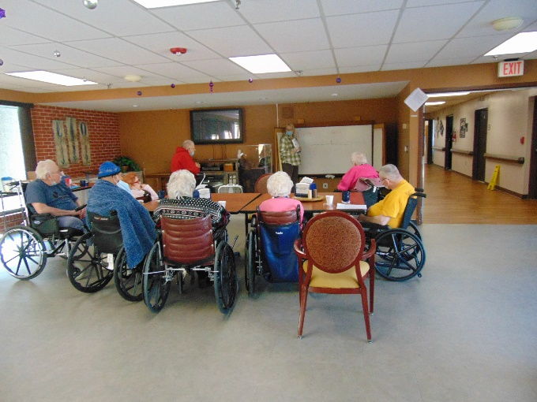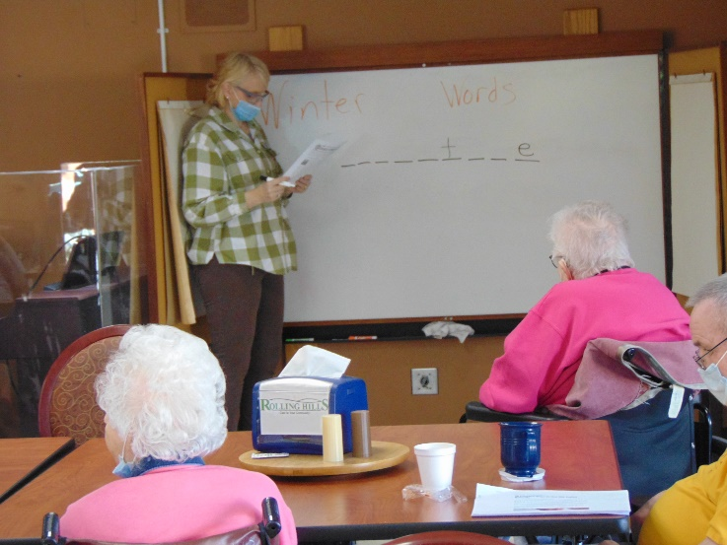
Winter Words Hangman
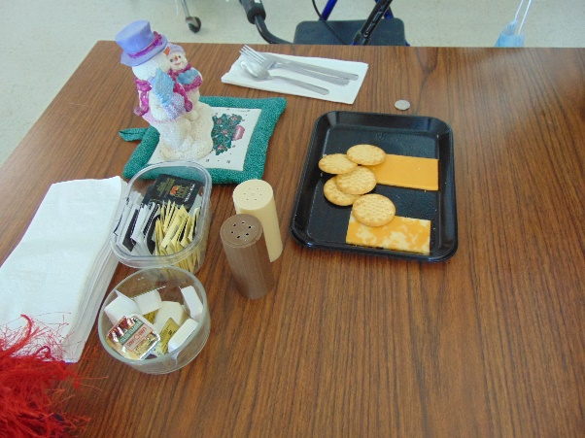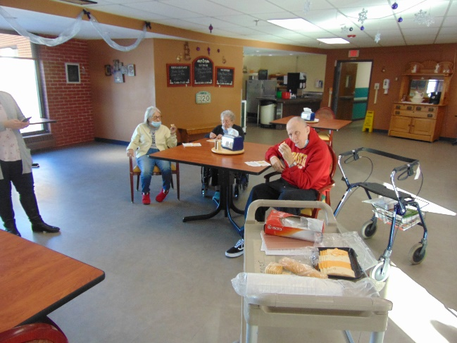
Cheese Tasting and Fun Cheese Facts
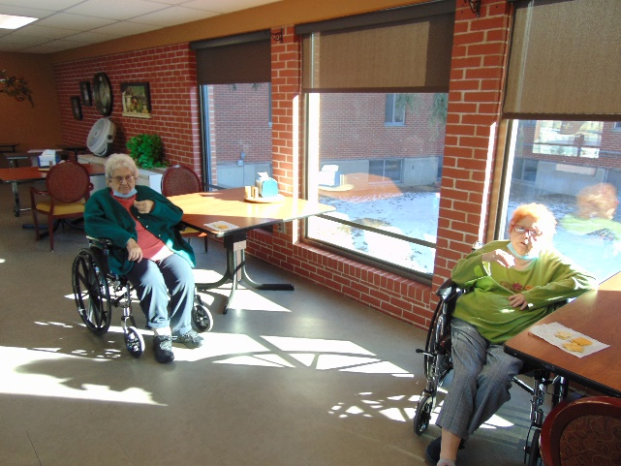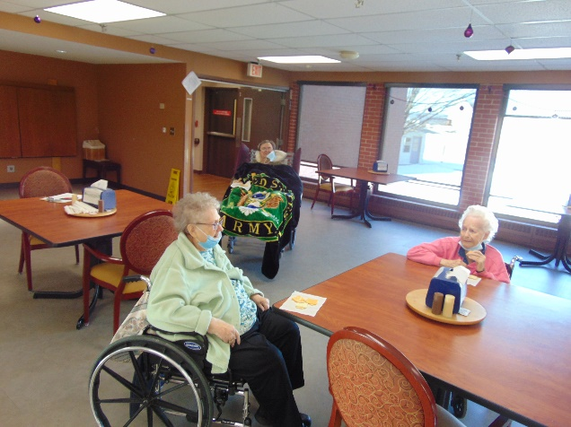

Happy Cold Friday everyone!
We have stayed warm indoors this past week. On Monday we enjoyed an educational talk about Tulips and made some of our own. Lisa played the piano on Wednesday for a sing-a-long. Some residents joined Elaine for cheese tasting and facts. A game of winter words hangman was enjoyed along with making snowflakes too. Have a good weekend.
-Linda

