December has arrived in pictures

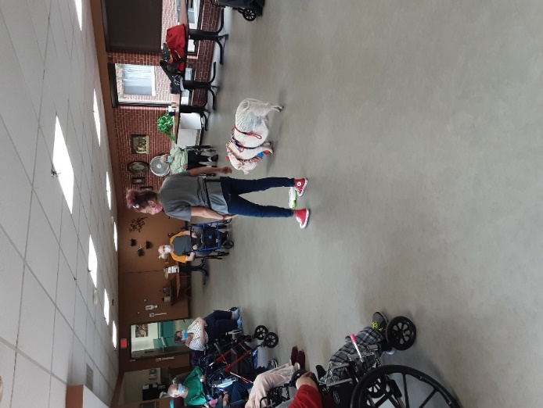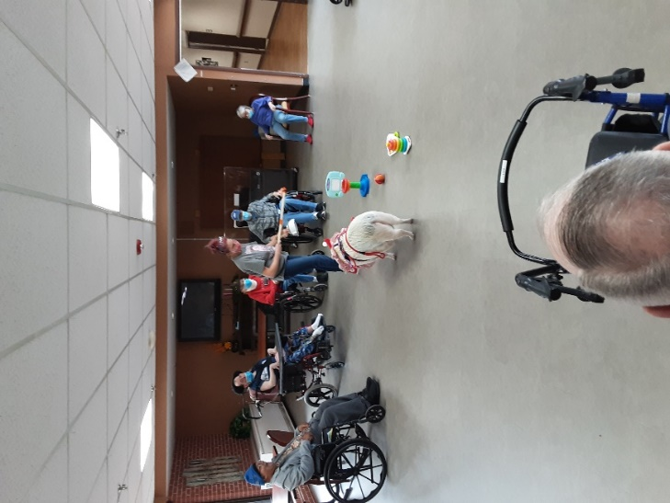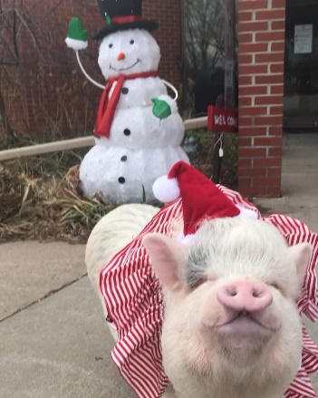

Brutus came to visit and share some of his tricks with us!

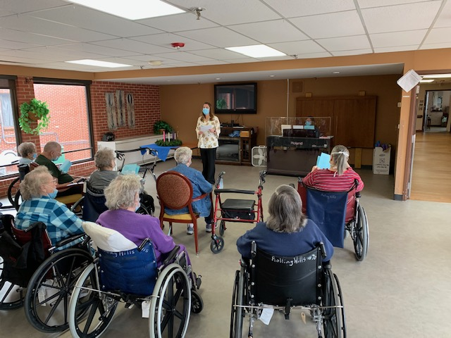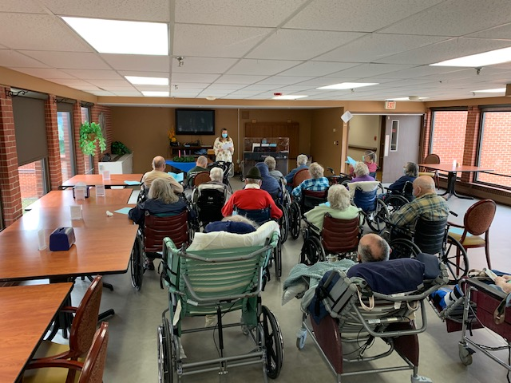

Linda and Lisa offered a nice Advent Service

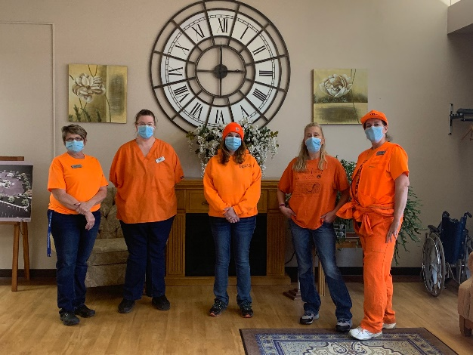 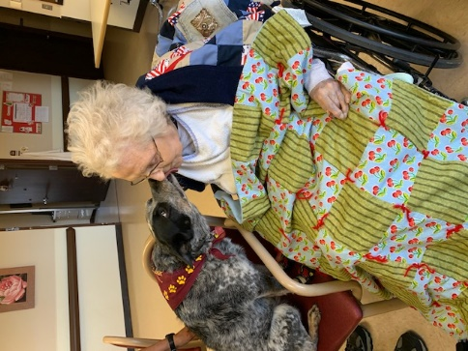

Blaze Orange Keota sharing her love

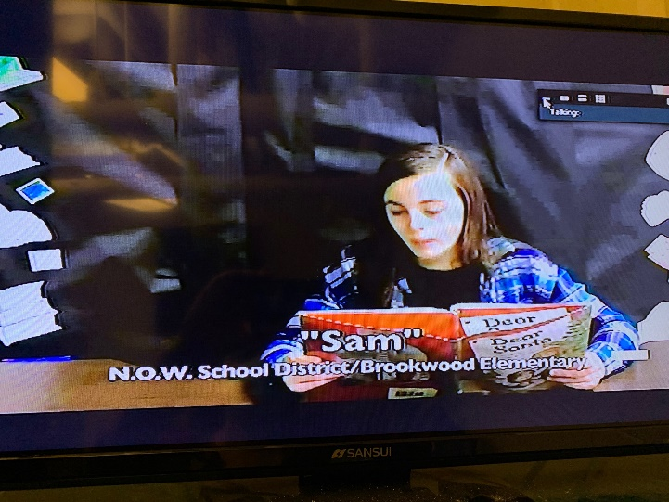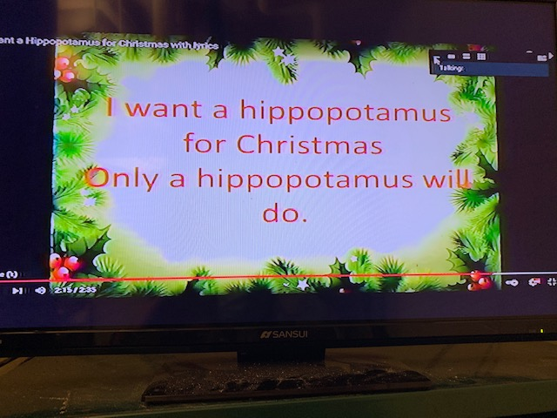

Channel 25 Christmas stories with Brookwood 6th graders and fun music to sing a long too

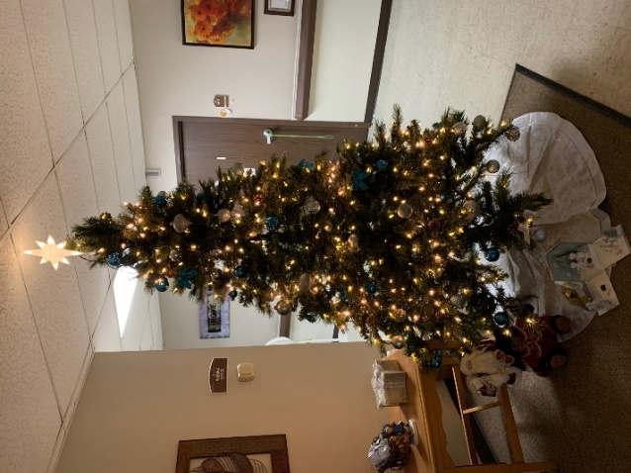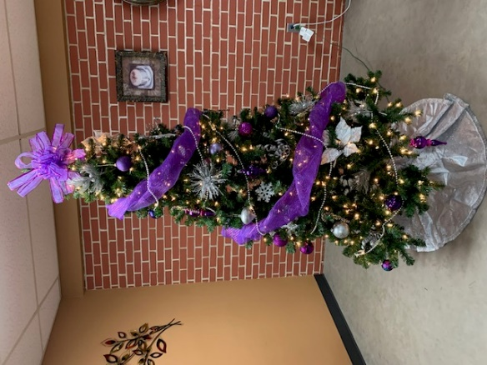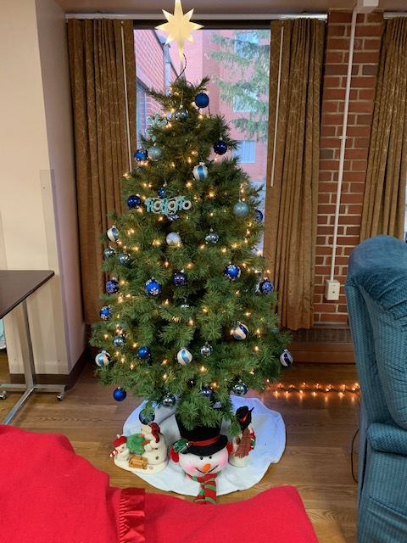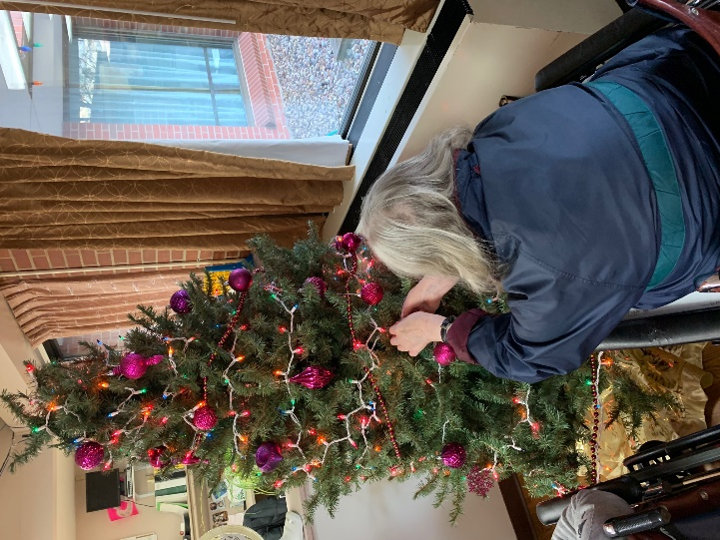

This week we began getting our home ready for the holidays. Christmas trees and decorations have found their spots amongst the hallways and living areas (so busy we forgot to take pictures of our helpers). We recognized the beginning of the Advent season in place of Bible study at the beginning of this week. Brutus is always a welcomed pet in our home and we love learning about him and other pigs from Jancee. Keota also came and spread smiles to those on Haven and Meadows. On our in house tv channel, residents got to listen to 6th grade students from Brookwood reading a Thanksgiving and Christmas story with more to come next week. We are happy to be listening to holiday music and spreading cheer this time of year!