Christmas is almost here!

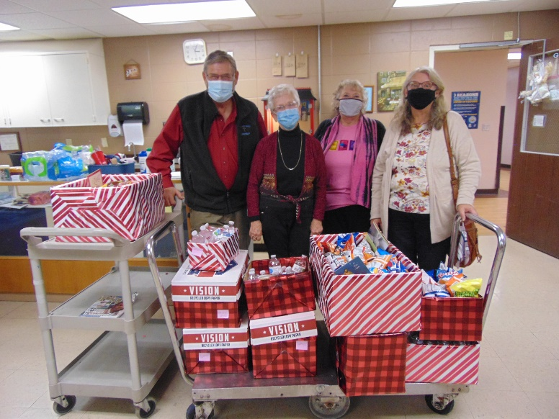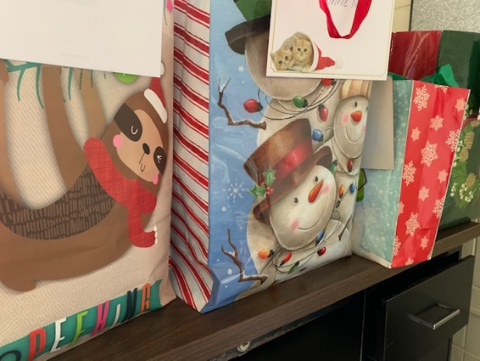

Hands & Feet ministry supplied our staff with some nice gifts following their church service

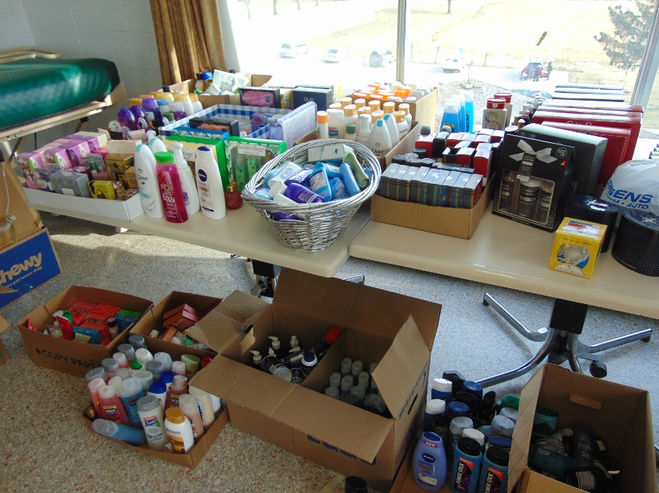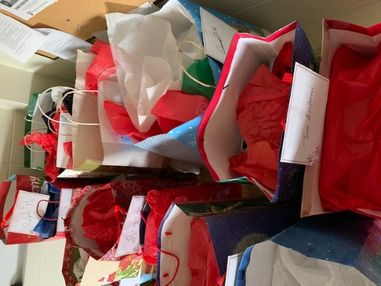

The elves have been busy selecting and wrapping gifts for all our residents thanks to our generous community

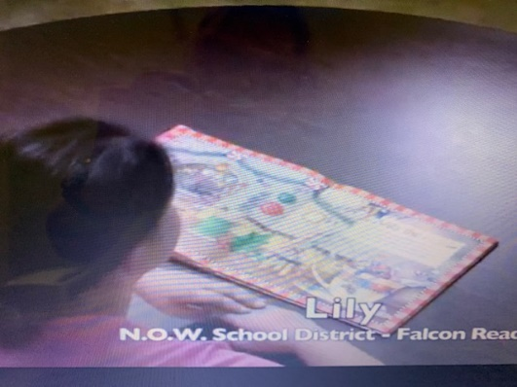 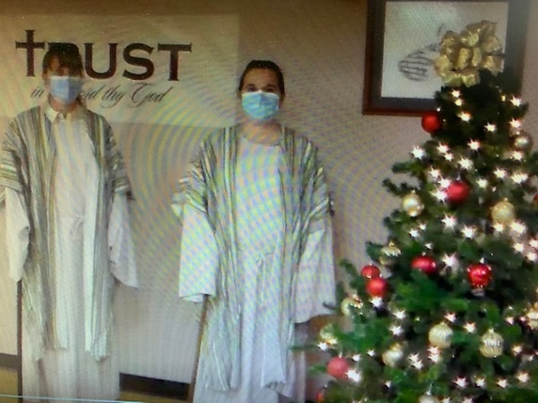

The residents watched a staff led Christmas pageant and heard Christmas stories read by Brookwood school kids and also a Christmas program put on by 4H children as well.

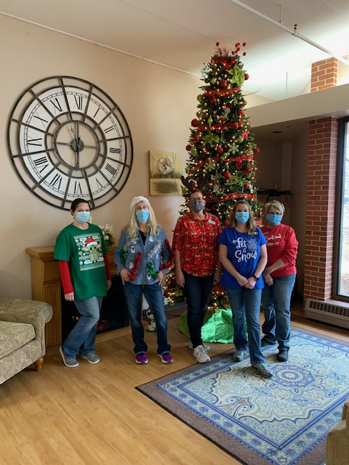Merry Christmas everyone!

This week is always a busy week. We are so grateful to Monroe county community members. The Knights of Columbus from Tomah puts out boxes to collect items to be used as gifts for our residents. Many other members of the community bring gifts, treats and cards to brighten the Holiday season too. A few of our retired activity staff came back to help wrap all the gifts, so that was a tremendous help. We have been using channel 25 this week to watch the staff Christmas program, the 4H Christmas program, Christmas movies and music too. Tomorrow Lisa will be playing some Christmas music on the piano and the kitchen has made some cookies for us to snack on while we learn some interesting facts about this holiday season.

Merry Christmas everyone!

Linda