3rd week of December in Pictures

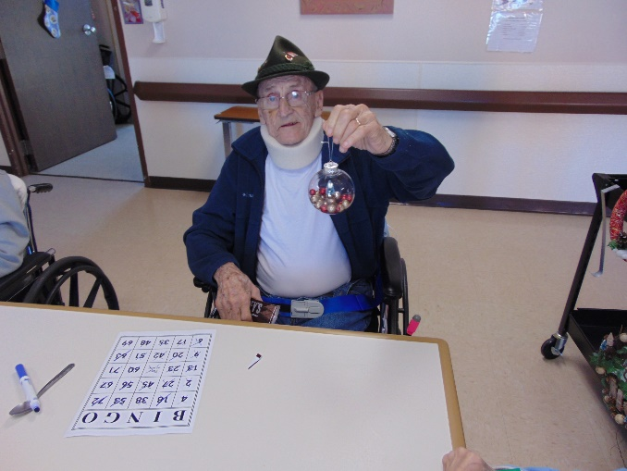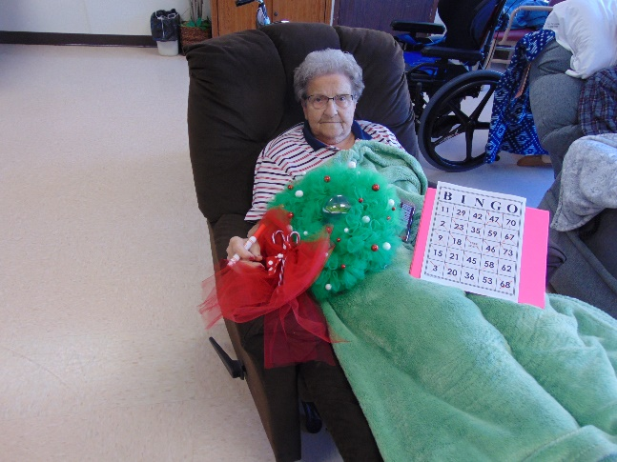

Christmas bingo was lots of fun. Thanks to Autumn and Sadie for the prizes this year!

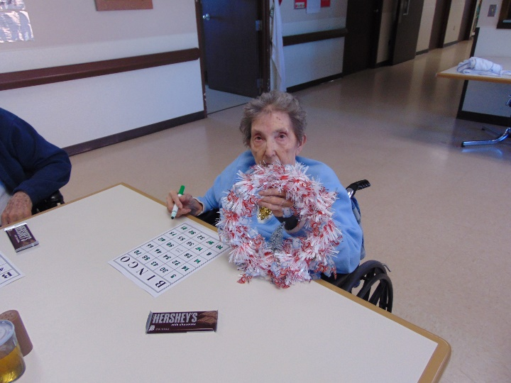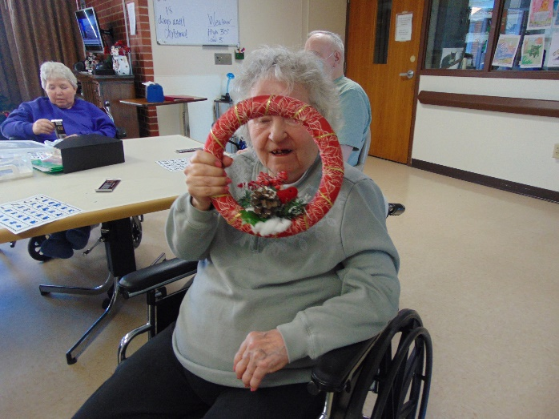 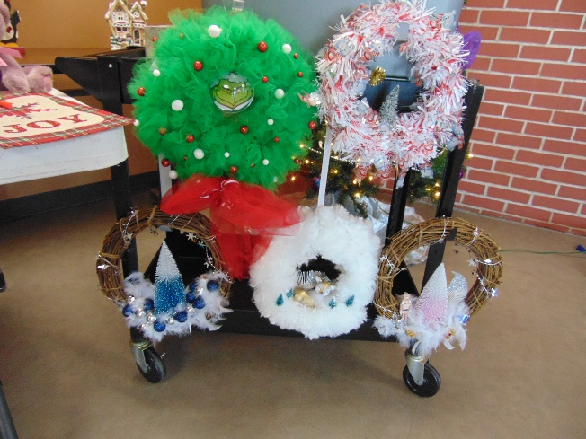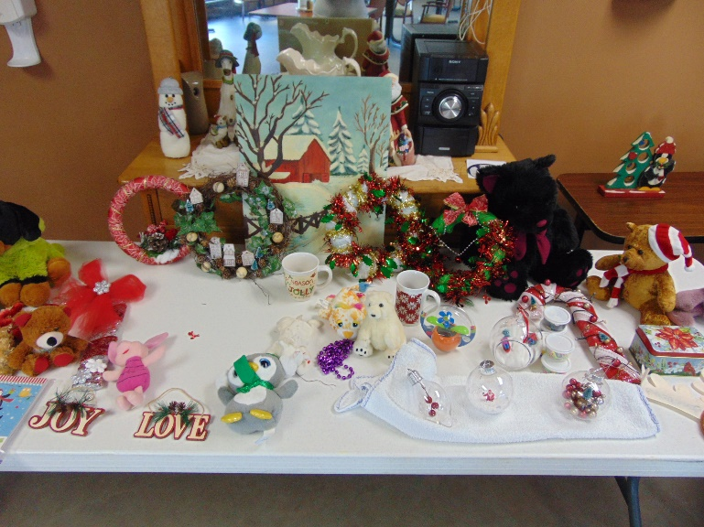

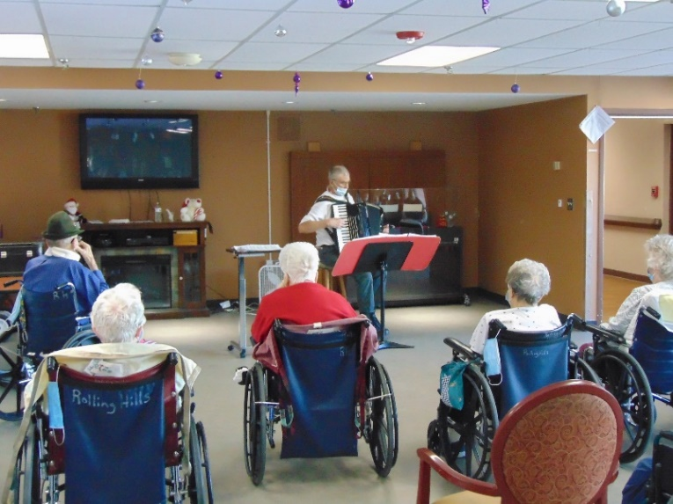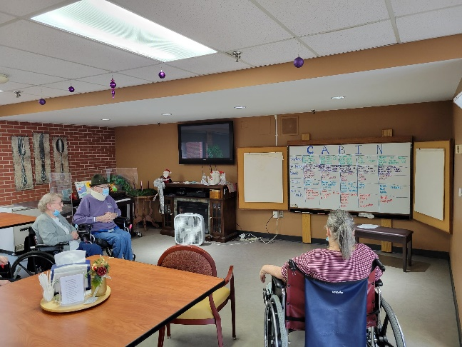

Christmas music on the accordion with Gary Word Games with Narissa

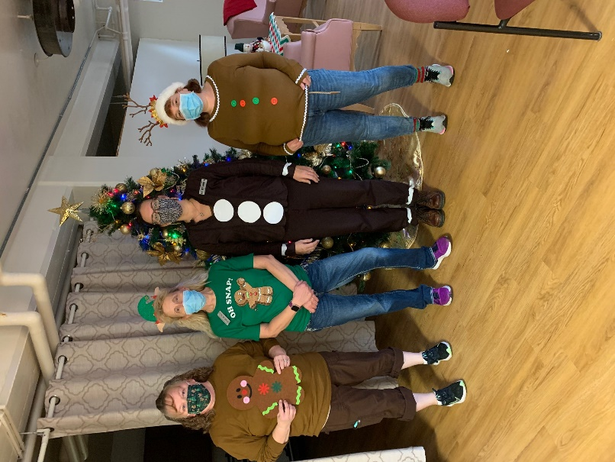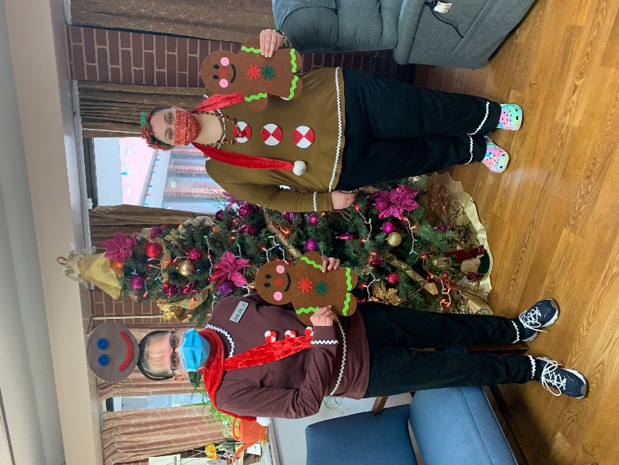

Gingerbread Dress up day theme

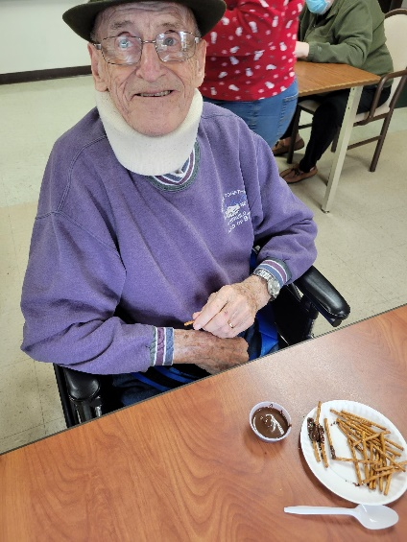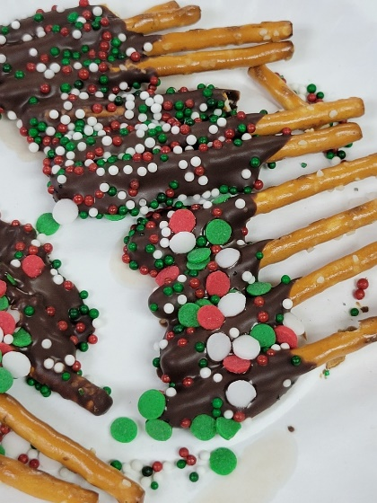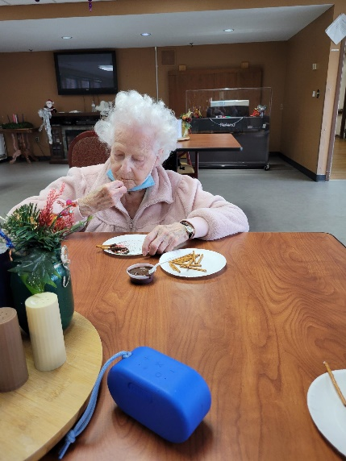

Making Treats

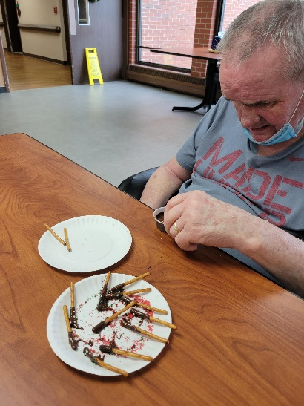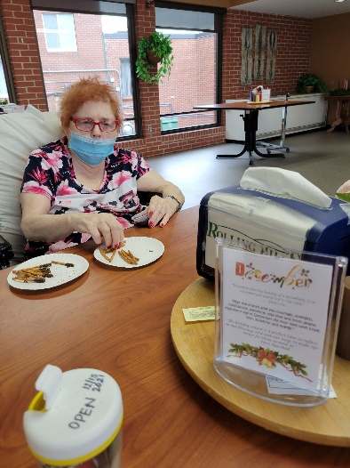

Can’t wait to hear if our tree wins an award for the county tree decorating contest!!

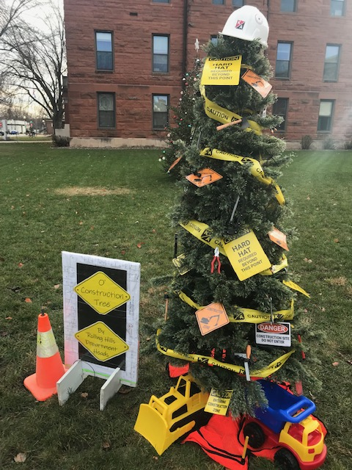 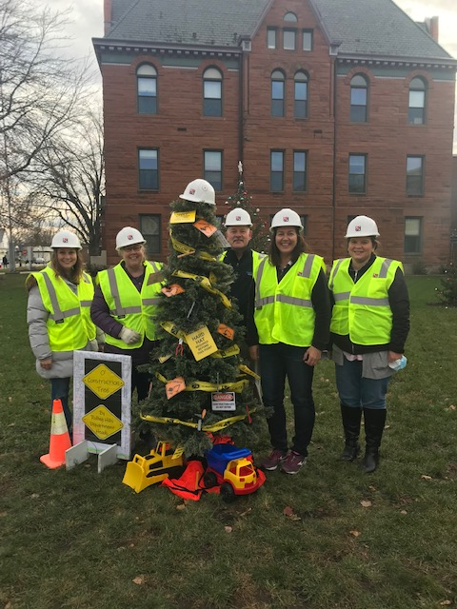

This busy week before Christmas we continued having fun. Gary came and played Christmas songs on his accordion that many sang along too. Elaine had a great turn out for her Christmas bingo. The residents won Christmas prizes, some were home made by Autumn and Sadie, when they called out bingo. We satisfied a sweet tooth making chocolate dipped pretzels for ourselves too. We also enjoyed another visit from Keota. Enjoy the Holiday Season!

Linda