2nd week of December Fun in Pictures

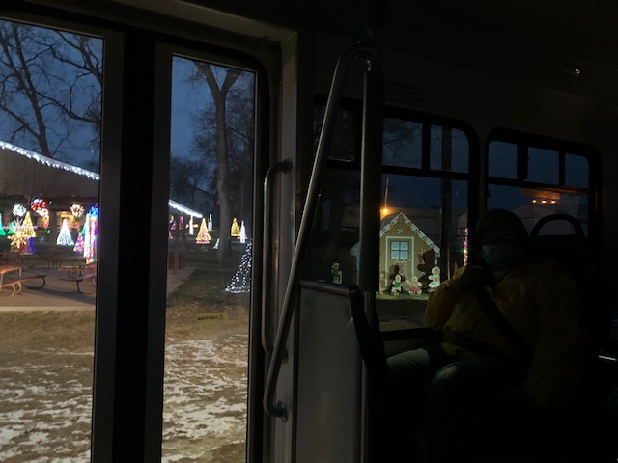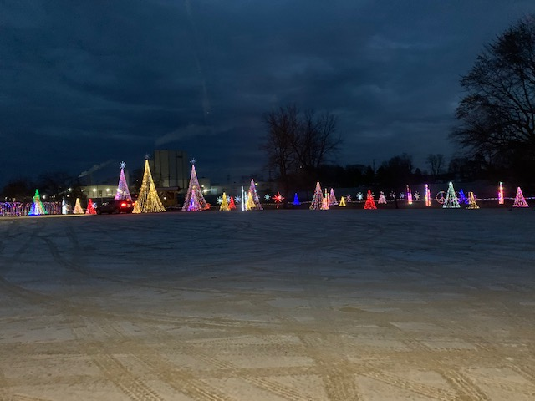

The Holiday Lights in Sparta were beautiful for the 4 vans that ventured there this week

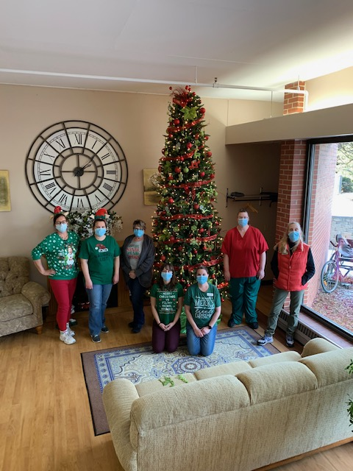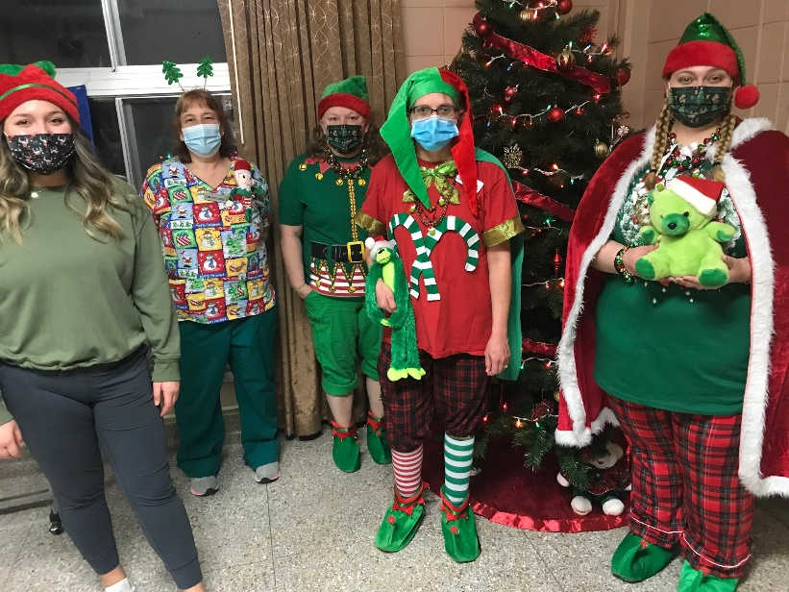

Red and Green theme for Wednesday dress up day!

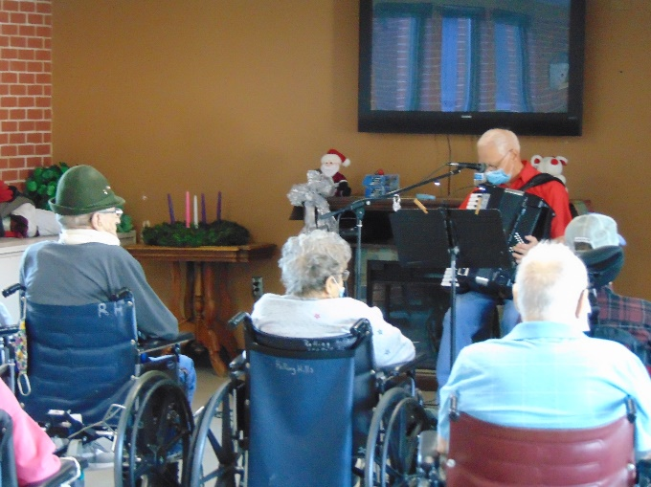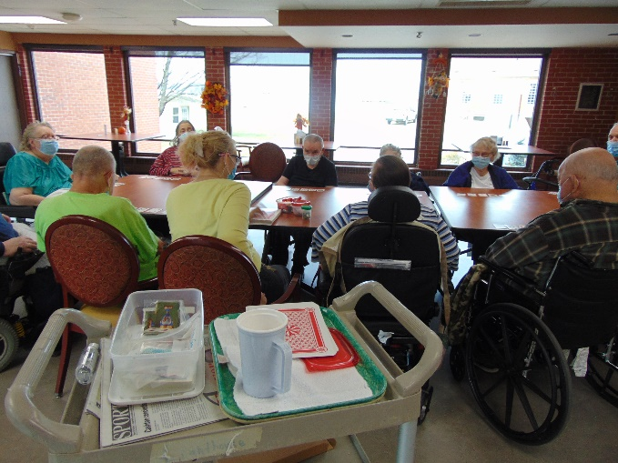

Music /w Myron Games on a Saturday

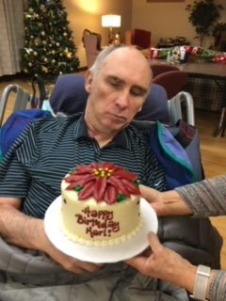

Cupcakes for all celebrating Karl’s Birthday!

This week we had fun enjoying the holiday season! We took 4 van trips over to downtown Sparta to see their wonderful light display. We sang Christmas carols with Lisa and wrote out Christmas cards. Some of us had one last trip to the quarter store at Rolling Hills to buy a treat for ourselves or a decoration for our room. We all had the opportunity to enjoy accordion music and song facts from Laurel too. Now we are thinking about making snowman with the weather prediction!!!

Have a great week!

Linda