Last full week of November in Pictures
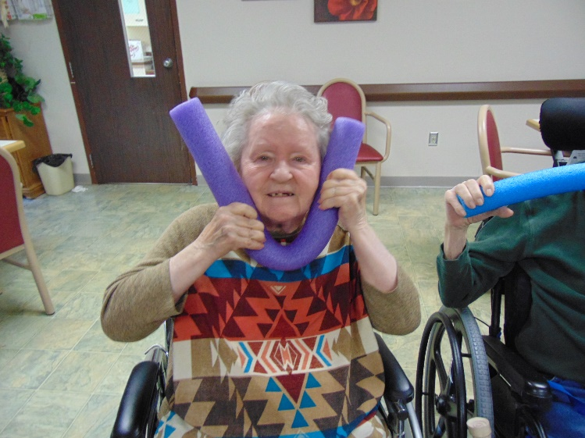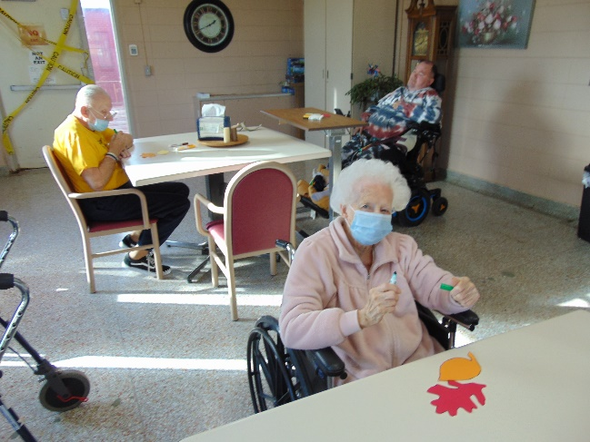
Noodle exercise fun! Thankful for…
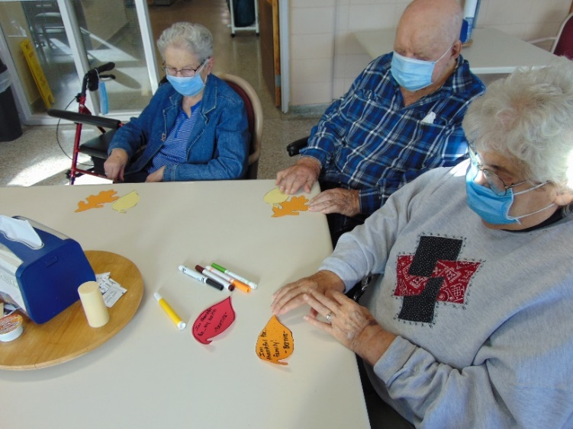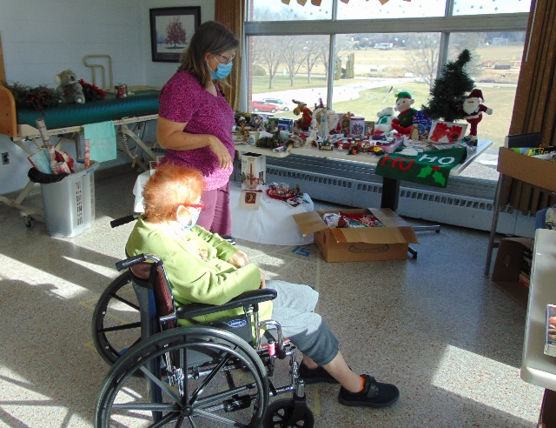
Quarter Shopping
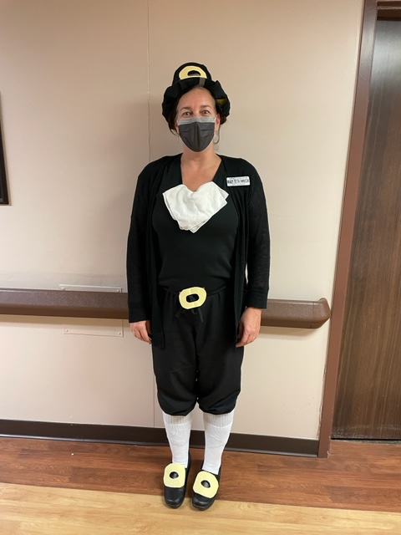

Dress up day: Pilgrim
This week was spent working on a Fall Craft and talking about what we are thankful for. Some of these things were written down and displayed on the walls around our home. We always have fun with weird news and a fun twist on exercise too. We surprised the residents by setting up a quarter shopping store. Some of them talked about how they loved that part of the bazaar and missed it. We thought it would be a great way to spend their bingo money and have a little fun “shopping” too.
We here at Rolling Hills wish everyone a healthy and safe Thanksgiving!

