2nd Week of November in Pictures

Thank you Rolling Hills Veterans. We were so blessed to have the VFW of Sparta and the DAV of Tomah donate blankets and chocolate to present to our Veteran’s during our program.

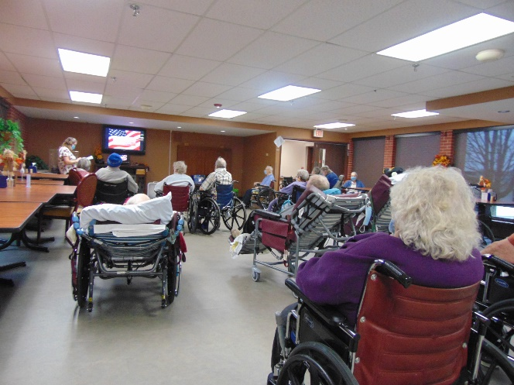 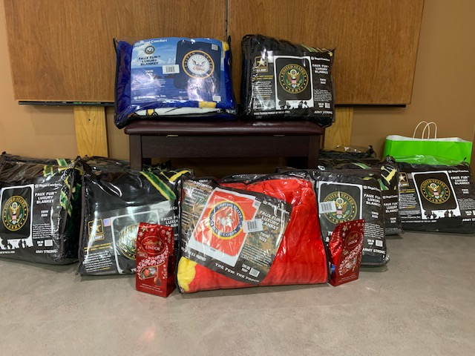

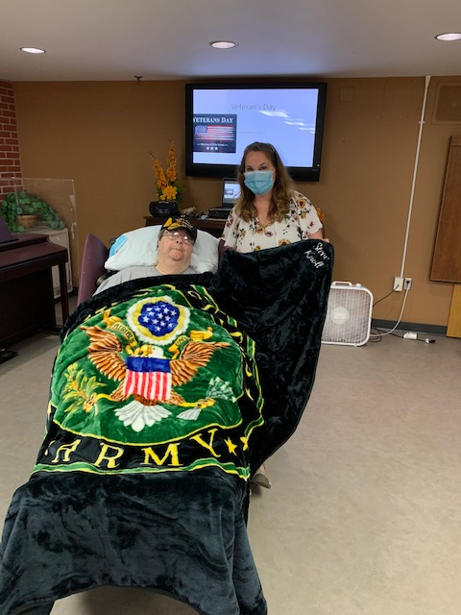 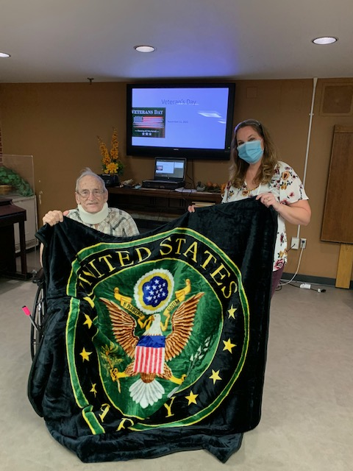 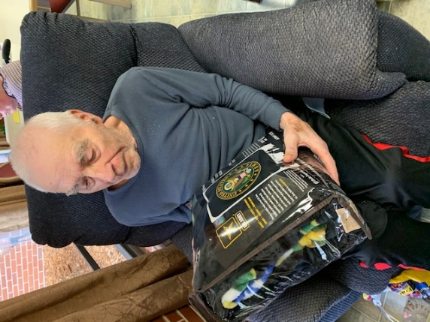

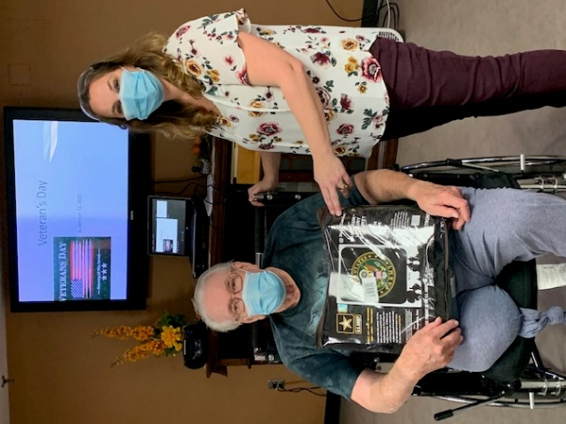 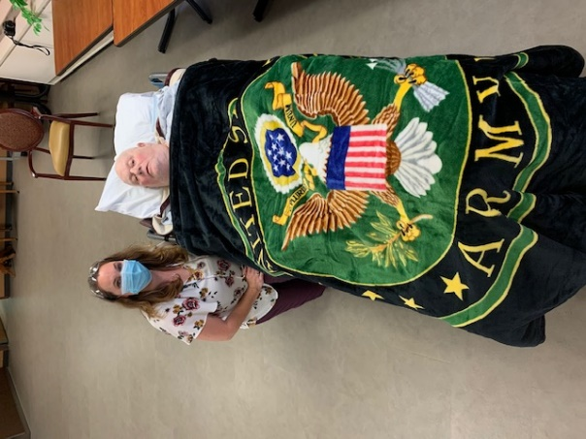 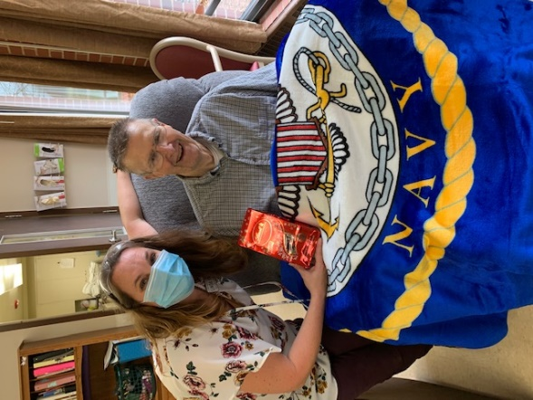

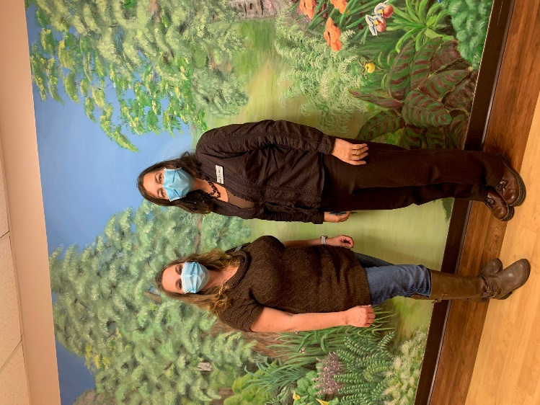 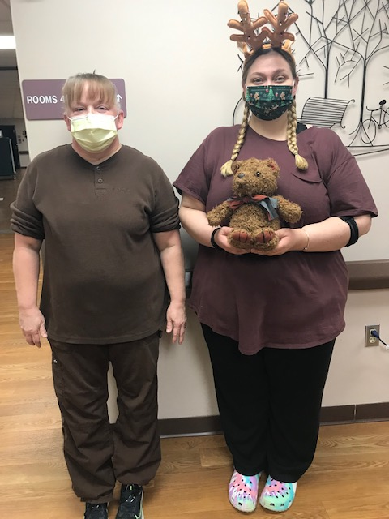

Brown Day

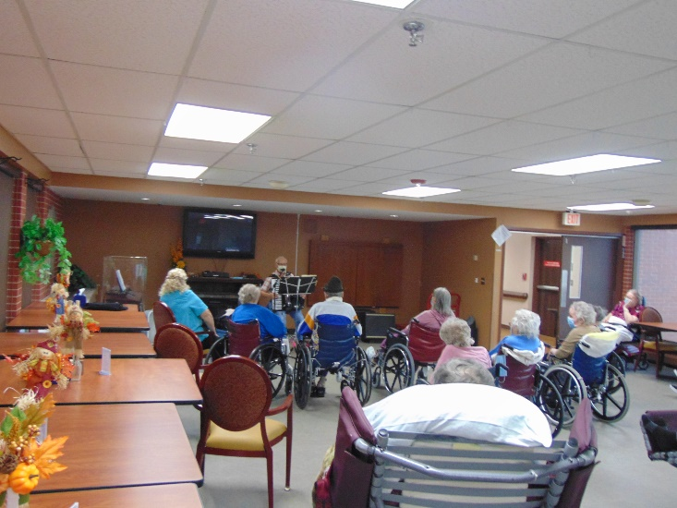 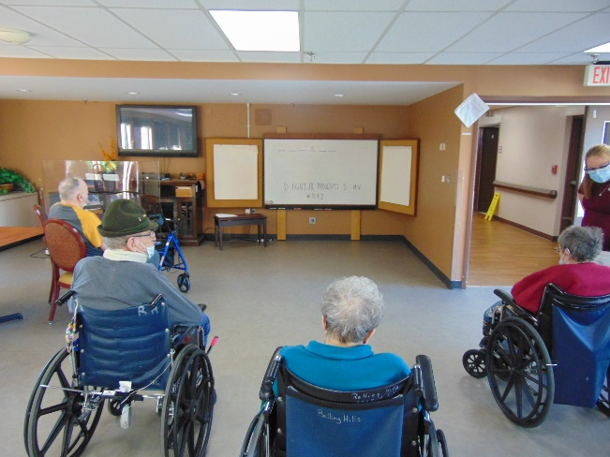

Music /w Laurel Hangman

This week we took time to thank our Veteran’s on Veteran’s Day. The VFW of Sparta and friends as well as the Tomah DAV brought in gifts for us to present to our Veteran’s at the program we offered. Also this week we enjoyed a game of Thanksgiving Hangman, music with Laurel and Dianne as well as attending Mass and going for a scenic drive. Maybe we will all get to enjoy some snowflakes this weekend. Take care, Linda

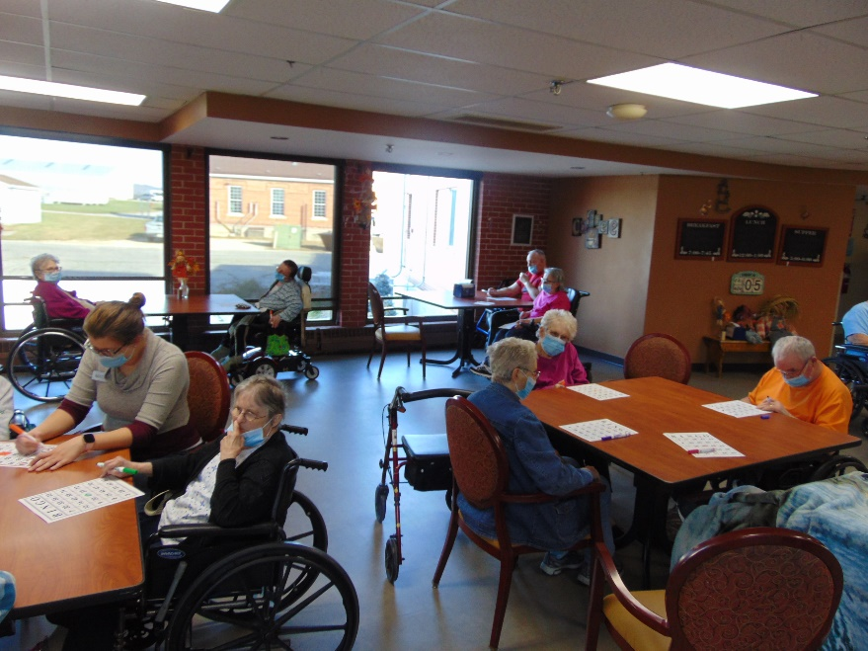

Bingo!