Welcoming in October in pictures

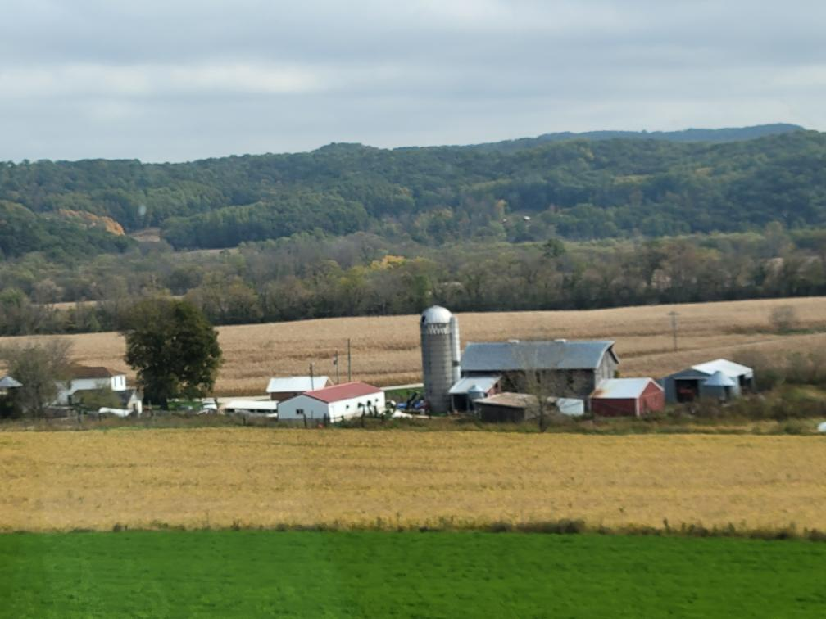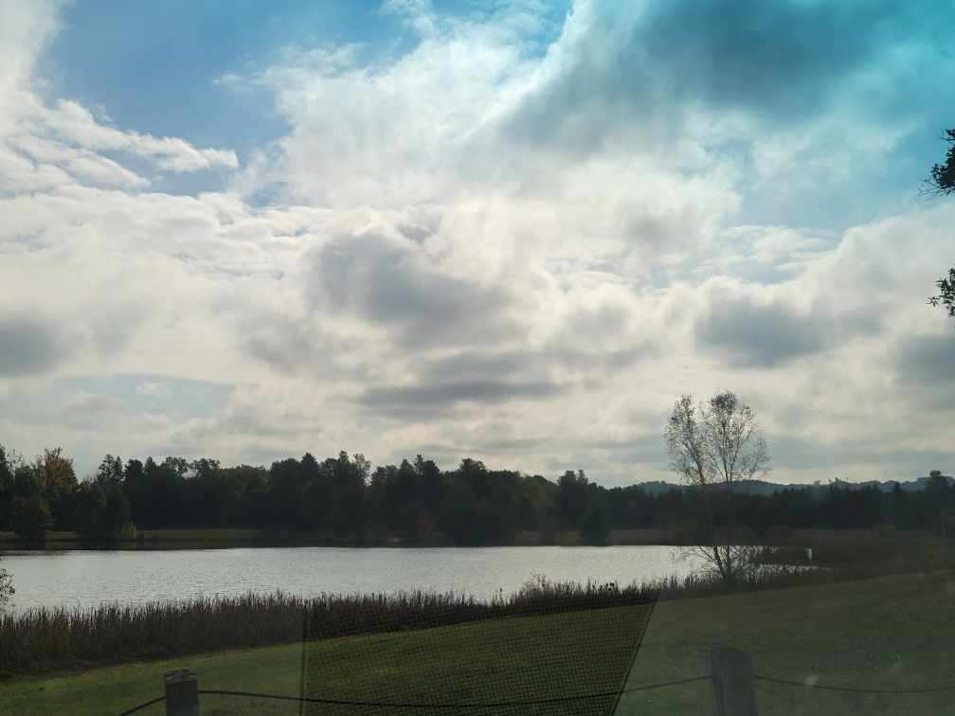

We took some scenic drives

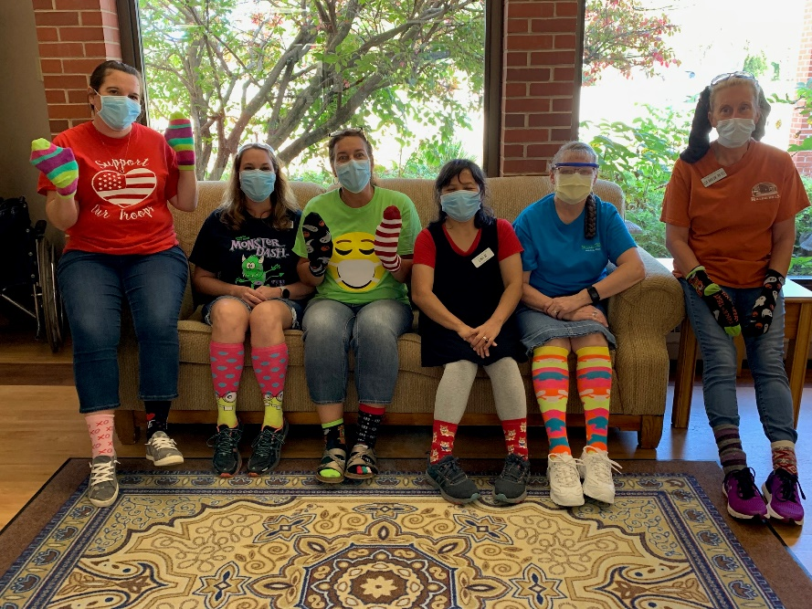

Staff made us laugh with their crazy socks!

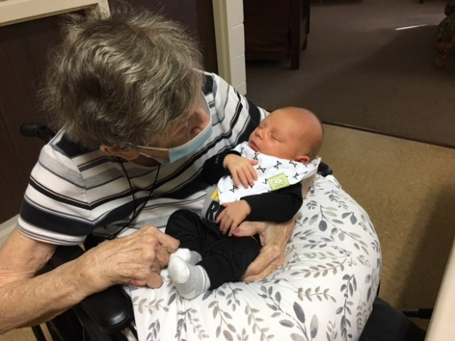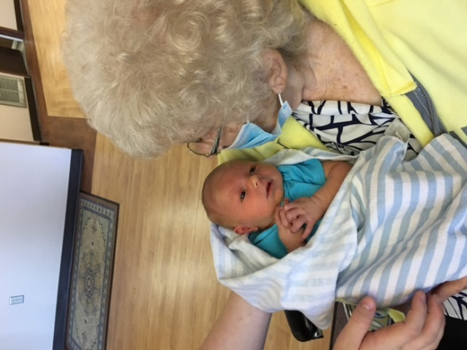

Meeting Great Grandchildren

Having fun with Keota this week

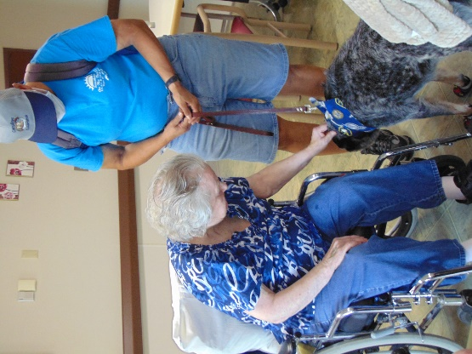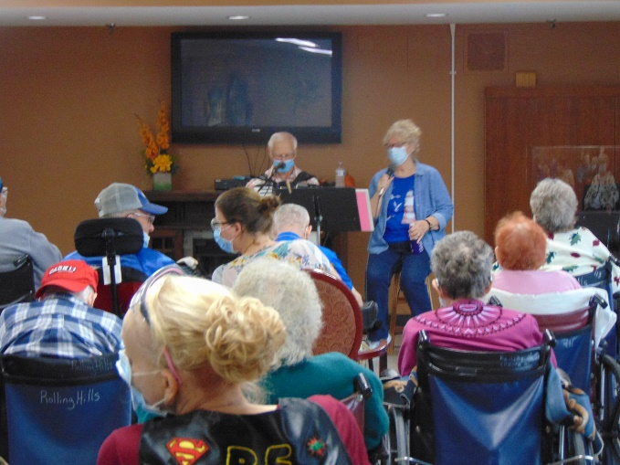

Fun time listening to music

This week we began by playing hangman, learning some interesting news stories, going for scenic drives, interacting with Keota and listening to some live music. We continue to take advantage of the nicer days outdoors and help the residents out with any special requests.

I am sharing some information with you regarding flowers for Spring and Summer of next year that was given to me to share in case you are interested.

Have a great weekend!

Linda

Need a unique gift idea for your loved one?

We offer fresh flower bouquet subscriptions,

delivered weekly (or biweekly) throughout the 2022 growing season.

We grow all of our flowers right in our backyard in Norwalk, WI, and love sharing blooms with our community.

**For 2022, we are waiving the delivery fee for any resident of Rolling Hills Rehabilitation Center in**

**Sparta, WI.  That means that if you order a flower subscription for your loved one who resides at Rolling Hills, it includes FREE delivery!**

We have subscriptions available in spring (May 2022) and summer (July-August 2022), in two sizes.

**Standard** bouquets (8-12 stems) fit into a narrow mouth jar or small vase.  **Premium** bouquets (18-25 stems) fit into a wide mouth jar or large vase.

|  |  |  |
| --- | --- | --- |
| **SPRING SUBSCRIPTION (May 2022)** | Spring Standard | Spring Premium |
| **4 bouquets (1 per week, for 4 weeks)** | **$43.20 + tax** | **$72 + tax** |

|  |  |  |
| --- | --- | --- |
| **SUMMER SUBSCRIPTIONS (July-August 2022)** | Summer Standard | Summer Premium |
| **8 bouquets (1 per week, for 8 weeks)** | **$86.40 + tax** | **$144 + tax** |
| **4 bouquets (1 every other week, over the course of 8 weeks)** | **$43.20 + tax** | **$72 + tax** |

**How do I sign up?**

You can email us at [schellfarmgardens@gmail.com](mailto:schellfarmgardens@gmail.com) or call us at 608-823-7210.  If you want to see pictures of our flowers and learn more, head to our website [www.schellfarmgardens.com](http://www.schellfarmgardens.com).  There, you will find subscription options in our online shop.  Note that if you purchase a subscription through our website, the full amount is charged at the time of purchase.  If you would rather pay half now and half later, you must sign up via phone or email.  Thank you!

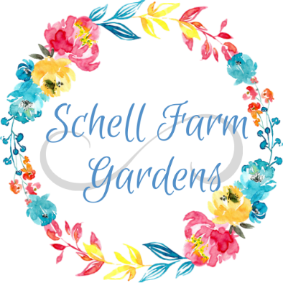

         Phone:  608-823-7210

Email:  [schellfarmgardens@gmail.com](mailto:schellfarmgardens@gmail.com)

                  Website:  [www.schellfarmgardens.com](http://www.schellfarmgardens.com)