Last week of September in pictures

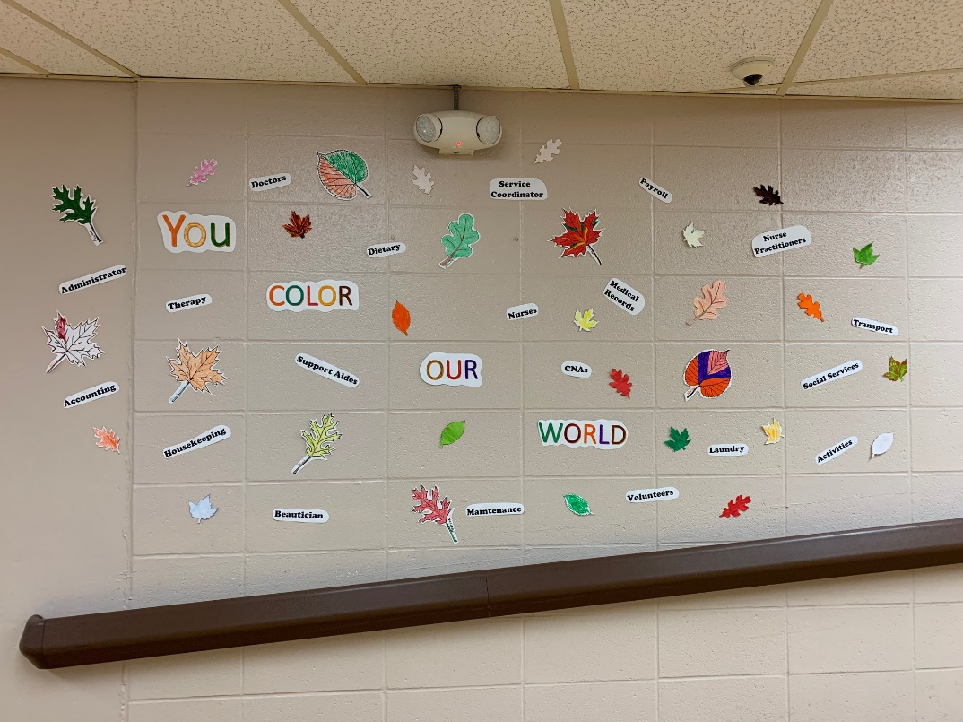 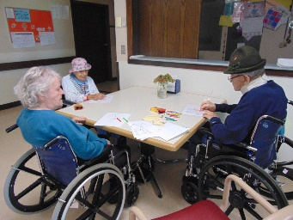

We had fun coloring these leaves for the start of Fall and for the staff

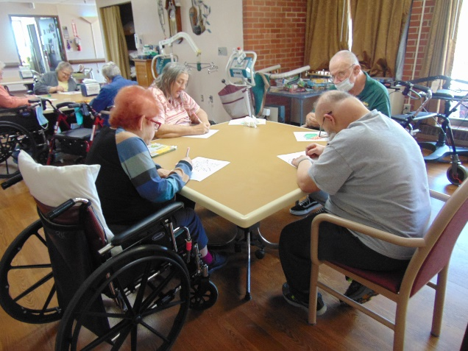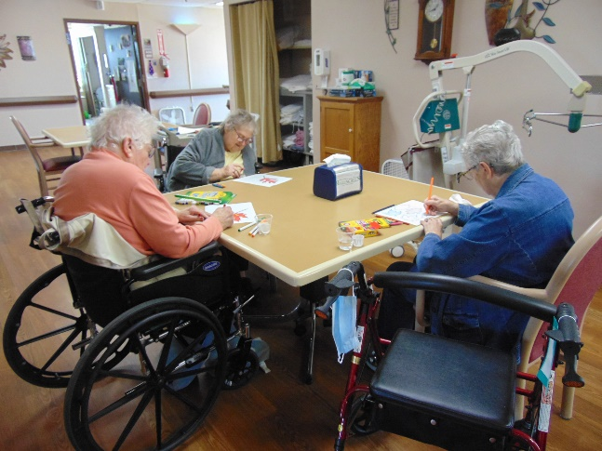

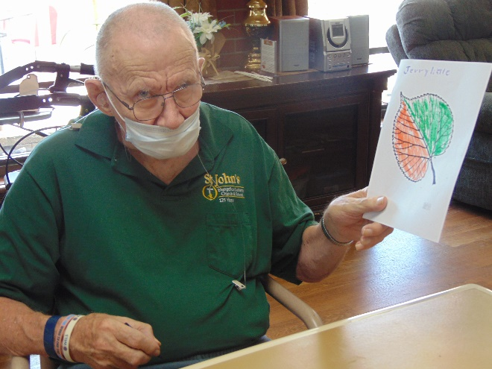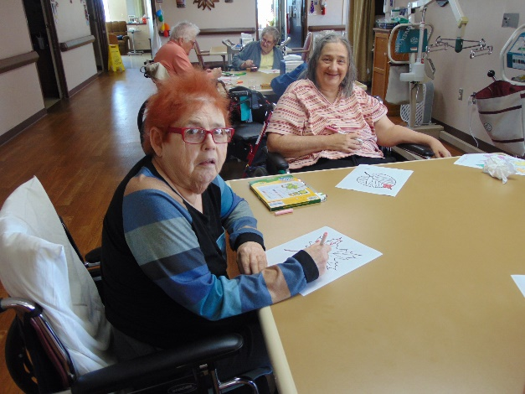

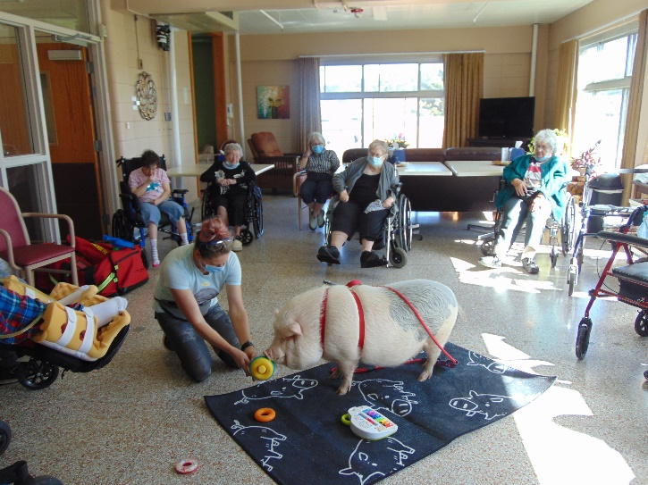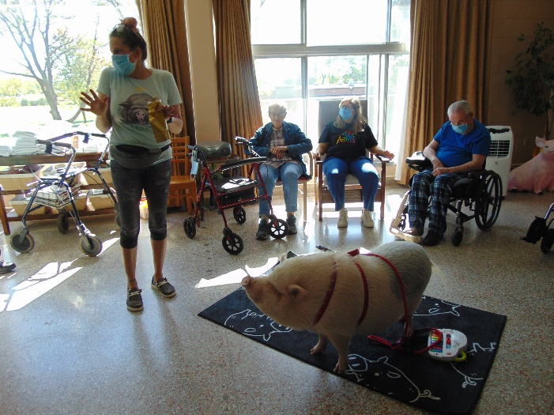

Brutus came for a visit

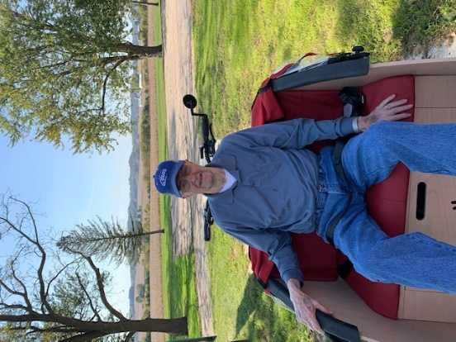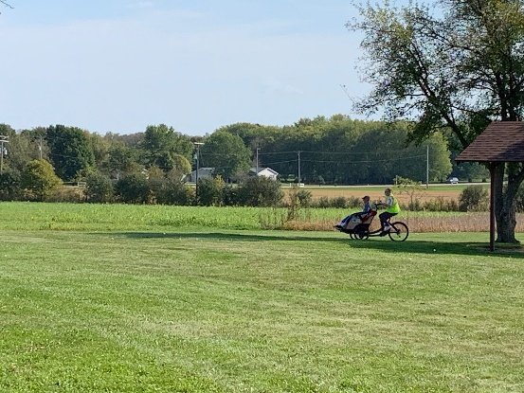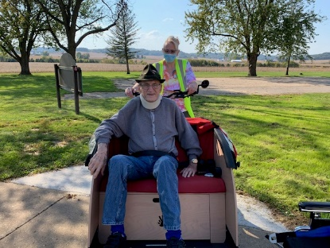

Bike Rides on a nice day!

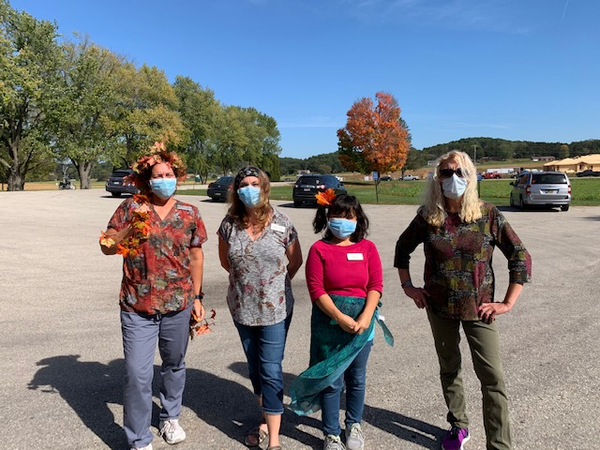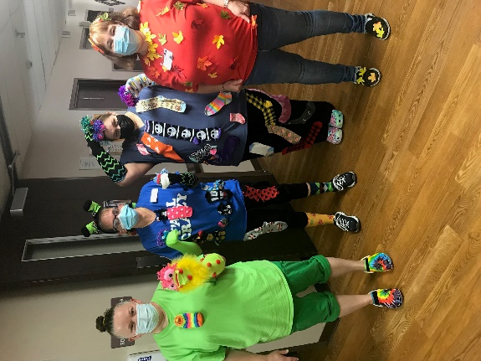

Celebrating with Leaves

This week we included our picture of how our staff “Color Our World”. We had a good time learning about Brutus the mini Pig and seeing all the tricks that Jancee can teach him. We worked off some calories by laughing during our attempt at exercise and heard some interesting news around the world. Then we played some bingo, went for a scenic drive and bike rides and heard some good short stories this week.

Enjoy your weekend!

Linda