2nd week of October in Pictures

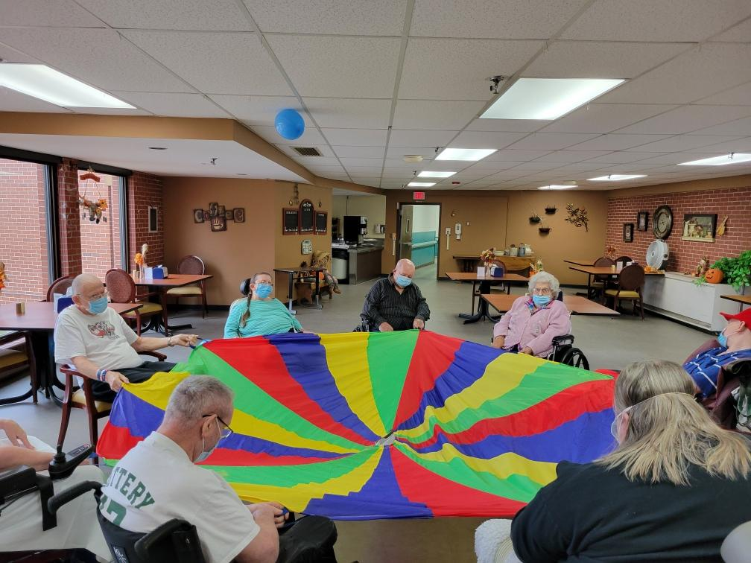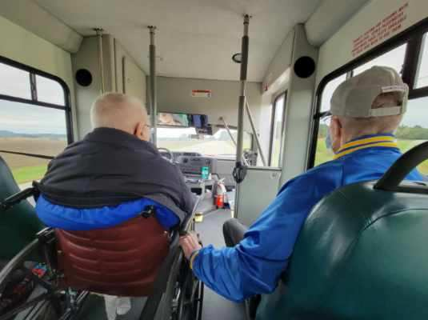

Parachute exercise games Rain held off so we could travel around

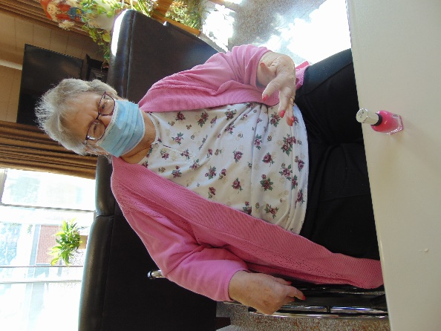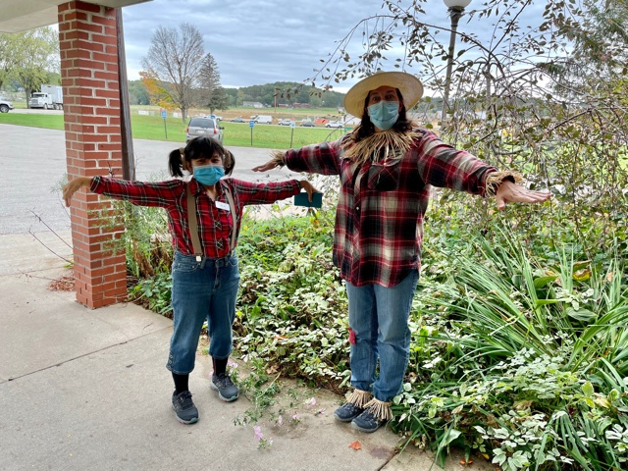

Manicure Morning Staff or Scarecrow????

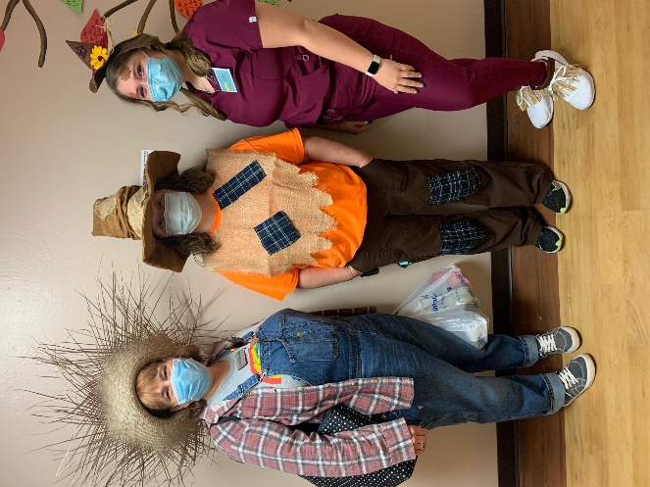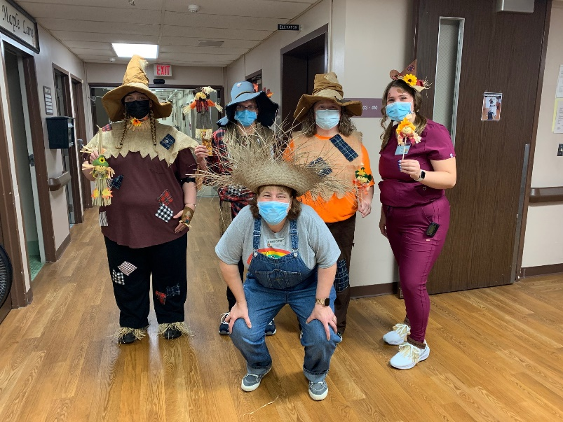

This week we had fun playing some word games to occupy an afternoon. We used the parachute to keep ourselves moving and grooving. We yelled out Bingo so we could win some chocolate or money and even went on some scenic drives again. A group ordered in Culvers and we are ending our week playing a variety of games like Uno, Left-Right-Center and more.

Enjoy your weekend!

Linda