2nd full week of September in pictures

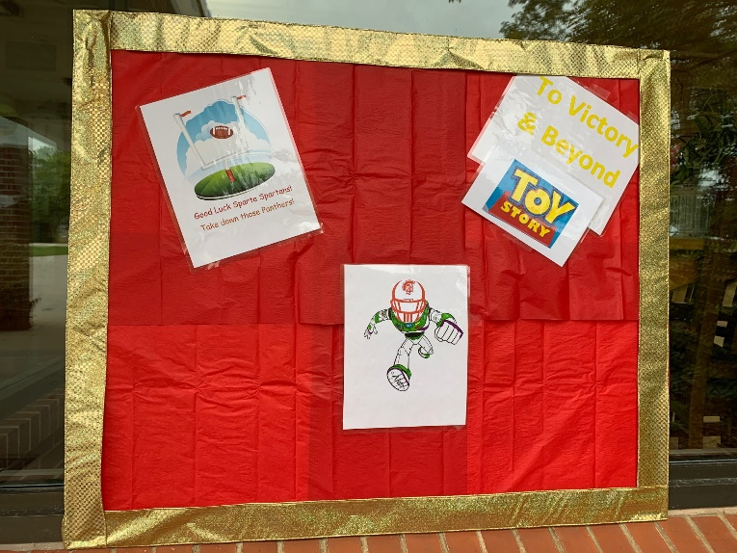

Window Decorating Contest for Sparta’s Homecoming

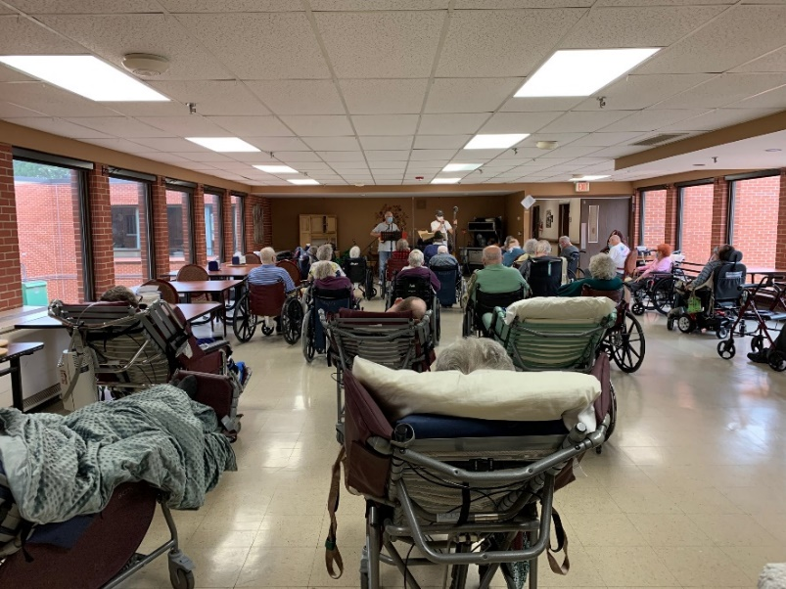 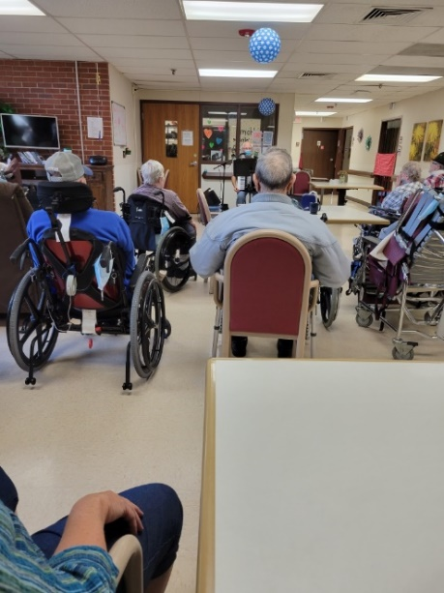

Never can get enough of music

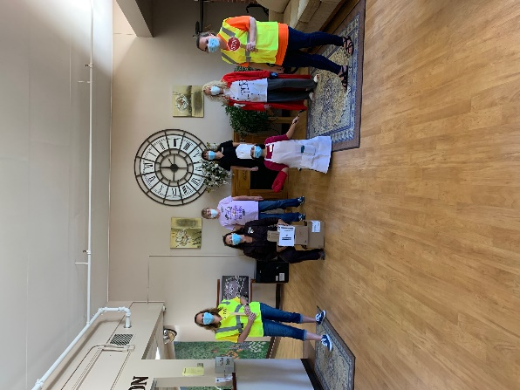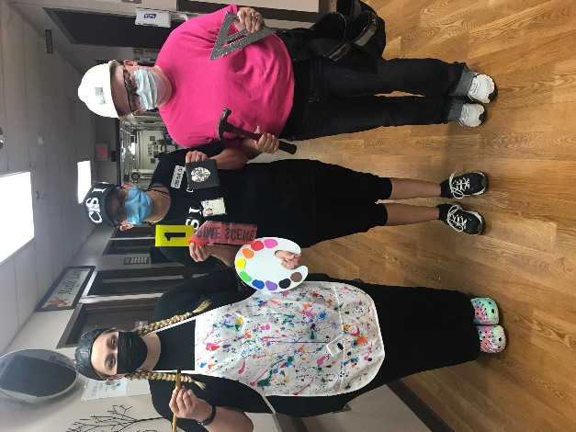

Alternative Occupation day

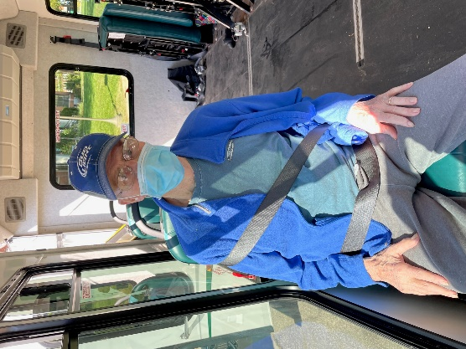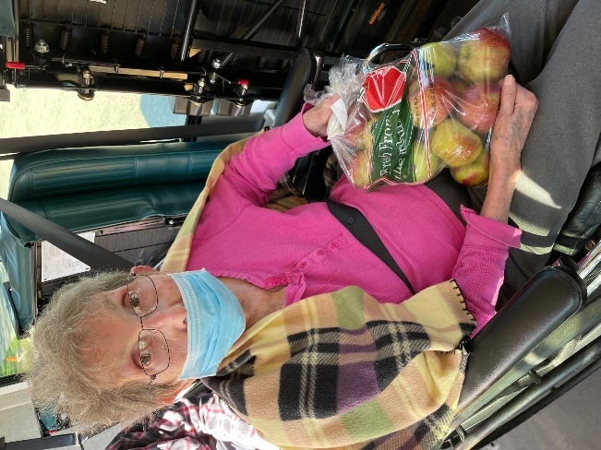

Just some pics from our trip to Rex Moseley Fruit & Vegetable Farm to get some apples and pumpkins

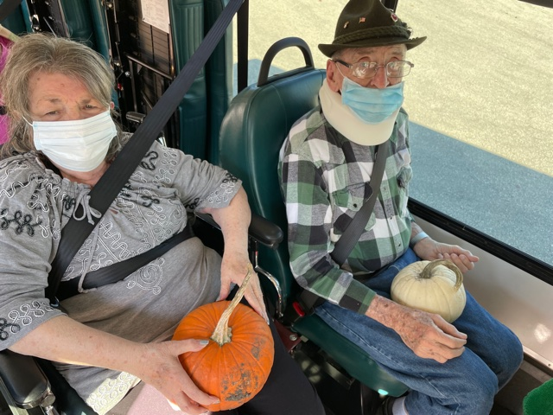

This week we enjoyed music from Old Moldy Hay, Laurel Brandt and our own Lisa. A few of us went on a scenic drive to pick up apples that we are then making into applesauce today. Some of us also are enjoying Culvers for lunch today as well. News & Exercise, Hangman, the café cart and playing games were all part of this past week too.

Don’t forget to get those scarecrows ready to put up on Tuesday. Help the residents have something to enjoy the Fall days as they sit outdoors ☺

Have a great weekend.

Linda