1st full week of September in Pictures

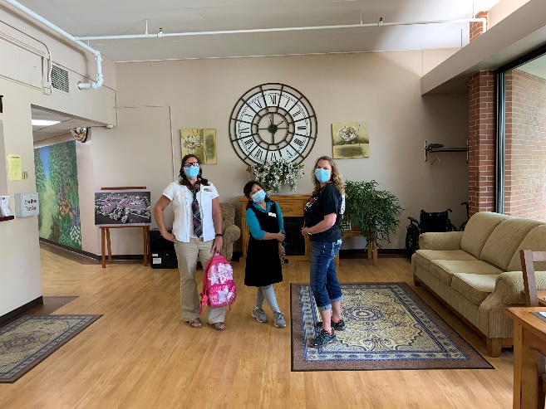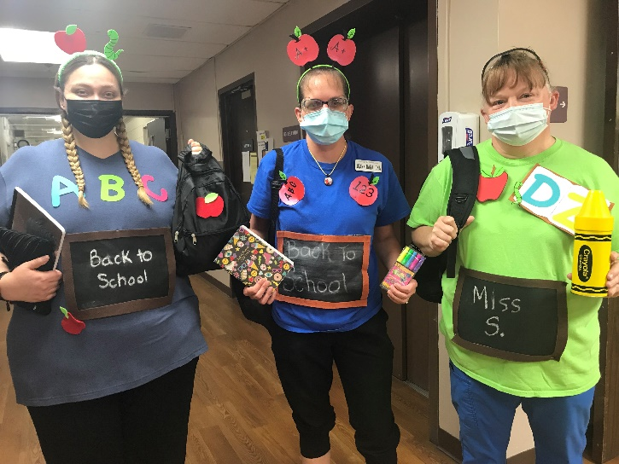

Back to school theme for staff

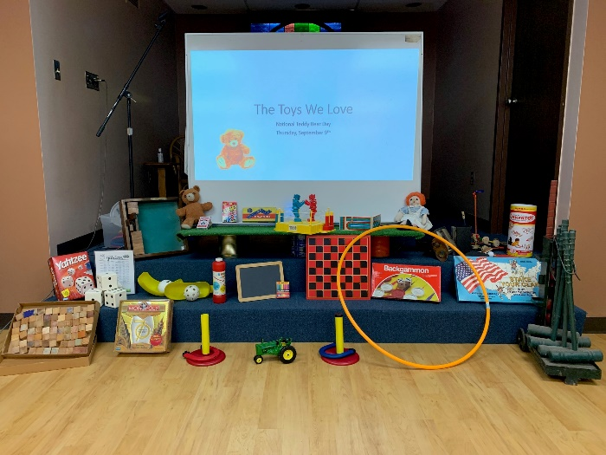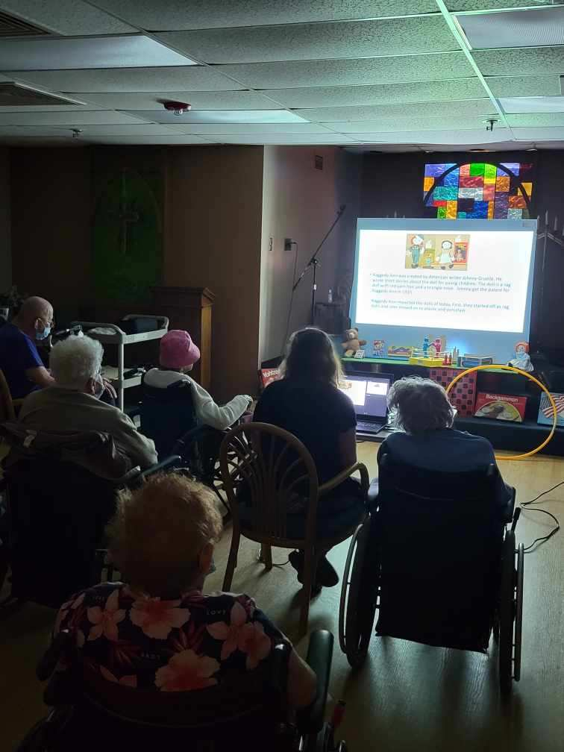

Toys through the decades presentation and reminisce proved to be a good time

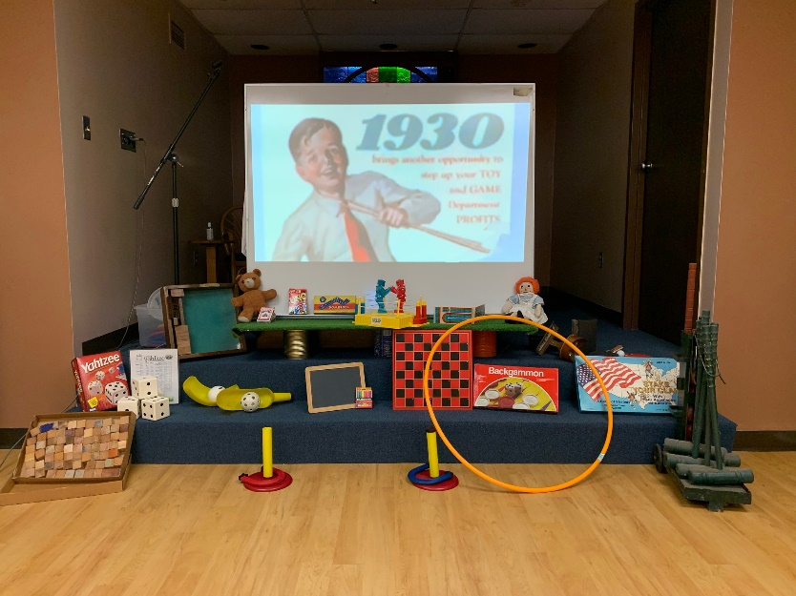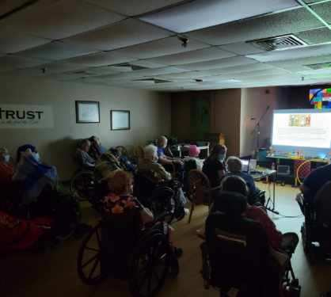

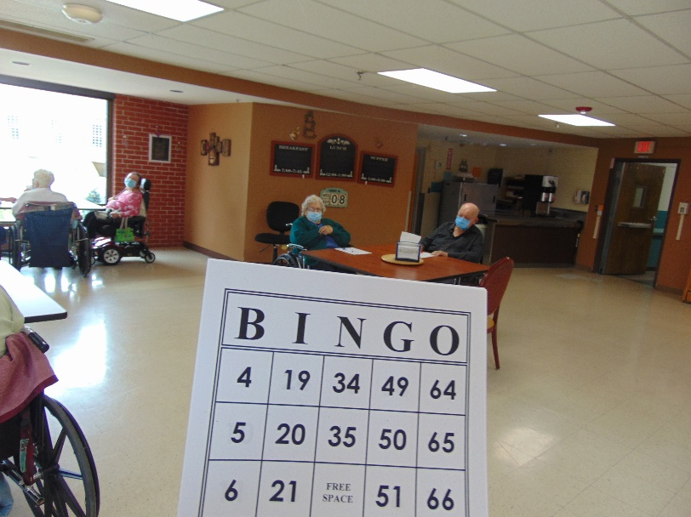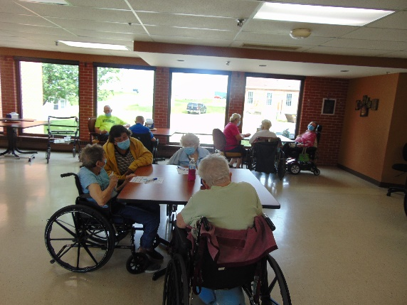

Never enough bingo!

This week we spent time playing bingo, going back to school, talking about the toys we have loved through the decades, listened to piano music and enjoyed taking care of special requests. When we recalled our school days, we snacked on a sandwich and shared stories of years ago. Then we talked about how school is today. For the toys program, Linda put together a power point complete with pictures and videos of toys from 1920 to today. As toys were talked about not in the program, Linda would look up when they were invented and pictures or videos of them.

Don’t forget to start planning your scarecrow to have by our front door by September 21st!

Linda