Welcoming in August in Pictures

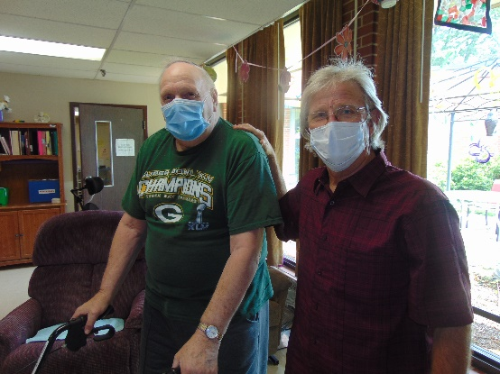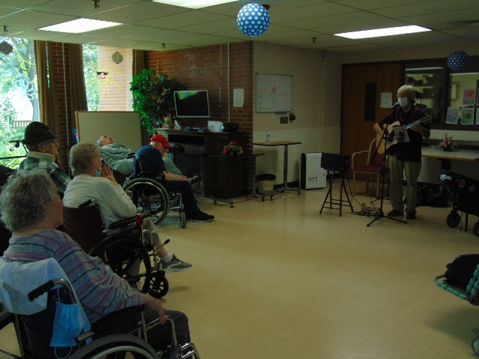

Music with Jay was a hit once again

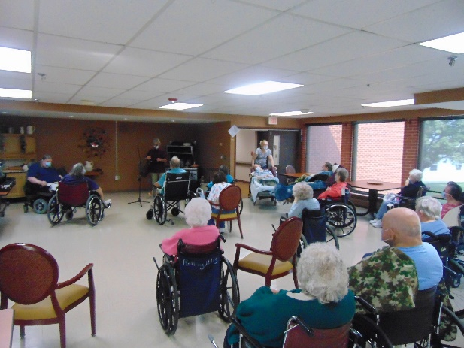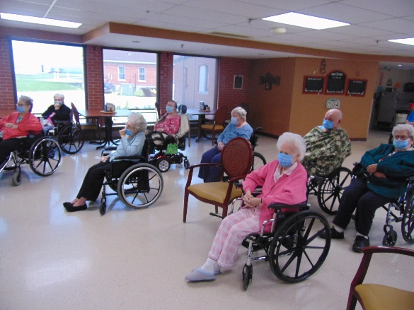

Dressing like Flamingos!

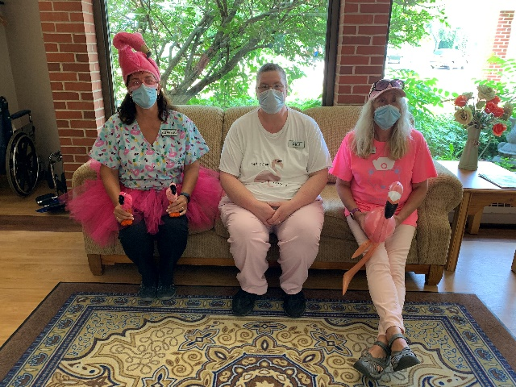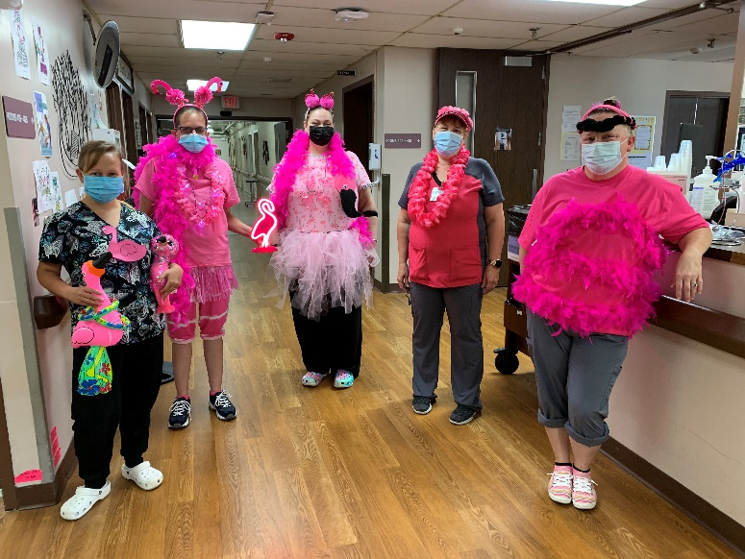

Visits with Keota

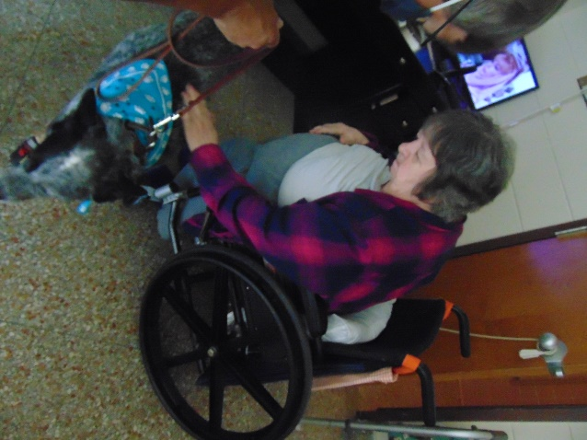 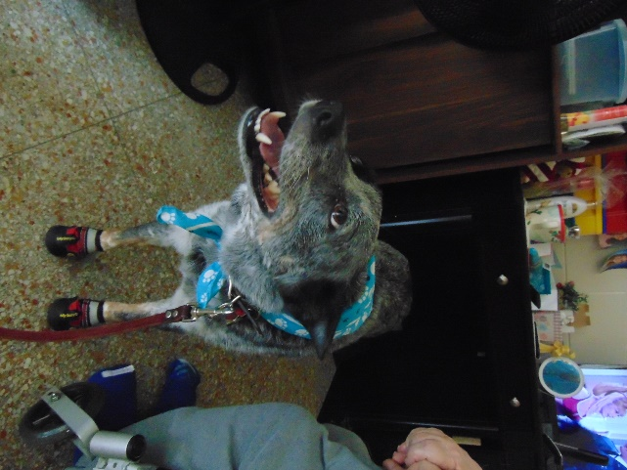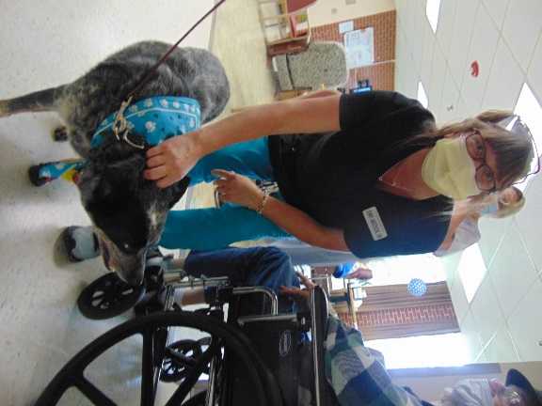

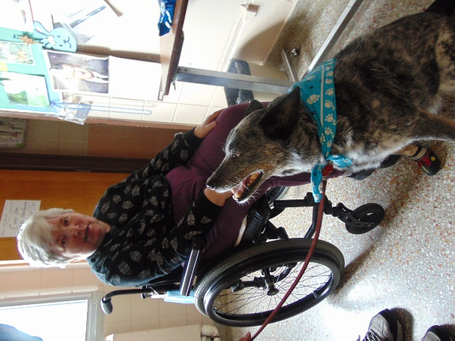 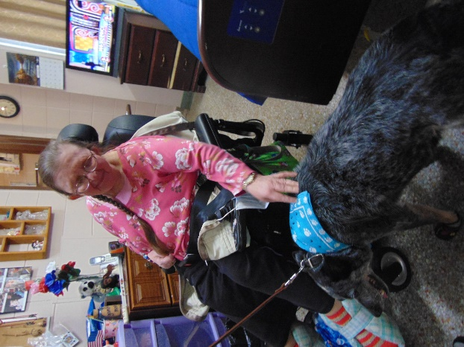

This week we welcomed in August by challenging ourselves with a complete the phrase game. Then we heard the news and moved our joints in fun exercises. Pastor Meyer and Kvale both came this week to offer services. We had a great time seeing Keota and playing bingo too! We are ending this week with Root Beer Floats in honor of National Root Beer Float Day.

Take care,

Linda