Last full week of August in pictures

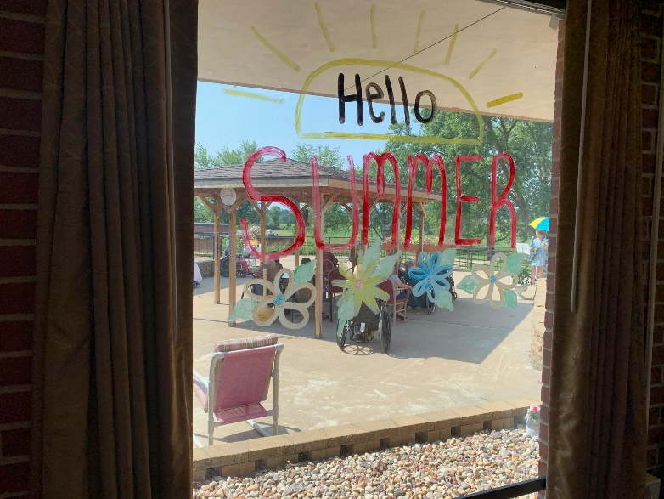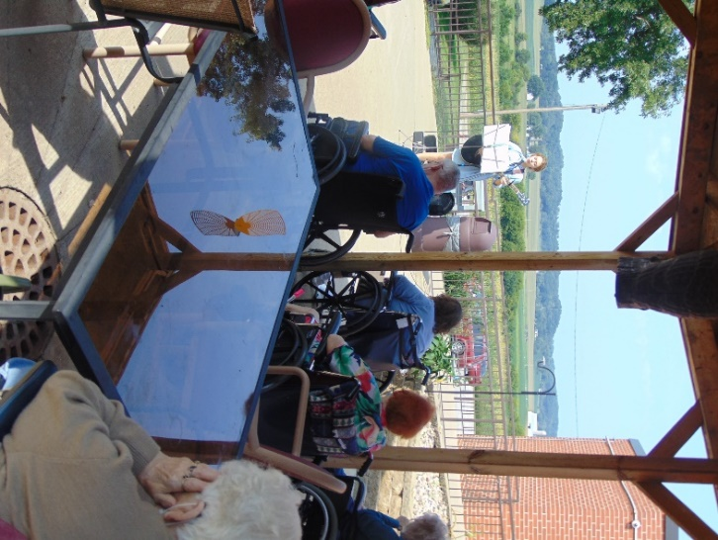

Lemonade and music on the patio

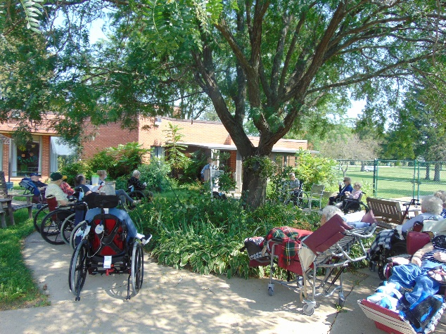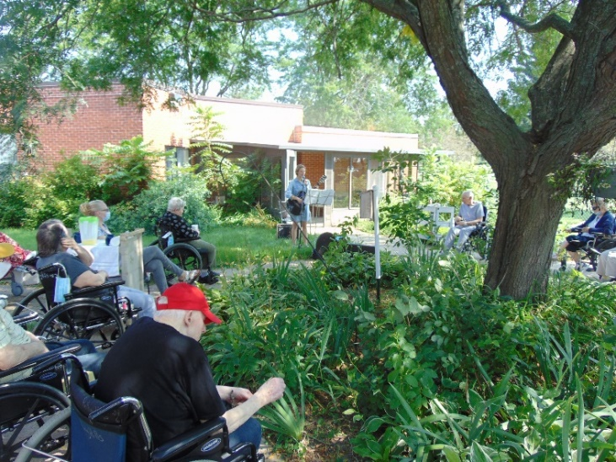

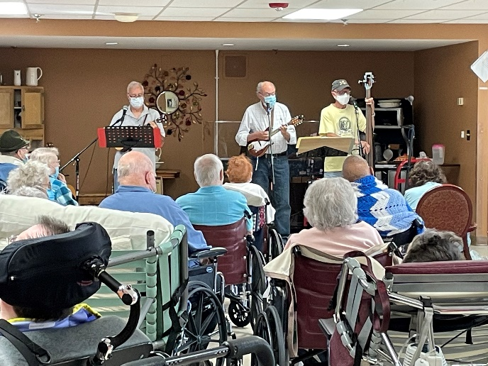

Music /w Old Moldy Hay was well attended



Crazy Hair day

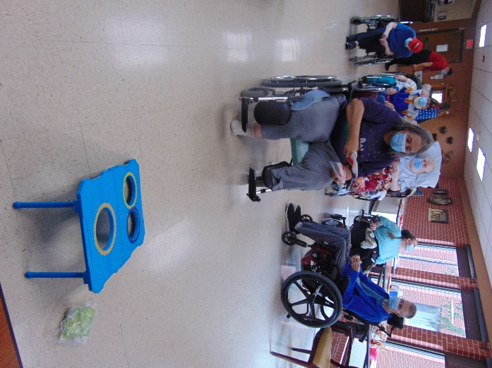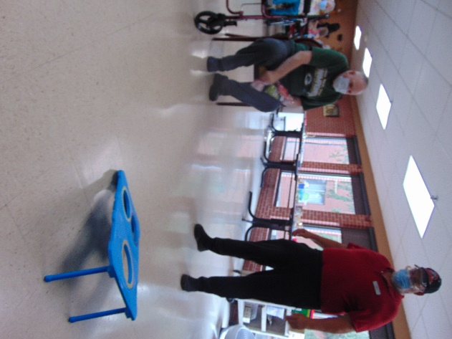

Fun at the Fair with Carnival Games

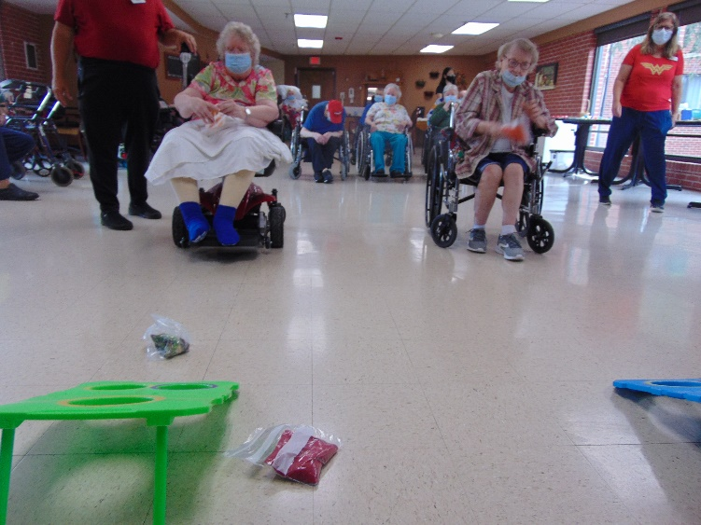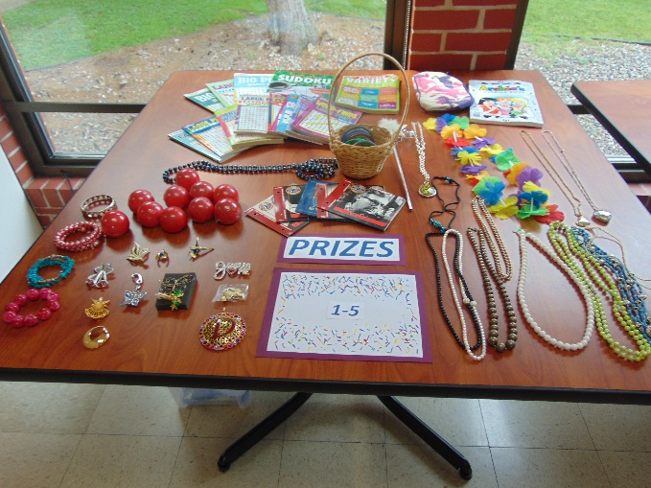

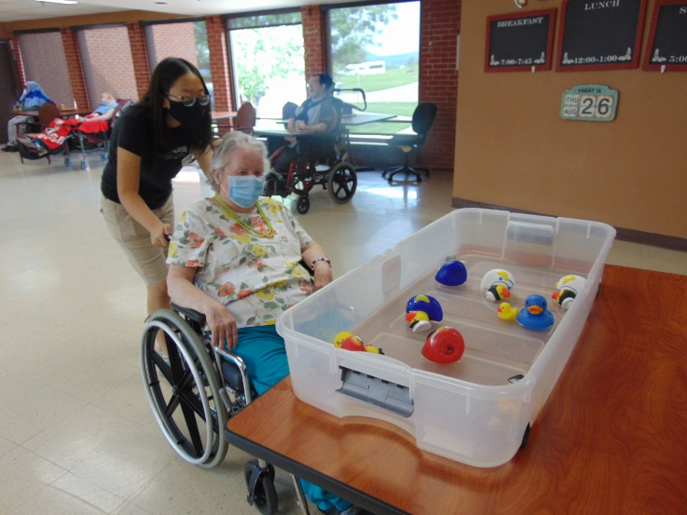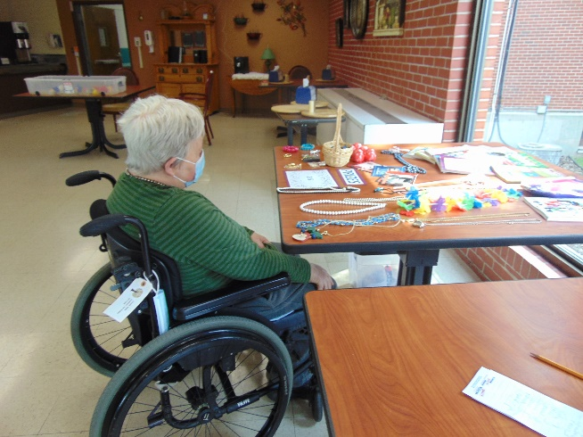

Pick a Duck Pick a Prize

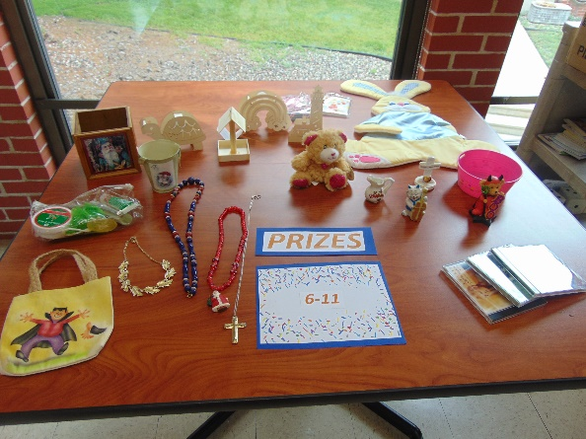

What a rainy Friday. Good thing we got outdoors when we could this week ☺

At the end of last week it was so fun drinking lemonade on the patio with fun facts and then listening to Laurel Adams play her guitar and sing. This week we enjoyed tapping our toes to Old Moldy Hay on Monday, eating a sweet ice cream treat, learning some interesting facts during news and exercise and getting out on the bike. We reminisced about fairs and even tried our hand at some carnival games to win a prize. More music and bingo to end the week and we are ready to welcome in September next week.