**3rd Week of August in Pictures!**

Another pontoon boat ride

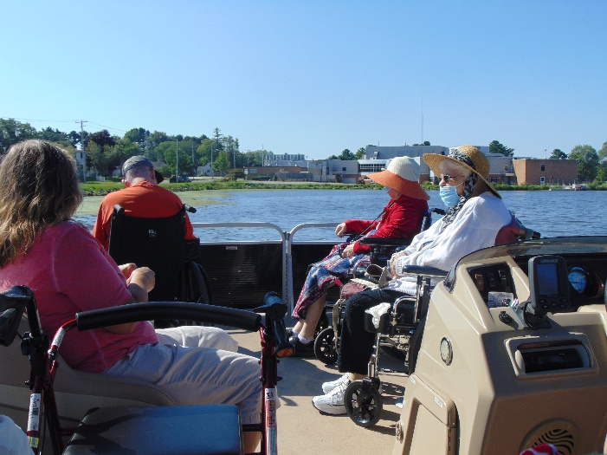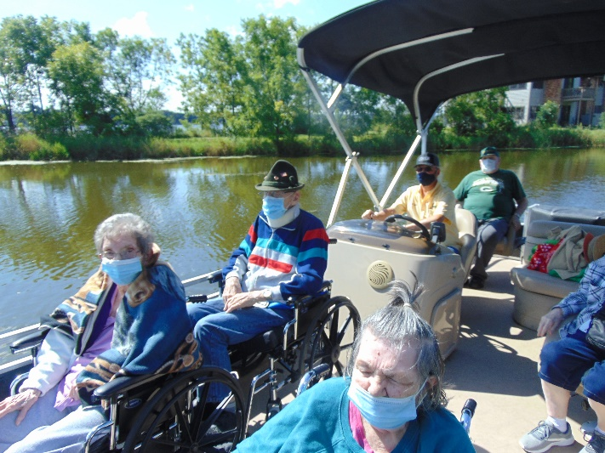

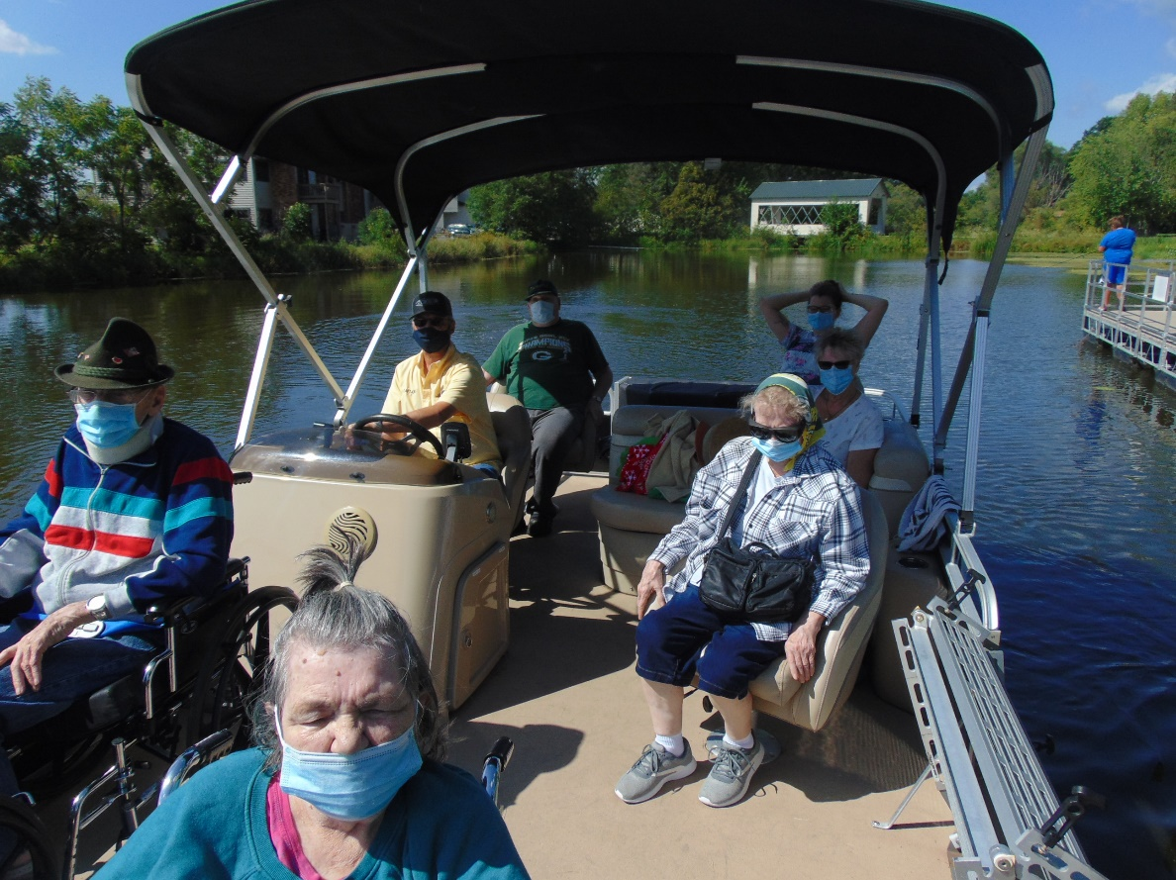 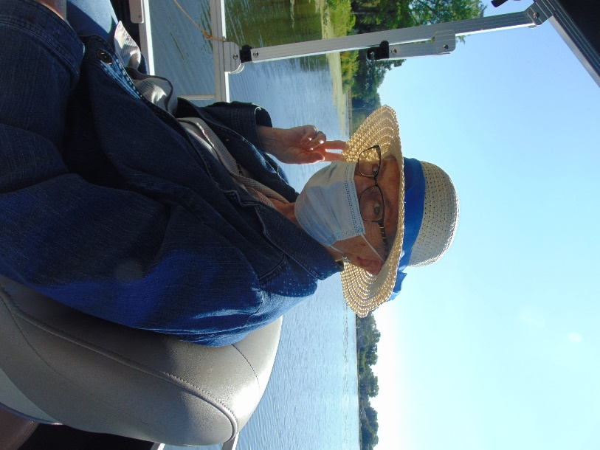

Dress up day this week was Grey

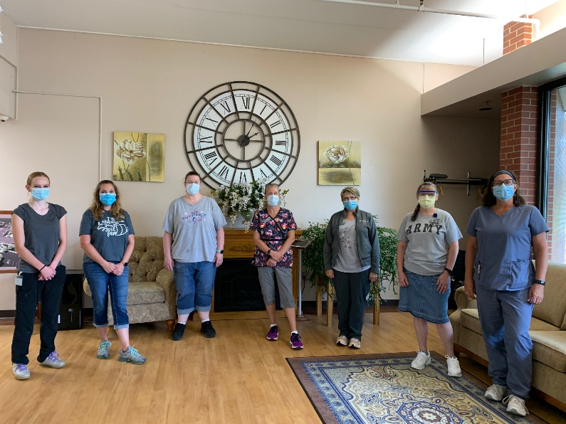

We started out our week with a sing-a-long. On Tuesday some of us enjoyed a pontoon boat ride on Lake Tomah. This week we also played bingo and enjoyed some camp reminisce, including reading history of camping, talked about different types of camps, did a camp skit, made s’mores, and sang camp songs. One of our pet therapy dogs, Keota, visited this week as well. We will close out the week with lemonade and music on the patio

Have a great weekend!