2nd week of August in Photos

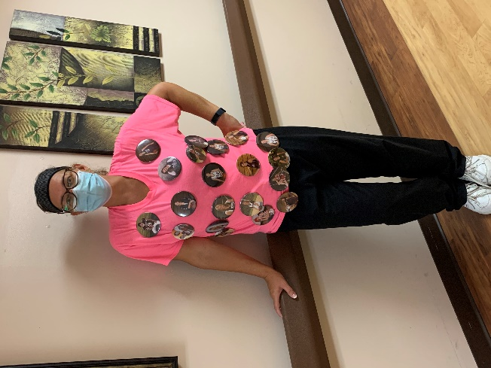

This Wednesday was Button Day!

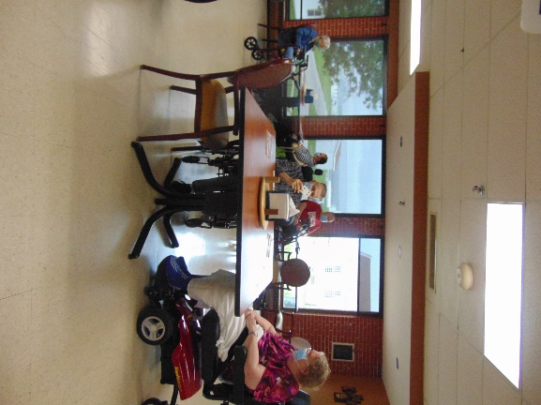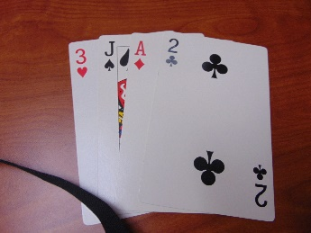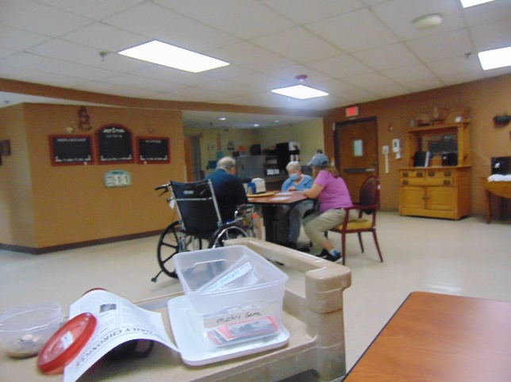

Playing some Mystery Card Games!



Went Fishing

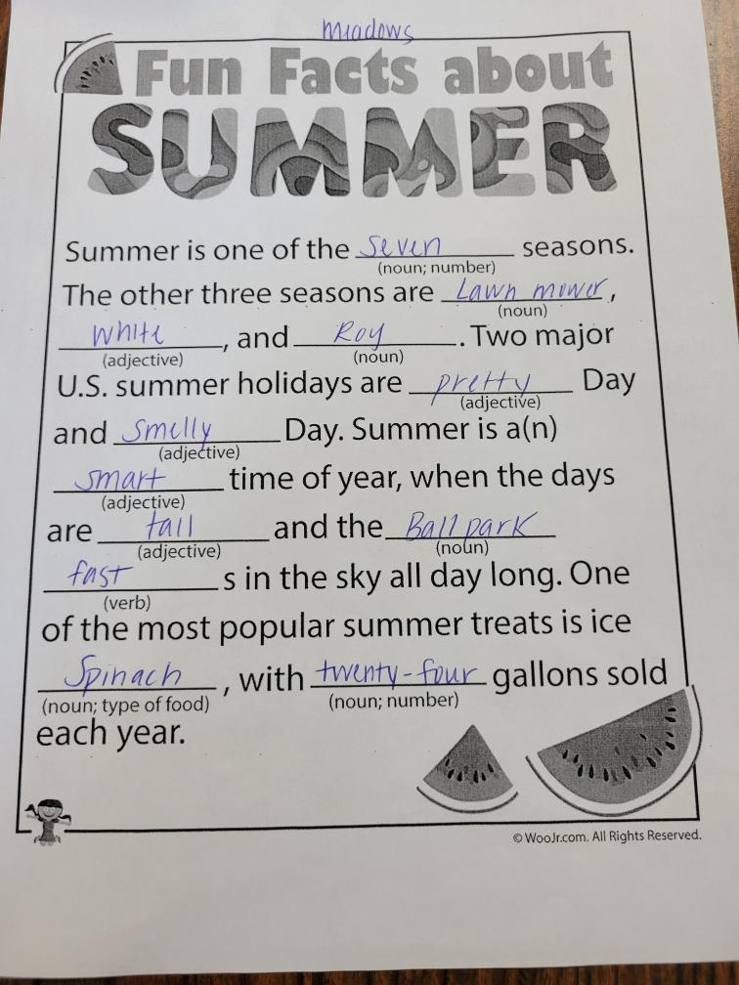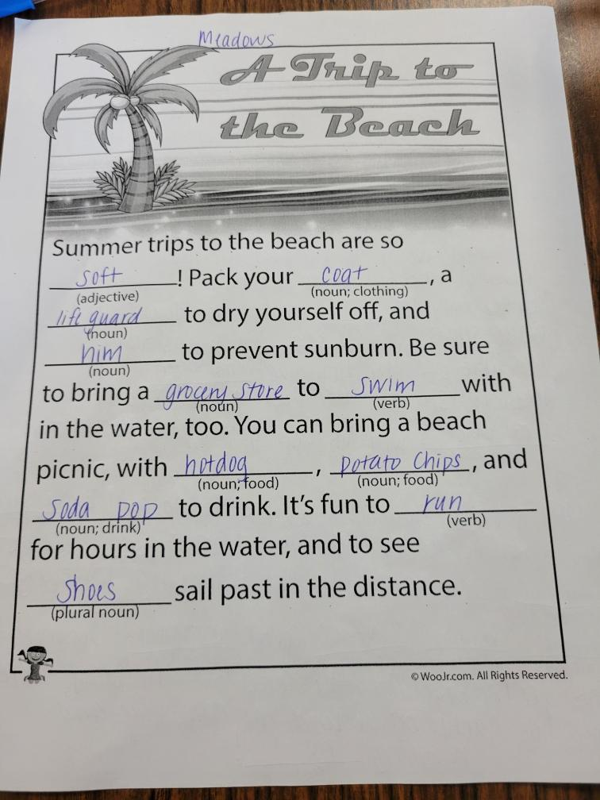

Fun with Mad Libs ☺

Some other lines included the following:

We are riding in a Chariot with my Great, Great Grandma and Grandpa.

Summer is one of the 100 seasons. The other 3 seasons are Colorado, Red and Motorcycle.

Be sure to bring a balloon to run with in the water, too.

One of the most popular summer treats is ice Cheetos, with 101 gallons sold each year.

This week when it was not stormy or raining, we headed out to check out the sites of the area. We enjoyed ice cream treats from our ice cream truck and went fishing too! One day we had fun doing summer theme mad libs. We hope you all are enjoying the final days of summer and staying cool.

Linda

