Welcoming in July

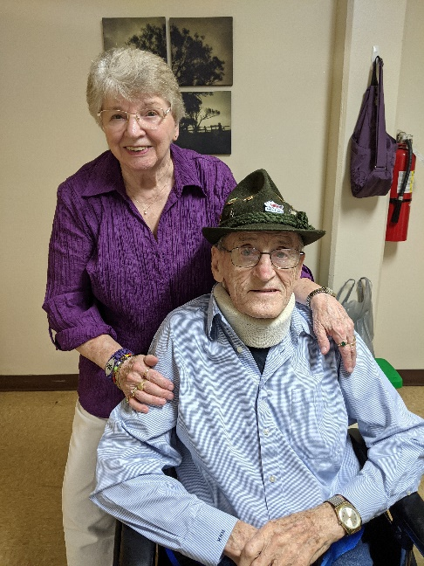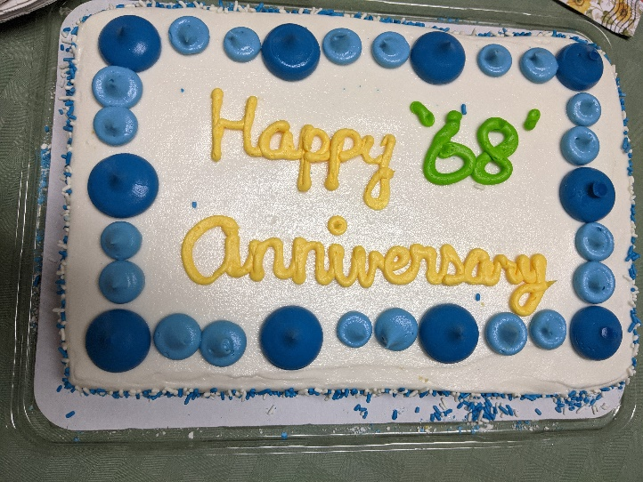

Anniversary during covid times

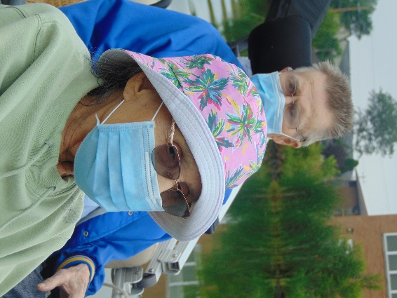

Pontoon Rides

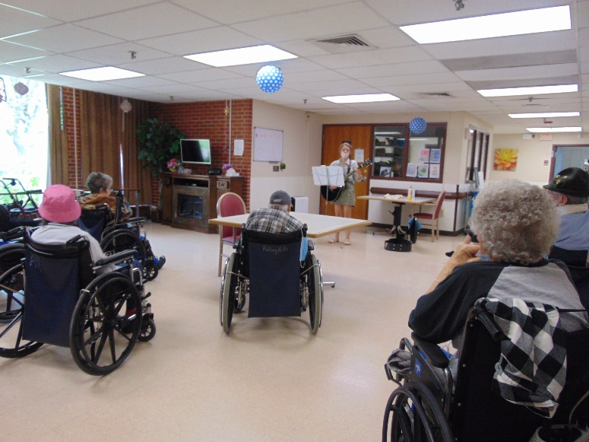

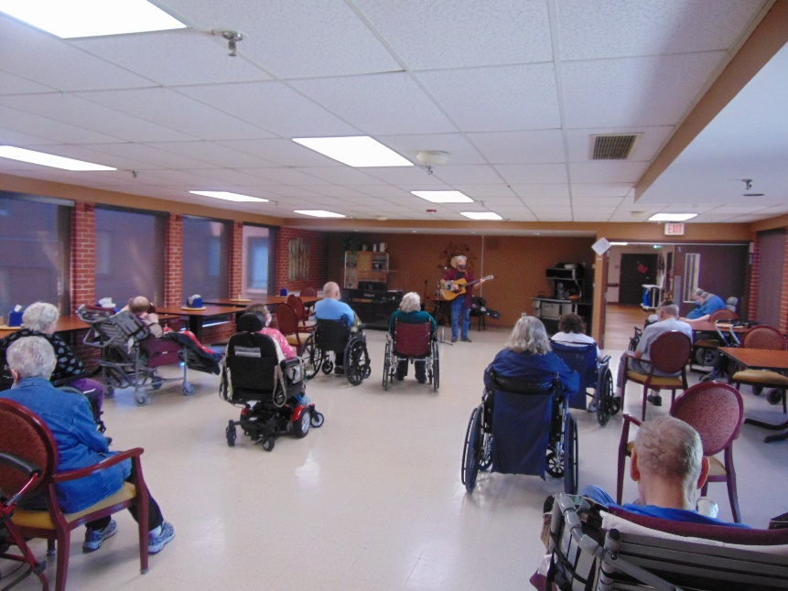

Music With Jay and Laurel (finally get to see them both in person instead of channel 25!)

HAPPY 4TH OF JULY!

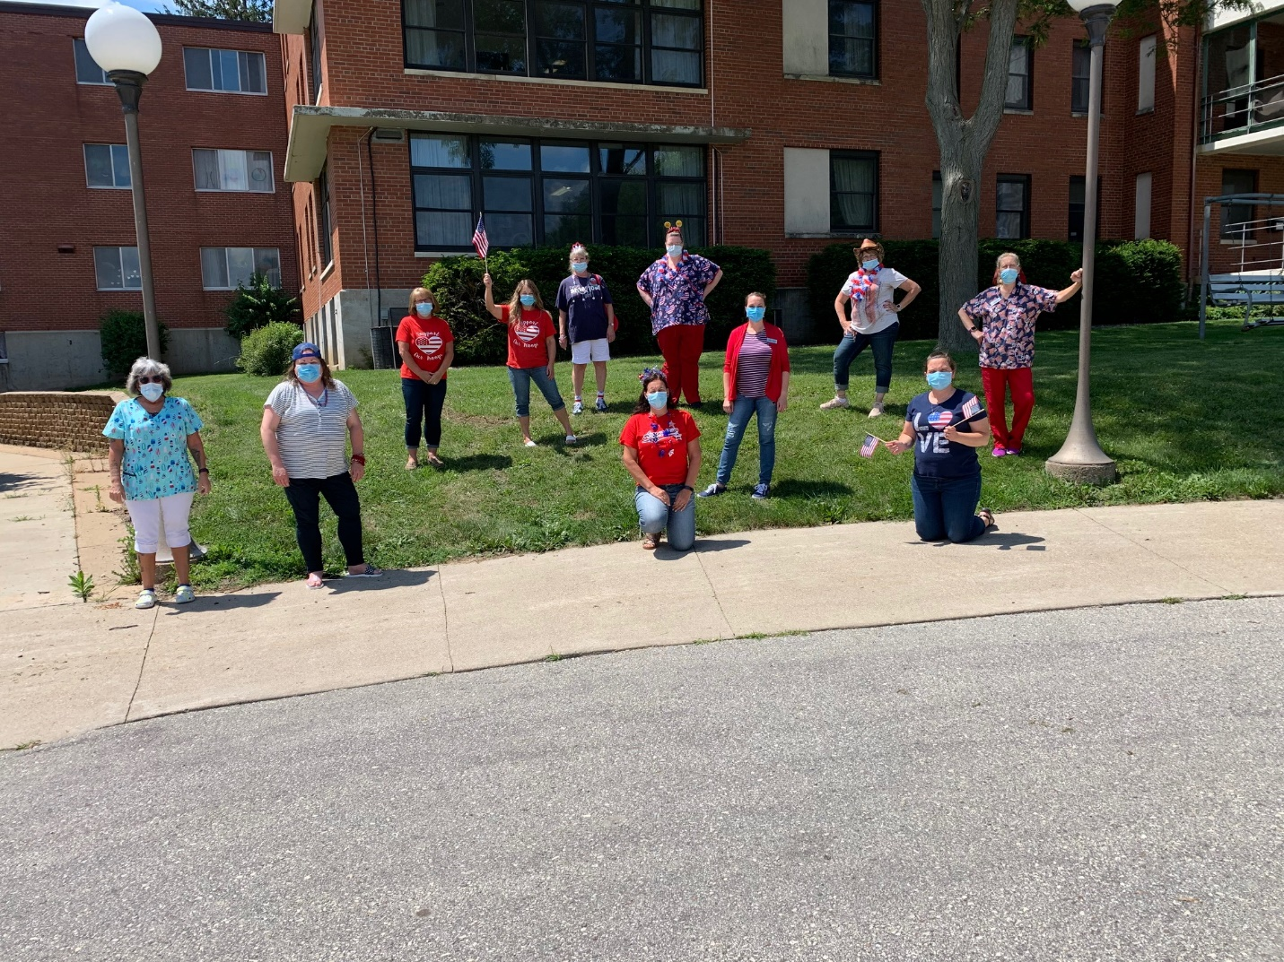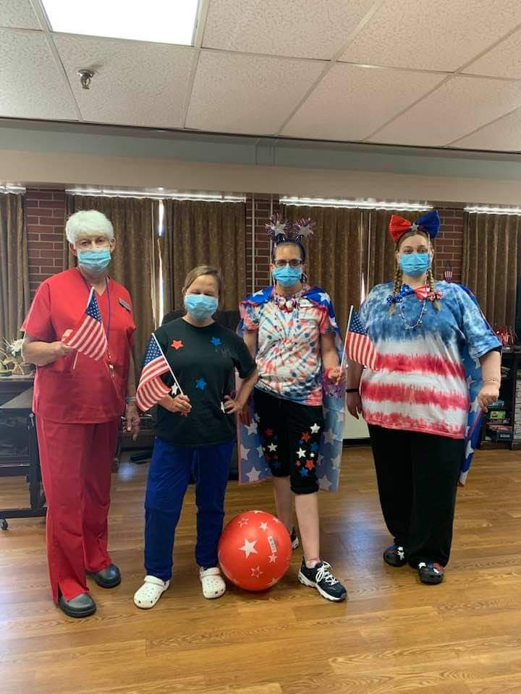 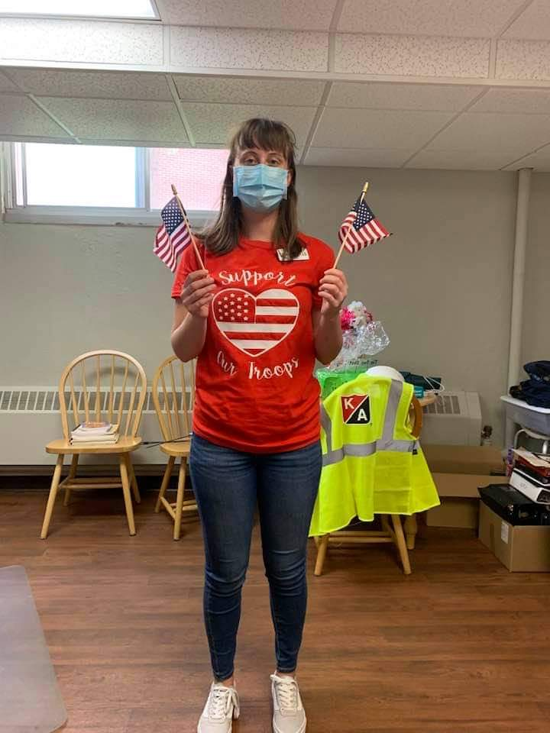 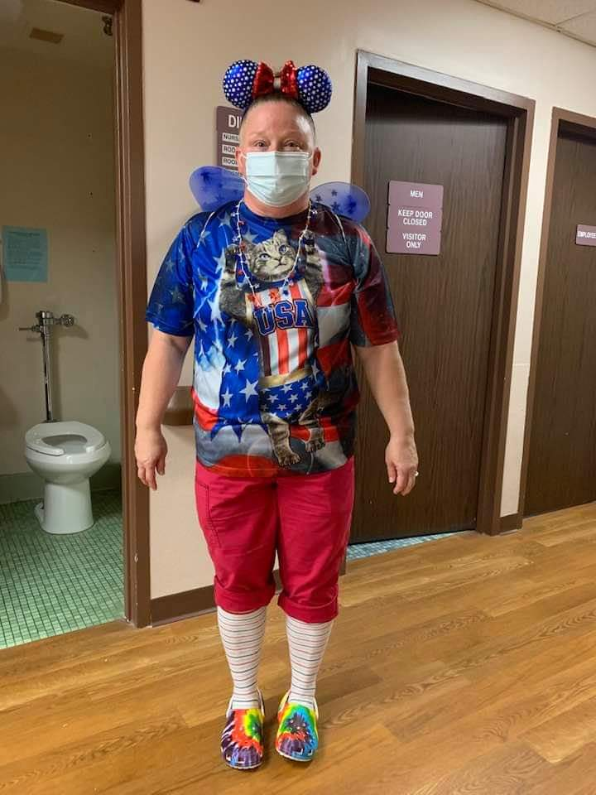

July is here and we continue to stay active. We heard some stories from Uncle John’s Bathroom reader in celebration of Bathroom reading day ☺. Then we enjoyed exercising so we could purchase a snack from the café cart. We enjoyed a farming reminisce day, worshiped with the Wels Lutheran Pastor and saw Keota too. Let’s not forget to mention a Culver’s order in, playing games, sitting on the patio and singing Patriotic songs. And we even got to welcome Laurel Adams and Jay Hoffman to play inside for us, instead of just on channel 25! Hope you all have a great 4th of July!

Linda