End of July in Pictures

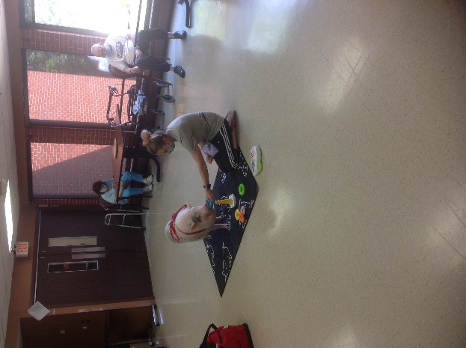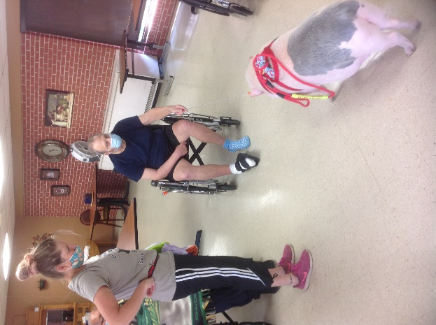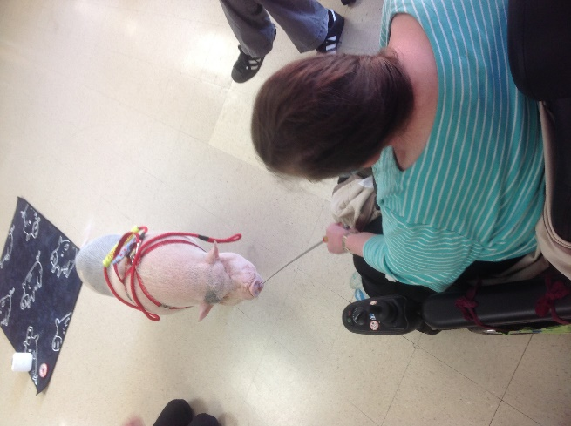

Hanging out with Brutus

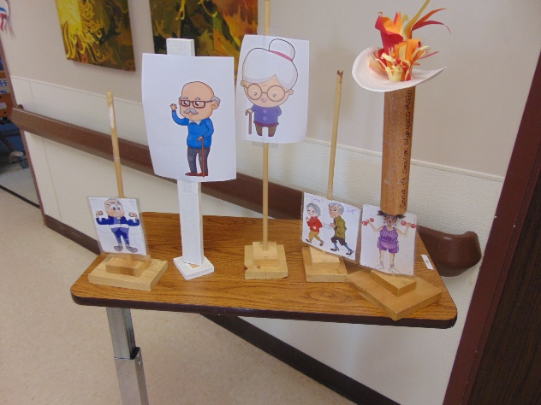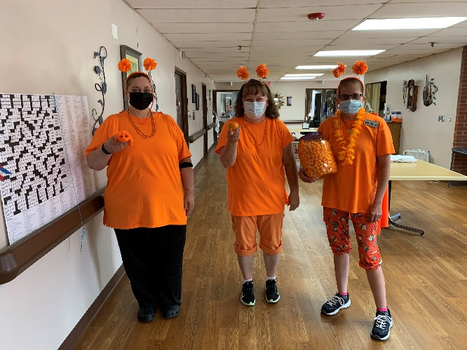

Olympic Races were a success!

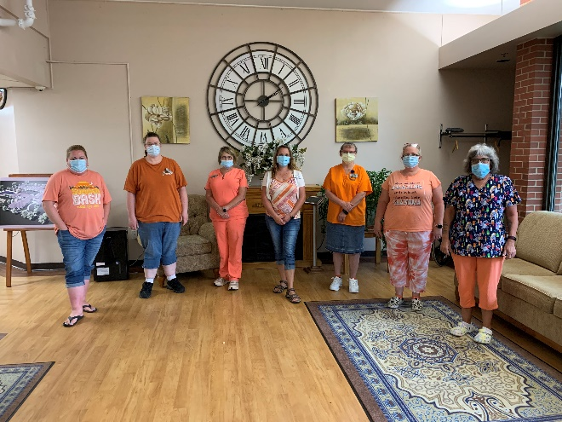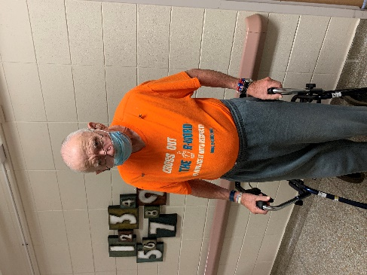

Orange was Wednesday’s theme

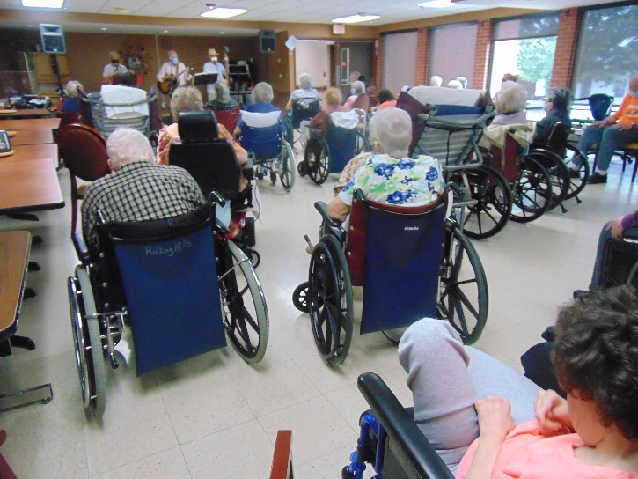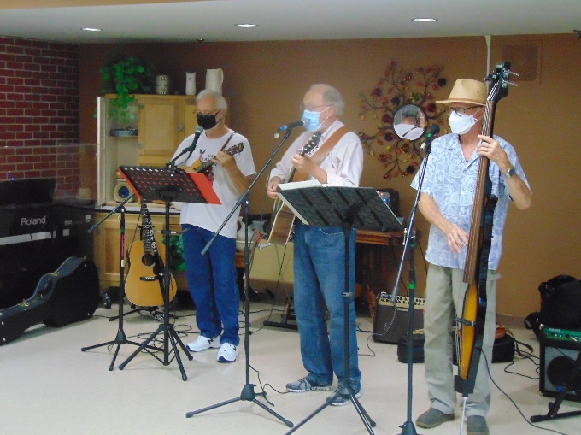

Nice turnout for music with Old Moldy Hay

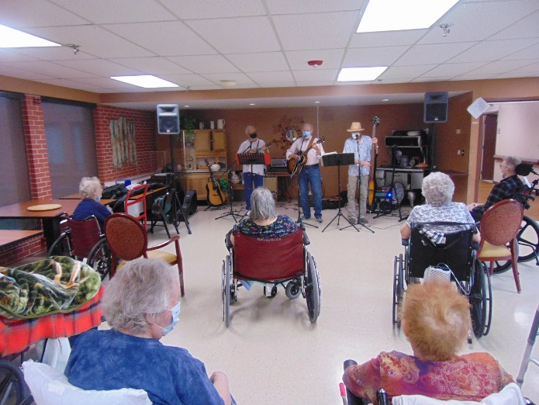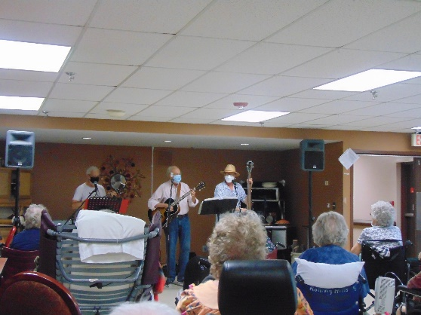

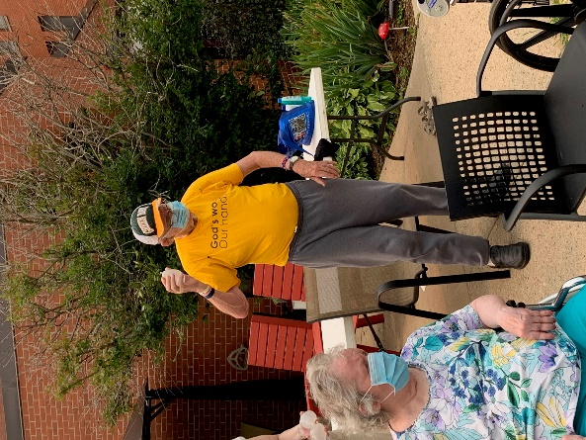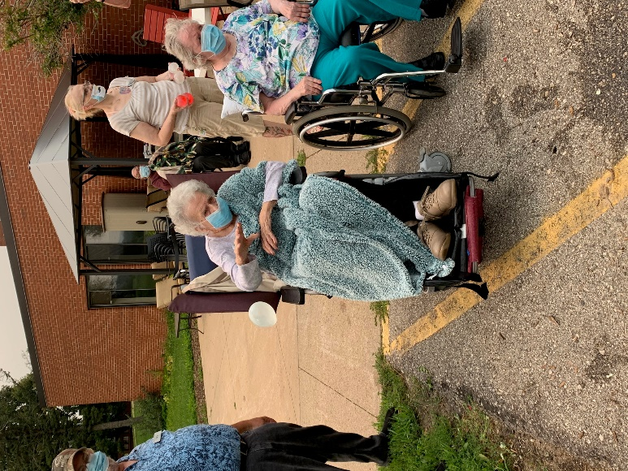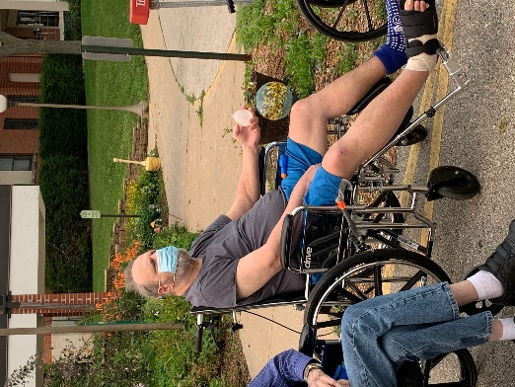

Water fun!

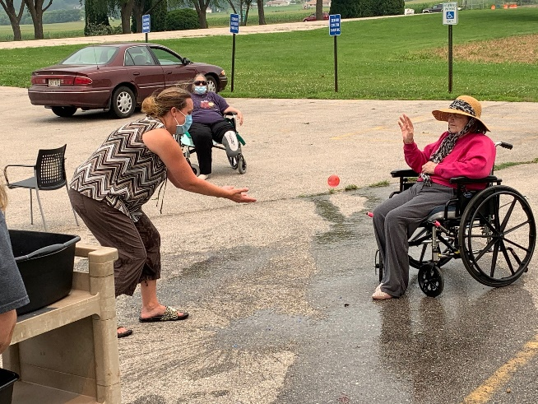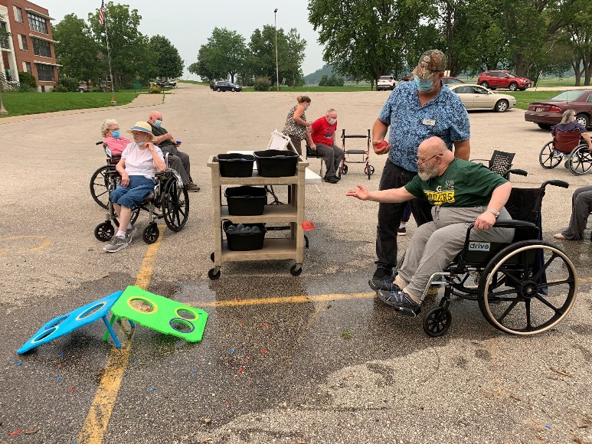

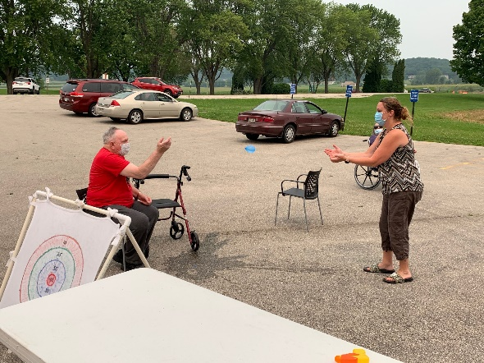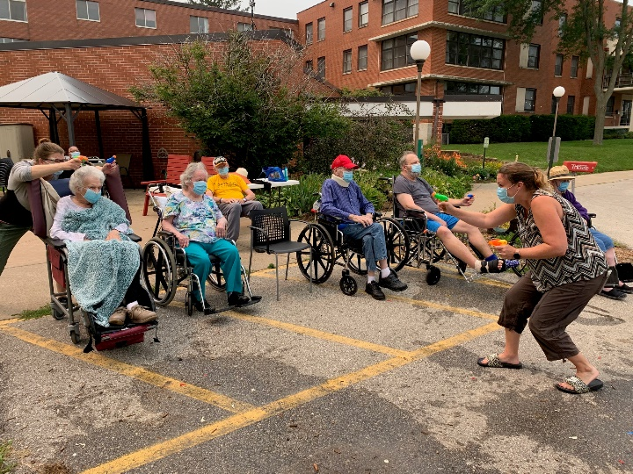

Water Balloons and Water Guns were a hit

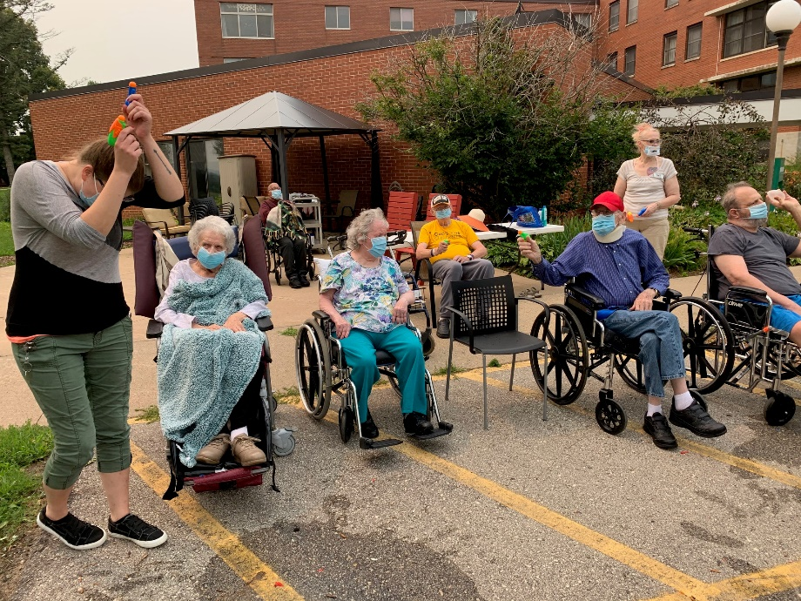

We cannot believe it is almost August already! This final week of July we spent visiting with Brutus, the mini pig. Some of us even got to feed him carrots with his nifty feeding stick! Others of us enjoyed listening to Lisa play the piano beautifully to songs we know so well. With the Monroe County fair just being held we took time to reminisce about the many fairs we have been too. Then, Old Moldy Hay performed for us too. We loved their tunes! We continued our Olympic games, this week it was the Olympic water balloon toss. This just turned in to get anyone when they are not looking with either the water balloons or the water guns that were provided to all. We will finish off this week with bike rides, the café cart and some one on one visits throughout the home. Have a good weekend.

Linda