3rd Week of July in Pictures

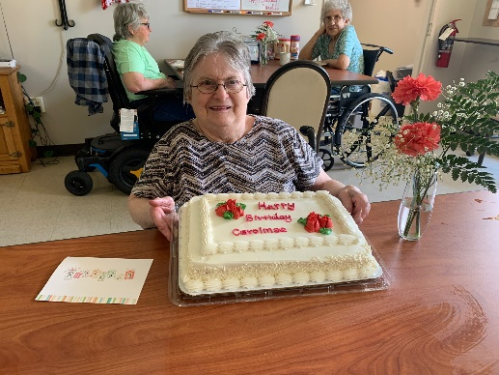 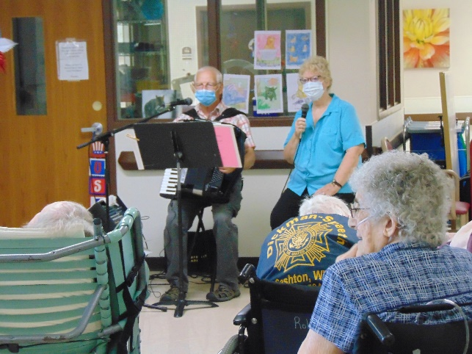

Birthdays continue to be celebrated Accordion Music for Haven and Meadows

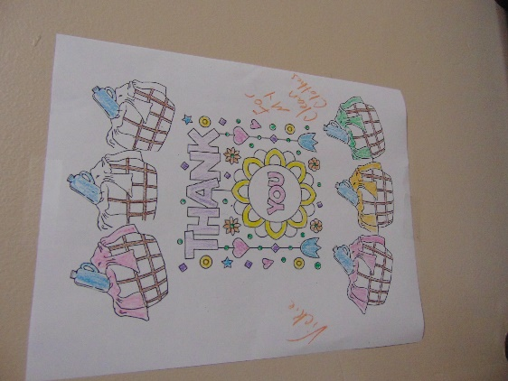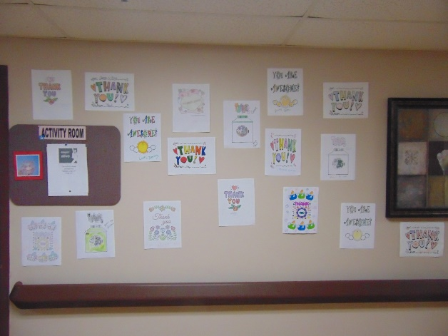

Thanks to our awesome Laundry staff!

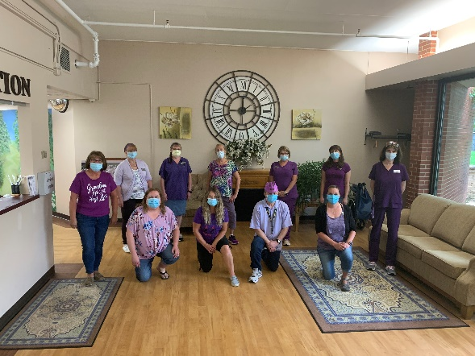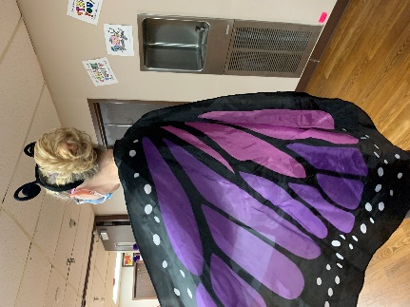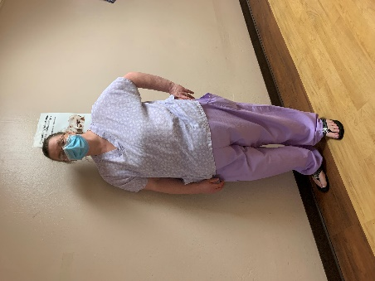

Dressing in Purple Wednesday

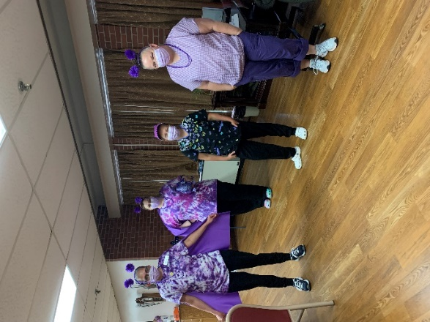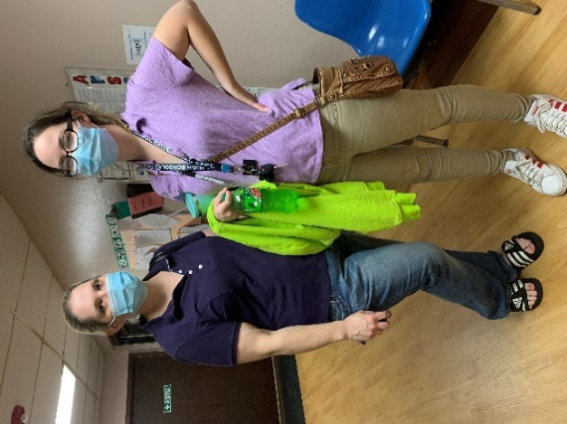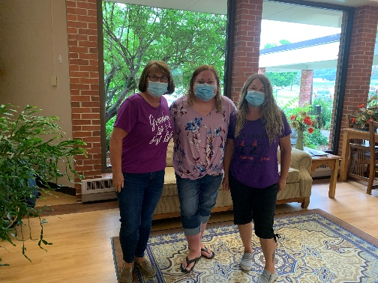

Keota loves coming here and we love having her!

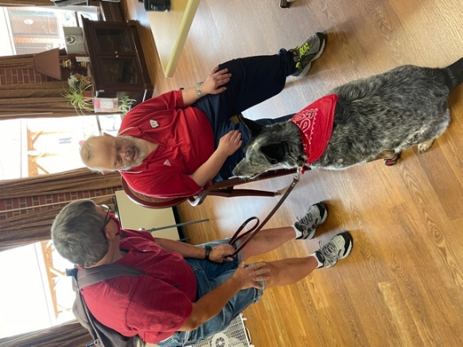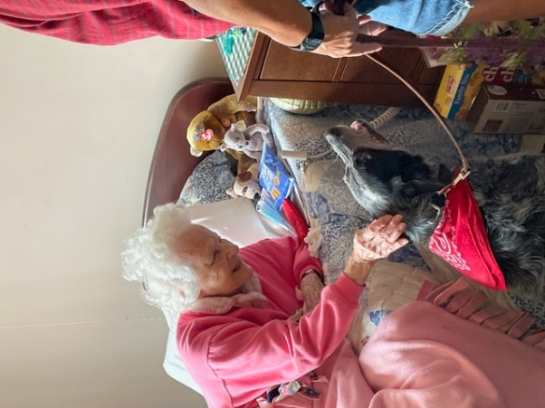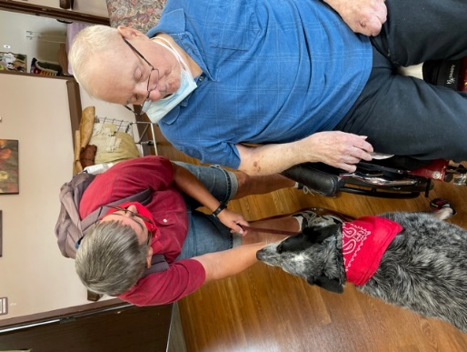

This week we took time to thank our laundry staff for National Laundry Worker’s Week. We love having our clothes well taken care of!

Then Haven House and Meadows had their turn to listen to Laurel and Dianne entertain them. We continued with our Olympic theme and played Olympic Bingo, but then played the real bingo game too. The day Keota made her rounds many smiles were made. Today, more pontoon rides are happening as well.

Have a great weekend

Linda