Welcoming in June

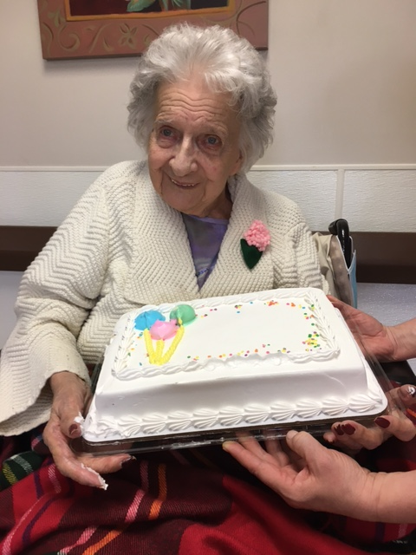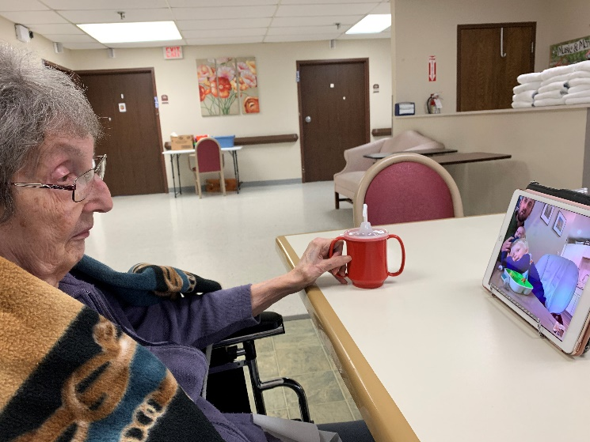

Birthdays and virtual visits!

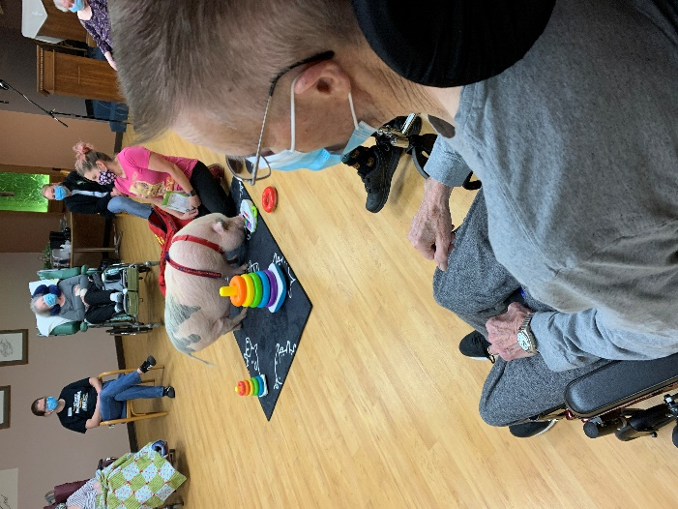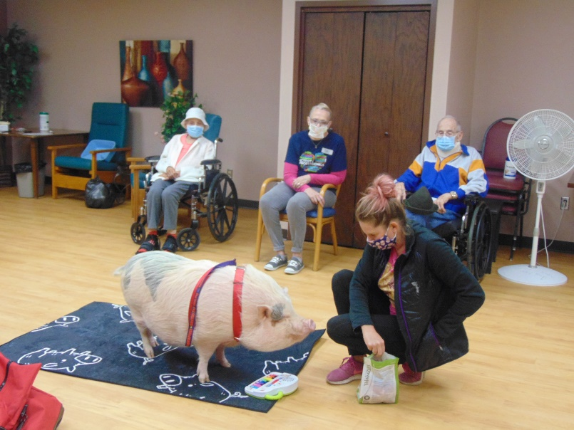

A visit inside with Brutus the mini pig!

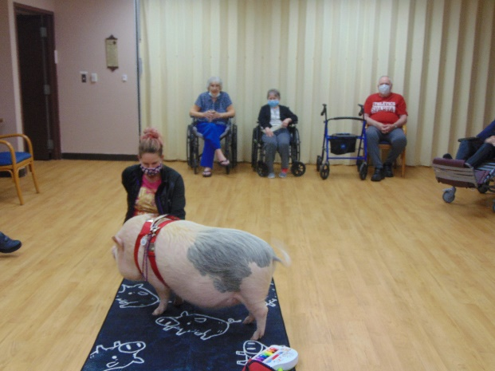

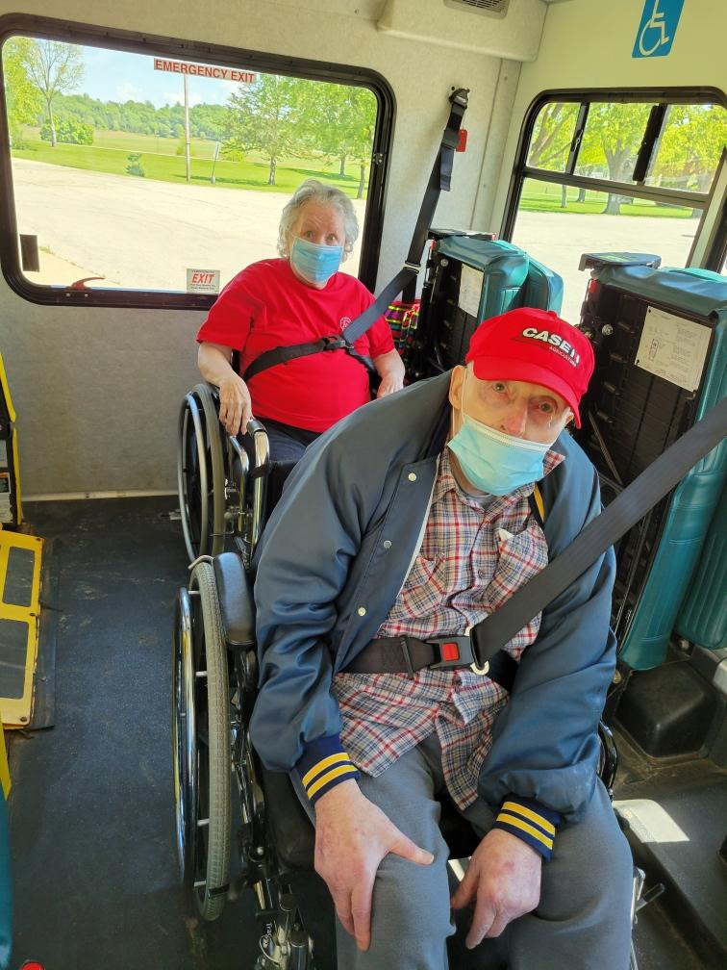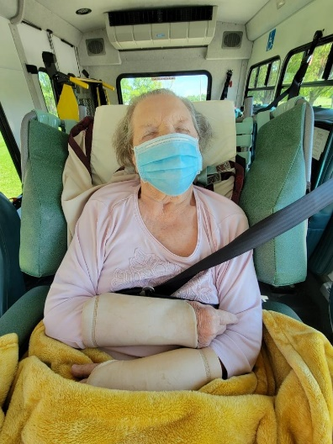

Scenic Drives on a gorgeous day!

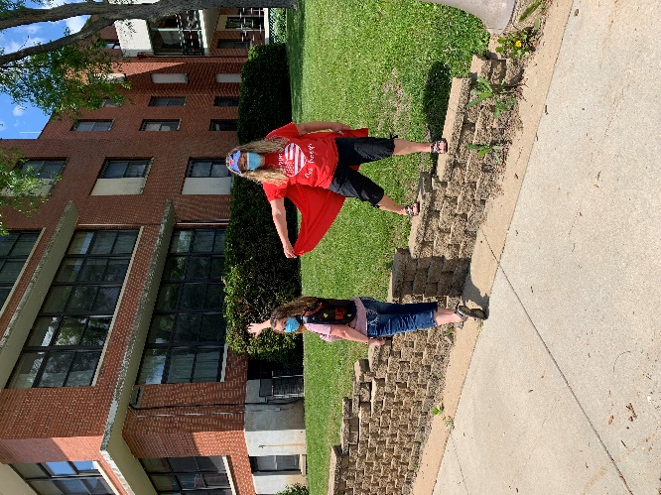 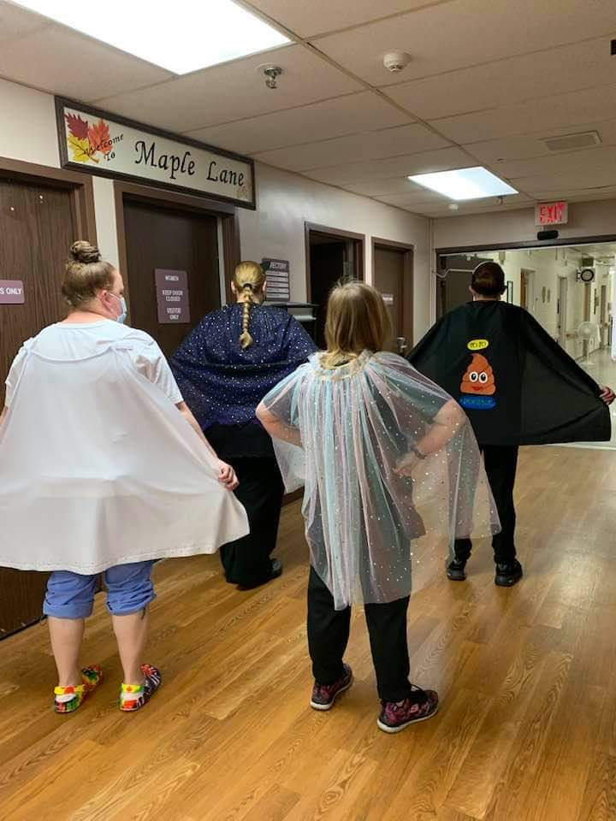

Calling all capes, report to Rolling Hills

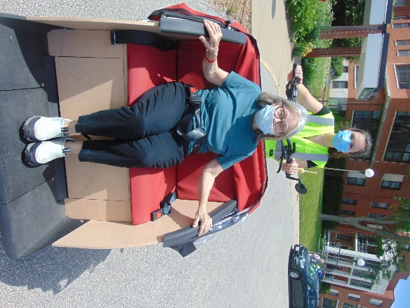 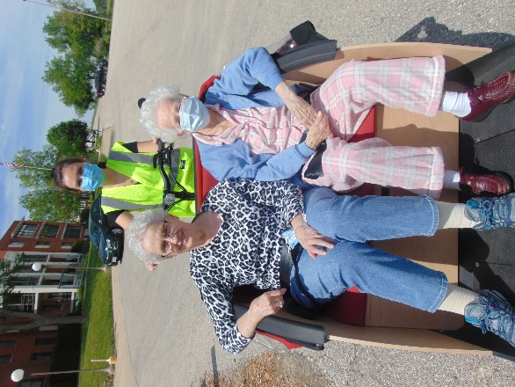

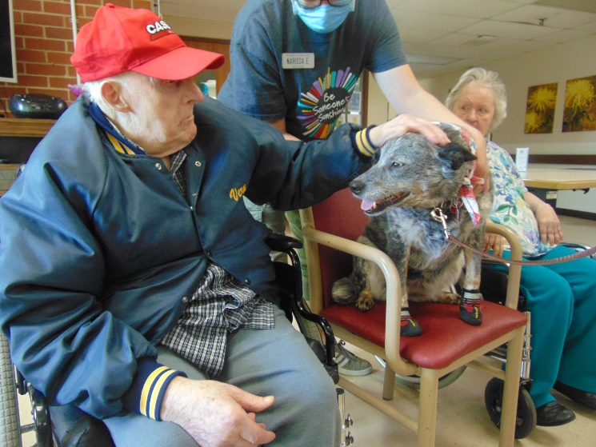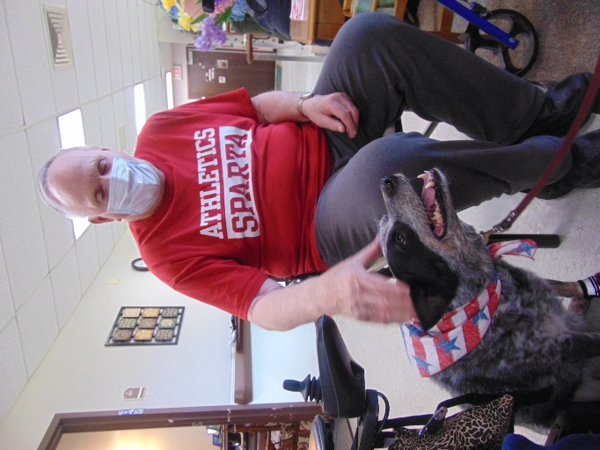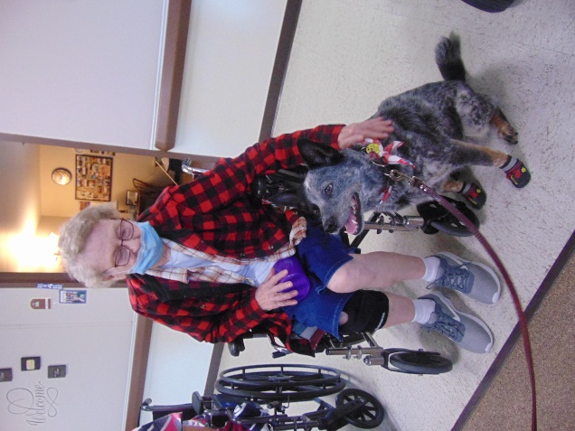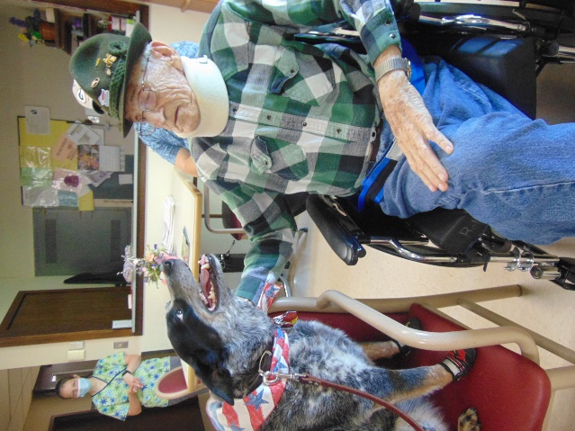

Keota could finally come inside!!!!

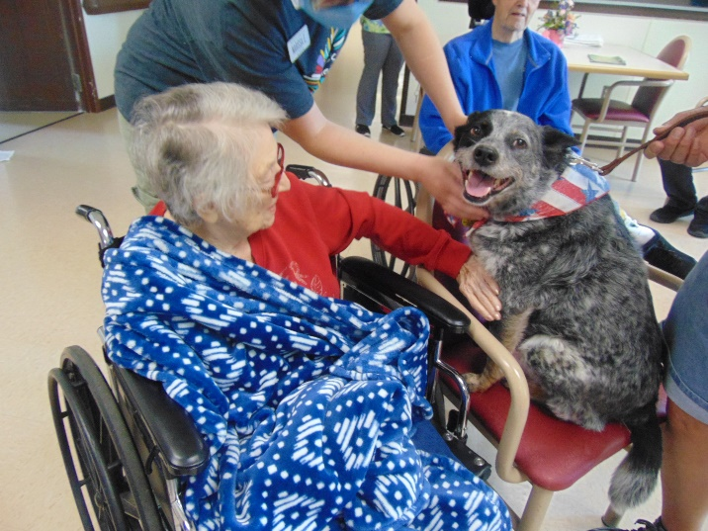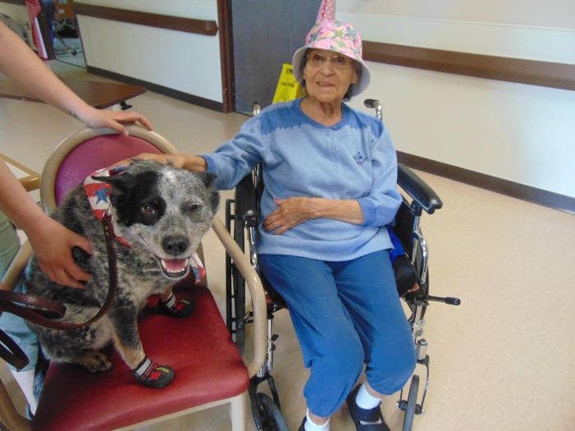

Wow, June is coming in HOT that is for sure ☺

We hope you all will stay cool and enjoy the summer days. We loved seeing the ice cream truck in our hallway this week to help keep us all cool.

This week our photos include pictures from our visit by Brutus, the Mini Pig. You read it right, our pet therapy pig is back! Jancee does such a great job teaching him tricks and educating us.

Before it got too hot, we spent a day getting out for some scenic drives and even some bike rides for world bicycle day. As this is being written, we were happy to welcome Jeremy back as a volunteer entertainer. He and Lisa play so well together and we love their music.

Until next time,

Linda