1st week of May in Pictures

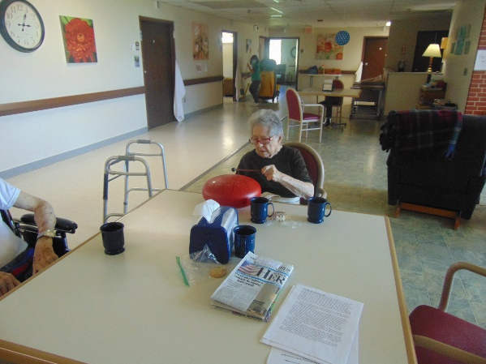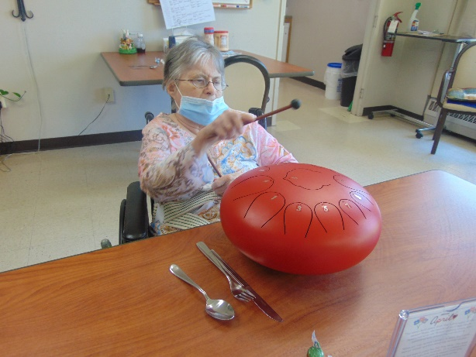

Making more music with our tongue drum 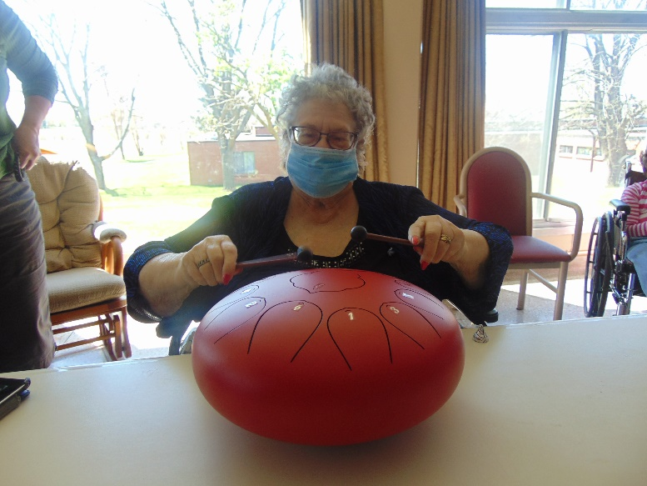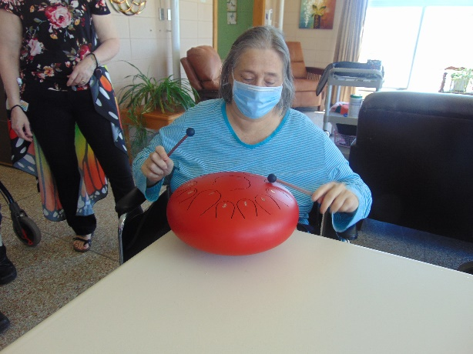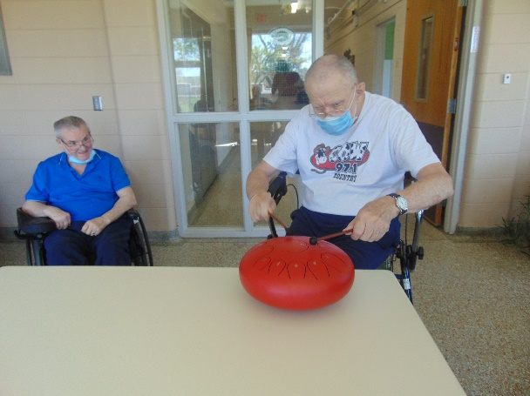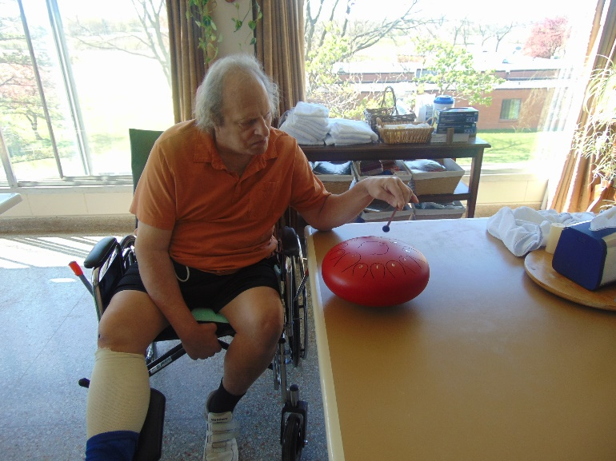

All residents received nice flowers and a card from some thoughtful community members for May Day

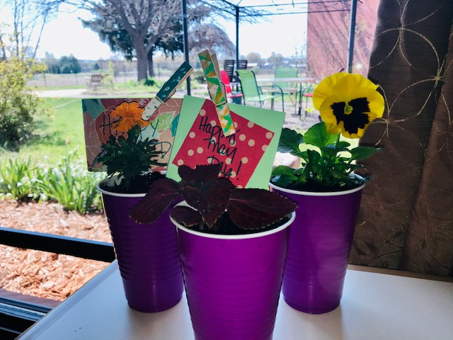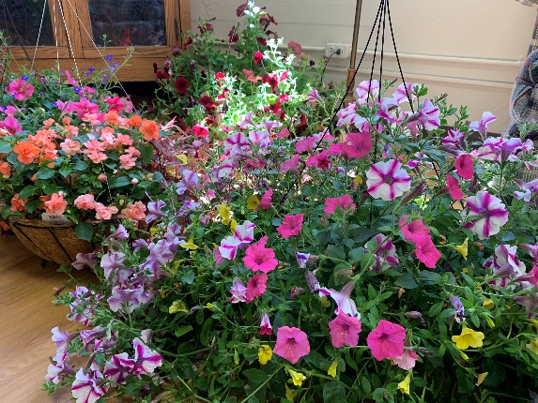

We are so thankful for all the support by purchasing our hanging baskets this year. Covid meant we had to do pre-order only this year.

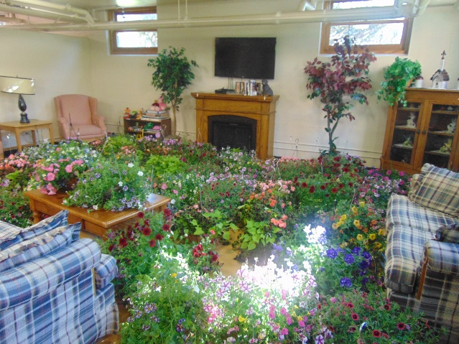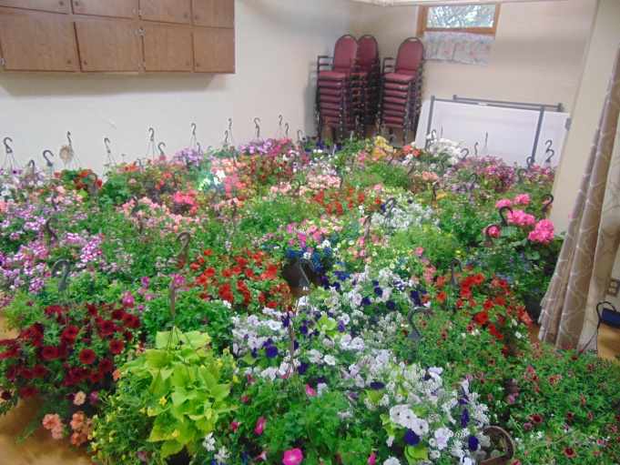

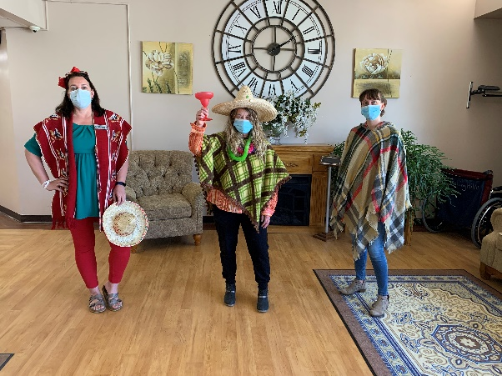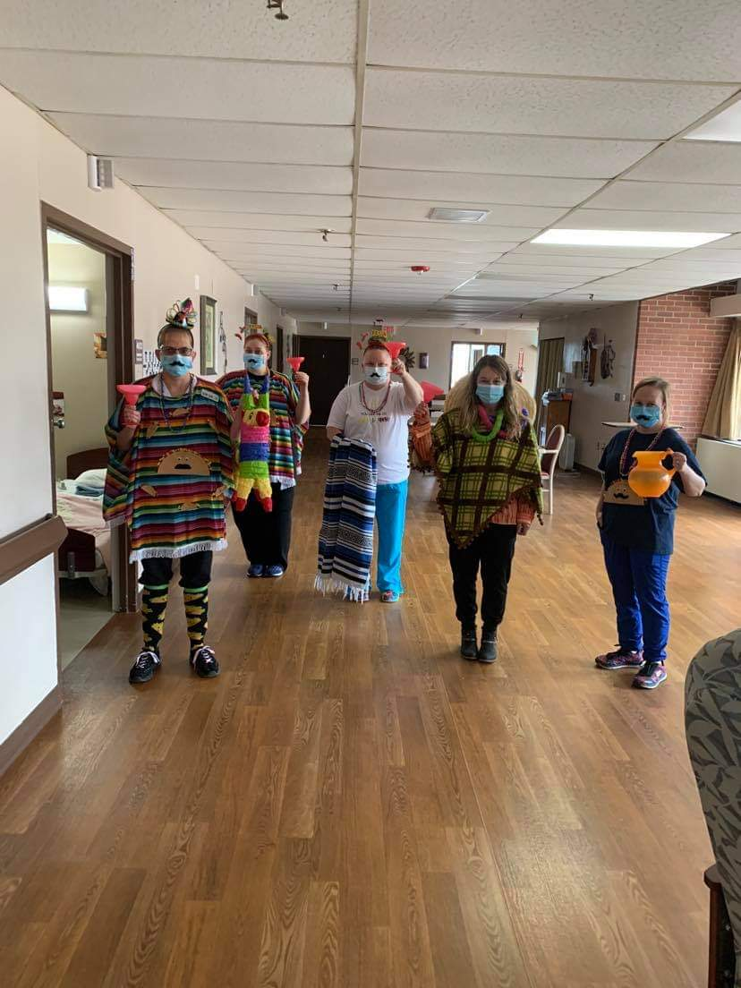

Happy Cinco De Mayo!

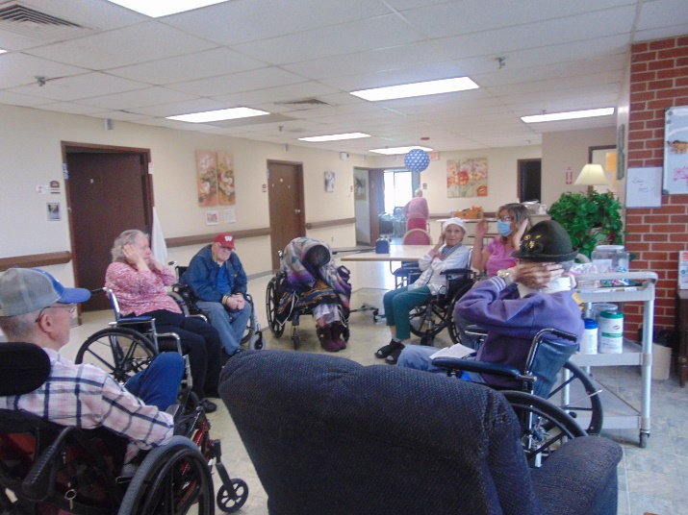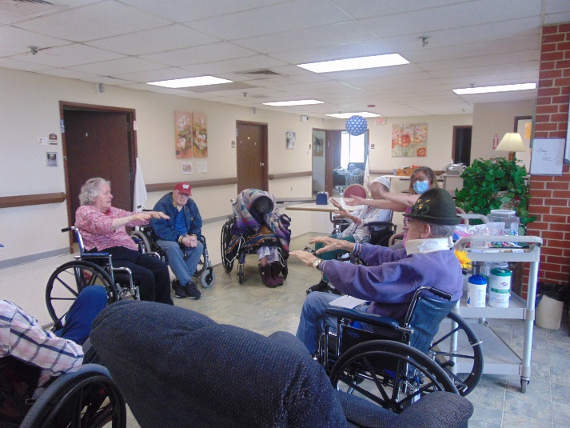

We even learned The Macarena (AKA MacaCHAIRana) Dance!

This week we enjoyed music with Lisa, exercising, talking about travel and even learning about google maps and celebrated Cinco de Mayo. Lisa had fun sharing facts and trivia and then taught everyone the Macarena dance. She was so excited to see the participation and hear the laughter as they moved along to the music! Our community helped share joy to all the residents on May Day with a flower and a card to brighten their days.

We also received our pre-ordered flowers for one of the biggest fundraisers we have for the activity department. With the activity room smelling like a greenhouse, we of course gave residents the chance to come and enjoy the smells and colors!