Mid-April in Pictures

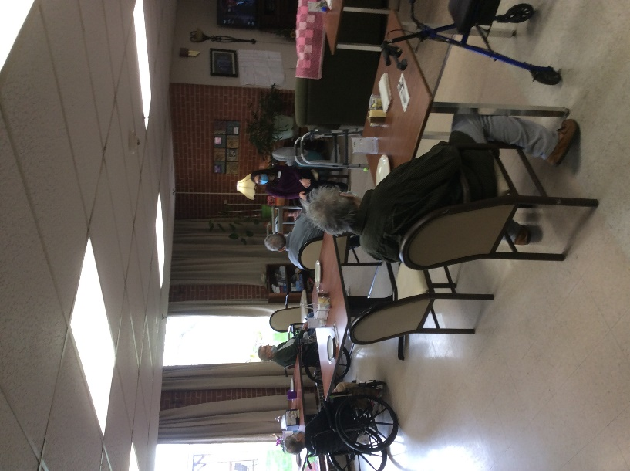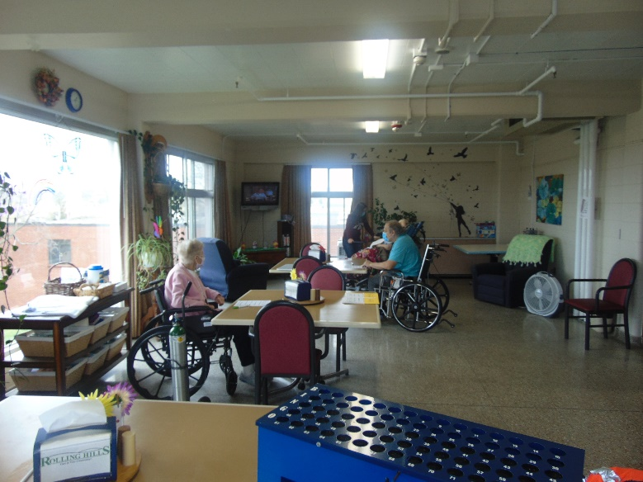

Exercises have become a weekly must! Always time for Bingo

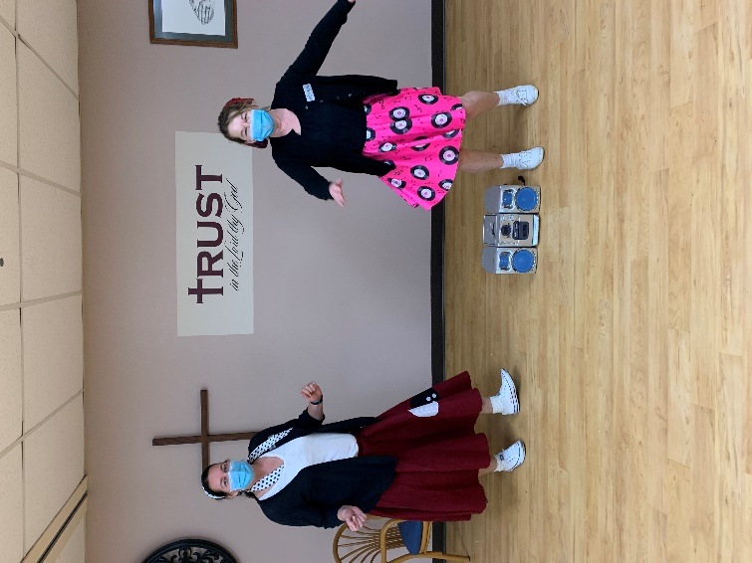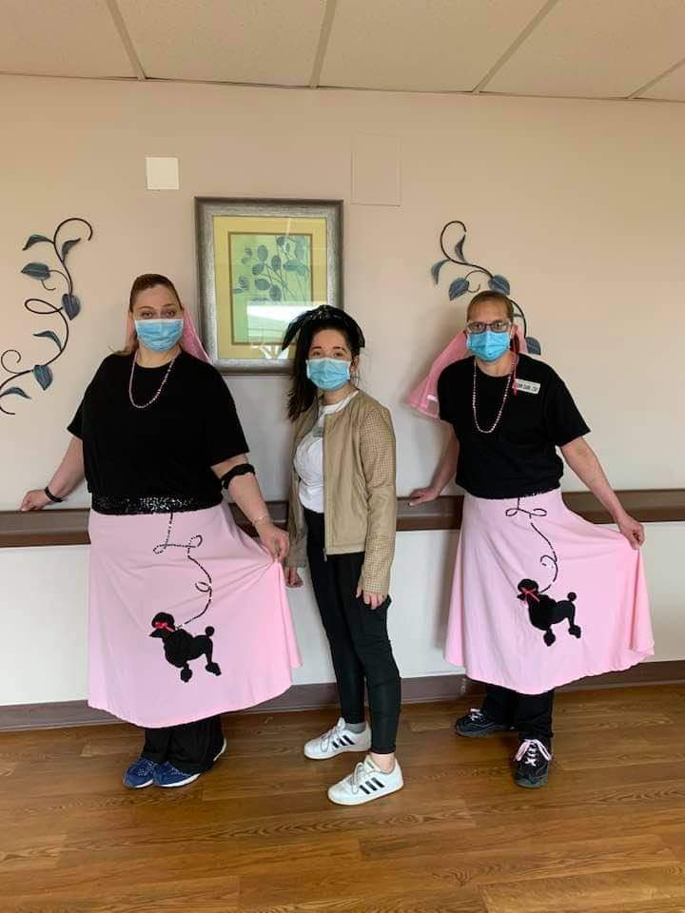

Soc Hop at Rolling Hills

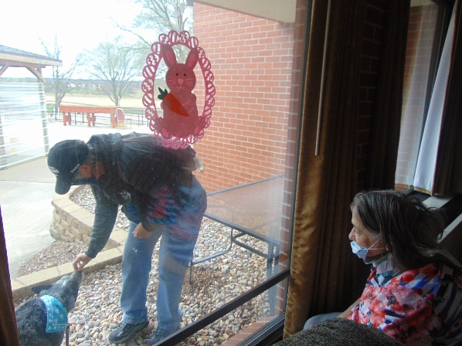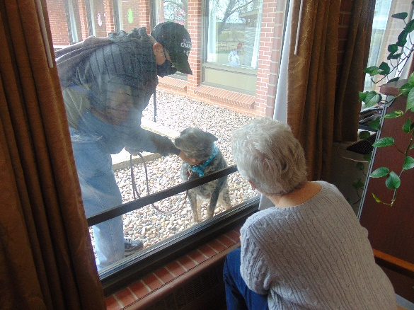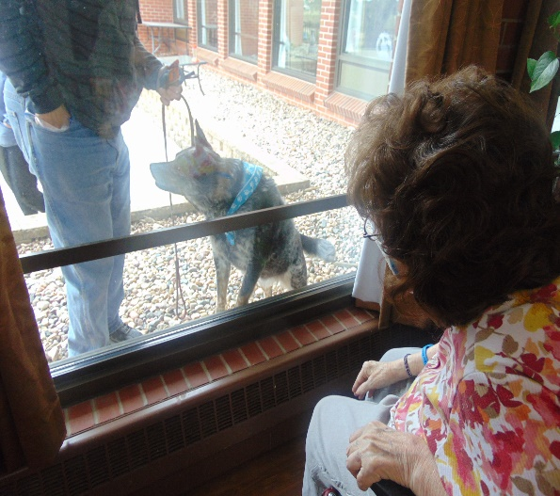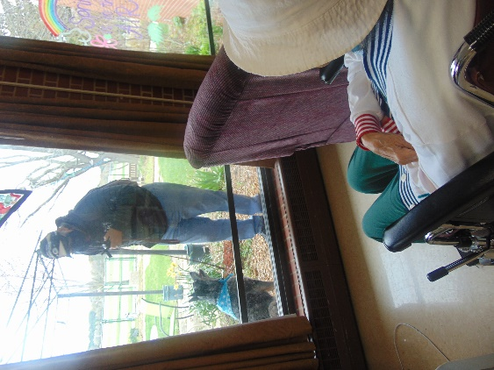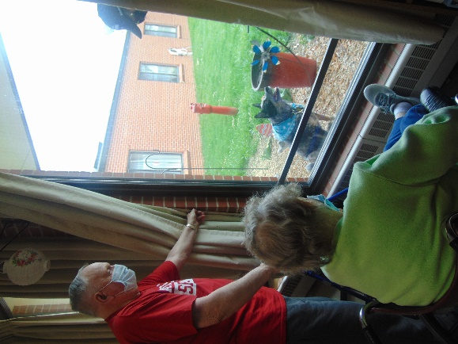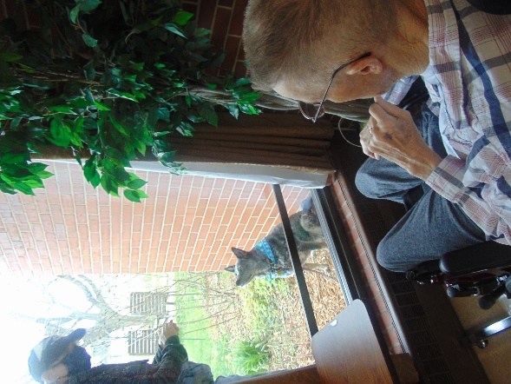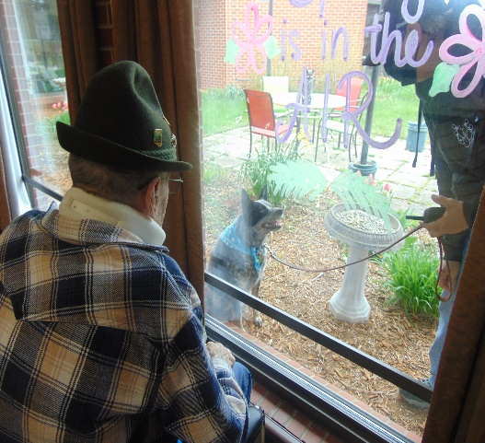

Visit with Keota

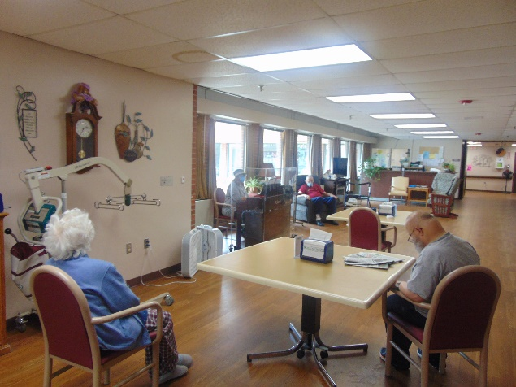

Piano Music with Lisa

Another Friday is upon us, amazing how fast time flies sometimes!

This past week we took time to play scrabble and learn about the inventor and game. We also enjoyed the activity staff making us laugh for Humor Month: Laughter is the Best Medicine. Playing bingo is a great time and highly requested too. We had another window visit with Keota and got to see her do some more fun tricks. Never a dull day when the piano music is filling the hallways either. We hope you all have a great weekend!

Linda