Week of April 19-23 in Pictures:
The Military Order of the Cootie dropped off some gifts for our Veterans:
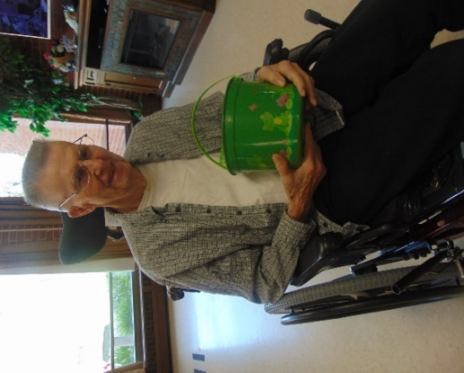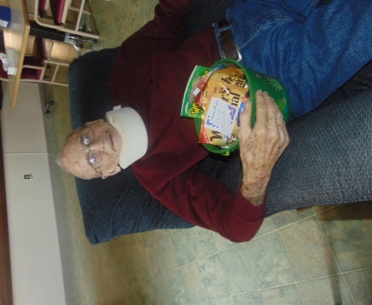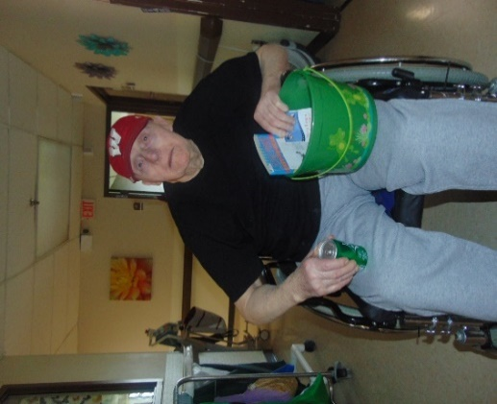
Enjoyed some Girl Scout cookies and Girl Scout facts:
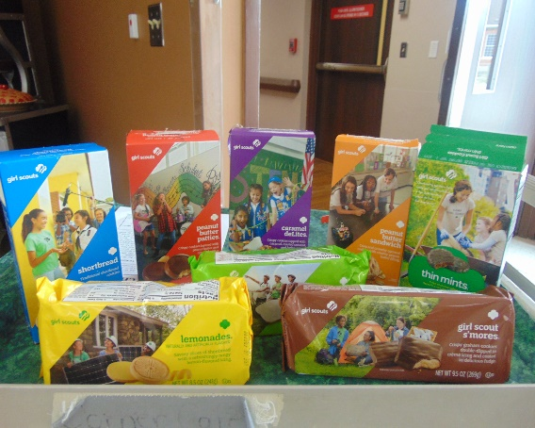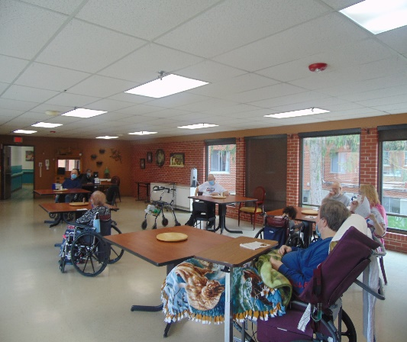
Did some pool noodle exercises:
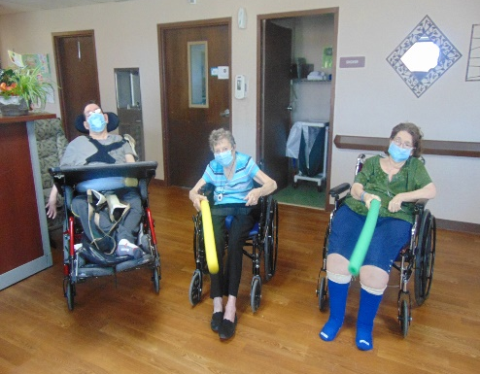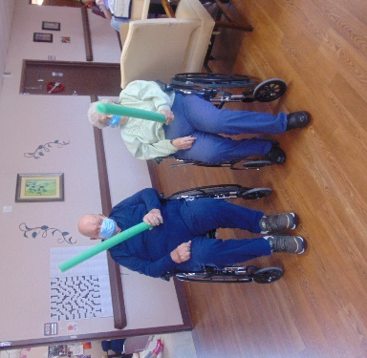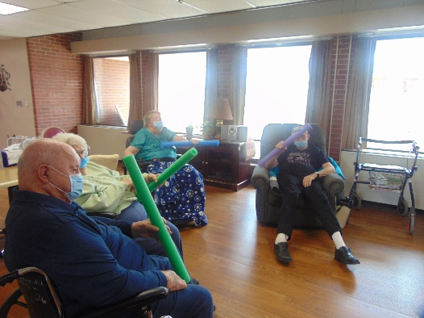

Celebrated National Banana Day!:
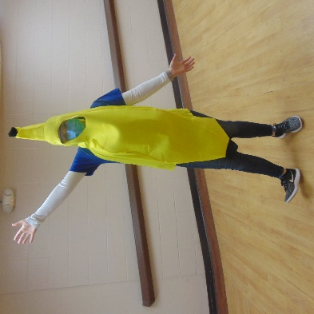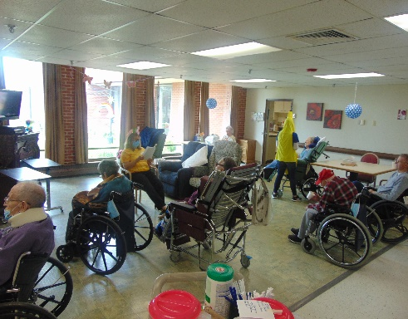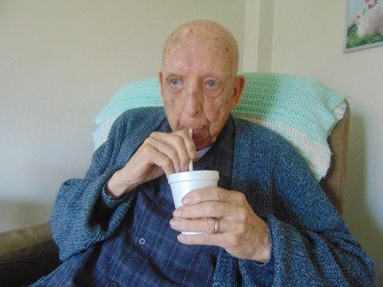
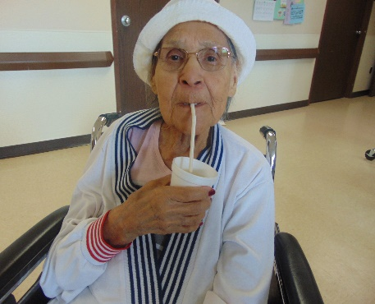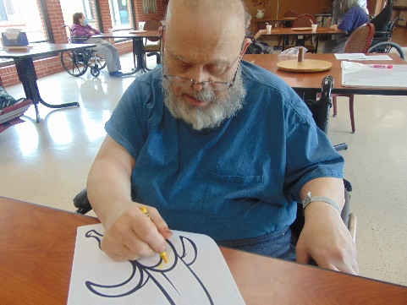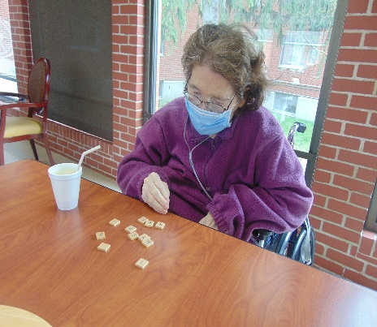
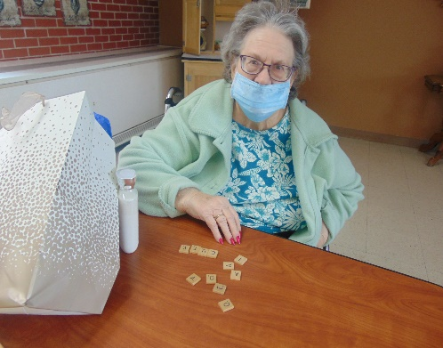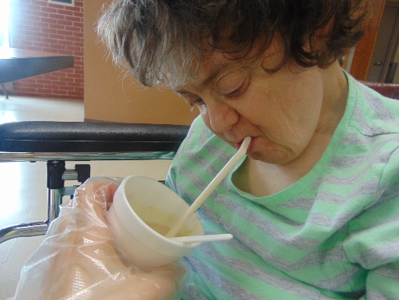
Staff Dress Up Day: Baseball: Playing our newest instrument: the Tongue Drum!:
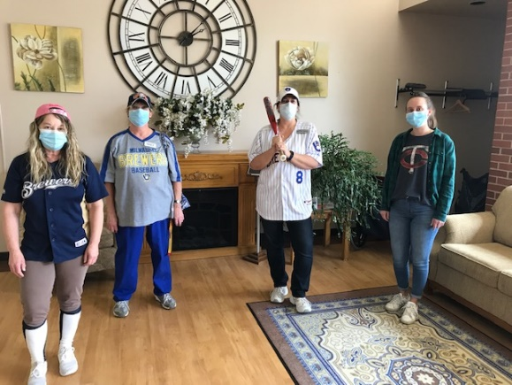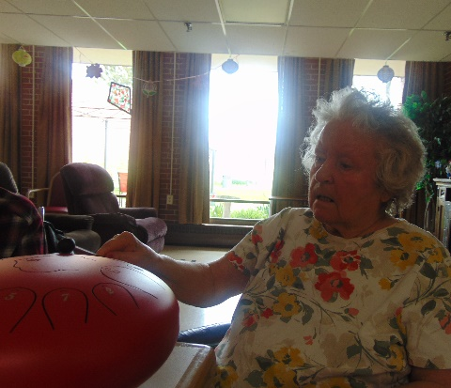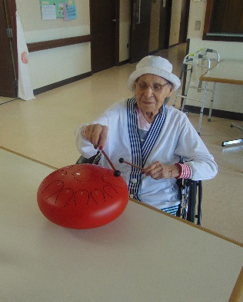

Painting Window Art Crafts for Earth Day:
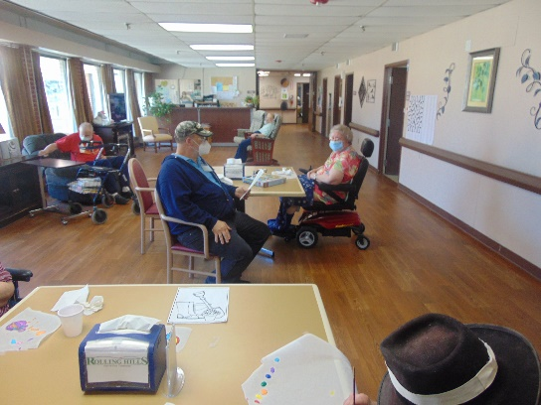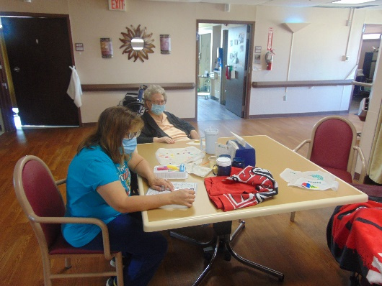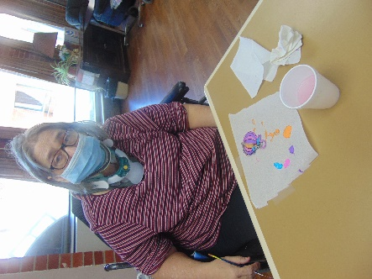
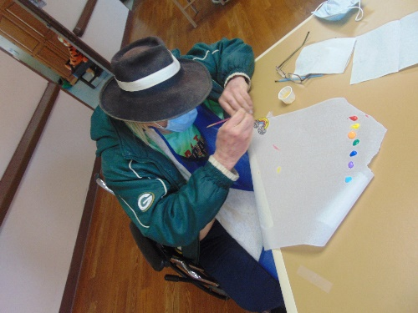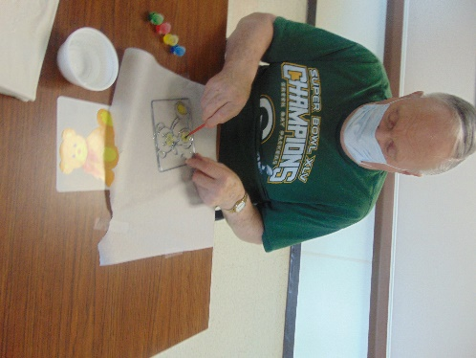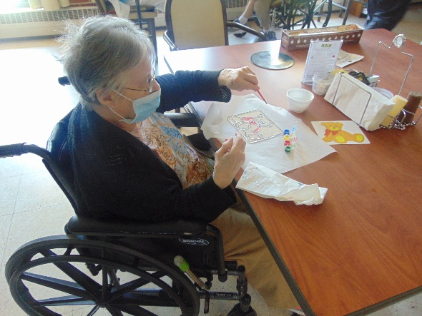
Hello everyone!
We had another fun week full of activities! This past weekend, the Military Order of the Cootie dropped off some nice gift baskets for our Veterans to enjoy. To start the week, we enjoyed some Girl Scout cookies and learned a few facts about Girl Scouts. We did some more exercises this week and go to use some pool noodles. We celebrated National Banana Day by enjoying some banana smoothies, learning some banana trivia, and playing a game of Bananagram. We enjoyed some piano music in the halls and got to play on our newest musical instrument, the tongue drum. We had the opportunity to create some window art crafts for Earth Day and hear some facts about Earth Day as well. Wishing everyone a great weekend ahead!

